LOCATION  4619 Old Court Rd.  Pikesville, MD 21208  ADDRESS  Pikesville International  SDA Church  DONATION  $10 in advance  $15 at the door  Tickets  Sabrina Richardson (443) 824-6606  Latonya Phipps (443) 465-8761  AAOMI2015@gmail.com  Presented by  - the NATIonal federation of the blind of md  March 22nd, 2015  4:00 PM- 7:00 PM  Refreshments will be provided |  |  | An Afternoon of musical inspiration  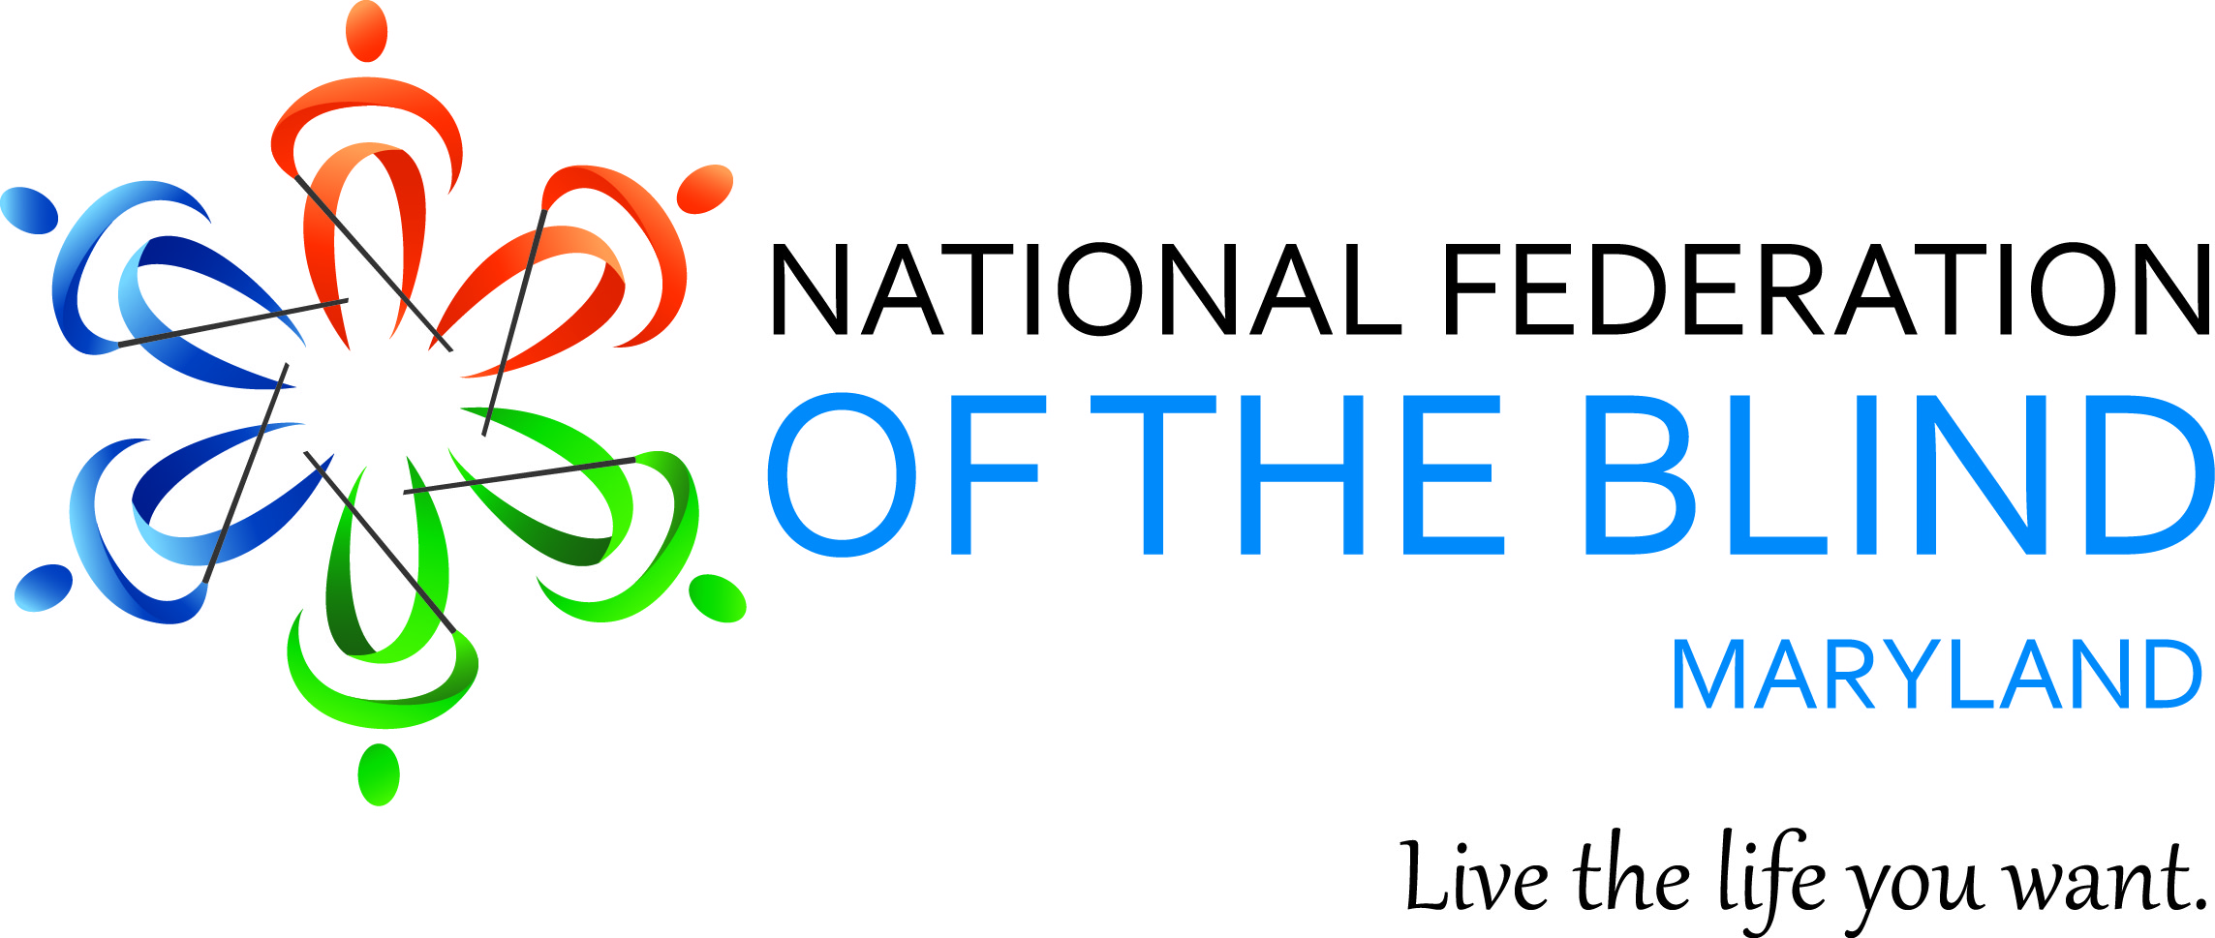  Proceeds benefit NFBMD  Summer Youth Programs

