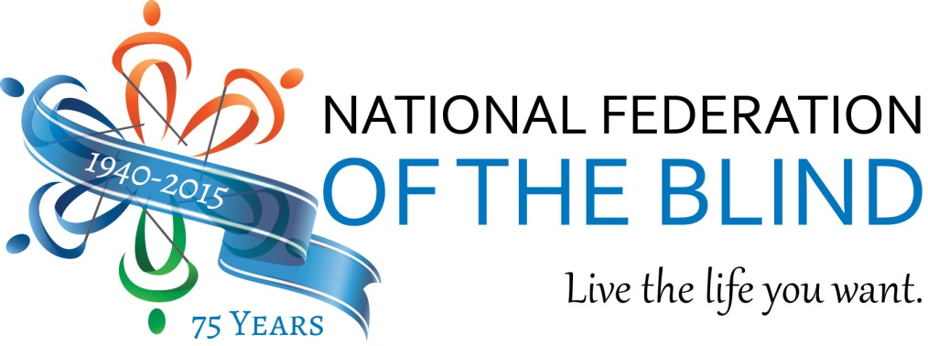

NFB Birthday Bash
Join us as we celebrate the National Federation of the Blind 75th anniversary!

November 16, 2015
Mother’s Federal Hill Grille
1113 South Charles Street, Baltimore, MD 21230
5:30 p.m. – 8:30 p.m.

Bring your family and friends to enjoy great food, music and fun, including a raffle for a Disney vacation package! A percentage of your purchase will benefit the National Federation of the Blind and will allow us to continue helping the blind live the lives they want for the next seventy-five years!
#NFBBirthdayBash #Happy75thNFB
For more information visit www.nfb.org.
