Baltimore Orioles
vs. Tampa Bay Rays

Friday, September 16

7:05 p.m. ● Fireworks night at Camden Yards!

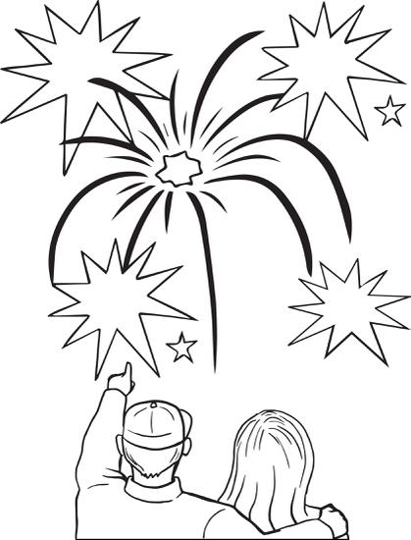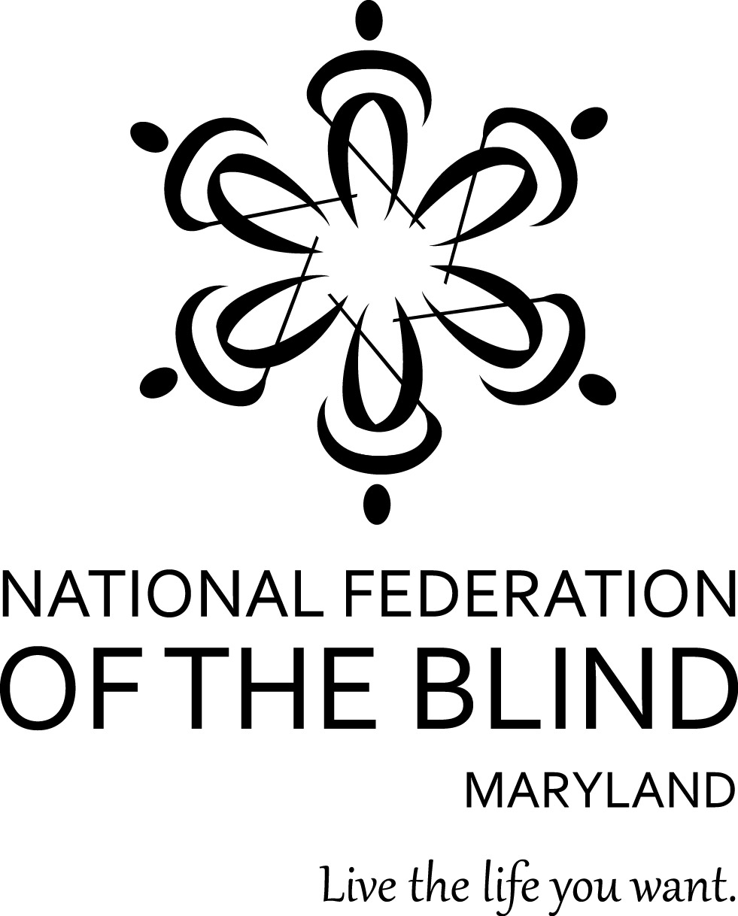

$20 Tickets ● Left Field Lower Reserve
Ticket Sales in Section 87 benefit the Baltimore Chapter of the National Federation of the Blind

Tickets on sale until Sunday August 21

For tickets or more information, call
William Jacobs 410-207-0825

