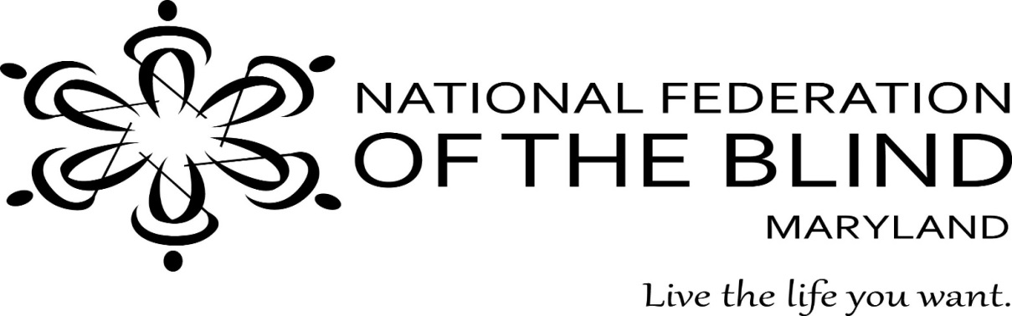
Living the Life You Want seminar
Low Vision Should Not Stop You!
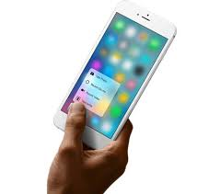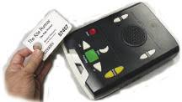
DATE: Friday, November 10, 2017
PLACE: Sheraton Baltimore North Hotel
903 Dulaney Valley Road, Towson, MD 21204
TIme: 9:30 AM - late afternoon
REGISTER by: OCTOBER 20, 2017
COST: $25 (includES lunch)
This practical seminar will answer such questions as:
“How do I read the mail, my prescription labels, or books…”
“How can I send email to my grandchildren?”
“How do I sort laundry and accomplish other household tasks?”
Look at technology. Meet other people with low vision who are living a meaningful life. Submit questions that you want us to answer at the bottom of the registration form which is on the back of this flyer. Please stay as long as you can. Take part in other Convention activities: BINGO, Cardio Drumming, other workshops, and more! If you have any questions about the seminar or convention, please contact Sharon Maneki at 410-715-9596 or nfbmd@earthlink.net.
Low Vision Seminar
REGISTRATION FORM
NAME:
ADDRESS:
PHONE:
EMAIL:
Number of Attendees: |  |  | x $25 | =
LUNCH CHOICE: |  |  | MEAT |  | VEGETARIAN

Please make checks payable to NFBMD and mail registration to:
NFBMD
9013 Nelson Way
Columbia, MD 21045

