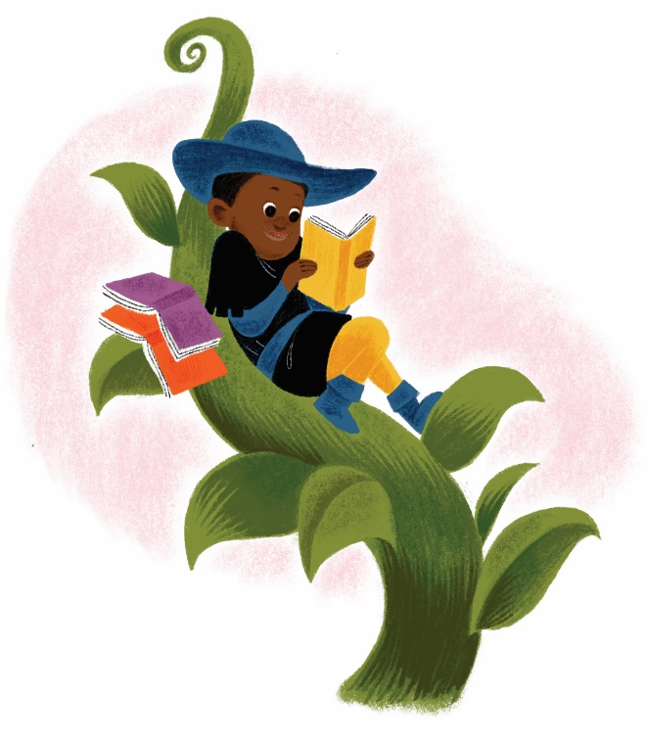
Fee-fi-fo-fum...
I smell some Maryland Summer Library Fun!

Summer Youth Programs at MD LBPH

2020 Summer Library Program @ MD LBPH

(June 22nd – August 8th)
Once upon a library program, there lived summer fun and engagement Why don’t you be part of the story? From June 22nd – August 8th, Maryland LBPH will participate in the “Imagine Your Story” Summer Learning Program! This year, our theme challenges you to explore myths, legends, magic, and folklore. All ages are welcome to participate as there is a challenge for everyone.
We challenge our patrons to read books, attend library programs, and complete activities throughout the summer. Keep track of your reading on our Beanstack site! MD LBPH is giving our readers options on how to earn points toward completion.
Check out updates on Facebook and Twitter! Be sure to use #summerstories when sharing on social media!
Need help? Email: reference.desk@maryland.gov or call 410-230-2424.

Meet Noggin, the Sled Dog and (her human)
Join us to meet Noggin, an Alaskan sled dog. Ms. Karen Land—writer, public speaker, and three-time participant in the 1,049-mile Iditarod Sled Dog Race across Alaska—and her Alaskan husky, Noggin, wants to chat with you in a one hour teleconference. She has given over a thousand talks in almost every state (she has a few left to visit). Karen loves providing MUSHING talks for always-eager students and enthusiastic library patrons. Dogs, the sport of mushing, and Alaska inspire a diverse audience, making this event fun and interesting for all ages.
Event Date: Wednesday, June 24, 2020
Time: 2 - 3 p.m.
Registration: https://forms.gle/PVUWVC8krXttKQ1a7

Youth Creative Story and Songwriting Virtual Workshops with Mr. Joe (SillyJoe)
Creating songs and stories isn’t magic; it’s a simple process of drawing material from everyday experience and transforming it into art. Following a few basic principles, youth will learn how to create stories and songs that will charm and delight their audiences. Do you have a creative side? Can you write some impressive lyrics? How about craft some awesome poetry? Then, this summer fun program is just right for you. Bring your creative genius and work with Mr. Joe (Silly Joe) in these virtual imaginative programs. Workshops will be held via teleconference and registration will be required. Each 45 minute session will be individually contained so you can join at any time.
Registration: https://forms.gle/gE7dJB9FBaMH6q4x6

Workshop Times:
2 p.m.: Elementary (Ages 6-12)
3 p.m.: Middle and High School (Ages 13 – 18)

Weekly Workshops
Week 1 (June 29th): Story Elements and Elemental Stories
- Topics include
  - What makes a story work?
  - How to turn experience into narrative
  - Adding twists
  - Telling the truth with fiction
Week 2 (July 6th): Making stories into songs
- Topics include
  - How to match sounds to content
  - Basic song structures
  - Song writing and recording programs (Cool Blind Tech)
Week 3 (July 13th): Writing Poems
- Topics include
  - Writing with your senses
  - Editing (very picking)
  - Sounds and structures

