National Federation of the Blind of Maryland

2021 Annual Convention

AGENDA

Focus Forward!

Friday, November 12 to Sunday, November 14

Image description: American flag, flying on a flagpole, waving in a slight breeze against a bright blue sky with a few wispy white clouds.

The Members of the Board of Directors and the
Host Committee welcome you to the 55th Annual Convention of the National Federation of the Blind of Maryland

Ronza Othman, President
National Federation of the Blind of Maryland

Meleah Jensen and Brian McCann, Co-Chairpersons
Convention Organization and Activities

Anil Lewis, President
Greater Baltimore Chapter

Qualik Ford, President
Maryland Association of Blind Students

Garret Mooney, President
Maryland Parents of Blind Children

Holiday Inn Downtown Baltimore Inner Harbor
105 W. Fayette St., Baltimore, MD 21201
410-347-5707

Welcome
Welcome to the 55th annual convention of the National Federation of the Blind of Maryland being held in Baltimore at the Holiday Inn Baltimore Downtown Inner Harbor. A detailed description of the layout of the hotel can be found later in this agenda. When you check in to the hotel, you will be asked to confirm your departure date. If you decide to leave earlier than the departure date you confirm when you check in, there may be a change fee.

Special Information for First-Time Attendees
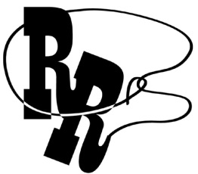
All first-time convention attendees are cordially invited to attend a First-Timers Orientation from 8 to 9:30 p.m., on Wednesday, November 4. The Ambassadors Committee will walk you through the events that will take place throughout the weekend, explain processes such as door prizes and voting, as well as make sure every first-time convention attendee is matched with a mentor.
Zoom Meeting ID: 624 813 8327
One-Number Conference Call: 339-209-4083

Diversity, Equity, Inclusion, and Social Conduct
We are committed to providing a safe and harassment-free environment for everyone. Thank you for cultivating an atmosphere in which participants from diverse backgrounds can learn, network, and share with each other in an environment of mutual respect. We are committed to diversity, equity, inclusion, and the free expression of ideas. These principles have been outlined in our code of conduct, which can be found at NFB.org/Code-Conduct.

We recognize a shared responsibility to create and uphold that atmosphere for the benefit of all. Prohibited behaviors include harassment, unwelcome sexual attention, and inappropriate use of the NFBMD convention space and platforms. Prohibited behavior or misuse of our space and platforms will not be tolerated and may result in removal from the convention and/or other consequences.
For assistance or to report an incident at the convention,
please call 504-621-4162 or email Convention@nfbmd.org for immediate attention.
Formal reports can be submitted to the NFB national office at:
NFB.org/About-Us/History-and-Governance/Code-Conduct/Grievance-Report-Form.
All formal reports will be fully investigated according to the code of conduct. Thank you for contributing to our community and the high expectations we strive to maintain.

Policy on In-Person Events
Note: The NFBMD Board of Directors may update this policy based on public health guidance. The most up-to-date version of this policy is available at NFBMD.org/EventPolicy.
This policy is applicable to all chapters, divisions, and the affiliate, as well as any activities, meetings, fundraisers, or in-person gatherings of an official nature.
- This policy augments any local public health requirements, including those established by the State of Maryland and the County where the event takes place. This policy is the minimum required for in-person events and activities and may be more restrictive than local guidance. However, if local public health guidance imposes additional or more restrictive requirements, the more restrictive requirements govern.
- The following individuals should stay home:
  - Individuals who feel sick, including experiencing any of the following symptoms: fever, sore throat, runny nose, loss of smell or taste, or those ordinarily associated with COVID-19;
  - Individuals who have tested positive for COVID-19 in the past 14 days;
  - Individuals who have a pending COVID-19 test;
  - Individuals who have been exposed to an individual who is known or suspected of having COVID-19;
- Individuals who purchase tickets for an event and either experience symptoms or later determine they do not feel comfortable attending a large gathering due to the pandemic may choose between requesting and receiving a full refund or donating all or part of the purchase price to the organization;
- The event host must have masks on hand for individuals who do not bring their own or whose masks are damaged or soiled;

Indoor Gatherings:
- Temperature screening will be conducted for all attendees of any in-person gatherings with more than 30 attendees, and anyone whose temperature is 100.4 degrees or higher will not be granted admission;
- Screening will be conducted for any events with more than 30 participants, and those reporting symptoms and/or recent exposure to COVID-19 will be denied admission;
- Individuals must wear masks that fully cover their mouths and noses at all times unless actively eating and drinking, and unless they have been granted a reasonable accommodation based on disability by the affiliate President or Vice Presidents;
- Physical distancing is required at all events, e.g., six feet apart unless from the same household. For events where individuals are at round tables, no more than six individuals may share a table. Where tables are rectangular, only every other seat may be occupied;
- Events are limited to 75% venue capacity, but where it would be difficult to ensure physical distancing as required by #8 above, capacity may be limited to 50%;
- Those working the event, including guides, ticket takers, servers, etc. must wash hands frequently consistent with CDC guidance;
- The event host must provide hand sanitizer and/or easy, convenient, and accessible means for event attendees to wash their hands consistent with CDC guidance;
- Individuals may only eat and drink while stationary;
- Food served at any events must be prepared by a commercial kitchen that adheres to COVID-19 food preparation requirements;
- Individuals serving food must wear gloves;

Outdoor Gatherings:
- Individuals must follow the county’s requirements concerning wearing masks;
- Physical distancing may be required at all events for individuals not from the same household, e.g., six feet apart.
- Those working the event, including guides, ticket takers, servers, etc. must frequently wash hands consistent with CDC guidance;
- The event host must provide hand sanitizer and/or easy, convenient, and accessible means for event attendees to wash their hands consistent with CDC guidance;
- Individuals may only eat and drink while stationary;
- Food served at any events is recommended to be prepared by a commercial kitchen that adheres to COVID-19 food preparation requirements;
- Individuals serving food must wear gloves;

Adopted: August 16, 2021
Last Updated: August 28, 2021

Pre-Registration and On-Site Registration
Registration activities take place in the Promenade Foyer, which is outside of the International Ballroom, between 2 and 6 p.m., on Friday; 8 and 8:25 a.m., and 12 and 12:15 p.m., Saturday; and 8:30 and 8:50 a.m., Sunday. All convention attendees (both local and from out of town) are asked to register. Those who pre-registered for convention may pick up their registration packets in the area designated pre-registration. Those who did not pre-register may go to the area designated registration. Please have your check or cash ready to pay the registration fee of $25 per person. We will pilot an on-site credit card platform, but we cannot guarantee it will work. Convention registration is a requirement for voting, door prize eligibility, and a number of other convention activities. We condition rates for hotel rooms on proof of registration.

Fun with Friends Convention Child Care Activities
All child care (for children ages 6 weeks to 9 years) will take place in International Ballroom E on the Main Level. Hours are: Friday 9:15 a.m. to 6:30 p.m.; and Saturday 8:15 a.m. to 5:15 p.m. and 6:30 to 10 p.m., or at conclusion of the banquet, whichever is earlier (lunch and dinner will be provided). Parents, contact Garret Mooney for details.

Exhibit Hall
The exhibit hall is located in the Pratt Room on the Lower Level. The exhibit hall will operate on Friday from 11 a.m. to 4 p.m.

Special Attention Items
- Banquet tickets may be purchased for $45 by cash or check at the on-site registration area. We will pilot a credit card purchasing process, but we cannot guarantee it will work flawlessly. No tickets will be available after
12 p.m., on Saturday. At the banquet ticket exchange table, you may make arrangements to reserve a specific seat for yourself or for a group of up to eight people. On the evening of the banquet, tickets will be required to enter the ballroom and will be collected at the tables. Tickets may be exchanged for vegetarian or meat meals at the banquet ticket exchange table if done so by 2 p.m. on Saturday.
- Banquet ticket exchange will be located in the Promenade Foyer outside the International Ballroom on Saturday between 1:20 and 2 p.m.
- General Sessions will be held in International Ballroom ABC.
- Boxed lunches will be resold if not picked up by 12:30 p.m., on Friday. Those interested in boxed lunches on Friday should visit the Promenade Foyer. Those failing to pick up their boxed lunches by 12:30 p.m., on Friday will forfeit them and will not receive a refund.
- Tickets for other meals may be purchased on a first-come, first-served basis from the registration Table and cost as follows:
  - Picnic and a Play: $20
  - Senior Issues Luncheon: $25
  - Parents Luncheon: $25
- Qualik Ford and Erin Daring are the co-chairs of the Door Prize Committee. Please turn in your door prizes to Qualik and/or Erin as soon as possible. You must be registered for the convention and be physically present when your name is called in order to win a door prize. Door prizes will be awarded during the general sessions on Saturday and Sunday and during the convention banquet.
- Mike Bullis is the Chairperson of the National Funding Support Committee, which manages our Bake and Experience Auction. Please consider bringing baked goods and donating experiences such as dinners, cooking lessons, etc., for this auction.
- We will have a cane walk with individualized cane travel instruction by an NOMC on Saturday morning. To reserve a slot for your child or for yourself, please contact Garret Mooney.
- On Sunday, you must check out of your room before 11 a.m.
- If you are leaving the Holiday Inn Baltimore Downtown Inner Harbor by an NFB of Maryland bus, please bring your luggage to the Hopkins Room on the lower level between 7:30 and 9 a.m., Sunday, where it will be tagged and held for storage until noon when buses will be loaded. Please be sure your luggage is clearly labeled with your name, address, and telephone number.
- The Guide Dog Relief Area is located on the lower level of the hotel outside of the Hopkins Room. Directly to the left of the door is a grassy area. There also is a large cement area just in front of the doors, about 15 feet wide and 30 feet long. There are stairs up to Liberty Street at the perimeter of the cement area, and you can choose to cross the street to visit the dog park on the other side of Liberty Street instead. When exiting the hotel on the lower level, please be sure to prop the door, as it will automatically lock behind you if you do not do so when exiting. Please also remember to make sure the door closes completely behind you when you come back inside the hotel.
Organization Information

National Federation of the Blind of Maryland
1800 Johnson Street, Suite N1, Baltimore, MD 21230
443-426-4110; President@nfbmd.org

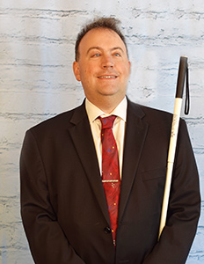 | 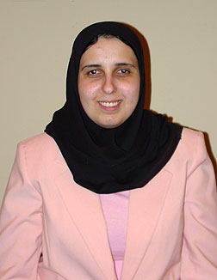
Image: Mark Riccobono  President  National Federation of the Blind | Image: Ronza Othman  President  National Federation of the Blind of Maryland

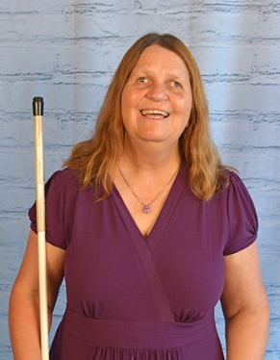
Image: Julie Deden
National Representative & Executive Director
Colorado Center for the Blind

Officers:
Ronza Othman, President, Baltimore
Deborah Brown, First Vice President, Rockville
Dezman Jackson, Second Vice President, Baltimore
Judy Rasmussen, Secretary, Kensington
Jenivieve White, Treasurer, Owings Mills

Board of Directors:
Anil Lewis, Baltimore
Sharon Maneki, Columbia
Mildred Rivera, Halethorpe
Melissa Riccobono, Baltimore
Melba Taylor, Bowie
Marguerite Woods, Baltimore

Our Credo
The National Federation of the Blind knows that blindness is not the characteristic that defines you or your future. Every day we raise the expectations of blind people, because low expectations create obstacles between blind people and our dreams. You can live the life you want; blindness is not what holds you back!

The National Federation of the Blind Pledge
I pledge to participate actively in the efforts of the National Federation of the Blind to achieve equality, opportunity, and security for the blind; to support the policies and programs of the federation; and to abide by its constitution.

About the National Federation of the Blind of Maryland

The National Federation of the Blind of Maryland (NFBMD), an affiliate of the National Federation of the Blind (NFB), is an organization of blind people and their family and friends. We believe in the full capacity of blind people; we have the power, influence, diversity and determination to help transform our dreams into reality. Our members work together for a brighter tomorrow by raising the expectations for blind people everywhere so that blind persons can live the lives they want.

Who We Are
The National Federation of the Blind of Maryland is a 501c(3) nonprofit comprised of blind people of all ages, their families and friends. Our strong local chapters and divisions, and well-trained leaders help newly blind people adjust to vision loss and promote the full participation and integration of blind people in our communities. We bring our collective experiences together to effect change at the state and national level.

What We Do
- Assist blind persons to acquire the skills of independence
- Help blind persons to develop confidence in themselves through our many service activities
- Teach blind persons the skills of leadership through active participation in conventions, chapter meetings, and civic activities
- Encourage blind seniors to continue their active and meaningful lifestyles
- Prepare blind students for productive tax-paying careers through academic and training scholarships
- Inform people with diabetes about their options for coping with vision loss
- Support parents and friends of blind children with information about the capabilities of the blind
- Protect and promote the civil rights of blind persons through public education and legislative action
- Advocate for policies that eliminate discrimination and guarantee equal access to educational programs and high-quality rehabilitation
- Educate the public through seminars, community activities and our publications

LIVE THE LIFE YOU WANT
Lyrics copied from October 2015 Presidential Release

Chorus: Live the life you want. Nobody can stop you.
Shoot for the sun and break on through.
So you're blind. You'll be fine. We've got good news!
You can live the life you want. Yes, we know the truth.
Grab a cane, get trained, gotta get movin’.
Make a change in the wage, that's what we're doin’.
Come with me, yeah
Chorus
You and me, NFB, let’s dream together.
NFB, you and me, lives on forever.
You will see yeah
Chorus
You can live the life you want. You’ll know the truth.

Thank You, Convention Sponsors

We extend profuse thanks to the following convention sponsors.
AdNet/AccountNet, Inc., Independence Level Sponsor
True Sounds Audio, Independence Level Sponsor
Brown, Goldstein and Levy LLP, Equality Level Sponsor
Maryland Relay, Equality Level Sponsor
Vanda Pharmaceuticals, Equality Level Sponsor
Friends of the Maryland Library for the Blind and Print Disabled, Opportunity Level Sponsor
Maryland Department of Disabilities, Opportunity Level Sponsor
The Low Vision Shop of Maryland and Virginia, Opportunity Level Sponsor
3D PhotoWorks, Freedom Level Sponsor

Navigating the Holiday Inn
The Holiday Inn Baltimore Downtown Inner Harbor is located at 105 West Fayette Street, near the southeast corner of Fayette and Liberty streets. This used to be the Crown Plaza Downtown Inner Harbor and shares space with the Radisson Baltimore Downtown. The two hotels share the conference facilities that are called the International Ballroom, Promenade, and Fayette Room, and the Holiday Inn side of the facility houses the Carroll Foyer and lower-level conference area. We will only use the sleeping rooms in the Holiday Inn Tower for our convention, but we will use all of the conference facilities at the property. The two hotels also share a restaurant, bar, and other common facilities. However, they each have their own entrances, parking valets, check-in desks, sleeping room towers, fitness facilities, and other amenities. The Radisson entrance also is on Fayette Street, about 150 feet east of the Crown Plaza entrance. Convention attendees should use the Holiday Inn entrance. However, there is a hallway that connects the Radisson and the Holiday Inn, as well as a walkway between the hotels through the restaurant. This description focuses on the Holiday Inn side of the facility, as well as the shared conference space.

We will provide descriptions using cardinal directions, and where possible, also use right and left. Imagine the Holiday Inn main level almost like an upside-down capital T with a capital L connecting to the capital T at its bottom left arm. The long arm of the upside-down capital T is the south hallway, and the crossbar of the capital T is the east-west hallway. The International Ballrooms and the Fayette Room are along the east (right) leg of the upside-down capital T. An
L-shaped hallway hangs off the left (west) end of the upside-down capital Ts crossbar. The north-south leg of the capital L is used primarily to connect the two conference areas to one another. The east-west leg of the capital L houses the Holiday Inn conference rooms: Carroll, Poe, and Mencken.

When you first enter the Holiday Inn hotel entrance, you will be facing south. The entrance to the Holiday Inn hotel is on Fayette Street. There is an automatic door that leads you into a vestibule. Immediately on your left (east) is the entrance to the shared restaurant, Harbor Sports Bar and Grill. You come across the entrance to this restaurant even before you enter the second doors to the Holiday Inn hotel, and so it is really in the vestibule rather than in the hotel itself.

If you walk into the Holiday Inn hotel main entrance and find yourself in the vestibule, you will find the second set of doors to the hotel on your right. Once you enter those doors, you are facing west, and the restaurant is behind you and Fayette Street is on your right. The check-in desks are on your right along the north wall. There are two of them with a space between them. At the west end of this part of the lobby and across from (south of) the second check-in desk is an unstaffed snack bar.

If you orient yourself so that your back is to the first check-in desk, you are at the top of the upside-down capital T; you enter a hallway that goes north and south, which we will call the south hallway. As you walk south along the south hallway, on your left you will pass a common area containing various desks and chairs for use by hotel guests, as well as an ATM. On your right is another common area with carpeting containing sofas and chairs with charging ports in the conversation areas. At the southern end of this carpeted seating area is a long tall table with high stools, where you can recharge your electronic devices. Past this seating area on the right is the accessible entrance to the hotel lobby bar. If you wish to visit the bar, look for a ramp to go up to the bar off towards your right. If you continue south past the lobby bar, you reach the apex of the upside-down capital T, which is an east-west hallway. The south hallway comes to a dead end here.

If you enter the east-west hallway (the crossbar of the upside-down capital T) by turning left (east), the elevator banks will be on your right (south) just before you encounter carpeting. If you turn into the elevator bank hallway, two elevators will be on your right (on the west wall) and one to the left (on the east wall). These elevators will take you up to the sleeping rooms and down to the lower-level conference facilities.

If you continue east along the east-west hallway (the crossbar of the capital T) past the elevator lobby, you come to a carpeted area followed by a strip of tile floor that is about five feet wide, and beyond it, more carpeting. Once you reach the second carpeted area, you are in the Promenade Foyer. Registration will be in the Promenade Foyer throughout the weekend. On your right (south) are the International Ballrooms, which are comprised of ballrooms A through F. You first encounter the doors for International Ballroom A. The doors to Ballroom A will be used for general session. Ballrooms B and C are south of ballroom A and all three will be combined together to make one big room, Ballroom ABC which will be used for General Session, the Board Meeting, Friday afternoon tours, and the Picnic and a Play event. If you keep walking east along the Promenade Foyer beyond International Ballroom A, the next ballroom you encounter is International Ballroom F. Past Ballroom F is another set of doors that leads into Ballroom D. Ballroom D has a raised fixed stage in it that we will not use.

Across from International Ballroom A on the north side of the Promenade hallway are restrooms (ladies’ room on the left and men's room on the right). Past the restrooms, across from Ballroom F is a hallway that branches off to the left (north) and leads to the Radisson Hotel. We will not use any facilities in the Radisson. The Promenade Foyer will come to a dead end at the east end at some steps leading up to Ballroom E and the Fayette Room. We will be using International Ballroom E and the Fayette Room for childcare. To avoid the steps leading down to the hotel business office, from this upper level, at the top of the steps continue straight (east) all the way to the east wall, before turning right (south) to find the entrance to Ballroom E. At the top of the steps continue straight (east) all the way to the east wall, before turning left (north) to find the entrance to the Fayette Room. The Fayette Room has glass walls. Directly to the right (south) of the steps leading up to Ballroom E and the Fayette Room is a wheelchair lift. Your cane can easily miss this obstacle, so to be forewarned is to be forearmed.

If at the apex of the upside-down capital T, you turn right (west), another entrance to the lobby bar is to your right and there is a set of steps that leads up to the bar from this side. The hallway will come to a dead end past the bar, and you would enter the capital L hallway if you turn left (south).

Along the east arm of the capital L hallway, there is a spiral staircase that leads to the lower floor of the hotel. Of course, you can reach the lower floor via the elevators as well. Past the area where the spiral staircase is, the L-shaped hallway continues south and comes to a dead end at its apex, another hallway that leads left (east). There are other arms that branch off of the capital L, but they are not relevant to our needs, and if you shoreline along the wall, you will reach the apex of the capital L. The entrance to the Carroll Room is on the left (north) side of this short east-west hallway. On the right (south) side of the hallway is the Poe Room followed by the Mencken Room. The east hallway (capital L) comes to a dead end at a service area and you'll have to retrace your steps to get to other parts of the hotel.

There are more meeting rooms we will use in the lower lobby. The lower-level conference space is like a capital H with the elevator hallway as the crossbar connecting the two legs of the capital H. To reach the area where we will have meetings and seminars, turn right from the set of two elevators or left from the single elevator towards the leg of the capital H with more meeting rooms. Pratt A and B are along the leg of the H, and Douglass is at one end of the leg while Peale is at the other. If you are facing the Pratt room, the Peale room is to your right (west) and the Douglass room is to your left (east).

For the Hopkins Room, turn left from the set of two elevators or right from the single elevator towards the leg of the capital H where there is only one meeting room and the spiral staircase as the major landmark. The Hopkins Room is along the leg of the capital H. Restrooms are at the top of that same leg of the capital H. This area also holds the spiral staircase which leads to the upper floor. To find the steps safely, go all the way to the west end by the entrance to the Hopkins Room and turn left (south).

To find the guide dog relief area, orient yourself so the side with the two elevators is behind you and turn left (until you meet a hallway). Turn left again and walk straight until you meet a set of double doors to the outside of the hotel.

The hallways on the guest room floors of the Crown Plaza are quite short. Each floor will have rooms with numbers ending with numbers 20 through 35. The lower numbered rooms are in the Radisson tower. Imagine each floor is like a capital H with the elevator bank as the crossbar of the H. If you put the side with the two elevators behind you and go clockwise starting with the bottom left leg of the H, you will encounter rooms ending 20 to 23 (northwest side), rooms ending 24 to 27 (northeast side), rooms ending 28 to 31 (southeast side), and rooms ending 32 to 35 (southwest side).

Chapters and Divisions of
the National Federation of the Blind of Maryland

At Large Chapter
Marguerite Woods, president, 443-271-1668, mwoods719@gmail.com
Monthly meetings third Tuesday at 7:30 p.m., via phone: 339-209-4083

Baltimore County Chapter
Ruth Sager, president, 410-602-9030, rsager78@gmail.com
Monthly meetings fourth Wednesday in Pikesville

Central Maryland Chapter
Graham Mehl, president, 301-875-8295, blind@trailstone.com
Monthly meetings first Tuesday in Columbia

Eastern Shore Chapter
Patty Ann Behr, president, 443-953-1464, pattyannbehr@gmail.com
Monthly meetings second Saturday in Salisbury

Greater Baltimore Chapter
Anil Lewis, president, 410-659-9314, ext. 2374, alewis@nfb.org
Monthly meetings third Saturday in Baltimore

Greater Carroll County Chapter
Brian Keseling, president, 410-855-5605, bkmaverick@gmail.com
Monthly meetings second Saturday in Westminster

Maryland Association of Blind Students
Qualik Ford, president, 301-312-9813, qsford@outlook.com
Periodic meetings throughout the year

Maryland Association of Blind Merchants
Melba Taylor, president, 240-381-1637, m.taylor@encoreassoc.com
Periodic meetings throughout the year

Maryland Parents of Blind Children
James “Garret” Mooney, president, 480-433-8003, james.garret.mooney@gmail.com
Periodic meetings throughout the year

National Harbor Chapter
Amber Woods, president, 301-978-6686, woodsamber83@gmail.com
Monthly meetings fourth Saturday in Suitland

Senior Issues Division
Ruth Sager, president, 410-602-9030, rsager78@gmail.com
Periodic meetings throughout the year

Sligo Creek Chapter
Debbie Brown, president, 301-881-1892, Deborahb14@verizon.net
Monthly meetings second Saturday primarily in Silver Spring

TLC Chapter
Meleah Jensen, president, 504-621-4162, MeleahHeather@gmail.com
Meetings third Thursday in Towson

Western Maryland Chapter
Chris Myers, president, 772-925-9484, cam76albino@gmail.com
Monthly meetings First Saturday in Cumberland
AdNet Advertisement:
AdNet advocates for workplace excellence and equality.
Leader in providing professionals with Accounting/Finance, Human Resources and Legal expertise
Serving the blind, deaf and mobility impaired community in their workplace by providing Reasonable Accommodations Support Services to government and corporate entities.
Contact Betsy Cerulo, CEO at bcerulo@adnetp3.com or 410-715-4035.

Stay Connected and Informed:
Follow the National Federation of the Blind of Maryland on Twitter:
twitter.com/NFBMD

Friend the National Federation of the Blind of Maryland on Facebook: facebook.com/NationalFederationOfTheBlindOfMaryland

Stay connected with your fellow Maryland Federationists by joining our state email listserv. This list allows you to receive affiliate and national announcements, and also to start and participate in discussions regarding blindness and blindness issues. To sign up visit nfbnet.org, click on “join or drop NFB mailing lists,” and activate “NFBMD” link, and follow the instructions. Many of our local chapters now also have a listserv. Talk to your chapter president to learn how to sign up so you don’t miss important information about chapter news and events.

Visit our website at nfbmd.org. Check out our blog for the President’s Messages. We welcome blogposts from all of our members. Be sure to check out the Blindness Resources link, and the Know Your Rights link to keep up to date on important information. Be sure to download and print “About NFBMD,” in the “About Us” tab on nfbmd.org, for use at chapter outreach events.

Braille Spectator
The Braille Spectator is published for members of the National Federation of the Blind of Maryland and others who share an interest in the work of this organization. The Braille Spectator can be read on the web at nfbmd.org/newsletter or can be listened to on the local channel of NFB-Newsline.

Expanding Our Prominence in Maryland

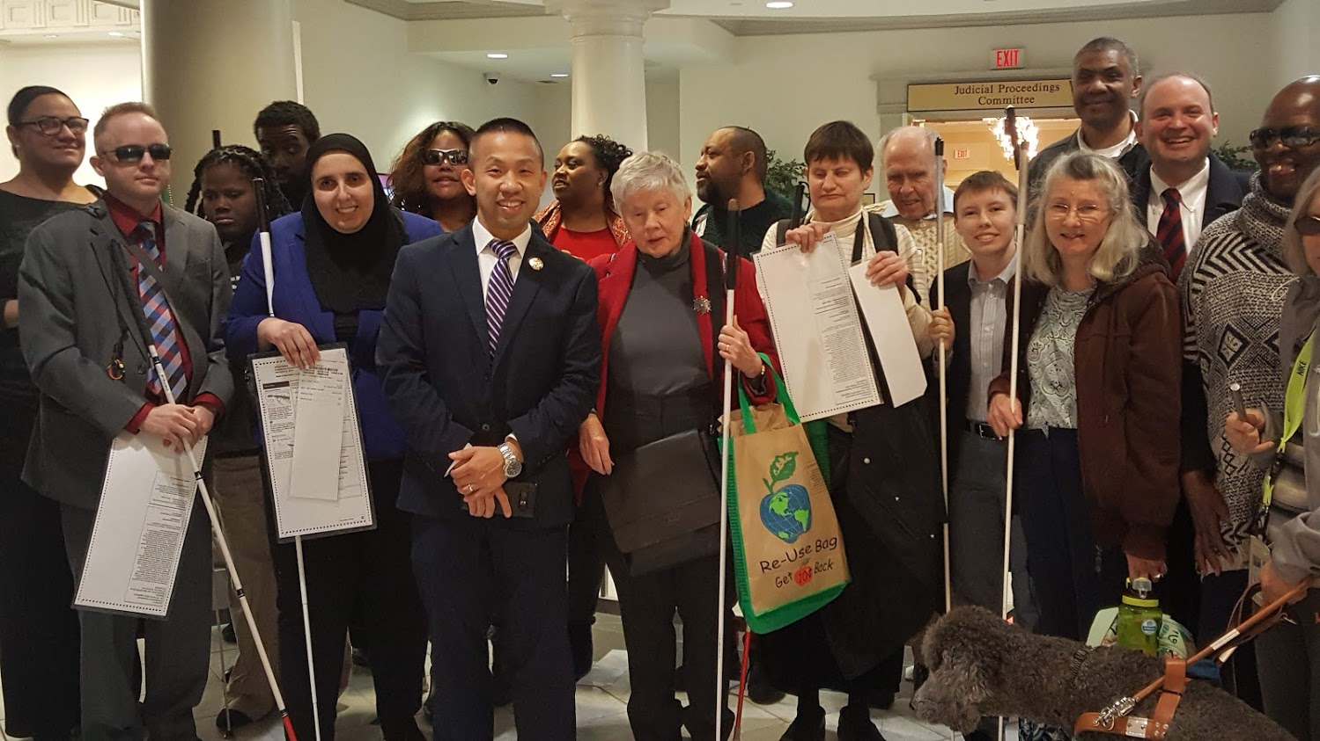
Image: NFBMD engaged in legislative advocacy in Annapolis with Senator Clarence Lam fighting for desegregated voting based on disability

Blind Equality Achievement Month
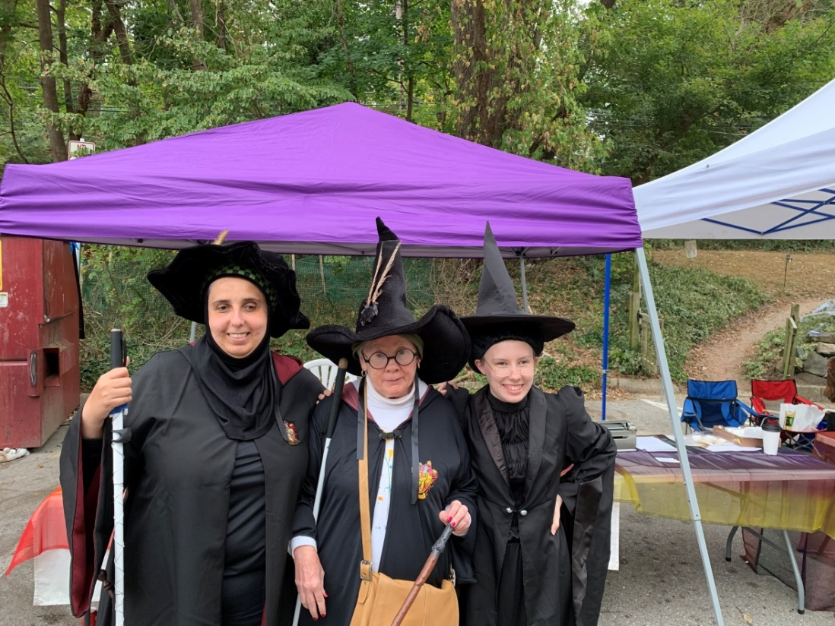
Image: Participants dressed in costume for the NFB Blind Equality Achievement Month Wizarding Weekend on Main in Old Ellicott City
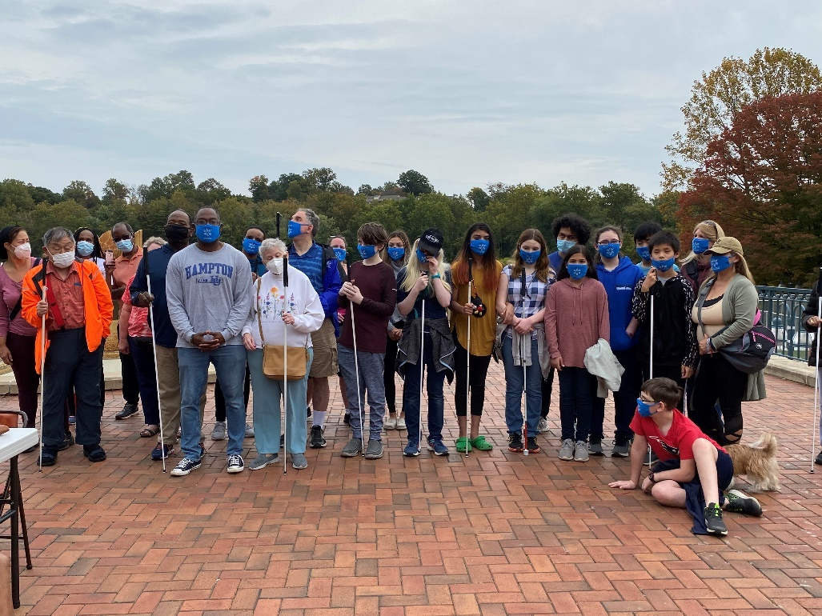
Image: Participants of the Central Maryland Chapter receive a White Cane Awareness Day proclamation from Howard County Councilperson Opel Jones.

NFBMD on the Hill

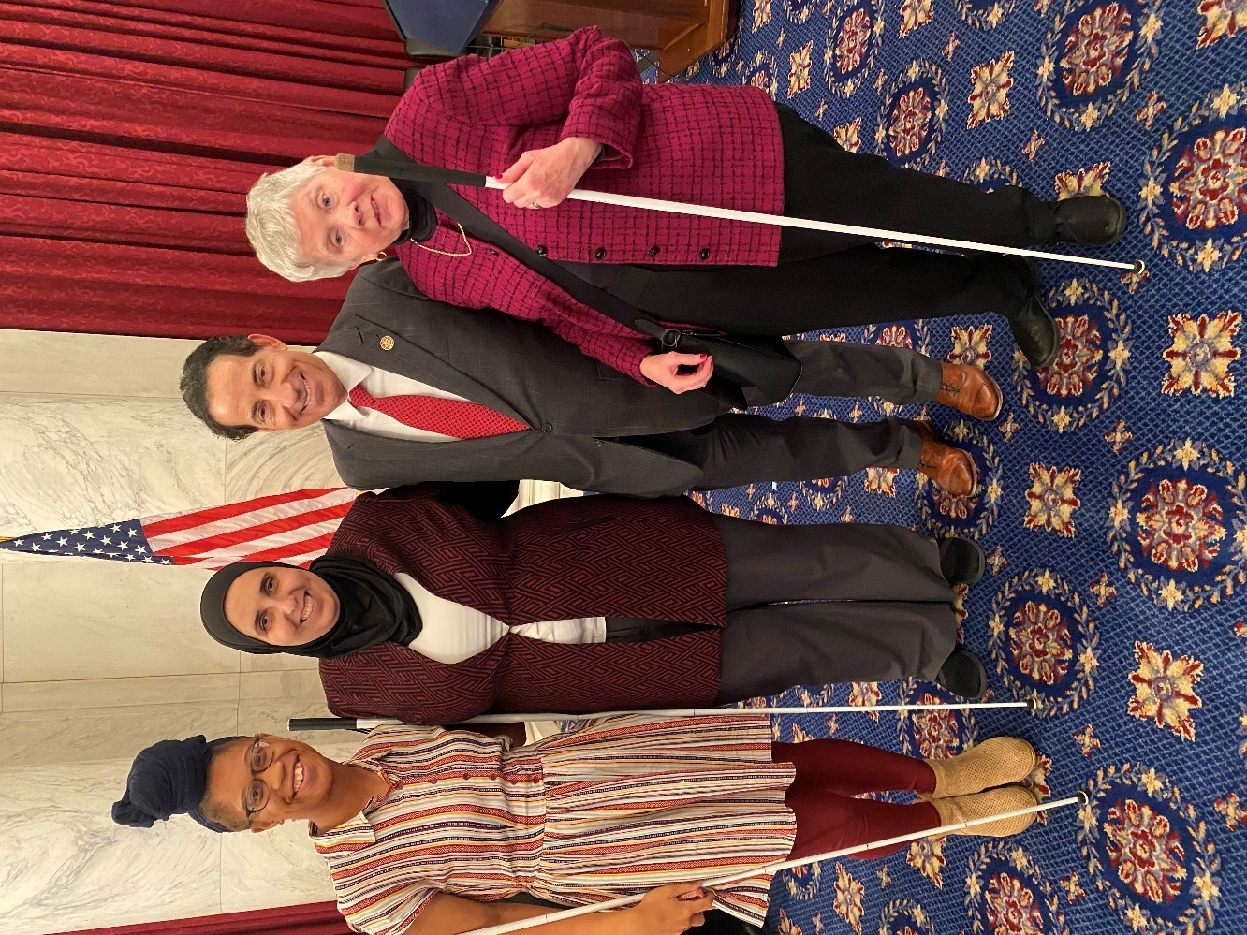
Image: President Ronza Othman, Legislative Chair Sharon Maneki, and Student Division Vice President Erin Daring stand with Congressman Jamie Raskin at the Washington Seminar.

Committees of the
National Federation of the Blind of Maryland
If you’re interested in being appointed to a particular committee, notify the NFBMD president at president@nfbmd.org or 443-426-4110.

Advocacy Committee
Sharon Maneki, chairperson

Ambassadors Committee
Judy Rasmussen, chairperson

Audit Committee
Barry Hond, chairperson

BELL Committee
Brittany Bomboy, chairperson

Braille Spectator Committee
Ronza Othman and Sharon Maneki, editors

Deaf-Blind and Hearing Loss Issues Committee
Janice Toothman, chairperson

Development and Fundraising Committee
Anil Lewis and Jenivieve White, co-chairpersons

Diversity, Equity, and Inclusion Committee
Anil Lewis and Qualik Ford, co-chairpersons

Employment Committee
Pam Goodman and Jannis Forbes, co-chairpersons

Guide Dog Issues Committee
Ashley Alvey and Janice Toothman, co-chairpersons

Legislation Committee
Sharon Maneki, chairperson

Membership Committee
Dezman Jackson, chairperson

PAC Plan Committee
John Paré and Stephanie Flynt, co-chairpersons

Public Relations Committee
Chris Danielsen, chairperson

Resolutions Committee
Chris Danielsen, chairperson

Scholarship Committee
Mildred Rivera, chairperson

Sharon Maneki Youth Empowerment Grant Committee
Sharon Maneki, chairperson

Social Media Committee
Karen Anderson, chairperson

Website and Technology Committee
John Berggren, chairperson

Youth Activity Committee
Lizzy Muhammad Park, chairperson

Convention-Related Committees

Anna Freysz Cable Award Committee
Debbie Brown, chairperson

Bernard Turner Committee
Ellen Ringlein, chairperson

Convention Child Care Committee
Brittany Bomboy, chairperson

Convention Organization and Activities
Meleah Jensen and Brian McCann, co-chairpersons

Convention Registration Committee
Marie Marucci, chairperson

Distinguished Educator of Blind Children Award Committee
Teresa Graham, chairperson

Door Prize Committee
Erin Daring and Qualik Ford, co-chairpersons

Gold Cup Crab Race Committee
Rose Warner, chairperson

Jennifer Baker Award Committee
Melissa Riccobono, chairperson

Kenneth Jernigan Award Committee
Sharon Maneki, chairperson

National Funding Support Auction Committee
Michael Bullis, chairperson

Nominating Committee
Debbie Brown, chairperson

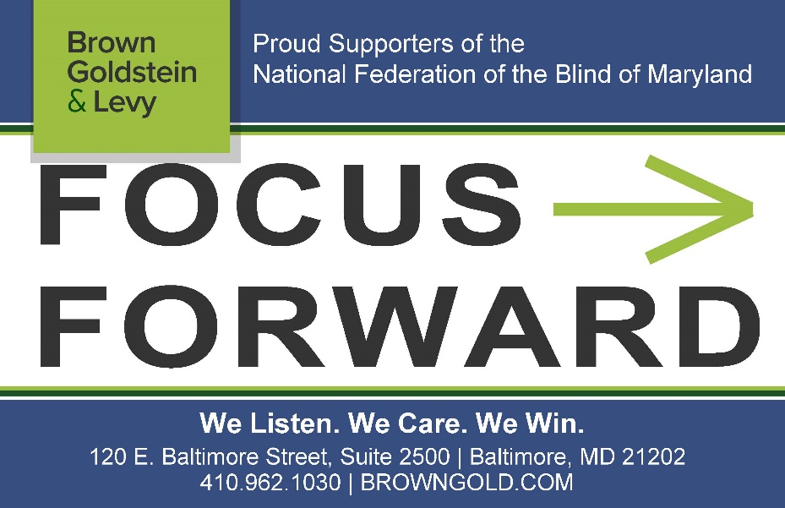
Brown Goldstein Levy Advertisement:
Proud Supporters of the National Federation of the Blind of Maryland
Focus Forward. We Listen. We Care. We Win.
120 E. Baltimore Street, Suite 1700, Baltimore, MD 21202
410.962.1030; www.browngold.com

Leaving A Legacy: Dream Makers Circle
You can help build a future of opportunity for the blind by becoming a member of our Dream Makers Circle. It is easier than you think. Just visit your bank and convert an account to a P.O.D. (payable on death) bank account which is payable after your passing to the National Federation of the Blind or the National Federation of the Blind of Maryland. Your legacy gift to the National Federation of the Blind or the National Federation of the Blind of Maryland can be made in the form of a will or living trust, an income generating gift, or by naming us as the beneficiary of a retirement plan, IRA, pension, or a life insurance policy. You can designate a specific amount, a percentage, or list NFB as one of several beneficiaries. For additional information, please contact Patti Chang at 410-659-9314, ext. 2422 or at pchang@nfb.org.

MARYLAND RELAY
Telecommunications Access of Maryland (TAM) is a division of the Maryland Department of Disabilities and operates the Maryland Relay and Maryland Accessible Telecommunications programs. Maryland Relay is a free, public service for individuals who are Deaf, hard of hearing, DeafBlind, or speech-disabled that enables them to communicate using the telephone. The Maryland Accessible Telecommunications (MAT) program offers a wide variety of solutions and tools—from amplified phones to Braille TTYs to tablets— needed to independently make or receive phone calls.
Visit www.mdrelay.org for information.

STRIVE
Lyrics by Barbara Elliott

Sometimes people tell me blind people should be quiet and sit down
But I say "No!" I say "No!" I say "No."
They contend that I should be content to let others lead me around,
But I say "No!" I say "No!" I say "No."
Everybody needs somebody to help sometimes, but I'm in charge of me,
Chorus: I've gotta strive, strive, strive a little farther,
Reach, reach, reach a little longer,
Work, work, work a little harder,
Hope, hope, hope a little stronger.
Watch me, watch me, watch me.
Nothin's gonna stop me, stop me, stop me.
I'm spreading my wings, soaring on a dream,
I can do anything!
I gotta be brave even when I'm afraid to do hard things.
I'll tell myself "Go!" I'll just go, I will go.
I'm not a fool; I need training and tools to live out my dreams.
So I'll say "Go!" I'll just go, I will go.
I'm not a passenger in my life. I'm gonna take control and drive.
Chorus

Convention Agenda

Friday, November 12
9:15 a.m. to 6:30 p.m. — Fun with Friends Childcare
International Ballroom E
Brittany Bomboy, Convention Childcare Coordinator; Baltimore, Maryland

9:30 to 10:30 a.m. — Resolutions Committee Meeting
International Ballroom D and F
Everyone is encouraged to attend!
Chris Danielsen, chairperson; Baltimore, Maryland

10:30 a.m. to 12 p.m. — NFBMD Board of Directors Meeting (Open to All)
International Ballroom ABC

11 a.m. to 4 p.m. — Exhibits
Pratt Room
Check out the latest offerings from a variety of companies and organizations that provide technology and services for the blind. Jenivieve White, sponsorship and exhibits coordinator and treasurer, National Federation of the Blind of Maryland; Owings Mills, Maryland

11:30 a.m. — Boxed Lunch Distribution
Promenade Foyer
*You paid for a boxed lunch at pre-registration.

12:30 p.m. to 1:30 p.m. — NFBMD B&O Railroad Museum Tour
International Ballroom ABC

12:30 to 1:30 p.m. — Crowd Source Workshop: Technology
International Ballroom D and F
There are many useful low-tech and high-tech technologies available for the blind. Participants will share their favorite apps, low-tech aids, and other technology they use. Each participant will have up to 90 seconds to demonstrate or describe their favorite gadget or application. Karen Anderson, First Vice President, Greater Baltimore Chapter, National Federation of the Blind of Maryland; Baltimore, Maryland

1 to 4 p.m. — Transition Fair
Hopkins Room
Come join the Maryland Transition Coalition to learn about services and resources for transition-aged persons. Maurice Peret, coordinator of Mentoring Programs, National Federation of the Blind; Baltimore, Maryland

1 to 2 p.m. — Deaf-Blind and Hearing Loss Issues Committee Meeting
Douglass Room
Share strategies and ideas to maintain independence. Anyone interested is invited to attend. Janice Toothman, chairperson; Bowie, Maryland

1:30 to 2:30 p.m. — Employment Workshop
International Ballroom D and F
Come learn best practices on how to get and keep a job. Pam Goodman, co-chairperson, NFBMD Employment Committee; Linthicum, Maryland; Janice Forbes, co-chairperson, NFBMD Employment Committee; Laurel, Maryland

1:30 to 4 p.m. — Senior Issues Seminar: Connecting to Independence During a Pandemic
Carroll Room
For seniors and others facing vision loss. Ruth Sager, president, Maryland Senior Issues Division, National Federation of the Blind of Maryland; Baltimore, Maryland; Ellen Ringlein, advisor to the president, National Federation of the Blind of Maryland; Baltimore, Maryland

1:45 to 2:45 p.m. — NFB National Center Virtual Tour
International Ballroom ABC

2 to 3 p.m. — Protecting the Rights of Guide Dog Users
Douglass Room
Share strategies and ideas on how to ensure that the rights of guide dog users are protected. Ashley Alvey, co-chairperson; Baltimore Maryland; Janice Toothman, co-chairperson; Bowie, Maryland

2 to 6 p.m. — Convention Registration and Packet Pickup
Promenade foyer

2:30 to 3:30 p.m. — Diversity, Equity, and Inclusion Workshop
International Ballroom D and F
Come learn about diversity, equity, and inclusion and help map the way forward on DEI in Maryland. Anil Lewis, co-chairperson, NFBMD DEI Committee; Baltimore Maryland; Qualik Ford, co-chairperson, NFBMD DEI Committee; Baltimore, Maryland

3 to 4 p.m. — Blind Parents Meeting
Peale Room
Share tips and tricks on how to parent using non-visual techniques. Network with other blind parents and caregivers. Melissa Riccobono, chairperson; Baltimore Maryland

3:30 to 8 p.m. — Student Workshop
Poe Room
Come learn about matters of interest to students including how to self-advocate in school, with potential employers, and in the world. Learn what resources are available for students. Includes a networking pizza party. Registration from 3:30 to 4 p.m. Qualik Ford, president, Maryland Association of Blind Students; Baltimore, Maryland

4 to 8 p.m. — Annual Conference for Parents and Teachers of Blind Children: Maryland Parents of Blind Children
International Ballroom D and F
What are the skills and tools blind students need in school and to live the lives they want? How do you make sure school services are appropriately addressing their needs? What can you do to support them at home? Learn about the benefits of summer programs and how to help your child with other blindness skills. These are only some of the topics to be discussed at this seminar. Includes a networking pizza party for families. Garret Mooney, president, Maryland Parents of Blind Children Division; Baltimore, Maryland

6 to 8:30 p.m. — Maryland Association of Blind Merchants Annual Meeting and Networking Mixer
Carroll Room
Come learn about matters of interest to blind merchants and those in the Business Enterprise Program. Melba Taylor, president, Maryland Association of Blind Merchants; board member, National Federation of the Blind of Maryland; Bowie, Maryland

7 to 8:30 p.m. — Picnic and a Play
International Ballroom ABC
The Braille is Beautiful Players will perform an original play written by Debbie Brown. Debbie Brown, play author and director; first vice president, National Federation of the Blind of Maryland; Rockville, Maryland

8:30 to 11:30 p.m. — Crab Idol
International Ballroom ABC
This American Idol-style evening promises to be fun for all ages. Those wishing to perform songs can do so for $5 per person per performance or $10 per group. Chapters and Divisions will battle it out to determine which has the most talent. Enjoy snacks and fellowship thanks to the Maryland Association of Blind Students and Maryland Parents of Blind Children. Proceeds support MDABS and MDPBC. To sign up to perform, contact Qualik Ford or Garret Mooney.

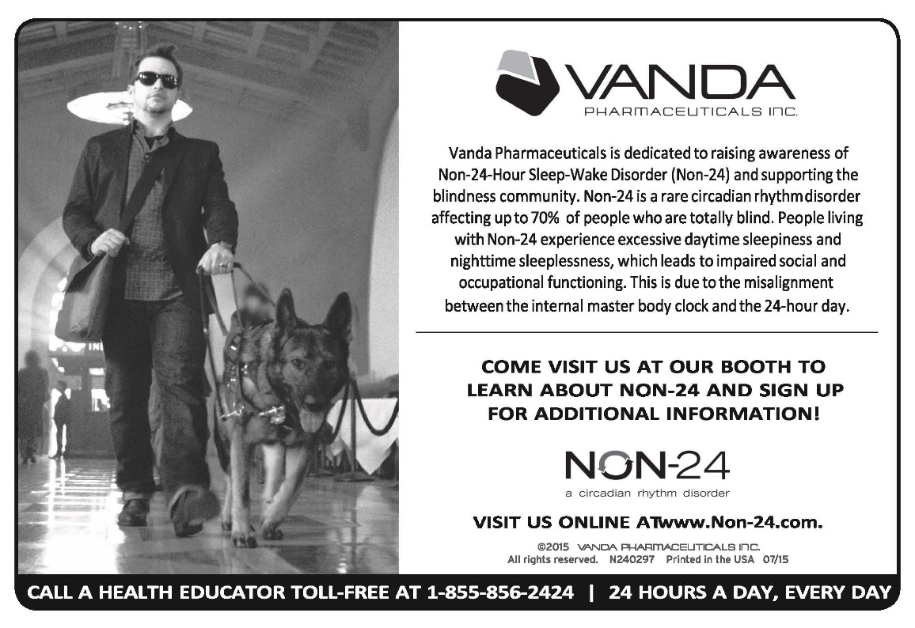
Vanda Pharmaceuticals Advertisement: Vanda Pharmaceuticals is dedicated to raising awareness of Non-24-Hour Sleep-Wake Disorder (Non-24) and supporting the blindness community. Non-24 is a rare circadian rhythm disorder affecting up to 70% of people who are totally blind. People living with Non-24 experience excessive daytime sleepiness and nighttime sleeplessness, which leads to impaired social and occupational functioning. This is due to the misalignment between the internal master body clock and the 24-hour day. Come visit us at our booth to learn about non-24 and sign up for additional information! Visit us online at
www.non-24.com. Call a health educator toll-free at 1-855-856-2424, 24 hours a day, every day.

Saturday, November 13
7 to 8:15 a.m. — Maryland Association of Blind Students Annual Meeting
Poe Room
The Maryland Association of Blind Students will hold its annual business meeting, including planning future workshops and events and holding elections. Continental breakfast will be available. Qualik Ford, president; Baltimore, Maryland

7 to 8:15 a.m. — Western Maryland Chapter Meeting
Mencken Room
The Western Maryland Chapter will meet face-to-face. Continental breakfast will be available. Chris Myers, president; Cumberland, Maryland

7 to 8:15 a.m. — At-Large Chapter Meeting
Carroll Room
The At-Large Chapter will meet face-to-face. Continental breakfast will be available. Marguerite Woods, president; Baltimore, Maryland

7 to 8:15 a.m. — NFBMD Cane Walk
Pratt Room
The Maryland Parents of Blind Children will host a cane walk for children and adults. Garret Mooney, president, Maryland Parents of Blind Children Division; Baltimore, Maryland

8 to 8:25 a.m. — Convention Registration and Packet Pickup
Promenade foyer

8 a.m. to 5:15 p.m. — Fun with Friends Childcare
International Ballroom E
Brittany Bomboy, coordinator; Baltimore, Maryland

8:30 a.m. to noon — Saturday Morning Session

International Ballroom ABC
8:30 a.m. — Call to Order and Opening Ceremonies

8:50 a.m. — Greetings from the National President
Mark Riccobono, president, National Federation of the Blind; Baltimore, Maryland

9 a.m. — Focus Forward on Equal Access to Education
Marcella Franczkowski, assistant state superintendent, Division of Early Intervention and Special Education, Maryland state Department of Education; Baltimore, Maryland
Conchita Hernandez, Blindness and Low Incidence Coordinator, Division of Early Intervention and Special Education, Maryland state Department of Education; Baltimore, Maryland

9:15 a.m. — Focus Forward on Our Internal Programs
Get on the Pac Plan - Stephanie Flynt, Maryland PAC Plan co-chairperson; Baltimore, Maryland
Gold Cup Crab Race - Rose Warner, ticket agent; Baltimore, Maryland

9:30 a.m. — Focus Forward with a National Lens: A Report from Our National Office
Julie Deden, executive director, Colorado Center for the Blind; Littleton, Colorado

10 a.m. — Focus Forward with a Student Lens: A Report from Our NABS Representative
Mausem Mehta, board member, National Association of Blind Students; Stanton, Virginia

10:10 a.m. — Just Keep Swimming
McClain Hermes, 2021 USA Paralympic Swimming Team; Baltimore, Maryland

10:20 a.m. — Focus Forward on Independence: Rehabilitation Services
Toni March, director, Office of Blindness and Vision Services, Maryland Division of Rehabilitation Services (DORS); Baltimore, Maryland

10:30 a.m. — Focus Forward on Employment
Panel Moderators: Pam Goodman, co-chairperson, NFBMD Employment Committee; Linthicum, Maryland; Janice Forbes, co-chairperson, NFBMD Employment Committee; Laurel, Maryland

11:10 a.m. — Without a Net: Tips for Blind Students in Preparing for Their Transition to College
Dan Burke, public relations specialist, Colorado Center for the Blind; Littleton, Colorado
11:25 a.m. — Focus Forward on Legislation and Advocacy
Sharon Maneki, director of Legislation and Advocacy and board member, National Federation of the Blind of Maryland; Columbia, Maryland

11:35 a.m. — Focus Forward on Innovation: Excellence in Nonvisual Access and Blindness Programs
Anil Lewis, executive director of Blindness Initiatives, National Federation of the Blind; board member, National Federation of the Blind of Maryland; Baltimore, Maryland

11:45 a.m. — Reports and Resolutions

Noon — Adjourn

12 to 12:15 p.m. — Convention Registration and Packet Pick-Up
Promenade Foyer

12 to 1:45 p.m. — Luncheon: The Education of Blind and Low-Vision Students
Pratt Room
For parents, teachers of the blind, and those interested in matters concerning blind students. Garret Mooney, president, Maryland Parents of Blind Children Division, National Federation of the Blind of Maryland; Baltimore, Maryland

12 to 1:45 p.m. — Luncheon: Reclaiming Independence After Vision Loss
Carroll Room
For seniors and others facing vision loss. Ruth Sager, president, Maryland Senior Issues Division, National Federation of the Blind of Maryland; Baltimore, Maryland; Ellen Ringlein, Advisor to the President; Baltimore, Maryland

1:20 to 2 p.m. — Banquet Ticket Exchange
Promenade Foyer

2 to 5 p.m. — Saturday Afternoon Session

International Ballroom ABC
2 p.m. — Call to Order

2:05 p.m. — Focus Forward
Ronza Othman, president, National Federation of the Blind of Maryland; Baltimore, Maryland

2:40 p.m. — Purpose to Action: A Report from the Maryland School for the Blind
W. Robert Hair, superintendent, Maryland School for the Blind; Baltimore, Maryland

2:50 p.m. — Perspectives from a Reader: What Blind People Should Know
Lauren McLarney, attorney, Rosenberg Martin Greenberg, LLP; Baltimore, Maryland
Blaire Freed, workplace task assistant, AdNet/AccountNet, Inc.; Baltimore, Maryland

3:20 p.m. — Focus Forward on Safety and Supports: Consent and Boundaries
Sar Surmick, director, Consent Academy; Seattle, Washington
Danielle Montour, educator, Consent Academy; Lubbock, Texas

4:05 p.m. — Focus Forward on State Programs
Carol Beatty, secretary, Maryland Department of Disability; Baltimore, Maryland
John Shatto, embassador, Maryland Able; Baltimore, Maryland
John Owen, director, Maryland State Library for the Blind and Print Disabled; Baltimore, Maryland

4:40 p.m. — A Welcome from the Maryland General Assembly
Brooke Lierman, Maryland State Delegate, District 46; Baltimore, Maryland

4:50 p.m. — Reports and Resolutions

5 p.m. — Adjourn

5 p.m. — Reception and Cash Bar
Promenade Foyer

6:30 to 10 p.m.* — Fun with Friends Childcare
International Ballroom E
Brittany Bomboy, coordinator
*Childcare ends at 10 p.m., or 15 minutes after the banquet ends, whichever is earlier

7 p.m. — 55th Annual Convention Banquet
International Ballroom ABCDF
Master of Ceremonies: Mark Riccobono, president, National Federation of the Blind; Baltimore, Maryland
Keynote Banquet Address: Julie Deden, executive director, Colorado Center for the Blind; Littleton, Colorado
Scholarships and Awards

Immediately after the Banquet — Maryland Gold Cup Crab Race
Race Callers: Ronza Othman and Rose Warner

TrueSounds

Mixing and Mastering
Audio and Video
Services

TrueSounds
10129 Matador
El Paso, TX 79924

Contact Joshua Lintz at 915-317-8211 or truesoundsaudio@gmail.com

Sunday, November 14
7:30 to 9 a.m. — Luggage Collection
Hopkins Room
For bus passengers only

8 to 8:45 a.m. — Nonsectarian Devotions
International Ballroom ABC
Judy Rasmussen, secretary, National Federation of the Blind of Maryland; Kensington, Maryland

8:30 to 8:50 a.m. — Convention Registration and Packet Pick-Up
Promenade Foyer

9 a.m. to noon — Sunday Morning Session
International Ballroom ABC
9 a.m. — Call to Order and Invocation

9:05 a.m. — Recognizing Our Veterans
Ed Jackson, board member, Greater Baltimore Chapter; Baltimore, Maryland

9:20 a.m. — A Report from Blind Industries and Services of Maryland
Michael Gosse, director of accessibility, Blind Industries and Services of Maryland; Baltimore, Maryland

9:35 a.m. — Focus Forward on Our Children: NFB BELL Academy
Lizzy Muhammad-Park, NFB BELL Academy coordinator for Maryland; Baltimore, Maryland

10:05 a.m. — Focus Forward on Independence: NFB Training Centers
Moderator: Julie Deden, executive director, Colorado Center for the Blind; Littleton, Colorado
Juhi Narula, secretary, Maryland Association of Blind Students; Bowie, Maryland
Brittany Bomboy, NFB Childcare coordinator; Baltimore, Maryland
Dezman Jackson, second vice president, National Federation of the Blind of Maryland; Baltimore, Maryland

10:55 a.m. — Financial Report
Jenivieve White, treasurer, National Federation of the Blind of Maryland; Owings Mills, Maryland

11:10 a.m. — Affiliate Elections

11:25 a.m. — Resolutions, Audit Committee Report, and Other Business

Noon — Adjourn

A Closing Message
On behalf of the officers and Board of Directors, I’d like to take this opportunity to thank all Federationists and friends for your generous monetary donations and gifts of goods and services. We had a very successful year and an outstanding convention because of your help!
Ronza Othman, President

BRAILLE IS BEAUTIFUL

Na na na-na na na, na na na-na nah.
Na na na na nah, na na na-na nah.

Chorus:
Go on and live your life,
Don't need a bit of sight.
In the end you'll find
Braille is beautiful.
Put your fingers on the page.
Tell your friends it's all the rage.
It's all gonna be OK, yeah
Braille is beautiful!

Na na na na na na, Na na na-na nah Braille is beautiful!
Na na na-na nah, Na na na-na nah.

Verse
Louis Braille was his name. Slate 'n' stylus was his game.
They tried to stop him, but we adopted the code that paved the way.

Chorus

Na na na na na na, Na na na-na nah Braille is beautiful!
Na na na-na nah, Na na na-na nah.
Na na na-na nah, Na na na-na nah.

BRAILLE IS BEAUTIFUL!

2021 NFBMD Exhibitors
The following is a list of organizations that are participating in the 2021 NFBMD Exhibit Hall. Check NFBMD.org for updates and additions to this list.

- Vanda Pharmaceuticals
- Maryland State Library for the Blind and Print Disabled
- Maryland Technology Assistance Program
- Maryland Department of Disabilities
- Maryland Able
- Integration Technologies Group
- Low Vision Specialists of Maryland and Virginia
- Maryland Division of Rehabilitation Services (DORS)
- Maryland Relay/Telecommunications Access of Maryland
- National Aquarium
- Industries for the Blind
- Vispero
- PS You Are Fabulous
- NFBMD National Harbor Chapter
- NFBMD Western Maryland Chapter

