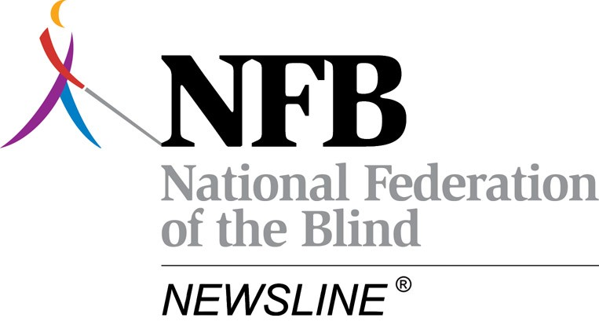

NFB-NEWSLINE®

1800 Johnson Street
Baltimore, Maryland 21230
(410) 659-9314

GENERAL OVERVIEW of NFB-NEWSLINE®

The National Federation of the Blind offers NFB-NEWSLINE®, a free electronic newspaper service that carries 308 publications to 42 states and the District of Columbia. Over 70,600 subscribers across the nation presently listen to their local and national newspapers every day using a standard touch-tone telephone or over the Internet using their computer. NFB-NEWSLINE® keeps the blind and visually impaired up-to-date on the news happening in their communities and the world around them. Newspapers offer much more than news; they include the latest on travel, food, science, books, technology, fashion, music, dance and the arts. NFB-NEWSLINE® offers ten magazines including The Economist, the New Yorker, Time Magazine, Science News and all three AARP publications, and six newspapers in Spanish.

The New York Times, the Wall Street Journal, and USA Today, are among the many national and local newspapers offered. Subscribers have access twenty-four hours a day, seven days a week, through a local or toll-free telephone number.

Subscribers also can enjoy hourly updates from United Press International and the Associated Press for national and international news as well as a specific AP news feed for Michigan and other states.

NFB-NEWSLINE® also features television listings that are highly interactive and allow you to get to the information quickly. You can choose your favorites and also move through channels, dates and times. Set up is as easy as providing your zip code, source of television and your time zone.

On March 31, 2009, NFB-NEWSLINE® announced the addition of an online web site, www.nfbnewslineonline.org in order to provide our subscribers with exciting new reading options. On this web site subscribers will be able to view all the publications offered on NFB-NEWSLINE® through their web browser and download content to their portable device such as the Victor Reader Stream.

For more information, visit the website at www.nfbnewsline.org or call NFB-NEWSLINE® at (866) 504-7300.

Michigan NFB-NEWSLINE® - Service Eligibility Criteria

The NFB-NEWSLINE® service is available to all residents of Michigan that have a qualifying print disability. In order to qualify for Michigan NFB-NEWSLINE® a person must, reside in the state of Michigan and meet the blindness or disability criteria used for eligibility for the Books for the Blind and Physically Handicapped program administered by the Library of Congress and cooperating network libraries.

Michigan NFB-NEWSLINE® - Services Offered

Currently there are six newspapers from Michigan on the NFB-NEWSLINE® system including the Detroit Free Press, Detroit News, Flint Journal, Flint Journal classified ads, Grand Rapids Press, Lansing State Journal, and The Mining Journal.

In addition to the six state newspapers, Michigan NFB-NEWSLINE® subscribers can also read Associated Press articles pertaining to their state, which are updated every hour. The Associated Press content is the same information that is sent to television and radio stations through out the state.

It is important to note that not only do Michigan NFB-NEWSLINE® subscribers have access to the newspapers previously mentioned but also they have access to national publications such as The Christian Science Monitor, the New York Times, USA Today, and the Wall Street Journal. For a complete list of publications available on NFB-NEWSLINE®, please visit www.nfbnewsline.org. Also for those on the go, the NFB-NEWSLINE® system can send a subscriber their newspapers via email. These email newspapers can then be read on the computer or transferred to portable devices such as the Book Port, Braille Note, Victor Stream etc. for on the go listening.

The Michigan NFB-NEWSLINE® system also contains a local channel facility where information specific to the blind and visually impaired community of Michigan can be posted. Types of material that you would find on the local channel would include information on events in the Michigan blindness community, information from the agency serving Michigan’s blind and visually impaired election information etc.

Michigan NFB-NEWSLINE® Statement

October 1, 2008 through September 30, 2009

Outstanding invoice to be paid:

Invoice number: 0810MCB0909
Invoice period: October 1, 2008 through September 30, 2009

Annual service: $53,386

Annual telecommunications: 21,614

Newspaper Operational Fee: $5,000
(The Mining Journal)

Total amount for invoice 0810MCB0909: $80,000

Michigan NFB-NEWSLINE® Usage Information
October 1, 2008 through September 30, 2009

As of 09/17/09, Michigan NFB-NEWSLINE® is serving 2,655 subscribers.

During the reporting period, there were 60,182 calls to NFB-NEWSLINE® from Michigan residents and 197 new subscribers added to the system.

Number of minutes used by Michigan subscribers during the period: 1,130,598

Percentage of NFB-NEWSLINE® calls from Michigan sent over the local number network during the period: 50%

Michigan NFB-NEWSLINE® - Michigan Newspapers Accessed

Please find below a chart containing the name of the Michigan publications along with the number of times that it was accessed between 10/01/08 and 09/30/09.

Associated Press Michigan: 7,386
Detroit Free Press: 46,736
Detroit News: 16,285
Flint Journal: 3,199
Flint Journal Classifieds: 2,112
Grand Rapids Press: 5,639
Lansing State Journal: 6,028
Michigan Information Channel: 1,894
The Mining Journal: NA

NOTE: The above chart does not report on any reading of newspapers from other states or magazines by Michigan NFB-NEWSLINE® subscribers. Nor does it report on any reading of any national publications such as The Christian Science Monitor, the New York Times, USA Today, the Wall Street Journal, or the Washington Post etc. by Michigan subscribers.

Michigan NFB-NEWSLINE® - Subscribers Receiving their

Newspapers via Email

During the time period of 10/01/08 through 09/30/09, 45,615 email newspapers were sent out to NFB-NEWSLINE® Michigan subscribers.

Michigan NFB-NEWSLINE® – Persons Downloading their

Newspaper from Bookshare.org

At this time it is not possible to quantify the number of Michigan residents downloading NFB-NEWSLINE® newspaper content from Bookshare.org.

Michigan NFB-NEWSLINE® - Recommendations for

Improvements in the Service

A more human quality voice is planned to be added to the NFB-NEWSLINE® system over the next few months. It is believed that the addition of the more human quality voice will be of benefit to newly blinded / low vision persons who are just getting started with synthetic voices. Also it is believed that a more human quality voice will be popular with seniors, especially those with some hearing loss.

It is recommended that the sponsor investigate the possibility of adding one or two more newspapers to the Michigan NFB-NEWSLINE® system to provide more local newspaper coverage to the state.

Additionally, a relationship with a Radio Reading service or other source of local content could be developed in order to provide audio files of such readings as grocery store ads for example.

~~~

This Michigan NFB-NEWSLINE® status report was submitted by:

Scott A. White

Director of Sponsored Technology Programs

National Federation of the Blind

Phone: 410-659-9314 Extension 2231
E-Mail: swhite@nfb.org
http://www.nfbnewsline.org

