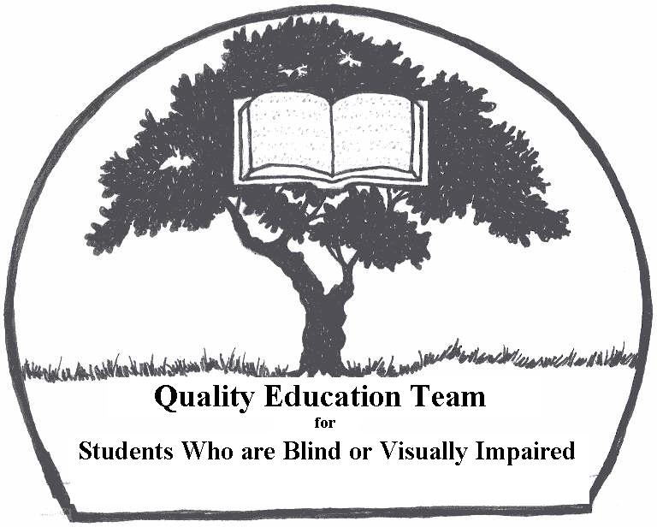
3rd ANNUAL
VI Students, Siblings, Parents, Teachers, Friends…. Activities for Everyone!

BRAILLE-A-THON

Sponsored by the
Quality Education Team for
Students Who Are Blind or Visually Impaired (QET)
AND
Michigan Parents of
Children with Visual Impairments (MPVI)
When: June 21st -2011
Where: Michigan State Capital Building - south lawn
Time: 11:00 a.m. to 3:00 p.m.
What’s happening: Activities include…

- Braille contests for tactile readers of all ages and levels.
- Games, including a scavenger hunt, Braille Bingo, Braille Feud, and Limbo under the white cane.
- Simulated Braille & Visual Impairment Awareness Activities
- Entertainers who are blind or visually impaired are encouraged to apply to perform.

Braille-A-Thon Mission Statement:
This event is being offered to all blind, visually impaired, and sighted children, adults, their parents, and interested community members of the state of Michigan, in order to:
- Raise awareness of the importance of Braille literacy and skills of blindness.
- Demonstrate the capacity of blind children and adults.
- Educate Michigan’s legislators on the importance of effectively teaching Braille and skills of blindness in Michigan’s Public schools.

To Make a Tax Exempt Donation to the 2011 Braille-a-Thon please include the information below with your Check Payable to MPVI and mail to….
MPVI- Amy Shepherd, 725 Arlington Blvd. Ann Arbor, MI 48104
MPVI is a 501C3 organization (tax ID #382957938). A letter of receipt will be sent to you via e-mail

Donor name:__________________________ Donor Phone:_____________________________
Donor Address: _________________________________________________________________
Donor E-mail Address:_______________________________

For information on how to Register a Student, participate as a Vendor or Volunteer please contact
Event Coordinators:
Gwen Botting mpvi@intergate.com or Amy Shepherd 734-915-5138 ashepherd1@aol.com

