COMMISSION FOR THE BLIND

MICHIGAN COMMISSION FOR THE BLIND,
PETITIONER

v.

HAZELL BROOKS,
RESPONDENT

Docket No: 2010-109

A Decision of the Michigan Commission for the Blind Board
Ms. Jo Ann Pilarski, Commissioner and Chair
Mr. Michael Geno, Commissioner and Vice Chair
Mr. John Scott, Commissioner
Ms. Geri Taeckens, Commissioner
Ms. Margaret Wolfe, Commissioner

DECIDED: July 20, 2010

ISSUED: August 10, 2010

Final Decision
As provided in Vending Facility Program rule 393.56(9), 1999 AC, R. 393.56, the commission board has reviewed the Recommended Decision of the Administrative Law Judge in the State Office of Administrative Hearings and Rules, Docket No. _2010-109__. The Commission Board rejects in whole the Recommended Decision and issues its final decision as follows:

- The Commission for the Blind Board passed a motion to reject the ALJ recommended decision to uphold the revocation of Ms. Brooks license by the Commission for the Blind.

“Yea” votes: Absent:
Mr. Michael Geno, Vice Chair None
Mr. John Scott
Ms. Geri Taeckens

“Nay” votes: Recused:
Ms. Margaret Wolfe None

Abstained:
None
- The Commission for the Blind Board passed a motion that the Board remand this issue for hearing to determine damages; and to have Ms. Brooks return the computer to staff prior to the hearing.

“Yea” votes: Absent:
Mr. Michael Geno, Vice Chair None
Mr. John Scott
Ms. Geri Taeckens

“Nay” votes: Recused:
Ms. Margaret Wolfe None

Abstained:
None

Notice: If you are dissatisfied with this final decision, you may file a complaint with the federal Secretary of Education. The complaint shall be accompanied by all available supporting documents, including but not limited to, the Recommended Decision of the Administrative Law Judge, and this Final Decision. The Secretary will convene an ad hoc arbitration panel in accordance with 34 CFR §395.13.

_______8/9/10_________ ____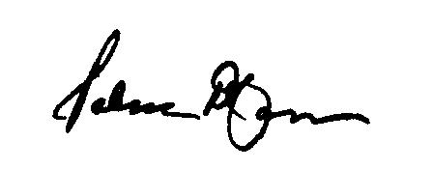___________
Date Patrick D. Cannon, State Director

