COMMUNITY CALENDAR
Link to MPVI’s Calender of Events for more details
www.mpvi.org
Amy Shepherd- amyshepherd@mpvi.org

- 1st and 2nd Saturday’s of each Month- MI Birdbrains- Birding By Ear-Locations are: 1st Saturday UofM Dearborn Environmental Interpretive Center - 2nd Saturday Jamer Nature Center in Lansing-Donna Posont- donnabutterfly50@gmail.com 313-220-8140
- March 1-2, 2014- Michigan Blind Athletic Assoc. MI State GoalBall Tournament- jessica.kusku@gmail.com
- March 7, 2014-MDE-LIO- Independent Living Skills Team Transition & Careers workshop-@ Kalamazoo KRESA- 5-9pm for MS & HS Students- Registration Deadline March 3- To register www.mde-lio-cenmi.org Connie Patrick 888-760-2206
- Mar. 15, 2014 - Ann Arbor Pediatric Vision and Eye Disease Support Group-@ Kellogg Eye Center- Topic - Congenital Eye Diseases-www.kellogg.umich.edu
- Mar. 28, 2014- MDE-LIO Transition Workshop- Karen Wolffe- Parent Discount- FABULOUS SPEAKER for Parents- Register http://mde-lio.cenmi.org/
- Mar. 29, 2014- Ann Arbor Center for Independent Living Transition Workshop- 11-3pm- Ages 14 and older- Anna Dusbiber-Gossage, Youth Services Coordinator (734) 971-0277 x17 or anna@aacil.org
- April 4-6, 2014 - OUB Spring Fling @ Indian Trails Camp - gwen@oubmichigan.org
- May 1-2nd 2014-MAER Annual Conference in Livonia- Parents Welcome http://www.maerbvi.org/conference.htm -
- Parents don’t miss out on this fabulous opportunity to hear Grace Soto speak at the MAER Conference!
- Thursday, May 1, 9:45-11 am (Letting Your Child's Wild Side Out) and
2:15-3:30 pm (Letting Your Child's Literate Side Out). MPVI will also be sponsoring a Parent Luncheon from 12:30- 1:30 with Grace Soto as our presenter. There will also be a session for Hispanic Families to meet with Grace Soto, who is Hispanic herself, from 5:00-6:30pm. More Details to follow or contact amyshepherd@mpvi.org
- May. 3, 2014- Ann Arbor District Library/Wash. Library for the Blind- Helen Keller Exhibit- http://www.aadl.org/
- May 4-6th, 2014- WMU VI Junior Sports Camp-Register by March 1- michigansec@gmail.com or https://mbaa-mi.com/Sports_Camp_HNNF.html
- May 7-10,2014- WMU VI Senior Sports Camp-Register by March 1- michigansec@gmail.com or https://mbaa-mi.com/Sports_Camp_HNNF.html
- May 10, 2014-Foundation Fighting Blindness Vision Walk- adiuble@aol.com
- May 14, 2014- Ann Arbor District Library/Wash. Library for the Blind Visions Technology Fair- http://wlbpd.aadl.org/
- April 4-6,2014 - OUB Spring Fling @ Indian Trails Camp - gwen@oubmichigan.org
- May 16-18, 2014- OUB /MPVI Family Camp/Gardening/Open House @ Indian Trails Camp - gwen@oubmichigan.org
Summer
- June 8 – 14,2014- OUB Tech Camp (Adults 18 and over)@ Indian Trails Camp - gwen@oubmichigan.org
- June 15 – 28, 2014- OUB Blindness Immersion Camp @ Indian Trails Camp - gwen@oubmichigan.org (planning to partner with Assoc. for the Blind and VI so that Transition aged kids can do the Summer in the City Program but sleep over at Indian Trials Camp with the OUB program)
- June 16-19 & 23-26, 2014- Assoc. for the Blind and VI Summer in the City (Ages 14-18) -Grand Rapids-Amy Schreiner for more information 616-458-1187 x. 332 aschreiner@abvimichigan.org
- June 16-20 Goalball Camp Greater Detroit Agency for the Blind- Mary Beth Kullen at 313-272-3900 or kullen@gdabvi.org
- July 5, 2014- Lions Bear Lake Camp Open House- http://www.bearlakecamp.org/services.htm
- July 6 – 12-OUB Survivor Art Camp @ Indian Trails Camp gwen@oubmichigan.org
- July 13-19, 2014- Lions Bear Lake Camp First Timers- http://www.bearlakecamp.org/services.htm
- July 13-26, 2014- Lions Bear Lake Camp for Lifers- http://www.bearlakecamp.org/services.htm
- June 16-20, 2014-Greater Detroit Agency for the Blind Goalball Camp-9-noon daily-Mary Beth Kullen at 313-272-3900 or kullen@gdabvi.org
- June 20-27, 2014 Leader Dog Summer Experience (16-18yrs)- www.leaderdog.org/programs/youth or call 888-777-5332. Applications are due by April 1, 2014.
- July 13-23, 2014- OUB Adventure Trip (Ages 12- HS)@ Beaver Island Lake Charlevoix gwen@oubmichigan.org
- July 14-25, 2014-Greater Detroit Agency for the Blind Elementary Enrichment Day Camp( Ages 6-10)- 9am-3pm M-F-Mary Beth Kullen at 313-272-3900 or kullen@gdabvi.org
- July 28-31 NFB Science Camp - Donna Posont donnabutterfly50@gmail.com 313-220-8140
- Aug. 4-15, 2014- National Federation of the Blind MI Bell (Braille) & Science Camp- Ages 4-12- Terri Wilcox trising@sbcglobal.net (734)663-4050
- Aug. 4-15, 2014-Greater Detroit Agency for the Blind MS & HS Youth Enrichment Camp (11-14yr. old) 9am-3pm M-F -Mary Beth Kullen at 313-272-3900 or kullen@gdabvi.org
- Aug. 12-14, 2014- MDE-LIO- Junior Camp (ages 9-12 yrs.) @ Camp T (517) 373-2887 https://mde-lio.cenmi.org
- Aug. 13-18,, 2014- Bureau of Services for Blind Persons - Transition Zone@ Camp Daggett Walloon Lake- Registration available on the Challenge Mountain Website- http://cmski.org/transitionzone.html (989) 732-5814 or e-mail Julie Clark clarkj3@michigan.gov
- Aug. 15-17, 2014- MDE-LIO- Senior Camp (ages 13-18 yrs.) @ Camp T (517) 373-2887 https://mde-lio.cenmi.org
- Aug. 22-24, MDE-LIO- Family Camp @ Camp T (517) 373-2887 https://mde-lio.cenmi.org
Want to Add your Event to our Calendar?
E-mail Robin Decker at robindecker@mpvi.org with a description, website link, dates and times, and contact information.

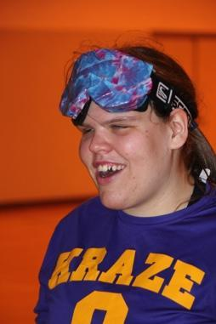
MI Youth Goalball 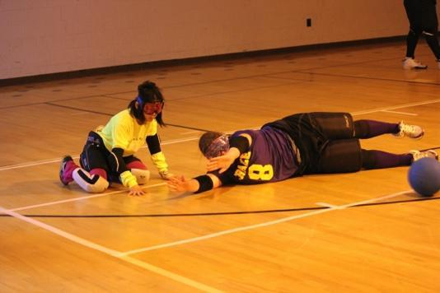
These dates are as often as we can do it, but not every week, so call to confirm. All ages and abilities are welcome. Bring gear if you have it, some gear is available but we don't have much. We are accepting donations of gear if you are no longer in need of yours.
Wednesday nights :Grandville 6pm-9pm -Contact Nikki Buck 269-598-3864
Saturday mornings :Kalamazoo 8:30am-12:00pm -Contact Nikki Buck 269-599-3864
Saturday: Birmingham 9am-4pm -Contact Heather Bowman-Tomlinson 586-872-8299

Washtenaw Library for the Blind and Visually Impaired @ Ann Arbor District Library
Save these dates!
http://wlbpd.aadl.org/
Saturday, May 3, 2014: Child in a Strange Country: Helen Keller and the History of Education for the Blind and Visually Impaired-APH traveling Exhibit. Opening day Celebration! Ann Arbor District Library Director Josie Parker and American Printing House Museum Director Michael Hudson will be onsite to welcome you to this special event! The exhibit will be on display during the entire month of May.

Wednesday, May 14, 2014: VISIONS Fair 2014:What’s New in Technology for the Blind and Visually Impaired. A variety of Michigan exhibitors will demonstrate the latest products and services for the blind and visually impaired. Magnifiers, electronic readers, Braille devices, library services, CCTVs, Leader dogs, support services for the blind and transportation services are just a few of the many outstanding services and products on display.

WMU/MBAA
SPORTS EDUCATION CAMPS for Students with Visual Impairments 2014!

The Michigan Blind Athletic Association (MBAA) Sports Education Camps for kids who are blind and visually impaired (impairment of 20/70 or greater) is held on the beautiful campus of Western Michigan University in Kalamazoo, MI. This year's camps will be held on the following dates:

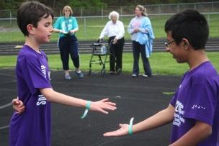
Junior Camp (athletes aged 9-12): Sunday May 4 to Tuesday May 6, 2014: A series of clinics designed to teach younger students fundamental athletic skills.

Senior Camp (athletes aged 13-17): Wednesday May 7 to Saturday May 10, 2014: A series of clinics designed to teach middle and senior high school students intermediate athletic skills.

Michigan State Games: Friday May 9 to Saturday May 10, 2014: (Open to all athletes ages 13-19 who have previously attended camp. All campers must still be in High School.): Opportunity for students to compete individually and as teams.

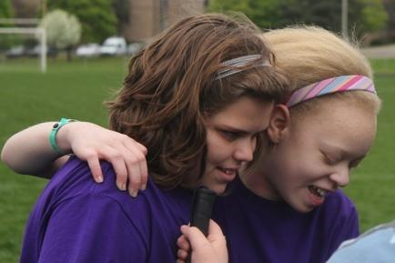
The camps are designed to introduce students with visual impairments to sports and recreational activities and to provide continued training to those demonstrating athletic potential. Typical Junior Camp activities include: introductory running, throwing, jumping, kicking, swimming, gymnastics, wrestling, rock climbing wall, judo, and goalball. Senior Camp activities will likely include: track and field (athletics), swimming, wrestling, goalball, tandem cycling, ERG rowing, weight training, rock climbing wall, and judo.

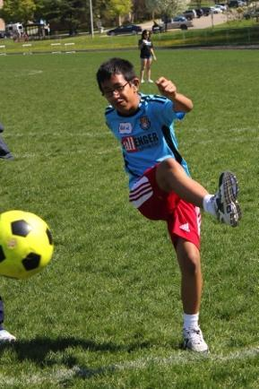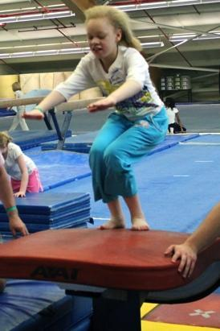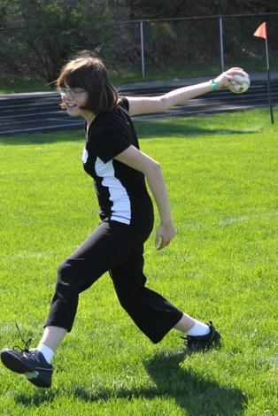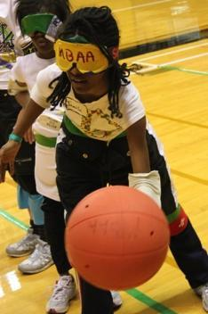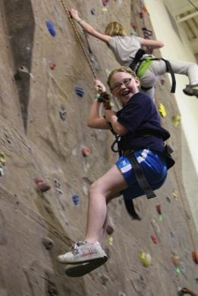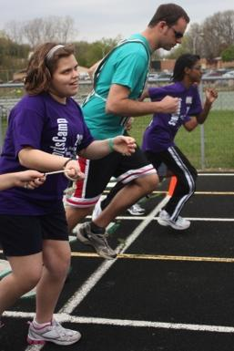

Application Deadline has been extended!
Register Now!
Please complete the application that can be found at:
https://mbaa-mi.com/Sports_Camp.html
If you have any questions please contact Scott or Leanne Ford at michigansec@gmail.com or 231-715-1732.

Check out this Youtube Video link to see what the Jr. Camp is all about! http://www.youtube.com/watch?v=pjFgy50qbuE&feature=email

