C:\Program Files\Microsoft Office\MEDIA\CAGCAT10\j0199036.wmf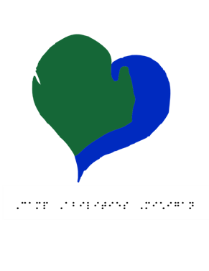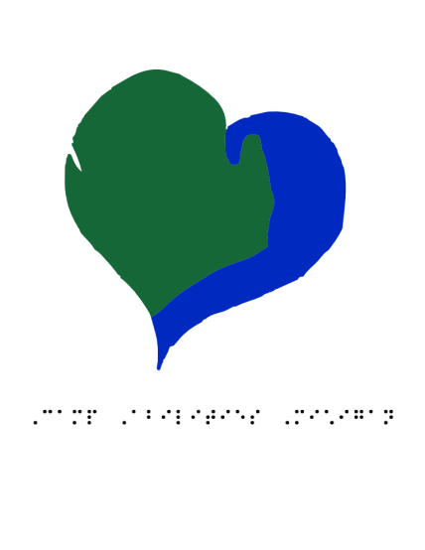

Camp Abilities Michigan (CAM) provides children and youth with visual impairments an authentic “summer camp” experience, including adapted sports, such as beep baseball and goal ball. The opportunity for them to successfully participate, sorely lacking in individual communities, increases their personal empowerment and improves how they are perceived by others.

CAM is affiliated with Wayne State University and operated by volunteers; college students and others studying in the fields of Physical Education, Adapted Physical Education, and Special Education.

CAM strives to increase awareness through support of local events with hands-on activities, and the distribution of information about visual impairment outdoor activities. By teaching our campers what the CAN do in sports, recreation, and other activities, we foster independence resulting in a healthier lifestyle, better well-being, and greater self-confidence.

Save the dates:

August 20th-22nd for our first annual sports camp!

To sign up for volunteering/donations/camp please visit our website @ campabilitiesmichigan.org

You can download the forms and send them to ericahope1234@gmail.com

Detroit, MI 48202

Phone (586) 945-6597

scmcnamara23@campabilitiesmichigan.org

Campabilitiesmichigan.org

Phone: 586-945-6597

Email: scmcnamara23@campabilitiesmichigan.org

Website: campabilitiesmichigan.org

**Camp Abilities Michigan**

# Summer Sports Camp for Children with Visual Impairments

#### OUR MISSION

We will be participating in all types of different activities and sports that are specifically created for the visually impaired and to improve their quality of life. Here is a list and brief description of some of the different activities that the children will be enjoying:

* Goal Ball: A game currently being played at the Paralympics.   
  This game uses a ball with bells in it and the students will need to use their listening skills to try and stop the ball
* Beep Base Ball/Kick Ball: Like baseball and kickball, the major difference is that the balls and bases beep and the children will use their listening skills to engage in the game
* Yoga: Campers will be able to increase their flexibility and have time to relax while they participate in some beginning yoga activities.
* Arts and Crafts: The children will be creating different pieces of crafts while using different tactile objects to help build the crafts
* Cooperative Games: Our team is built of Adapted Physical Educators that will be implementing various cooperative games that will help build children’s self-esteem. concepts

# Structuring Your Content

# At Camp Abilities Michigan we are trying to make a big impact on children in the Metro Detroit Area with visual impairments lives. We hope to impact them in multiple ways. Here are our three primary goals that we will be pursuing:

# 1. Campers will increase their physical fitness through engaging in activities during Camp Abilities Michigan

# 2. Successfully participating in sports and games modified for children that are visually impaired will help raise camper's confidence and self-esteem

# 3. Campers will develop greater independence and become more empowered as a result of being involved in camp programs

Camp Abilities Michigan is a Non-Profit Corporation that is a 501(c) 3 private, non-profit educational corporation charted by the State of Michigan.

For the Federal ID # please contact our Director, Scott McNamara at [scmcnamara23@campabilitiesmichigan.org](mailto:scmcnamara23@campabilitiesmichigan.org)



**BOARD OF DIRECTORS**

The Board of Directors consists of hardworking, dedicated and passionate educators from local school systems. Our Board of Directors has monthly meetings to prepare and collaborate for the events doe Camp Abilities Michigan. A listing of our meetings can be found on our website, campabilitiesmichigan.org.

The Board of Directors works hard to write grant proposals, plan fundraisers, locate and collaborate with other outreach programs and devise our activities for camp.

### ACTIVITIES AT CAMP Our Goals NON-PROFIT STATUS