2014
Michigan State Plan for Independent Living Status Report - FINAL
May 2014 Committee of the whole
prepared by silc staff

Table of Contents:

1 – Table of Contents
2-6 – SPIL Status Dashboard
7-11 – SPIL Status Detail Narrative
12-13 – Section 3.1 Catchment Data Analysis
14-23 – CIL Three Year Service Trend by Priority Area
- Accessibility - 14
- Assistive Technology - 15
- Education - 16
- Employment - 17
- Health Care - 18
- Housing -19
- On-Going Supports - 20
- Recreation - 21
- Relocation - 22
- Transportation -23
24 – Graphic Representation of Consumer Services
25 – Graphic Representation of Information and Referral Services
26-27 – Section 7 Review
28-30 – Data Collection Protocol

FY 2014 – FY 2016 State Plan for Independent Living Implementation Dashboard:

SPIL Objective | Measurable Indicator | Year One Status:
Objective 1: Michigan’s CILs will operate in accordance with federal standards and assurances in section 725(b) and (c) of the Act; subparts F and G of 34 CFR 366; SPIL requirements; and state grant requirements. | - Annual 704 reports accepted by RSA.  - Quarterly grant reports accepted by MRS.  - Monitoring Activities conducted by RSA and/or the DSU. | - On Target - All Part I and Part II 704 Reports Completed  - On Target - All 1st Quarter FY 2014 grant reports accepted by MRS  - Final RSA report of Disability Advocates of Kent County Attached (Page ##)
Objective 2: Include the independent living and community-based needs of individuals with disabilities in the Michigan Comprehensive Statewide Needs Assessment (CSNA) and develop a plan to address the needs identified. | - The CSNA planning committee will include representation by MRS, BSBP, and SILC.  - The CSNA will be designed to include the independent living and community-based needs of individuals with disabilities.  - The CSNA will be conducted during FY 2014 by MRS contract with MI SU PE. | - Completed  - Completed  - On –Target, In process
Objective 3: Strong collaboration between VR and CILs to promote quality employment outcomes and independence for persons with disabilities. | - Increased referrals for MRS services from CILs, resulting in more rehabilitation closures.  - Increased referrals for CIL core services provided to MRS and BSBP customers, resulting in improved coordination of services and increased employment and employment retention for MRS and BSBP customers. DN/M and BSBP will create, sign and implement mutually developed Memorandum of Understanding to outline coordination of services.  - Develop education and awareness training with local CIL staff & BSBP staff at minimum annually. Provide BSBP data by county to SILC to establish a baseline & increased referrals to CIL’s by BSBP staff.  - Create parameters in BSBP data collection system for tracking.  - Annually determine and evaluate methods to maximize participation in the Personal Assistance Services for Employment Program (PASREP) | - Baseline being established  - Baseline being established  - MOU Signed  - In Progress  - No Action
Objective 4: Continue to develop relationships with the Area Agencies on Aging (AAA) and the state Office of Services to the Aging to identify future needs & develop a formal referral process. | - Annually, BSBP will coordinate informational meetings at the local AAA’s.  - BSBP staff will follow through with the technology investment (Software: Zoomtext & JAWS; including set-up and initial training, large screen monitor, headphones, low vision keyboard) at the identified AAAs that have accessible technology on site.  - Quarterly, BSBP Consumer Services Division will increase collaboration with the Office of Services to the Aging Michigan Association of AAAs both informally and formally. | 1. Completed  2. In Progress – On Target  3. On-Target
Objective 5: Statewide outreach activities to blind or VI Native Americans are enhanced in order to provide IL services to the population. | 1. In following the signed MOU with the Hannahville Indian Community VR program agreement, BSBP will collaborate with the tribal coordinator to identify and provide outreach to the various statewide local tribes.  2. Provide data to SILC regarding the number of Native Americans served by BSBP annually.  3. Affirm data collection is accurate in BSBP data system for IL program. | - In Progress  - Data Provided  - On Target
Objective 6: Finalize approved Policies & Procedures by BSBP | 1. BSBP is working toward ensuring that all Bureau materials & website are accessible to the disability community including persons who are legally blind. BSBP is currently in the process of revising our policy and procedure manual with an anticipated 1st draft date of December 2013 | - In Progress – On Target
Objective 7: Unified statewide voice is built to educate State and Federal legislators, program officials, and the general public regarding disability issues. | Provide a variety of educational and informational opportunities annually to legislators, program officials, and the general public associated with programs and the needs assessment including documentation within the Statewide Database System. | On Target - At the November SILC meeting education was provided on the WIA/Rehab Act Reauthorization to the council.
Objective 8: Michigan’s CILs, in collaboration with Michigan’s disability and aging service providers, will build a stronger partnership to enhance streamlined services that promotes access to quality health care and community living. | 1. MDRC, MDCH, Medicaid MI Choice Waiver Agents, integrated Care Organizations and CILs will meet twice annually to discuss topics of mutual interest to enhance partnership. MDCH will host regional forums annually for CILs, integrated Care Organizations, and Medicaid MI Choice Waiver Agents to discuss enhancements to Michigan’s Nursing Facility Transition program.  2. Michigan’s CILs, Integrated Care Organizations, and Medicaid MI Choice Waiver Agents will transition 1,200 people out of nursing homes each year. Michigan’s CIL staff will participate in monthly Nursing Facility Transition meetings done in collaboration with DN/M, MDRC and MDCH.  Michigan CILs are engaged in the development of local Aging and Disability Resource Collaboration partnerships.  3. Michigan SILS/CILs in coordination with Michigan Family Voices will continue to discuss issues impacting families of children and youth needing assistance in obtaining services. | - On-Target - Two Meetings Occurred (Oct, March)  - On-Target - Through March 2014, 664 have transitioned. On Target.  - On Target - Meetings occurred in October, November, December, January, February and March  - On Target – ADRC Leadership meeting occurred in March 2014. Each CIL continues to be engaged in ADRC Program.
Objective 9: The Michigan Statewide Independent Living Council members will engage in activities to promote integration and full inclusion of children, youth and adults with disabilities in Michigan. | - Service Delivery Workgroup  - Transportation Workgroup  - Children and Family Services Work Group  - Convene a Michigan Disability think tank to engage in dialogue around current issues and future trends in the field of disabilities.  - SILC website and social media presence is redeveloped and updated to increase accessibility and ease in securing Independent Living information by the redesign of SILC Website to improve traffic by 10% and Bi-Monthly postings to SILC Facebook page. | - Report  - Report  - Report  - No Activity  - On Target – Web Site updated.

Total amount of Objectives: 27
Year One Objectives which are on Target: 23
Year One SPIL Objectives with no action: 2
Year One SPIL Objectives with a baseline establishment: 2

Year One State Plan for Independent Living Detailed Activities:

Measurable Indicator Measurement:

- Annual 704 reports accepted by RSA.
  - Activities
    - All 704 reports were accepted by RSA
- Quarterly grant reports accepted by MRS.
  - Activities
    - All quarterly grant reports were completed and accepted by MRS
- Monitoring Activities conducted by RSA and/or the DSU.
  - RSA final report on the site review of Disability Advocates of Kent County was released. The report and response from DAKC are part of the meeting materials.
  - MRS completed a two day on site review of the Ann Arbor Center for Independent Living
    - As of 23 April 2014, a report has not been issued. A report is expected to be released.
- The CSNA planning committee will include representation by MRS, BSBP, and SILC.
  - Activities
    - The CSNA survey process is under way. The survey can be completed on the SILC web site and has been promoted by CILs.
- The CSNA will be designed to include the independent living and community-based needs of individuals with disabilities.
  - Activities:
    - The CSNA included representation from the Disability Network CEO, SILC Staff and one council member.
    - Specific independent living questions were included in the CSNA
- The CSNA will be conducted during FY 2014 by MRS contract with MI SU PE.
  - Activities:
    - The CSNA is in the process of being conducted.
- Increased referrals for MRS services from CILs, resulting in more rehabilitation closures.
  - Activities:
    - The VR/IL Strategic Alliance Evaluation team is working to conduct a baseline analysis for referrals.
    - The VR/IL Strategic Alliance Leadership team released an FAQ document addressing common questions for IL and VR staff and leaders.
- Increased referrals for CIL core services provided to MRS and BSBP customers, resulting in improved coordination of services and increased employment and employment retention for MRS and BSBP customers.
  - Activities:
    - <Data will be presented at meeting>
- DN/M and BSBP will create, sign and implement mutually developed Memorandum of Understanding to outline coordination of services.
  - Activities:
    - MOU Was completed in October of 2013
- Develop education and awareness training with local CIL staff & BSBP staff at minimum annually. Provide BSBP data by county to SILC to establish a baseline & increased referrals to CIL’s by BSBP staff.
  - Activities:
    - Regional summits were held with BSBP/CILs in five locations to include 12 of the 15 CILs. The remaining BSBP/CIL meetings will occur by the end of FY 2014
    - The Bureau of Services provides rehabilitation services to individuals based on the regions that are established by the agency. The three regions are Central, East and West. Individuals living within the specific region may be referred to the appropriate CIL that covers the area. Please see the attached territory list that identifies the offices that are within the region.
    - Currently, System 7 does not gather information at open or closed of a case relative to being a CIL referral or referring a client to a CIL.
- Create parameters in BSBP data collection system for tracking.
  - Activities:
    - BSBP will explore establishing check boxes on the Open Edit form or Demographic form (referral source) and on the Closure Data form for staff to complete
- Annually determine and evaluate methods to maximize participation in the Personal Assistance Services for Employment Program (PASREP)
  - Activities:
    - The administration of the PASREP program changed from the Ann Arbor Center for Independent Living to Disability Network of Mid-Michigan in November of 2013.
- Annually, BSBP will coordinate informational meetings at the local AAA’s.
  - Activities:
    - The offices within the regions make contact with the Area Agencies on Aging annually to discuss referral process and to improve collaborative relations resulting in services to seniors within the catchment areas. The Consumer Services Division Director contacts the Office of Services to the Aging annually to discuss ways to enhance programs for individuals who are blind and visually impaired that are being served by the agency. Staff participates in senior health fairs and senior job fairs in various locations within their geographical area. The Office of Services for the Aging is participating on BSBP’s Futuristic Committee.
- BSBP staff will follow through with the technology investment (Software: Zoomtext & JAWS; including set-up and initial training, large screen monitor, headphones, low vision keyboard) at the identified AAAs that have accessible technology on site.
  - Activities:
    - The staff including managers, continue to make periodic visits to the AAA senior centers to discuss with the staff to determine the use of the technology that was installed in their facilities. They also will be ascertaining whether or not the equipment is easily accessible and in operating order. When possible, they also collect information on the frequent use of the equipment by blind and visually impaired seniors.
- Quarterly, BSBP Consumer Services Division will increase collaboration with the Office of Services to the Aging Michigan Association of AAAs both informally and formally.
  - Activities:
    - Ongoing efforts continue with OSA with possible BSBP participation on the Long-Term Care Process Improvement Workshop.
    - Each quarter, the VR program staff will continue to make contact with the 17 AAA’s to increase collaboration for the purpose of sharing information regarding the agency’s services. Through these collaborative quarterly contacts, the referral process can be reviewed to ensure appropriate information is being obtained to share with the agency to increase services to seniors.
- In following the signed MOU with the Hannahville Indian Community VR program agreement, BSBP will collaborate with the tribal coordinator to identify and provide outreach to the various statewide local tribes.
  - Activities:
    - BSBP make contact with the Native Americans through health centers to share information regarding services that are available to persons who are blind and visually impaired. The Native Americans health centers have been instrumental in working with the bureau in providing referrals to the agency. The bureau have made visits to the Hannahville Indian community and the Chippewa community to share and exchange information. The Hannahville Indian Community Vocational Rehabilitation Program is a 121 federal program that is required by the Rehabilitation Services Administration to establish a memorandum of understanding agreement outlining specific service requirements.
- Provide data to SILC regarding the number of Native Americans served by BSBP annually.
  - Activities:
    - For the past three Fiscal Years, BSBP served a total of 70 Native Americans as follows:
      - FY 13 – 24
      - FY 12 – 25
      - FY 11 – 21
- Affirm data collection is accurate in BSBP data system for IL program.
  - Activities:
    - Data is accurate in the case management system for the IL program.
- Finalize approved Policies & Procedures by BSBP
  - Activities:
    - BSBP is working toward ensuring that all Bureau materials & website are accessible to the disability community including persons who are legally blind. BSBP is currently in the process of revising our policy and procedure manual with an anticipated 1st draft date of December 2013

- Provide a variety of educational and informational opportunities annually to legislators, program officials, and the general public associated with programs and the needs assessment including documentation within the Statewide Database System.
  - Activities:
    - During the November SILC meeting, education was provided on the WIA/Rehab Act Reauthorization to the council.
- MDRC, MDCH, Medicaid MI Choice Waiver Agents, integrated Care Organizations and CILs will meet twice annually to discuss topics of mutual interest to enhance partnership. MDCH will host regional forums annually for CILs, integrated Care Organizations, and Medicaid MI Choice Waiver Agents to discuss enhancements to Michigan’s Nursing Facility Transition program.
  - Activities:
    - Joint meetings occurred in October 2013 and March 2014
- Michigan’s CILs, Integrated Care Organizations, and Medicaid MI Choice Waiver Agents will transition 1,200 people out of nursing homes each year.
  - Activities:
    - Through March 2014, 664 people have transitioned form nursing homes to community based independent living.
- Michigan’s CIL staff will participate in monthly Nursing Facility Transition meetings done in collaboration with DN/M, MDRC and MDCH.
  - Activities:
    - Meetings occurred in October, November, January, February and March of the fiscal year.
- Michigan CILs are engaged in the development of local Aging and Disability Resource Collaboration partnerships.
  - Activities:
    - ADRC Leadership team meetings occurred in March 2014. CILs continue to develop their ADRCs in local communities.
- Michigan SILS/CILs in coordination with Michigan Family Voices will continue to discuss issues impacting families of children and youth needing assistance in obtaining services.
  - Activities:
    - <Lisa will report out at meeting>
- Service Delivery Workgroup
  - Activities:
    - The service delivery workgroup has went from concept to mapping of data. The intention of the group was to map service data across the state from various agencies and determine any specific trends or holes in the data.
    - The group has successfully mapped data from BSBP, CIL Network, DHS Community Grants and MRS. The data is broken down by the ten Michigan Prosperity Regions.
    - The group is now evaluating what they have, looking at the trends and any specific holes in data. Several early analysis points include:
      - CILS have a more difficult time reaching rural areas than the State Agencies. This is due to the State having a physical presence in all counties.
      - In areas where a CIL does have a physical presence, there are fewer services provided by BSBP or MRS. The group is analyzing the data further to determine if collaboration with IL can assist with serving more individuals.
- Transportation Workgroup
  - Activities:
    - <Workgroup will be reported at meeting>
- Children and Family Services Work Group
  - Activities:
    - <Workgroup will be reported at meeting>
- Convene a Michigan Disability think tank to engage in dialogue around current issues and future trends in the field of disabilities.
  - Activities:
    - No Activity
- SILC website and social media presence is redeveloped and updated to increase accessibility and ease in securing Independent Living information by the redesign of SILC Website to improve traffic by 10% and Bi-Monthly postings to SILC Facebook page.
  - Activities:
    - Bi-Monthly postings are in progress. The Facebook page will be assisted by a council member to include new postings.
    - The SILC staff took input and made referrals from three individuals after the redesign (January to April). The staff had not taken a web site referral prior to the redesign.
    - Traffic for the redesigned Web site has fluctuated. Overall there is a slight increase but it remains less than 10%. Additional activities will be designed to add more content to the site. Web statistics are available below:

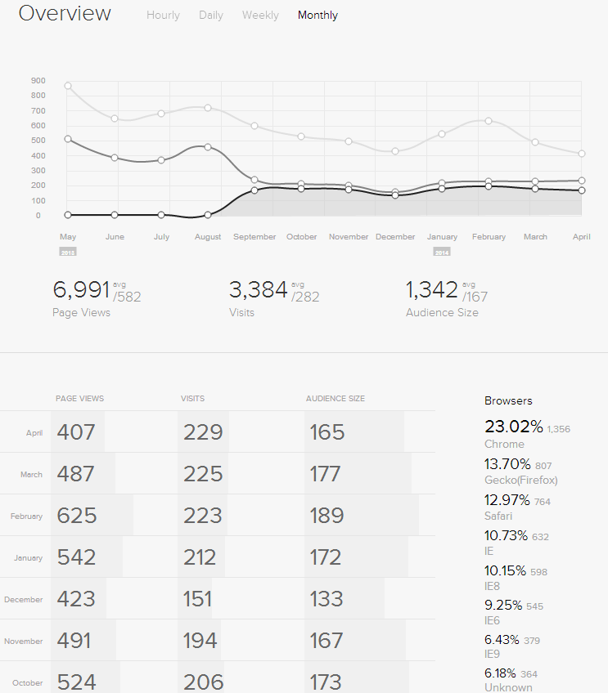
Section 3.2 Expansion of Network (Catchment Area)
There are 16 counties (Alcona, Alpena, Cheboygan, Crawford, Ionia, Iosco, Lake, Mecosta, Montcalm, Montmorency, Ogemaw, Osceola, Oscoda, Otsego, Presque Isle, and Roscommon) or 4% of Michigan's total population which do not have sufficient population or geographic area to support an individual CIL or satellite.
In order to address statewide coverage, and in support of SPIL Goals (I, II, and V) these 16 counties have been affiliated with adjoining CIL service areas. This has been done with the explicit understanding that the needs and preferences of these 16 counties will be addressed on the basis of the Comprehensive Statewide Needs Assessment to be coordinated by SILC (Goal II, Objective 2) and other consumer/community input. The consistency of these affiliations with community needs and preferences will be reviewed, and the affiliations will be confirmed and/or adjusted as appropriate.
Catchment Count Services (Oct 1st 2013 to April 15th 2014)
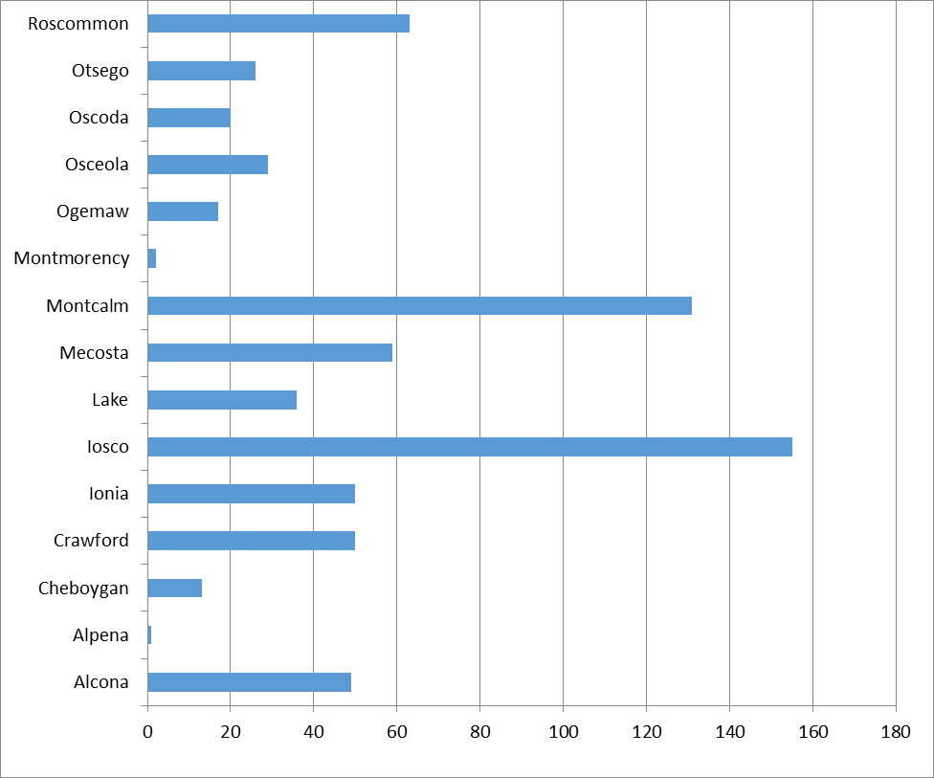

Catchment County Number of Individuals Served
County: | Number of Individuals Served:
Alcona | 49
Alpena | 1
Cheboygan | 13
Crawford | 50
Ionia | 50
Iosco | 155
Lake | 36
Mecosta | 59
Montcalm | 131
Montmorency | 2
Ogemaw | 17
Osceola | 29
Oscoda | 20
Otsego | 26
Roscommon | 63
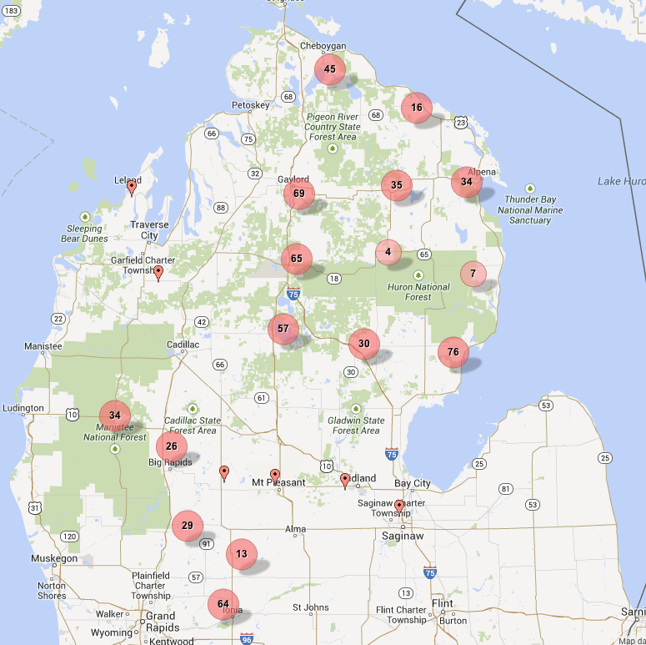
ACCESSIBILITY SERVICES:
Assistance and /or representation in obtaining access to benefits, services, and programs to which a consumer may be entitled.

- Accompany consumer to county commission meeting Assist with voter registration
- Advocate for interpreter services
- Represent a person with a disability at a Social Security hearing
- Provide intervention on behalf of a consumer regarding eviction, hostility, violence or other issue
- Assist a consumer in understanding his or her rights under civil/disability rights laws

Individual Accessibility Outcomes:
- Enhanced access to goods and services in the community
- Enhanced accessibility of home/apartment

SPIL Service Trend
Outcome: | FY 2011 | FY 2012 | FY 2013
Enhanced access to goods and services in the community | 343 | 163 | 110
Enhanced accessibility of home/apartment | 385 | 269 | 241
Total Outcome Amounts: | 728 | 432 | 351

Consumers Served:
Consumers Served | FY 2011 | FY 2012 | FY 2013
 | 220 | 173 | 132

Assistive Technology

Any assistive technology device, that is, any item, piece of equipment or product system that is used to increase, maintain or improve functional capabilities of individuals with disabilities and any assistive technology service that assists an individual with a disability in the selection, acquisition or use of an assistive technology device.

- Provide assistive devices
- Assist with repair and maintenance of equipment and devices

Individual Assistive Technology Outcomes:
- Increased functional and safe use of AT
- Acquired AT
- Repaired AT
- Acquired AT funding
- Acquired information regarding AT options

SPIL Service Trend
Outcome: | FY 2011 | FY 2012 | FY 2013
Acquired information | 178 | 170 | 183
Acquired AT | 811 | 1125 | 1331
Acquired AT Funding | 12 | 22 | 40
Increased functional and safe use of AT | 54 | 117 | 53
Repaired AT | 62 | 86 | 99
Total Outcome Amounts: | 1117 | 1520 | 1706

Consumers Served:
Consumers Served | FY 2011 | FY 2012 | FY 2013
 | 1570 | 1579 | 1490

Education

Academic or training goals that are expected to improve the consumer’s knowledge or ability to perform certain skills that would expand his/her independence, productivity or income-generating potential.
- Improve Basic Literacy Skills
- Acquire a High School Diploma or GED
- Acquire a College Degree
- Acquire Post-Secondary Training (Vocational, Technical, Community College, Certification Program)
- Learn Foreign Language/ Sign Language
- Learn Braille

Individual Education Outcomes:
- Completed an educational program
- Acquired educational accommodation(s)
- Self-advocated for educational accommodation(s)
- Enrolled in an educational program
- Increased knowledge of educational options

SPIL Service Trend
Outcome: | FY 2011 | FY 2012 | FY 2013
Acquired educational accommodation(s) | 36 | 9 | 14
Completed an educational program | 148 | 152 | 107
Enrolled in an educational program | 48 | 51 | 51
Increased knowledge of education options | 41 | 25 | 51
Self-advocated for educational accommodations | 9 | 8 | 6
Total Outcome Amounts: | 282 | 245 | 229

Consumers Served:
Consumers Served | FY 2011 | FY 2012 | FY 2013
 | 427 | 375 | 1490

Employment

Any services designed to achieve or maintain employment.
- Provide training in employability skills
- Assist with reasonable accommodations
- Provide assessments/ evaluations
- Arrange/provide job development/job placement
- Arrange/provide job coaching/ mentoring/ shadowing
- Provide volunteer experience as a prelude to employment

Individual Employment Outcomes:
- Improved job status via workplace promotion
- Maintained employment
- Acquired reasonable accommodation
- Obtained employment
- Obtained volunteer work experience
- Increased work search skills
- Increased knowledge of employment options (work incentives, rights and responsibilities, etc.)

SPIL Service Trend
Outcome: | FY 2011 | FY 2012 | FY 2013
Acquired reasonable accommodation | 21 | 15 | 7
Improved job status via workplace promotion | 2 | 3 | 2
Increased knowledge of employment options (incentives, rights, etc.) | 1269 | 1253 | 770
Increased work search skills | 872 | 904 | 842
Maintained employment | 60 | 53 | 59
Obtained employment | 178 | 122 | 97
Obtained volunteer work experience | 136 | 47 | 35
Total Outcome Amounts: | 2538 | 2397 | 1812

Consumers Served:
Consumers Served | FY 2011 | FY 2012 | FY 2013
 | 2971 | 3039 | 1172

Health Care

Restoration services including medical services, health maintenance, eyeglasses, and visual services.
- Coordinate eye exams and glasses
- Coordinate dental exams
- Coordinate physical therapy services

Individual Health Care Outcomes:
- Acquired appropriate health care services (medical, mental health, etc.)
- Acquired access to appropriate insurance coverage
- Increased knowledge of healthcare options/insurance options

SPIL Service Trend
Outcome: | FY 2011 | FY 2012 | FY 2013
Acquired access to appropriate insurance coverage | 58 | 41 | 36
Acquired appropriate health care services (medical, mental health, etc.) | 779 | 461 | 740
Increased knowledge of healthcare options/insurance options | 104 | 122 | 118
Total Outcome Amounts: | 941 | 624 | 894

Consumers Served:
Consumers Served | FY 2011 | FY 2012 | FY 2013
 | 1069 | 842 | 638

Housing

These services are related to securing housing or shelter, adaptive housing services (including appropriate accommodations to and modifications of any space used to serve, or occupied by individuals with significant disabilities).
- Assist in locating an apartment or house
- Survey a home for barriers
- Modify a home
- Arrange for emergency housing coordination

Individual Housing Outcomes:
- Acquired accessible affordable housing
- Increased housing search skills
- Increased awareness of housing options

SPIL Service Trend
Outcome: | FY 2011 | FY 2012 | FY 2013
Acquired accessible, affordable housing | 155 | 141 | 116
Increased awareness of housing options | 195 | 130 | 168
Increased housing search skills | 29 | 18 | 27
Total Outcome Amounts: | 379 | 289 | 311

Consumers Served:
Consumers Served | FY 2011 | FY 2012 | FY 2013
 | 1151 | 1121 | 1012

Other Supports

Individual Other Supports Outcomes:
- Acquired financial supports (SSI, SSDI, food stamps, emergency rent, mortgage, payments, etc.)
- Acquired PA/PASREP services
- Acquired maintained other necessary supports (peer, natural supports, etc.)
- Acquired/increased IL skills
- Increased awareness of community resources to maintain community-based independent living

SPIL Service Trend
Outcome: | FY 2011 | FY 2012 | FY 2013
Acquired financial supports (SI, SSDI, food stamps, etc.) | 355 | 306 | 282
Acquired PA/PASREP services | 21 | 16 | 37
Acquired/increased IL skills | 784 | 775 | 1124
Acquired/maintained other necessary supports (peer, natural supports, etc.) | 417 | 391 | 408
Increased awareness of community resources to maintain community-based independent living | 194 | 435 | 260
Total Outcome Amounts: | 1771 | 1923 | 2111

Consumers Served:
Consumers Served | FY 2011 | FY 2012 | FY 2013
 | 2028 | 2112 | 1633

Recreation

Provision or identification of opportunities for the involvement of consumers in meaningful leisure time activities. These may include such things as participation in community affairs and other recreation activities that may be competitive, active, or quiet.
- Identify recreation activities and arrange for participation
- Participate with consumers in activities

Individual Recreation Outcomes:
- Participated in sports, recreation and leisure opportunities
- Enhanced access to sports, recreation and leisure opportunities
- Increased knowledge/skills in sports, recreation and leisure activities

SPIL Service Trend
Outcome: | FY 2011 | FY 2012 | FY 2013
Enhanced access to sports, recreation and leisure opportunities | 63 | 32 | 43
Increased knowledge/skills in sports, recreation and leisure activities | 50 | 47 | 18
Participated in sports, recreation and leisure opportunities | 250 | 95 | 161
Total Outcome Amounts: | 363 | 174 | 222

Consumers Served:
Consumers Served | FY 2011 | FY 2012 | FY 2013
 | 264 | 248 | 269

Relocation

Individual Relocation Outcomes:
- Moved from nursing facility/care facility to a community setting
- Moved from correctional facility to a community setting
- Diverted/prevented move to an institutional setting
- Developed and initiated implementation of plan to move into a community setting
- Increased awareness of community-based independent living options

SPIL Service Trend
Outcome: | FY 2011 | FY 2012 | FY 2013
Developed and initiated implementation of plan to move into a community setting | 103 | 126 | 188
Diverted/prevented move to an institutional setting | 19 | 3 | 1
Increased awareness of community living options | 175 | 199 | 241
Moved from correctional facility to a community setting | 6 | 1 | 1
Moved from nursing facility/care facility to a community setting | 307 | 327 | 336
Total Outcome Amounts: | 610 | 656 | 767

Consumers Served:
Consumers Served | FY 2011 | FY 2012 | FY 2013
 | 625 | 732 | 614

Transportation

Provision of, or arrangements for, transportation.
- Assist in acquiring bus passes
- Coordinate transportation services
- Provide / arrange for drivers’ education for a driver’s license
- Provide transportation using center’s vehicle
Assist in planning emergency transportation

Individual Service Transportation Outcomes:
- Acquired access to transportation
- Acquired financial resources for transportation
- Acquired skills to unitize transportation
- Acquired knowledge of transportation options

SPIL Service Trend
Outcome: | FY 2011 | FY 2012 | FY 2013
Acquired access to transportation | 2514 | 2778 | 2211
Acquired financial resources for transportation | 176 | 261 | 371
Acquired knowledge of transportation options | 828 | 429 | 152
Acquired skills to utilize transportation | 58 | 40 | 19
Total Outcome Amounts: | 3576 | 3508 | 2753

Consumers Served:
Consumers Served | FY 2011 | FY 2012 | FY 2013
 | 1176 | 1036 | 875

Graphic Representation of Consumers Served in Michigan (FY 2013):

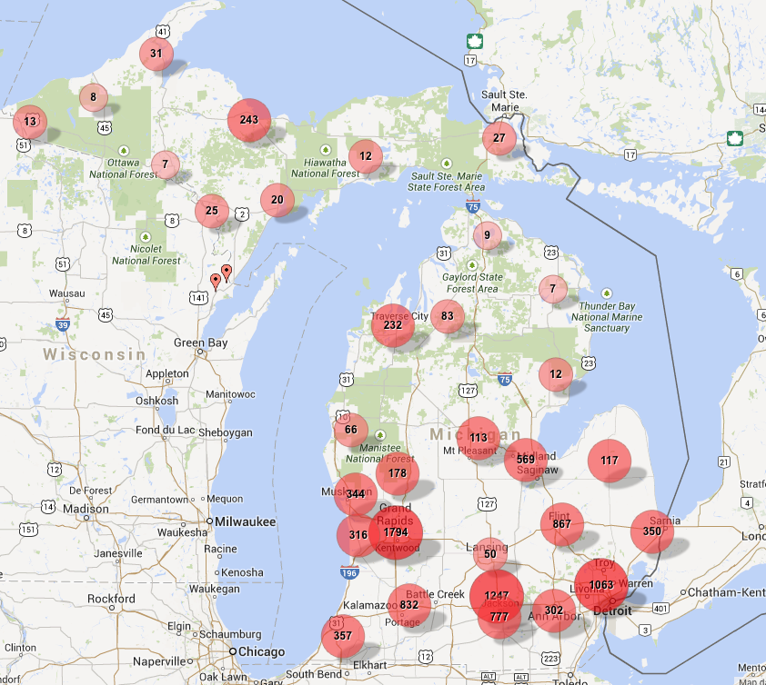

Graphic Representation of Information and Referral Services (FY 2013)

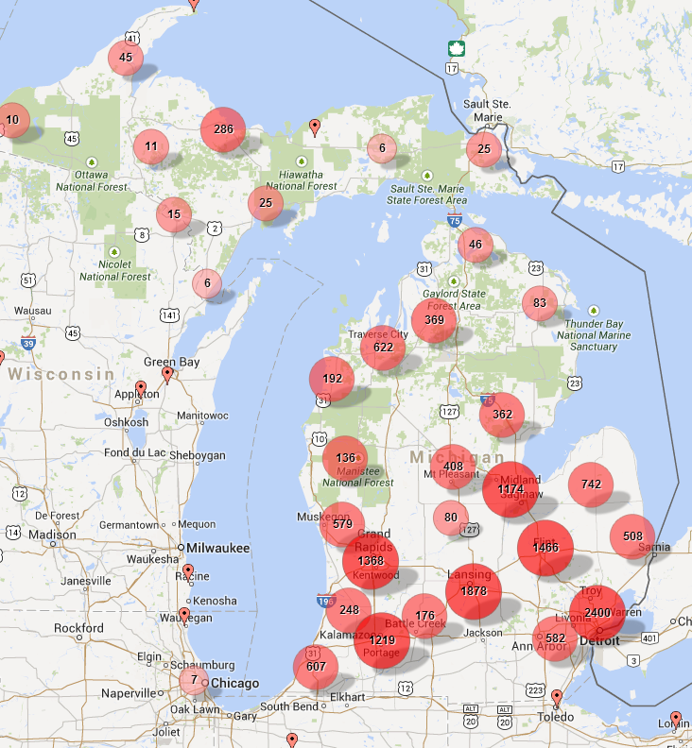
SPIL Section 7 Review:
1. How well are the SPIL Objectives being achieved?
2. How satisfied are the consumers of services provided?
3. How can the State's IL Program be improved or expanded?
4. Does the SPIL require amendment?
The methodology utilized to evaluate the effectiveness of Michigan’s SPIL involves the following components:

- Creation of semi-annual SPIL status report including service numbers and outcomes from the Michigan Statewide Database system which is inclusive of data from both the CIL Network and BSBP. This report will be reviewed by the SILC Council "committee of the whole" prior to the November and May SILC Council Business Meetings. The "committee of the whole" meetings will report results for Council ratification and/or amendment.
  - This report is considered the semi-annual SPIL status report. In addition a second report is available which consists of public comment, forums, and other IL related information for council review.
- Submission of an annual “State of Independent Living” report. This report is comprised of the current status of the SPIL and Independent Living in Michigan.
  - As of this reports creation, a draft version has been submitted to the executive committee for review.
- Compile annual Statewide Consumer Satisfaction survey by producing a combined satisfaction rate via submitted survey results to the SILC. The Consumer Satisfaction survey rate will be shared with the Council and DSUs, placed into relevant Section 704 and utilized in SILC reports. Target reporting date will be the first Council meeting of the fiscal year (November).
  - Consumer satisfaction is being compiled and will be available for the November Committee of the whole meeting.
- Compilation and submission of the annual Section 704 report to RSA by SILC, BSBP and MRS. It will be completed no later than 90 days from the end of the fiscal year.
  - The Part 1 704 report was submitted on time and accepted by RSA
- SILC will participate in and receive reports on formal reviews of Michigan's CILs conducted by RSA. The reports will be summarized upon receipt and provided to the next "committee of the whole" meeting. SILC will also participate, as an invited observer, of any MRS on-site reviews of CILs.
  - SILC participated as an observer in:
    - DAKC RSA Review (Final Report and Response are attached to this report)
    - MRS On-Site review of the Ann Arbor CIL (As of this reports creation, a report has not been issued)
- Participation in review of MRS grant proposals and annual grant evaluations. Team review of the CIL annual grant applications provides opportunity to consider their consistency with the SPIL goals, objectives, and CIL allocation plan. The MRS grant review team typically includes, by invitation, representation from SILC, BSBP, MCRS, CAP, and any other entities MRS deems appropriate. In addition, all grantees are required to provide statistical, narrative and fiscal reports to MRS and to the SILC including quarterly Netcil Data uploads for creation of the Michigan Statewide Database.
  - SILC provided DSU requested data in support of the MRS grant proposal evaluations.
  - Data from the Statewide Database has also been used in this report
- Input derived from various SILC Council work groups on the effectiveness of the SPIL and determination of necessary amendments along with engagement in a continual SPIL development process.
  - Work Group reports are available.

Statewide SPIL and Annual Report Data Protocol:

Consumer Counts: (Distinct Counts, Individuals Served)
- In order for a consumer to be in a specific data set the following will be necessary
  - They will have had to a record present in the Consumer History Table during the time frame of the dataset.
  - This could include any type of HistoryCodeID.
  - Will need to be a ContactTypeID 1 or 7 (Active or Inactive Consumer)

Consumer Service Counts (Unduplicated Count, Amount of Services)
- In order for a consumer service to be counted in a specific data set, the following will be necessary.
  - They will need to be ContactTypeID 1 or 7 (Active or Inactive Consumer)
  - Recorded Consumer Services under ServiceID filed will need to be present.
  - Records with null Hours values will not be counted as a completed service.

Consumer Demographics Counts:
- Demographic counts of consumers will be counted in data sets under the following standards:
  - They will need to have had a service during the time frame of the dataset.
  - This follows the Duplicated Service Count procedure.
    - If the ConsumerID is present in the Duplicated Service Count procedure, the demographics of that consumer will be included in all demographic counts for the time period of the data set.

Information and Referral Counts: (Distinct Count, Individuals Served)
- In order for an Individual to be counted as receiving an Information and Referral service, the data set will be counted under the following standards.
  - I&R Counts will be regardless of contact type as consumers can receive I&R services
  - Recorded I&R services under ServiceID field will need to be present
  - Records with null Hours values will not be counted.
  - Referrals will also be counted under the same guidelines form the Referral module tables.
    - A completed date will be necessary for the referral to be considered in the count
    - The Distinct count of the PersonID field will produce the amount of individuals served.
    - Breakdowns of what type of individual received the I&R service will be taken from the ContactTypeID field. For example, this will show the amount of I&R's to:
      - Organizations
      - Consumers
      - Information and Referral Contacts

Information and Referral Counts: (Unduplicated Count, Amount of I&Rs)
- In order for an Information and Referral to be counted as being received, the data set will be counted under the following standards:
  - I&R Service counts will be regardless of contact type as consumers can receive I&R Services
  - Recorded I&R services under ServiceID field in Consumer History will need to be present
  - Records with Null Hours values will not be counted.
  - Referrals will also be counted under the same guidelines form the Referral module table
    - A completed date will be necessary for the referral to be considered in the count
    - Breakdowns of what type of individual received the I&R Serice will be taken from the ContactTypeID filed. For example this will show the amount of I&R Services to:
      - Organizations
      - Consumers
      - Information and Referral Contacts

Information and Referral Demographics:
- Demographic counts of I&Rs will be counted in data sets under the following standards:
  - They will need to have had a service during the time frame of the dataset.
    - This would include a service from either the ConsumerHistory or Referral Table.
  - This follows the Duplicated Service Count procedure.
    - If the ConsumerID is present in the Duplicated Service Count procedure, the demographics of that I&R will be included in all demographic counts for the time period of the data set.

Successful Consumer Outcomes
- In order for a goal to be considered successfully completed the following will be necessary for inclusion into the data set.
  - A completed date in the date range of the data set in the Consumer Goal History Table.
  - An Outcome score greater than 0

