What: The NFB Bid for Equality Auction
When: November 28, 2014 until December 4, 2014
Donations accepted through: October, 31 2014

Dear Friend:

The National Federation of the Blind (NFB) is organizing our second annual nationwide auction to improve opportunities for blind Americans, and we would like your help. We are seeking donations to combine into exciting packages for our online fundraising auction to support the valuable work of the NFB.

The NFB knows that blindness is not the characteristic that defines blind people or our future. Every day we raise the expectations of blind people, because low expectations create obstacles between blind people and our dreams. You can help support our mission by donating goods or services to the NFB to be featured in our auction this November. Your donation will go a long way toward helping blind Americans live the life they want.

In acknowledgement of your donation, you have the opportunity to gain marketing and web exposure. Your donation will be featured on our auction's website at www.biddingforgood.com/bid-for-equality along with a detailed description of your organization, your logo, and a link to your website. In addition, we will publicize the auction on our listservs and in social media via Facebook and Twitter.

We appreciate your consideration of our request, and we look forward to having your support. Your donation will help us continue to create innovative, empowering programs that will raise the expectations of blind people across the country. Please feel free to contact Michelle Chacon with questions about this nationwide auction.

Sincerely,
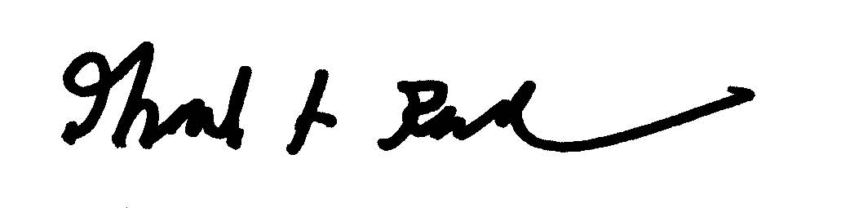
Mark Riccobono, President
National Federation of the Blind
MAR/rb

Auction Coordinator: Michelle Chacon
Email: bidforequality@nfb.org

Mail donations to:
Raquel Brown
National Federation of the Blind
200 E. Wells Street at Jernigan Place
Baltimore, MD 21230

Tax ID Number: 02-0259978

