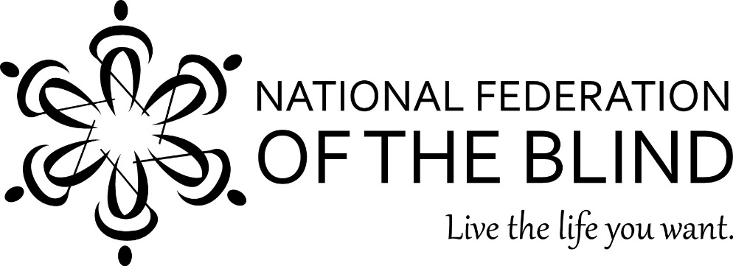
The National Federation of the Blind of Illinois Presents a Seminar for Parents and Teachers

“Raising the Bar”

Friday, April 17, 2015
8:00 a.m. to 5:00 p.m. – Chicago Marriott Midway
CPDUs are Available
On Friday, April 17, 2015, the National Federation of the Blind of Illinois will hold its teachers’ seminar at the Chicago Marriott Midway, 6520 S. Cicero Ave., Chicago, Il. 60638. The seminar will be a day-long event consisting of meetings for teachers of children with visual impairment or blindness. Topics will include technology, physical activity, and encouraging others to foster independence.
Our keynote speaker will be Natalie Shaheen, director of education programs at the NFB Jernigan Institute in Baltimore.
Cost: $30, including box lunches. Overnight accommodations are available for $109 at
the Chicago Marriott Midway, 708-594-5500. Indicate that you are asking for the National Federation of the Blind rate. For those traveling from outside the Chicago-metro area, financial assistance may be available. Please apply through the Chappell-Dennis Memorial Awards at www.nfbofillinois.org on or before March 15, 2015.
The National Federation of the Blind (NFB) is a 50,000-member organization that works to insure the full participation of blind people in all aspects of society.
If you would like to attend the seminar, please submit the registration form by April 3, 2015. For more information, please contact Debra Kent Stein at (773)-203-1394 or dkent5817@att.net or Denise R. Avant at (773)-991-8050 or davant1958@gmail.com. Vision impairment can be reduced to a nuisance with proper training. Please come and work with teachers, students, and mentors with a positive outlook on blindness.

For more information on NFB go to www.nfb.org. For more information on our Illinois Affiliate of NFB, go to www.nfbofillinois.org.

