Holiday Owl Prowl
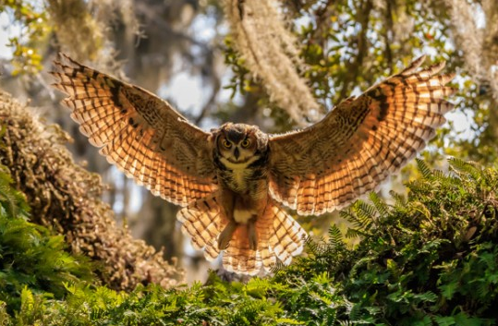
Celebrate with us the holiday season along with the magnificent “World of Owls”.

On Saturday, December 15, 2018 we will enjoy fun and fellowship and fantastic feathered birds of prey at the University of Michigan-Dearborn Environmental Interpretive Center. We will be joined by Francie Crock and the Michigan Avian Experience for a presentation about the Great-horned Owl and other species. There will be refreshments, white elephant game and a walk in the winter woods to hear the Great-horned owls in the natural area. Please consider joining us from 2-8 pm. If you have any questions or would like more information please contact Donna Posont, 313-220-8140, dposont@umich.edu

