2019 Birding by Ear and Beyond
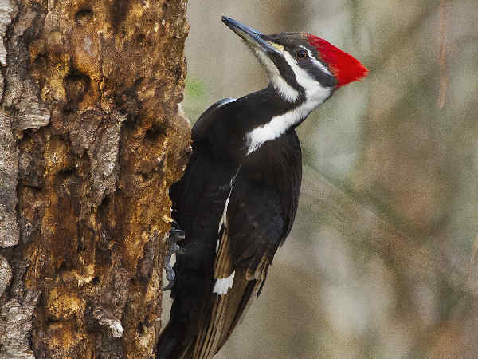
January 12, 2019 10a m-3p m
Environmental Interpretive Center (EIC)
University of Michigan-Dearborn, 4901 Evergreen Rd.
“Walking within the woods while watching for woodpeckers”
Lunch will be served.
February 15, 16, and 17, 2019
Great Backyard Bird Count
Citizen Science with Cornell Lab of Ornithology
Location to be announced.
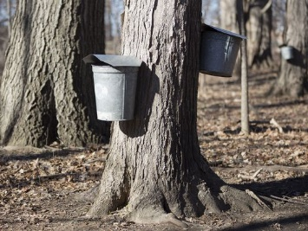
March 9, 2019 10a m-3p m
Making Maple Magic while Searching for Signs of Spring
University of Michigan-Dearborn 4901 Evergreen Rd.

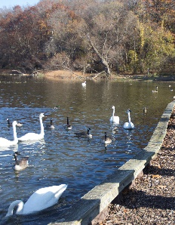
April 13, 2019 10a m
Arrival of waterfowl-Kellogg Bird Sanctuary, Battle Creek, Michigan

May 11, 2019 10-3p m EIC
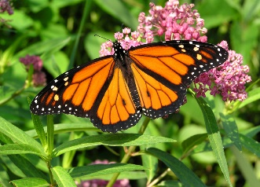
University of Michigan-Dearborn 4901 Evergreen Rd.
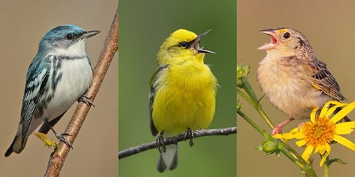
Welcoming the Warblers, Sensory Signs in the Matt Clew Butterfly Garden
Lunch will be served

June 8, 2019 9a m-4p m
Celebrate Urban Birds, Location to be announced

August 4-11, 2019 “SASS”
Sense-sational Adventures in Summer Science
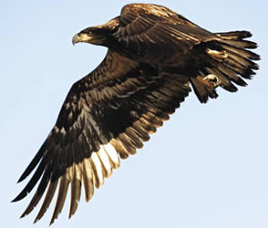
Environmental Interpretive Center, University of Michigan-Dearborn 4901 Evergreen Rd.

September 14, 2019 10a m-3p m
Raptor Retreat and Saying So Long Songbirds
Environmental Interpretive Center University of Michigan-Dearborn 4901 Evergreen Rd.

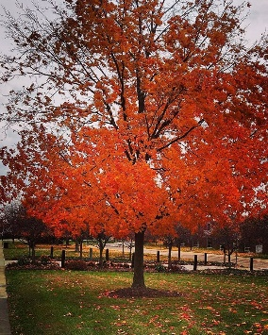
October 12, 2019 10a m-3p m
Leaving Leaves and Migration Madness
EIC University of Michigan-Dearborn 4901 Evergreen Rd.

December 14, 2019 10a m-3p m
Checking Chatter coming from Black-capped Chickadees
EIC University of Michigan-Dearborn 4901 Evergreen Rd.
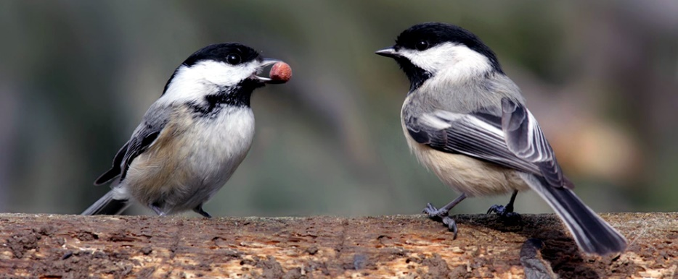

For Further information contact;
Donna Posont @ 313-220-8140 or donnabutterfly50@gmail.com

