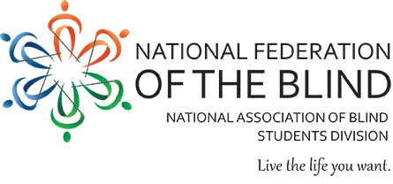
National Federation of the Blind: Kalamazoo Chapter Meeting

Continuing to promote blind residents of Kalamazoo and Portage to “Live the Life You Want.”.
Discussions Include: upcoming local fundraising options, opportunities for joining chapter committees, updates from blind students and merchants, information about our growing social media presence, and information about our approaching National Convention in July.
- When: March 11, 2019
- Time: 7pm
- Where: Hunan Gardens Chinese Restaurant
5059 W. Main St.
Kalamazoo, MI 49009

For more information, follow our Facebook page “NFB of Kalamazoo.”
Direct Inquiries to Robert Parsons, (804) 801-7674 or Rachel Pavone, (810) 701-1614. Please arrive 30 minutes early if interested in ordering dinner.

