Kellogg Bird Sanctuary

April 13, 2019 11a m-4p m

Join us for a glorious return to spring with experiencing Trumpeters Swans, Black Swans and even a Mute Swan. Wood Ducks along with other water fowl will be loud and active as mating season is in full swing. We will meet at the sanctuary at 11a m and spend the day exploring the land and water. Weather permitting we will eat lunch outside at picnic tables at 1p m. So you can either pack lunch or we will order from NED’s on Gull Lake. If it is too chilly we will go to NED’s in Hickory Corners which is a few minutes away. After lunch we will return to the grounds of the bird sanctuary to walk off the delicious lunch.

Please consider joining us at Kellogg Bird Sanctuary at 12685 E. C Ave. in Hickory Corners, Michigan. We will be bringing a van from the Detroit area so if you wish to ride in it or just travel together please call me at 313-220-814 or [donnabutterfly50@gmail.com](mailto:donnabutterfly50@gmail.com).

Wishing you a bird song filled spring, Donna Posont

[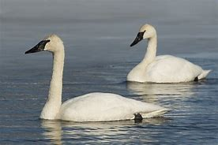](https://www.bing.com/images/search?view=detailV2&ccid=w50Tinpo&id=AFEA47B6F54C35B858F42B6B39F011BC2494D31C&thid=OIP.w50TinpoMrJSmHvbSYxVuwHaE8&mediaurl=https%3a%2f%2fwww.purelypoultry.com%2fimages%2ftrumpeter-swan.jpg&exph=600&expw=900&q=trumpter+swan&simid=608020136341146167&selectedIndex=2)