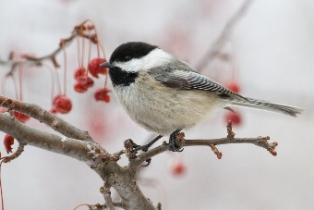**Great Backyard Bird Count**

**Action Agenda**

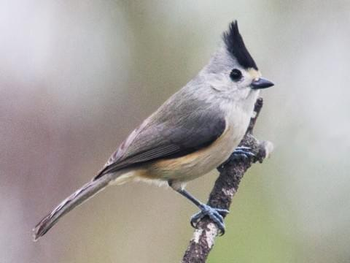

**Friday, February 14, 2020**

3p m Welcome to the woods

5p m Supper in White Pine

7p m What is the Great Backyard Bird Count?

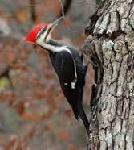8p m Which Woodpeckers will we witness?

9p m Bedtime reading: Winter Songbird

10p m Head for habitat

11p m Eliminate Illumination

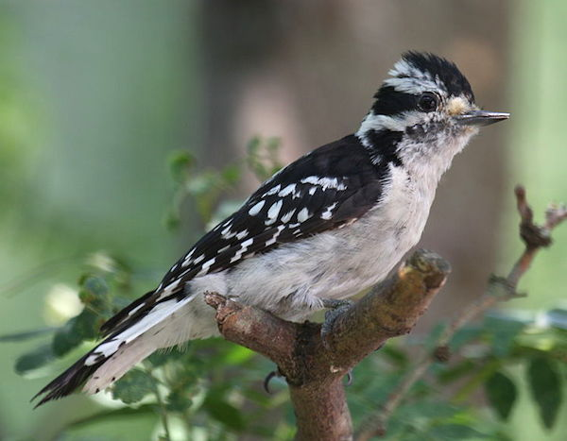**February 15, 2020**

6:30a m Counting with Coffee

7:00a m Make morning movements

7:30a m Breakfast in White Pine

8:30a m Playdough Preparation

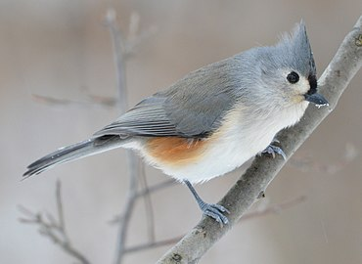9a m Basic Beaks, Tracing tracks

10a m Traveling trails to tally tufted treasures

10:30a m Eating like a bird

11a m Forming food for feathered friends

Noon Lunch in White Pine

1p m Building birdhouses in boathouse

2:30p m Enjoying Eating bird crumbs

3p m Life with Lori Taylor; Motor City Mayhem

5p m Supper

6:30p m Dramatic dissertation/making music

8 p m Birdbrain Jeopardy

9p m Who? Who? Who’s the best?

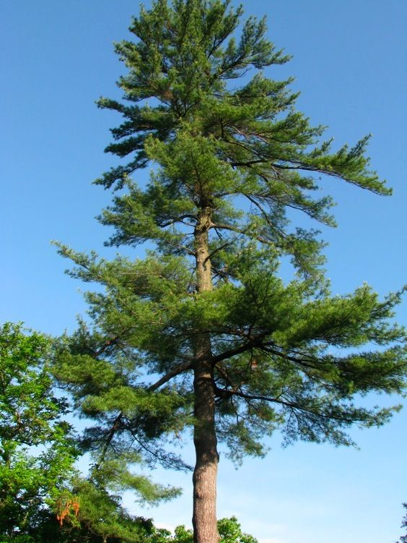10p m Goodnight Moon

11p m Loss of light

**February 16, 2020**

7a m Rise and Rejoice

7:30a m Breakfast with the birds

8:30a m SASS Snapshots

9a m White Pine wrap up

10a m Linger and leave

This weekend has been brought to you by Birding by Ear and Beyond in partnership with the National Federation of the Blind of Michigan