Guided Running and Walking
A Mary Free Bed Wheelchair and
Adaptive Sports Event

Theme: “Increasing Mobility, Empowering Activity”
What: In partnership with the Mary Free Bed Wheelchair and Adaptive Sports, the Association for the Blind and Visually Impaired (ABVI) is offering a three-week guided mobility class for recreation and sport. Across the nation, people with visual impairment partake and compete in Paralympic and recreational runs and walks. Learn about the logistics and techniques of running with a sighted guide, what it takes to be a guide, and take part in runs or walks with an inclusive, proactive team.
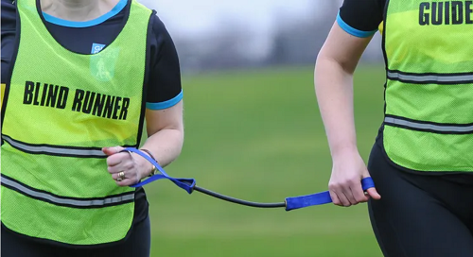
Where: Mary Free Bed YMCA
5500 Burton St. SE
Grand Rapids, MI 49546

When: May 11, 18, and 25, 2021 (6pm-7:30pmEST)
Cost: $11.35 (Includes processing fee)
Click here to register
All attendees are encouraged to attend all three sessions to establish true connectedness with their sighted guide or participant. The registration fee covers all three sessions as well as tethers for loan. For more questions about registration or the event, please contact Robert Parsons (ABVI Vision Rehabilitation Therapy Intern) at 616- 840-7236 or Jeovani Pantoja (Mary Free Bed Wheelchair and Adaptive Sports Coordinator) at Jeovani.pantoja@maryfreebed.com.

