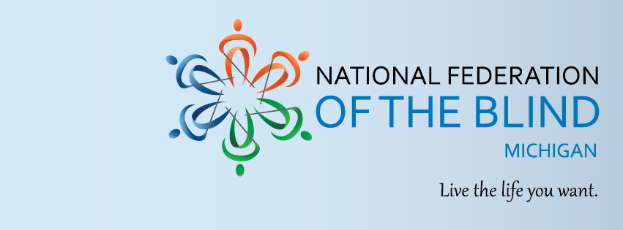
2022 State Convention Assistance for Families (SCAFF)

“Returning to the Rapids!”
Are you a family of a blind child, adolescent or adult? Interested in attending an event packed with advocacy modelling, information gathering, community building, and social awareness? The National Federation of the Blind of Michigan’s SCAFF program supports families of blind Michiganders with costs associated with attending our 2022 State Convention in Grand Rapids from November 4-6. Attend family-oriented events and programming like our “White Cane Karaoke” and Braille Carnival with comfort.

Registration for this program closes Saturday, October 1, 2022 at 12am EST.

Please direct questions to Mike Powell (President@nfbmi.org).

Eligibility for the NFBMI SCAFF program requires applicants to be:
- A Family of two or more
- A family with at least one person that is legally blind
- A family with at least one member of child or adolescent age
- Willing to travel to and attend the entire 2022 NFB of Michigan State Convention in Grand Rapids November 4-6

Applicants should compose a one-page letter stating their interest in attending the 2022 state convention, their reason for wanting to attend, and what their family could gain from their attendance. This letter should be submitted to Mike Powell (President@nfbmi.org), by October 1, 2022. This information, along with an interview will be considered by the program committee. For more information about the 2022 State Convention of the National Federation of the Blind of Michigan, please visit www.nfbmi.org/convention.

