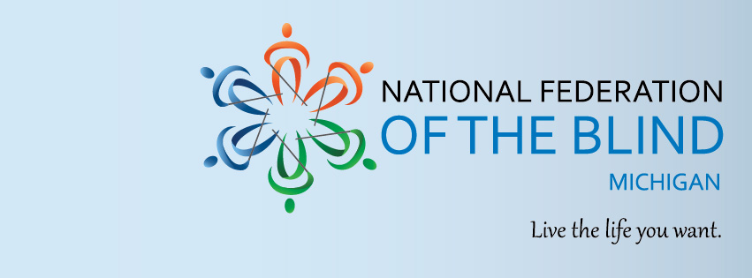

2022 MDOJ City of Detroit paratransit Town Hall

Hosted by the National Federation of the Blind of Michigan and Warriors on Wheels
If you are a rider of Metro Lift within the City of Detroit with DOCUMENTED service concerns, we invite you to participate in our town hall, where we hope to discuss current concerns with service, announcements made by DDOT and elected leadership and potential solutions for the paratransit riders of the City of Detroit. Please be prepared to participate actively with:
- Relevant Service Dates
- Records of Actions Taken When Service Concerns Occurred
- Length of Time Rider Has Used Metro Lift Service

Date: December 17, 2022
Time: 1pm EDT
Zoom Link:
https://zoom.us/j/97759102593
Meeting ID: 977 5910 2593
Dial into Zoom at: (312) 626-6799
Address:Conference Room A
11000 McNichols RD.
Detroit, MI 48221

For questions about this event, or how to support our programs, please email Robert Parsons (President@nfbmi.org)

