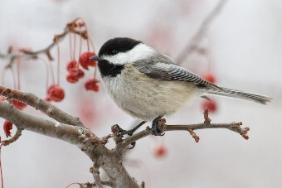**Great Backyard Bird Count**

**Action Agenda**

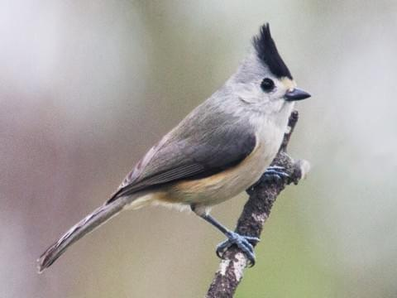

**Friday, February 16, 2024**

3p m Welcome to the woods

5p m Supper in White Pine

7p m What is the Great Backyard Bird Count

7:30p m Who, who gives a hoot?

8p m Owl Prowl

9p m The Moon of the Owl

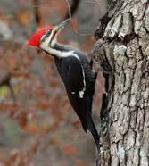

9:30 Bedtime Snack

10pm Head for habitat

11p m Eliminate Illumination

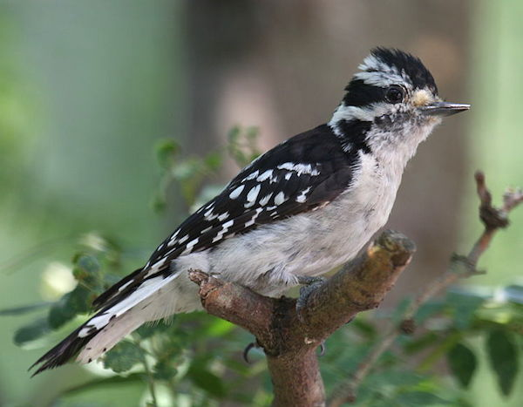**February 17, 2024**

6:30a m Counting with Coffee

7:00a m Make morning movements

7:15a m Enjoy environment while walking your way to White Pine

7:30a m Bring on Breakfast in White Pine

8:30a m Finding who Fits the Bill

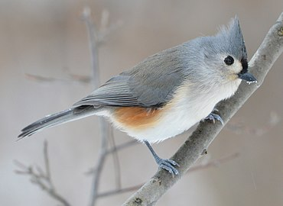10a m Traveling trails to tally tufted treasures

10:30a m Eating like a bird

11a m Who, who was in my tummy?

11:45a m Making music for meal

Noon Lunch in White Pine

1p m Building birds with basic beaks, fluffy feathers and

functional feet

2:00p m Which woodpeckers will we witness when we walk in the woods?

2:30p m Where will we wander while witnessing woodpeckers?

3:30p m Life with Lori Taylor; Children’s Author and Illustrator; Sounds of Spring and Stuff

4:45p m Sing for your supper

5p m Enjoy eating everything

6p m Campfire concert; Drumming like Woodpeckers, Rattling like Ravens,and Singing like Songbirds

7:15p m Birdbrain Jeopardy

8:30 Who? Who? Who’s the best? Presentation of prizes

8:45p m Food, Fun and Fellowship

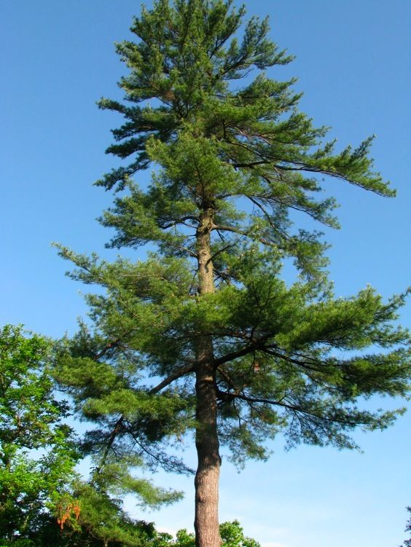10p m Goodnight Moon

11p m Loss of light

**February 18, 2024**

7a m Rise and Rejoice

7:30a m Breakfast with the birds

8:30a m Dealing with data

9a m White Pine wrap up

9:30a m Ray Brown’s Talkin Birds

10a m Linger and leave

This fun-filled weekend was sponsored by

Birding by Ear and Beyond

University of Michigan Dearborn

Environmental Interpretive Center

4901 Evergreen Road

Dearborn, Michigan

Meeting March 9 for Making Maple Magic

This weekend has been brought to you by Birding by Ear and Beyond in partnership with the National Federation of the Blind of Michigan