# **“Exploring and Expanding the Blind People’s Movement”**

# **2024 Annual State Convention**

National Federation of the Blind of Michigan

Robert Parsons, Jr., M. A., CRC, CVRT, LLPC| President

Thursday, October 31, 2024 – Sunday, November 3, 2024

Radisson Plaza at Kalamazoo Center

100 W Michigan Avenue

Kalamazoo, MI 49007

(269) 343-3333

## Message from the President

Greetings and welcome to the 2024 state convention of the National Federation of the Blind of Michigan; where blindness is a characteristic that does not define you or your future!

Our convention theme this year, “Exploring and Defining the Blind People’s Movement,” is reflected in much of our convention programming, where our business, discussions and sessions encourage attendees to explore the inherent power that Michigan’s blind hold in organization and action. With a multitude of engaging opportunities for new members and seasoned Federationists to become activated, I invite everyone to try at least one new convention experience this year in Kalamazoo. Our agenda is a wonderful tapestry of skilled members and presenters that truly embody the philosophy of the Federation. As we continue this legacy of exploration in the Michigan affiliate, let’s stay grounded in our philosophy, purpose, and direction : ”to achieve equality, opportunity and security for the blind.”

An effective way to stay grounded while exploring the Blind people’s movement in Michigan is through pairing sessions or activities this weekend. I encourage all attendees to register for our state convention, as you’ll have many opportunities for door prizes during our banquet, business meeting or general session. Though there are many breakout sessions throughout the weekend, the three aforementioned meetings are where business takes place, members’ votes count and where these opportunities for attendees occur. I look forward to all of your input as we continue to build the Federation!

With Love, Hope and Determination

Robert Parsons, Jr., President

### NFB Pledge

I pledge to participate actively in the efforts of the National Federation of the Blind to achieve equality, opportunity, and security for the blind; to support the policies and programs of the Federation; and to abide by its constitution.

### NFB One-Minute Message

The National Federation of the Blind knows that blindness is not the characteristic that defines you or your future. Every day we raise the expectations of blind people because low expectations create obstacles between blind people and our dreams. You can live the life you want; blindness is not what holds you back.

## Tell Your Friends

We encourage all attendees to talk about the convention with your friends on social media. Our official hash tag is #NFBMI24.

## Convention Registration

We encourage everyone to register for the convention. Only registered attendees are eligible to win door prizes that are given away throughout the weekend. Additionally, registered, dues-paid members of a local chapter or state division in our affiliate are considered a part of the blind people’s movement in both Michigan and our national organization. During the convention, attendees will have the opportunity to purchase a Braille Readers Brigade (BRB) passport for $15 to participate in the exhibit hall passport drawing program.

Limited banquet tickets will be available for purchase at the convention. In-person registration is $20, and banquet tickets are $50. Registration is located in the Pre-Glens,found on the Lower Level of the hotel. The registration table will be open throughout the day on Friday and Saturday, as well as Sunday morning.

## Inclusivity, Diversity, and Code of Conduct

We are committed to providing a welcoming, safe, and healthy environment for everyone. Thank you for cultivating an atmosphere of mutual respect where participants from diverse backgrounds can learn, network, and share with each other. We are committed to diversity, equity, and the free expression of ideas. These principles have been outlined in our Code of Conduct found at https://nfb.org/codeofconduct.

We recognize a shared responsibility to create and uphold an inclusive atmosphere for the benefit of all. Prohibited behaviors include harassment, sexual misconduct, and inappropriate use of the NFB virtual convention platform. Prohibited behavior or misuse of the platform will not be tolerated and may result in removal from the convention and other consequences.

For assistance or to report an incident at the convention, please call

(410) 659-9314, extension 2475, or email [code@nfb.org](mailto:code@nfb.org). All reports will be fully investigated according to the steps outlined in our code of conduct. Thank you for doing your part to contribute to our community and the high expectations we strive to maintain at all our events.

## Door Prizes

Door prizes will be drawn periodically throughout the convention weekend; specifically, during the annual business meeting, Crazy Costume Karaoke, general session, and our banquet. All registered attendees are eligible to win a door prize if they are present in the room when their name is called. If you are hoping to donate a door prize at convention, please locate Donna Posont, New Wayne County President, or inform the volunteers at the convention registration table.

## A message from our platinum and gold sponsors

### Bureau of Services for Blind Persons—Platinum Sponsor

Welcome to the Michigan Bureau of Services for Blind Persons

The Michigan Bureau of Services for Blind Persons (BSBP) believes in the capacity of people who are blind or visually impaired to achieve employment and independence. BSBP provides counseling, guidance, training and related services that empower persons with disabilities to achieve their individual goals.

If you live in Michigan and you are blind or visually impaired, BSBP will partner with you to define your goals and identify appropriate training and related services.

#### AVAILABLE SERVICES

##### Adult Services

Vocational Rehabilitation - counseling, guidance, training and other services that support and match skills and interests with in-demand career paths supported by the labor market.

Independent Living Older Blind Program - training and other services for adults, age 55 years or older to promote independence.

##### Youth and Transition Services

The Youth Low Vision Program - available to youth from birth through 13 years of age.

Pre-employment transition services - available to students ages 14-26 years of age focused on post-secondary outcomes.

##### Specialized Programs and Services

**DeafBlind Services - provides direction on how to access interpreter and sign language services to support vocational rehabilitation and independent living programs.**

**Business Enterprise Program - unique career path for individuals completing specialized training to prepare for self-employment in the food and vending industry.**

**Training Center - comprehensive rehabilitative center that offers instructional services for adjustment to blindness and summer programs for students qualifying for pre-employment transition services. The training center located in Kalamazoo provides instruction virtually, as a day student, or on-campus resident.**

**Braille and Talking Book Library - lends audio and braille books to Michigan residents unable to comfortably read standard print materials due to a visual, physical or reading disability.**

**BSBP services are not framed within an entitlement program. To be eligible for BSBP services, you must be legally blind, which means you meet at least one of these criteria:**

**• The field of vision is restricted to 20 degrees or less; or**

**•Central acuity does not exceed 20/200 in the better eye with corrections; or**

**•Visual acuity with the best correction must be 20/100 or worse in the better eye with a prognosis of rapid deterioration; or**

**•The individual must have visual fields that subtend an angle of less than 40 degrees in each eye with the prognosis or rapid deterioration.**

**BSBP has adopted the following Mission. Vision and Core Values guide our services to Michigan residents.**

#### MISSION STATEMENT

To provide opportunities to individuals who are blind or visually impaired to achieve employment, and/or achieve maximum and meaningful independence in life through comprehensive rehabilitative services.

#### VISION

To help Michigan become a better state for blind and visually impaired persons to be equal contributing citizens that enjoy all the advantages of a full, independent life.

#### CORE VALUES

Accountability / Reliability, Client-focus, Demand-Driven Employment, Diversity / Inclusion, Efficiency, Excellence, Integrity / Honesty, Positive Mental Attitude, Safety, Teamwork, Transparency / Open Communication, Trust, Respect

The Bureau of Services for Blind Persons, a part of the Michigan Department of Labor and Economic Opportunity, will not discriminate against any individual or group because of race, religion, age, national origin, color, height, weight, marital status, sex, sexual orientation, gender identity or expression, political beliefs, or disability. Under the Americans with Disabilities Act, you are invited to request any assistance you need with reading, writing, or hearing by contacting your local BSBP office.

The programs described in this brochure are funded as follows: Vocational Rehabilitation (VR) funded 78.7% through a grant from the U.S. Department of Education (USDOE) and 21.3% through State funding; Independent Living Older Blind (ILOB) funded 90% through a grant from the USDOE and 10% through State funding; Pre-Employment Transition Services (Pre-ETS) funded 100 percent through the USDOE VR grant. For the federal fiscal year 2023, federal grant funds were as follows: VR $19,146,385; Pre-ETS reserve included in VR $2,871,958; ILOB $994,565.

Bureau of Services for Blind Persons

www.michigan.gov/BSBP

702 W. Kalamazoo Street

P.O. Box 30652 Lansing, MI 48909

Phone: 517-241-1100

Fax: 517-335-5140

Toll-Free Numbers 800-292-4200

### Discover Kalamazoo—Platinum Sponsor

As the official destination marketing organization for Kalamazoo County, Discover Kalamazoo features a team of sales, service and marketing professionals who strive to inspire visitors and residents to discover Kalamazoo. We work to provide the resources, platforms and opportunities for individual local businesses to market their services and products to a variety of travel audiences, including leisure tourists, convention planners and meeting/trade show attendees. Our mission is to attract and wow visitors for the economic advancement of our county, with the vision of sharing Kalamazoo with everyone.

Visit the Discover Kalamazoo information table to get resources on best ways to discover Kalamazoo, including our Travel Guide and Dining Guide’.

Website: [discoverkalamazoo.com](https://www.discoverkalamazoo.com/)

### Non-24—Platinum Sponsor

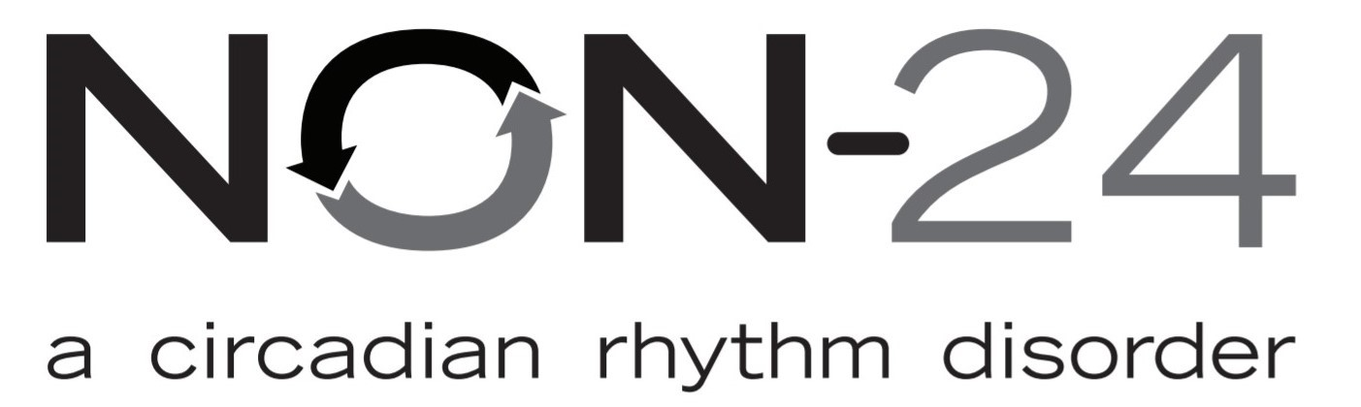

* Non-24-Hour Sleep Wake Disorder (Non-24) is a serious chronic disorder that disrupts a person’s circadian rhythm which can lead to disrupted sleep-wake cycles.
* Up to 70% of people who are totally blind have Non-24 and may not even know it.
* Trouble falling asleep, staying asleep and daytime sleepiness are signs of Non-24 as well as waking up feeling groggy or tired.

Learn more about this disorder, its cause, and how to advocate for help. Join an education session and discussion at this convention with a Non-24 Nurse Educator, Jennifer Lyman, R.N., B.S.

Jennifer Lyman, R.N., B.S.

Non-24 Nurse Educator

202-875-4714

jennifer.lyman@vandapharma.com.

### Eye Learn, LLC—Platinum Sponsor

11000 W McNichols Road #109, Detroit, MI 48221

Phone: 313-530-5905

Email:

srice@eyelearn2016.com

Eye Learn is a technology center for the blind, low vision and senior citizens located in Detroit, Michigan providing specialized training in technology through the use of screen reader technology using structured discovery. Eye Learn customizes programs which are tailored to the needs of both individuals and small groups providing in person and remote lessons. Eye Learn is able to customized training based on individual/group needs

Services Offered:

* Technology Assessment All Devices
* JAWS Training
* Zoomtext Training
* Fusion Training
* MS Windows 11
* MS Office Suite: Excel, Word, Powerpoint, Outlook
* PC Set up Hardware & Software Installs
* MAC Book Set up & Hardware Installs
* IPhone/Android Training
* Zoom Cloud Meeting Host Training
* Zoom Cloud attendee Training
* Microsoft Teams Training
* iPad Training
* Various App Training iPhone and iPad
* Victor Reader Stream & Trekk Training
* Talking Typer Set up and Training

### Michigan Department of Education: Low incidence Outreach—Gold Sponsor

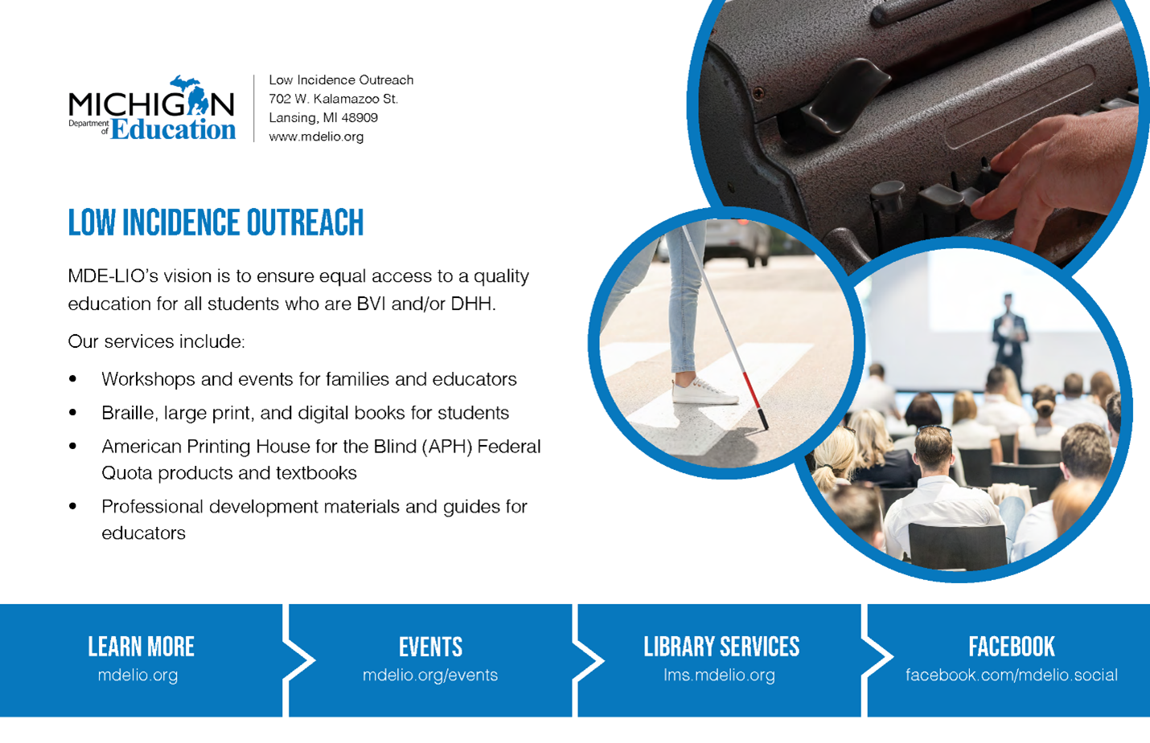

Low Incidence Outreach

702 W. Kalamazoo St.

Lansing, MI 48909

www.mdelio.org

MDE-LIO’s vision is to ensure equal access to a quality education for all students who are BVI and/or DHH.

Our services include:

• Workshops and events for families and educators

• Braille, large print, and digital books for students

• American Printing House for the Blind (APH) Federal Quota products and textbooks

• Professional development materials and guides for educators

Learn More: mdelio.org

Events: mdelio.org/events

Library Services: lms.mdelio.org

Facebook: facebook.com/mdelio.social

## Wednesday, October 30, 2024

### 8 PM—Sponsor and exhibiter showcase

Stop by our affiliate Zoom room for our virtual sponsor and exhibitor showcase. Here, sponsors and exhibitors will share what they will be offering at the convention so you can be prepared for the exhibit

hall on Friday afternoon. Plus, you will be able to hear from some exhibitors who will only be at the virtual event. Please see the exhibitor guide on the convention website for a complete list.

## Thursday, October 31, 2024

### 7:00 pm—NFBMI “Taste of Kalamazoo” Dinner Activity

Join four leaders of the National Federation of the Blind of Michigan as we embark with convention attendees on a Halloween-special culinary visit to one of four local Kalamazoo restaurants for a dinner experience. This networking opportunity aims to connect members and visitors of our convention from different areas. All interested attendees are encouraged to view the attached restaurant menus and contact the corresponding group leader prior to reservation date of October 25, 2024, if they are interested in joining.

Group One: Burdick’s

100 W. Michigan Ave.

Kalamazoo, MI 49007

Menu: https://www.oldburdicks.com/downtown-menus/

Leader: Sheila Fulmore, (810)241 -6124

Group Two: Latitude 42 Brewing

6101 W. Main St.

Kalamazoo, MI 49009

Menu: https://order.toasttab.com/online/latitude-42-oshtemo-6101-w-main-st

Leader: Robert Parsons, (269) 216- 8640

Group Three: Barrio Tacos + Tequila + Whiskey

215 E Michigan Ave  
Kalamazoo, MI 49007

Menu: https://barrio-tacos.com/food/  
 Leader: J.J. Meddaugh, [vp@nfbmi.org](mailto:vp@nfbmi.org) or (989) 284-7915

Group Four: HUB Tavern + Grill

359 S Kalamazoo Mall  
Kalamazoo, MI 49007  
Menu: <https://www.hubkalamazoo.com/all-day-menu>

Leader: Damontae Scott, (810) 295-6422

## Friday, November 1, 2024

### 10:00AM - 6:00 PM Registration –Pre-Glens, Lower Level

We encourage everyone to register for the convention. Limited banquet tickets will be available for purchase at our NFB of Michigan exhibit hall table. Registration is $20 and banquet tickets are $50.

### 11:00 am – 6:00 pm Exhibit Hall–Great Lakes 2,3, and 4, Lower Level

Stop by the NFBMI exhibit hall, where a variety of chapters, divisions, exhibitors, sponsors, and vendors are eager to share information about their latest products and services with you. While networking with our exhibitors ;learn about options for access technology and services that may benefit you.

#### BRB Exhibitor Passport Program

The National Federation of the Blind of Michigan is grateful for the generosity of so many of its donors and sponsors. Through these efforts and the work of our membership, opportunities like our BRB Exhibitor Passport program gives us a chance to thank you for being dedicated to the blind people’s movement. If you are a BRB Passport holder, be sure to show your braille ID card to every exhibitor in exchange for a code word. These words will create our 2024 BRB phrase. Provide this phrase while handing in your braille passport ID card to President Parsons after general session, before 5pm on Saturday, November 1 for an opportunity to be entered into a drawing for $150. BRB Passport ID cards can be purchased at the convention registration table.

### 12:00 pm – 3:00 pm Senior Coffee and Conversation– “The Upjohn Suite’”—Room 937

Event Generously Sponsored by the Blind Michigan Seniors Advocating for Seniors.

### 12:00 pm – 1:00 pm Aira: Access is a Human Right! —Prairies 4—Everette Bacon

Come hear about all of the new happenings from Aira. Whether you are new to the service or a seasoned user, blind smart phone users can benefit from this breakout session on the latest in visual interpretation technology.

### 12:00 pm – 1:00 pm Michigan Diabetes Action Network informational meeting—Prairies 6—Diana Mohnke, Secretary, Capital Region Chapter

Come and learn the basics about diabetes and how to manage it from a Diabetes Care and Education Specialist. Hear tips and tricks on how to manage diabetes as a blind person and hear from individuals who have diabetes.

### 1:00 pm – 3:00 pm Live the Life You Want: A Blindness Philosophy You Can Live By—Prairies 4—Sanho Steele-Louchart—At Large Chapter President

Join NFB leaders to discuss the merits of a positive blindness Philosophy. Don't think you have a blindness philosophy? Perhaps you'll be pleasantly surprised. We know that low expectations create obstacles between blind people and our dreams. What we forget is that we have the power to change them. Come to be reminded of your personal power and that together, we transform dreams into reality.

### 1:00 pm – 3:00 pm Brain Games: Accessible Live Jeopardy—Prairies 6—Robert Parsons, Jr.—National Federation of the Blind of Michigan President

Generously Sponsored by Rehabilitation WAY, LLC

Are you a trivia guru? Believe you can compete with the Federation's best in Michigan? Compete in "Brain Games," the Michigan Affiliate's take on Jeopardy's Tournament of Champions. In this best-of-five series, competitors will have a chance to use their knowledge to elevate to prizes and bragging rights.

### 3:00 pm – 4:00 pm Resolutions Committee Meeting– Prairies 6—Robert Parsons, Jr., National Federation of the Blind of Michigan President

Are you looking to become an active voice in the blind people's movement? The resolutions committee is the perfect place to start. Resolutions are the official policies set by our organization each year that often predict the objectives of our movement. Don't miss your chance to affect change with everyone.

### 4:00 pm – 6:00 pm Pumpkin Patch Activity– “The Upjohn Suite”—Room 937—Donna Posont, New Wayne County President

Pumpkin Patch Party preparation must include pouring some pumpkin potion  resulting in a delicious pumpkin product. Exploration of pumpkin properties may result in pumpkin explosions.

### 4:00 pm – 5:00 pm Hunting Blind– Prairies 4—Scott Norris, National Library Services for the Blind and Print Disabled.

Step into the world of hunting from a blind perspective in this engaging session. We’ll explore the thrill of tracking game, the skills it takes to succeed, and how blind hunters connect with the outdoors in unique ways.

### 4:00 pm – 6:00 pm Self-Defense– Prairies 5—Steven Handschu, Detroit Chapter Member.

Can blind people defend themselves effectively? Yes we can. This seminar will introduce affective self-defense training techniques for blind people by blind people. Learn how to defuse, avoid, and protect yourself in difficult situations.

### 4:30 pm – 5:30 pm Non-24 Informational Session– Prairies 6—Vanda Pharmaceuticals

### 8:00 pm – 11:00 pm Crazy Costume Karaoke– Glens 1-3, Lower Level

General Admission $15

Join the NFBMI At Large chapter as they host our “Crazy Costume Karaoke,” showcase and hospitality event. Support blind attendees as they encourage blind people across our great state during their performances in an encouraging atmosphere that shows our Federation family at its finest. Our hospitality event offers attendees great entertainment, refreshments, door prizes and a cash bar while they celebrate with the Federation. Our theme encourages creativity and a sense of humor ,so we hope everyone has a wonderful time. While participating, please consider supporting chapter and division representatives in the “2024 Federation Fire Challenge”.

## Saturday, November 2, 2024

### 7:30 am – 8:30 am—Senior hospitality coffee hour—“ The Upjohn Suite”—Room 937

Hosted by the Michigan Seniors

### 8:00 am – 8:45 am Registration Pick-Up –Pre-Glens, Lower Level

We encourage everyone to register for the convention. Limited banquet tickets will be available for purchase in-person. Registration is $20 and banquet tickets are $55.

### 9:00 am – 12:00 pm Opening General Session – Glens 1-3, Lower Level

9:00 am Call to Order and Welcoming Remarks, Robert Parsons, Jr., President, National Federation of the blind of Michigan

9:10am A Welcome from our Hosts, Patricia Pyle and Sanho Steele-Louchart, Senior Division and At Large Chapter Presidents, National Federation of the Blind of Michigan

9:25 am A Message from Our National Office, Everette Bacon, Second Vice President, National Federation of the Blind

9:55 am NABS Report, Qualik Ford, Board Member, National Association of Blind Students

10:10 am, Introducing our 2024 NFBMI Convention Sponsors, J.J. Meddaugh, NFBMI First Vice President

10:25am Introducing the 2024 Scholarship Finalist, Sabrina Rice, Scholarship Committee Chair, National Federation of the Blind of Michigan

10:45 am Continuing Effective Education for Blind and Low Vision Youth, Roxanne Balfour, Director, Michigan Department of Education Low Incidents Outreach

11:05am Innovations in state services for Blind and Low Vision Customers, Mike Pimble, Acting Director, Bureau of Services for Blind Persons (BSBP)

11:25am Michigan PAC Report, Darryl Rice, NFBMI Board Member

11:30am An Employment Journey Check-In, Jerusalem Crawley, President, Michigan Association of Blind Students

11:45am My Advocacy Message, Felecia Bradford, NFBMI Board Member

12:00 pm Adjourn for Lunch

### 12:15 pm NFBMI Pizza Buffet Luncheon—Glens hallway, Lower Level

## 1:00 pm –5:00 pm Afternoon Breakout Sessions

### **1:00 pm – 3:00 pm Building and Connecting with the Michigan Association of Blind Merchants – “The Upjohn Suite”—Room** 937—Zach Eagle

Come join the restart on the NFB of Michigan's Merchants Division. Learn about being a blind entrepreneur and opportunities in the State of Michigan's Business Enterprise Program. The merchant's division will be providing information about NFB Blast as well. If you can't attend the meeting, stop into the hospitality room to rest and relax with snacks and refreshments.

### 1:00 pm – 2:00 pm Michigan Blind Seniors Advocating for Seniors (MBSAS) Annual Meeting- Prairies 4—Patricia Pyle, President

Are you losing your vision as you settle into retirement and wondering how to deal with your vision loss as you enter into your golden years of life? Have you been blind your whole life and are looking to meet other blind people who share some of the same goals and interests as you? Please join the senior division as they hold their annual meeting to pay annual dues, meet other members, and discuss general goals and directions of the division. There will also be a special presentation from the Bureau of Services for Blind Persons on services that are available for seniors and how you can determine your eligibility for these services.

### 1:00 pm – 2:00 pm Michigan Association of Blind Students (MIABS) Annual Business Meeting- Prairies 5—Jerusalem Crawley , President

Are you a blind high school or college student looking to network with others on aspects of student life? Join the Michigan Association of Blind Students for their first in-person business meeting since the pandemic where they will discuss important programs, accept new members through collecting dues and hold elections to determine leaders of our organization.

### 1:00 pm – 2:00 pm Kalamazoo Chapter Rebuilding Meeting—Prairies 6—Lisa Sledge

### 2:00 pm – 3:00 pm Navigating AI: Tools and Pitfalls for the Blind– Prairies 4—Jason Meddaugh, NFBMI First Vice President

Discover the latest AI-powered apps and resources designed for blind users, while learning to identify potential pitfalls and challenges. This session will provide insights on maximizing the benefits of AI technology in everyday life.

### 2:00 pm – 3:00 pm—NFBMI At Large Chapter Meeting – Prairies 6—Sanho Steele-Louchart, President

The At Large chapter of the NFB of Michigan is a statewide chapter that meets monthly via Zoom to support members that are not physically located near a local chapter or are unable to make in-person meetings. Join us as we meet for our first in-person meeting of 2024, where we will discuss the direction of our chapter efforts and how we can continue to build the Federation. Opportunities for chapter membership and annual dues will be available.

### 3:00 pm – 5:00 pm Employment Readiness Seminar– “Glens 1-3, Lower Level —Felecia Bradford—, NFBMI Board Member

Are you a potential job seeker looking for tips on empoyability? Our employment suite includes a presentation on various interviewing techniques, job skills, and professional development tips from leaders in different fields.

### 3:00 pm – 4:00 pm Accessible Gaming Seminar– Prairies 4—Ather Jammoa, NFBMI Communications Chair.

Join us for an exciting breakout session on accessible and audio games! This session will explore mainstream games that have integrated accessibility features from the ground up, such as Mortal Kombat 1, Forza Motor Sports, and The Last of Us series on PlayStation 5. These games showcase how developers are creating inclusive experiences for players of all abilities. Additionally, we'll delve into games specifically designed for the blind community, known as audio games, which provide immersive, sound-driven experiences built exclusively for non-visual play. Whether you're a gamer or simply curious, come learn about the past, present and future of accessible gaming!

### 3:00 pm – 4:00 pm BSBP Session– Prairies 5—TC Staff Member

### 3:00 pm – 4:00 pm Financial Protection: Tips to Avoid Scams— Prairies 6—Gail Bowman-Cuba, CEO, Bowman Business Solutions

If you are interested in learning how to improve your financial safety, to recognize financial impropriety and prevent being affected by financial scams, this session is for you. The number of email, phone and mail-based financial scams blind people experience are increasing every day; and you should be prepared for this phenomenon. By the end of this session, attendees will be able to identify common financial scams, understand how to protect themselves, and know what to do if they fall victim to a scam.

### 4:00 pm – 5:00 pm Blind Parents Division Interest Meeting—Prairies 4—Deborah Wellington, NFBMI New Wayne County Vice President

Are you a blind parent living in Michigan and trying to understand how the Federation speaks to you? Join us in this session where we discuss how the Federation offers spaces and places for blind parents and their families to grow. Opportunities for networking and future program building is abundant as we continue to work toward supporting a strong blind parents division in Michigan in the future.

### 4:00 pm – 5:00 pm iPhone Camera Skills for Blind Users: Capturing the World Through Touch and Voice—Prairies 5—Sabrina Rice, Eye Learn

Step-by-step instruction for using the camera on an iPhone.

### 4:00 pm – 5:00 pm Mastering Personal and Business Credit for Financial Success—Prairies 6—Credit Masters LLC

Credit Masters is proud to offer a comprehensive credit restoration seminar, designed to empower individuals and businesses alike. In this session we will dive deeper into how your credit report should be structured to achieve optimal results. You’ll learn how to identify and address inaccurate data that may be holding you back. Our team will also discuss strategies for maintaining a healthy credit profile over time. For entrepreneurs and business owners, we’ll explore the crucial steps for establishing and maintaining business credit. Whether you’re working on repairing personal credit or business credit, Credit Masters is here to help.

### 6:00 pm Happy Hour Social Hour – Glens hallway, Lower Level

### 7:00 pm –10:00 pm Banquet General Session – Glens 1-3, Lower Level

INVOCATION

INTRODUCTIONS—Maryann Murad, Secretary, National Federation of the Blind of Michigan

Braille Readers Brigade Winner— Mark Eagle, Treasurer, National Federation of the Blind of Michigan

Scholarship Awards Presentation— Sabrina Rice, Scholarship Committee Chair, National Federation of the Blind of Michigan

Investing in Our Future with NFBMI REAL – Sanho Steele-Louchart, At Large Chapter President, National Federation of the Blind of Michigan, Ather Jammoa, Communications Chair, National Federation of the Blind of Michigan

Keynote Address— Everette Bacon, Second Vice President, National Federation of the Blind

Federation Fire Challenge Final Report—Robert Parsons, Jr., President, National Federation of the Blind of Michigan

2024 NFBMI Convention Live Auction—Michael Powell—President Emeritus, National Federation of the Blind of Michigan

### 10:00 pm Banquet Adjourn

### 10:05pm Federation Fire Challenge—“ The Upjohn Suite”—Room 937

## Sunday, November 3, 2024

### 7:30 am – 8:30 am—Senior hospitality coffee hour—“ The Upjohn Suite”—Room 937

Hosted by the Michigan Seniors

### 9:00 am – 12:00 pm Business General Session – Glens 1-3, Lower Level

Call to Order—Robert Parsons, Jr.

Roll Call of NFBMI Board Members and Officers

Rules of Engagement—Robert Parsons, Jr.

Secretary’s report – Maryann Murad

Treasurer’s Report - Mark Eagle

President’s Report – Robert Parsons, Jr.

Attendee Content Questions

2025 Washington Seminar Planning

2025 National Convention Planning

2025 Leadership Weekend Planning

State Division Reports

Michigan Blind Seniors Advocating for Seniors

Michigan Association of Blind Students

Chapter Reports

At Large

Capital Region

Detroit

Flint Genesee

Attendee Content Questions

Old Business

NFBMI AT Leadership Academy Response

New Business

 Kalamazoo Chapter Reactivation

2024 NFBMI Election of Officers

Announcements, Special Dates, Upcoming Programs

Adjournment

## A message from our White Cane Sponsors

### Alpha Phi Omega

Alpha Phi Omega is the largest, inclusive service fraternity dedicated to building leaders in the United States. With chapters in over 500 college campuses and universities, the organization’s mission unites volunteers, professionals and students under three principles: leadership, friendship and service. Our initiatives and projects are centered in one or all of the organization’s three founding principles, further supporting all involved to be the most collaborative in this growing world.

### Birding by Ear and Beyond

Birding by Ear and Beyond, a program at the Environmental Interpretive Center at the University of Michigan-Dearborn, was developed as a way for people who are blind to learn about the natural world. Participants who are blind as well as sighted families and friends are encouraged to engage all their senses in the learning processes. Those who are blind have learned to identify birds by sound, trees by touch, flowers by smell, and herbs in the butterfly garden by taste. Anyone involved in the program finds out that an understanding of nature can occur even when one is blind by using techniques that do not depend on sight. As participants explore the wonder of nature they gain confidence in their abilities to learn about and care for the environment.

Phone number: (313) 220-8140

Email: donnabutterfly50@gmail.com

### Family Counseling and Mediation Services

Family Counseling and Mediation Services is a private practice in Kalamazoo since 2013.

We have four practitioners providing counseling for children, adolescents, adults, couples, and families.

Specialties include addiction, trauma, LGBTQIA2S+, children/adolescent family issues, and disability and minority issues.

In-person and virtual sessions as well as evening hours are available.

Phone number: 269-932-4973

Website: counseling-kalamazoo.com

Email: [laurierudolph@counseling-kalamazoo.com](mailto:laurierudolph@counseling-kalamazoo.com)

### iCanConnect

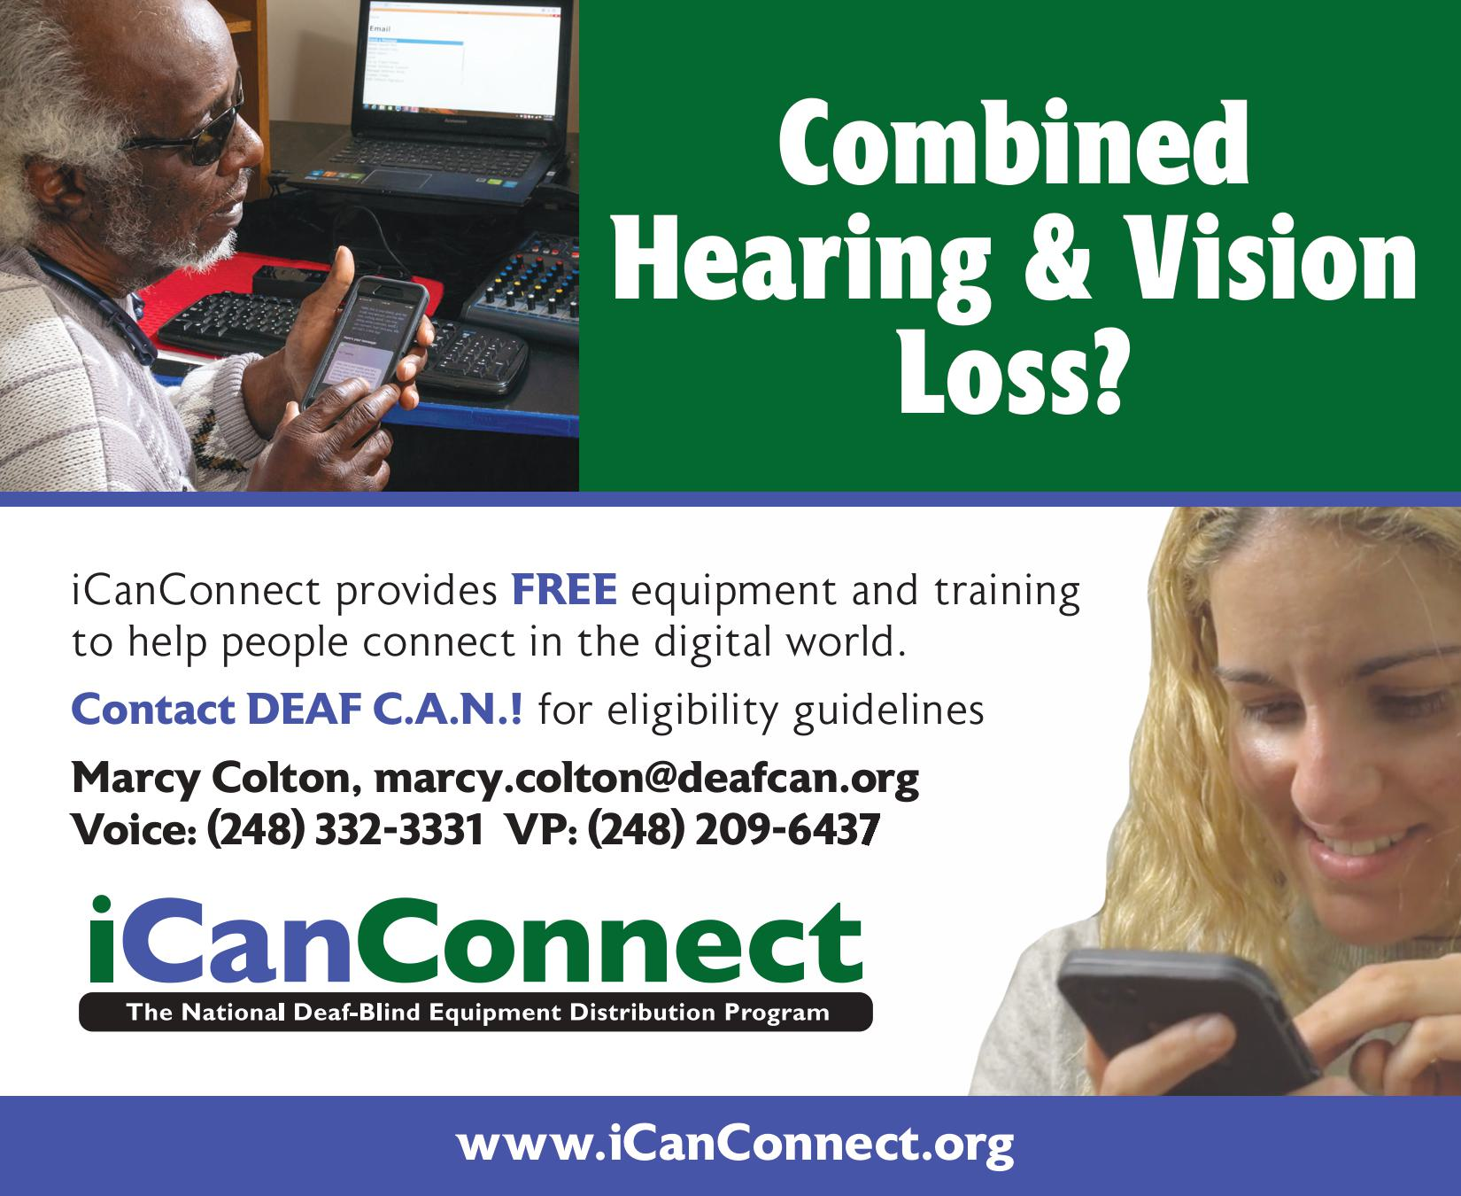

iCanConnect provides FREE equipment and training to help people connect in the digital world.

Contact DEAF C.A.N.! for eligibility guidelines

Marcy Colton, marcy.colton@deafcan.org

Voice: (248) 332-3331 VP: (248) 209-6437

Combined Hearing & Vision Loss?

www.iCanConnect.org

### Leader Dogs for the Blind

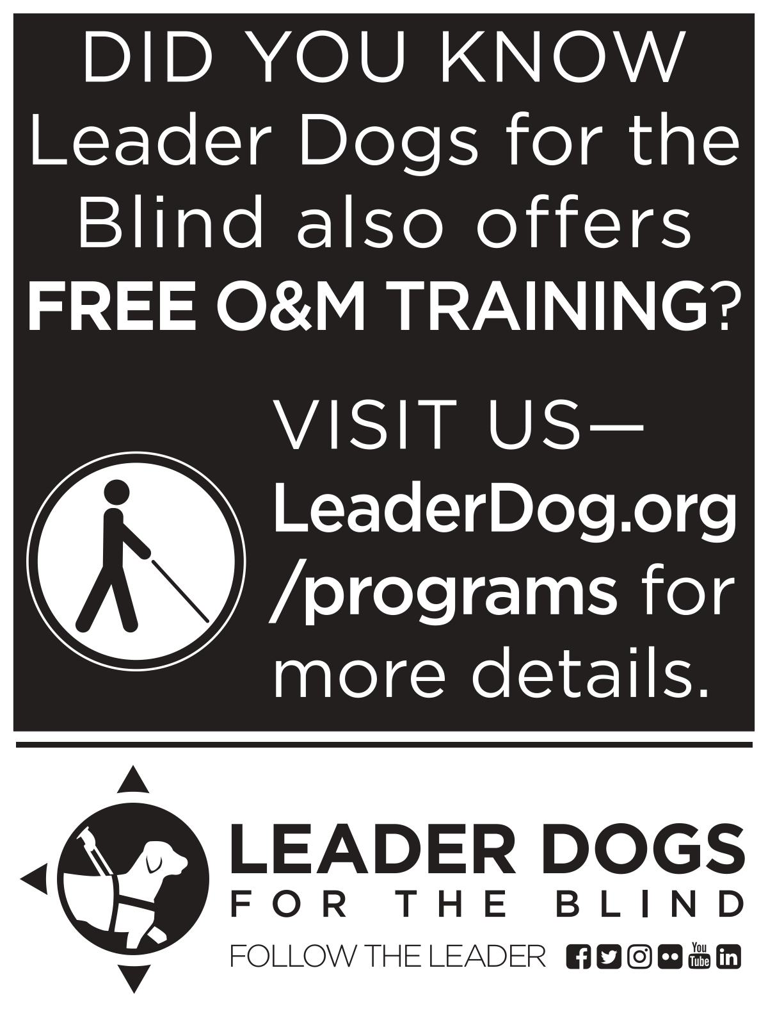

DID YOU KNOW Leader Dogs for the Blind also offers FREE O&M TRAINING?

VISIT US

LeaderDog.org/programs for more details.

### Rehabilitation WAY, LLC

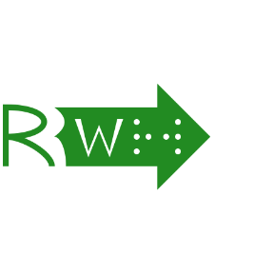

503 S. Westnedge Avenue, #1

Kalamazoo, Mi 49007

Rehabilitation WAY, LLC is a private rehabilitation practice that incorporates vocational empowerment and readiness into its work with people. The acronym that makes up its principles; working, accessing, and yielding; addresses the challenges to employment that all people have the potential to face. Nationally certified in various counseling specializations with an emphasis on blindness and low vision, the practice prides itself on its readiness to get you to go the distance for your goals. Whether new to blindness or still on the journey to your objective, our services can streamline your path; including:

* Disability Acceptance Counseling
* Individual Career Counseling and Assessment
* Employment Readiness Groups
* Workplace Accessibility Consultation
* Access Technology Assessment and Training

Contact: Robert Parsons, Jr., M. A., M. A., CRC, CVRT, LPC

(616) 528-4309

rehabilitationway@gmail.com

## Thank You!

Thank you for participating in the National Federation of the Blind of Michigan 2024 state convention. We hope to see you again next year at the 2025 state convention, or at your next local chapter or division meeting.