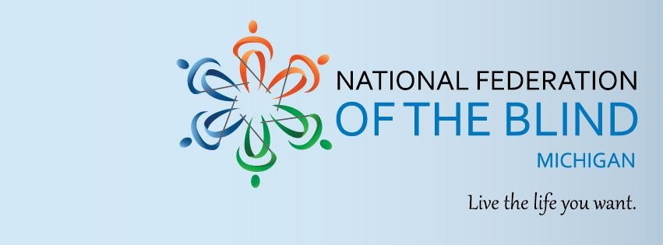

#RAISING EXPECTATIONS, ACCESSING LIFE

## An NFB Youth and Family Experience

**#R.E.A.L. 2025**

Are you ready for an amazing weekend of learning, fun, and friendship? Do you want to discover new possibilities and opportunities for your future? If so, mark your calendar for the **NFBMI R. E. A. L.** program, a weekend-long event that will inspire you to achieve more than you ever imagined!

**\*Dates:** June 27-29, 2025**

**Location:** Courtyard Detroit Dearborn, 5200 Mercury Dr, Dearborn, MI 48126

**NFBMI R. E. A. L.** is a developmental program that works with blind children and students on a holistic level to support their growth and exploration of topics and opportunities that raise the expectations of themselves, their families, and their educational community. Our age-appropriate programming offers a medley of interactive opportunities for children and students.