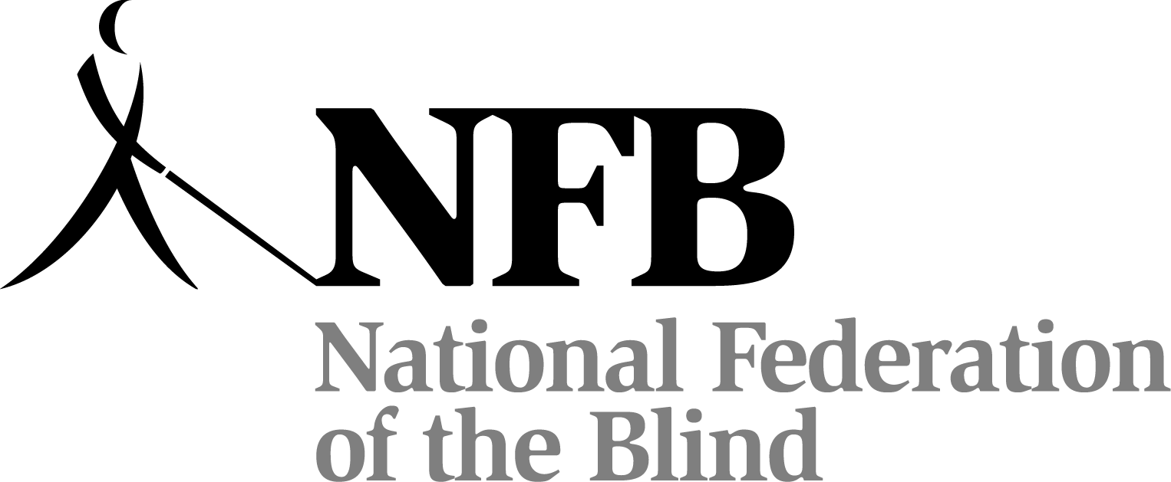
National Federation of the Blind 2010 Annual Convention

Exhibit Hall “Verbal Map”

OVERVIEW: The Khmer Pavilion Exhibit Hall in the Hilton Anatole of Dallas, Texas, is a rectangle, which has122 six-foot tables where you will find demonstrations, sales, and giveaways. Exhibitors include NFB divisions and affiliates, technology companies, federal organizations, and others. This year there are tables around an outside ring (placing the vendors’ backs to the walls), and there are two large rectangles in the center of the room. These are called A-Square and B-Square. The squares' short ends face east and west; their long sides are parallel to Khmer’s north and south walls, and A-Square is nearest to the entrance. Go through a break in the line of tables on the south wall to find the bathrooms. A door to the ladies' room opens on the south wall to the left of the break; the men's room is the first door on the left inside a corridor ahead of that break in the line of tables.

ENTRANCE: The hotel entrance to the pavilion is on the east wall. A water station is on your left just inside this door. Turn right and walk this ramped hallway that parallels the outside hallway and is decorated with Chinese horses on pedestals. You will enter the rectangular Khmer Pavilion at its southeast corner. The long sides are on the east and west walls. A wide aisle runs straight ahead of you and continues around the four sides of the room with one center aisle running east and west between the two squares from midway on the long east side and west side walls. From this entrance, the two exhibit hall information tables (numbers 1 and 2) are immediately on your right against the east wall. The tables to your left on the south wall show and sell the knfbReader Mobile (64-66).

EAST WALL, tables 1-20: At the information table, you can pick up a floor plan (print only) and exhibitor list with table numbers (in Braille or print). Keep the entrance behind you and the east wall on your right to check out east wall. Next you come to our title sponsor, Deque Systems (tables 3 and 4), then GW Micro (5-7), followed by the Diebold ATM (8). Some other notable vendors along the east wall are Sendero Group (9-10), Independence Science (11), Vanda Pharmaceuticals (13), and NFB-NEWSLINE® (15-16).

NORTH WALL, tables 21 to 35 (the back of the room): Turn the corner from the east side to explore the first half of the north wall, tables 21 to 28. The NFB Krafter’s Division is at table 23. At the halfway break find a water station against the wall. After the break, exhibit tables 29 to 35 include NFB’s Diabetic Division and Optelec.

WEST WALL, tables 36 to 53: The NFB of Mississippi (36) starts the line and the National Association of Blind Merchants (NABM) ends it at table 53. In-between are tables for guide dogs, jewelry, cars, and other interesting things.

SOUTH WALL, tables 54 to 66: NABM continues on table 54, UPS has a shipping counter at 57-58, RFB&D is 59, Oracle is 60, En-Vision America is 61-62, and onward to the last tables (64-66) holding the knfbReader Mobile back at the entrance.

A-SQUARE, tables A67 to A94: If you want the table numbers in order for A and B Squares, walk counterclockwise around them. To begin at A67, head to the east wall and put your back to the Diebold ATM. Cross the aisle to the east side of A-Square. Say hello to HumanWare which wraps this whole east end at tables A67 to A70 on the east side, two on the north side (A71-A72), plus two tables on the south side (A93-A94). The north side of A has tables A71 to A80, the west side has A81 to A84, and the south side has A85 to A94. You’ll find Independent Living Aids (A88-A89) next to Olympus America (A90), which is next to National Industries for the Blind (A91).

B-SQUARE, tables B95 to B122: This rectangle of tables is across the center aisle from the north side of A-Square. You’ll find Freedom Scientific covers B-Square’s east end (B67-B70) plus on the south side, tables B120 to B122. B-Square’s north side is B99 to B108, west side is B109 to B112, and south side is B113 to B122. NLS is at B112 and the FBI is recruiting employees at B104.

Happy looking and shopping!
Lorraine Rovig

