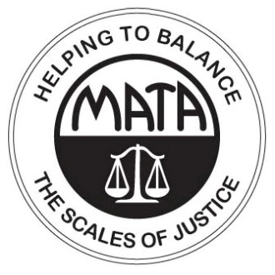 | SB 592  VOTE NO  Protect Whistleblowers
MO Constitution  Article I Sec. 14  That the courts of justice shall be open to every person, and certain remedy afforded for every injury to person, property or character, and that right and justice shall be administered without sale, denial or delay.  US Constitution  7th Amendment  In suits at common law where the value in controversy shall exceed twenty dollars, the right of trial by jury shall be preserved, and no fact tried by a jury shall be otherwise re-examined in any court of the United States, than according to the rules of common law. | What is a Whistleblower?  Whistleblowers are employees who report illegal conduct to their supervisors or public authorities, or who refuse to break the law.  Current Missouri law makes it illegal to fire an employee because he or she blows the whistle.  Protecting Whistleblowers is About Respect  Respect Employees:  - Employees should be encouraged to report wrongdoing.  - If the employer retaliates, the employee should be protected.  Respect Business:  - Protecting whistleblowers ensures an even playing field for all businesses.  - The business community is disrupted and the economy is harmed when bad actors are not found and stopped.  This bill severely weakens the protections provided to Missouri whistleblowers:  - Whistleblowers who report illegal conduct to a boss or supervisor will have NO protection if they are fired. This is the most common type of whistleblower – loyal employees who want their company to do the right thing.  - The protection for whistleblowers will only be there if the employee is right about whether the conduct is illegal. There is no protection for conduct that is immoral but doesn’t break any laws. There is no protection for conduct that only LOOKS illegal.  - Compensatory and punitive damages are severely limited. Corporate misconduct and public corruption will only stop when there are REAL sanctions. Punitive damages send an important message that protects the health and safety of the public. Putting limits on damages turns firing whistleblowers into part of the cost of doing business!  Protection for Whistleblowers is  Protection for All of Us!
Missouri Association of Trial Attorneys ~ 573.635.5215 ~ www.matanet.org ~ sharonjones@socket.net

