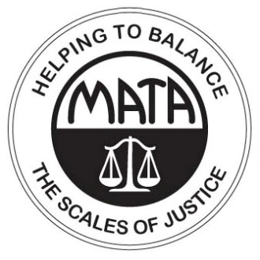 | SB 592  VOTE NO  STOP ABUSIVE WORKPLACES
MO Constitution  Article I Sec. 14  That the courts of justice shall be open to every person, and certain remedy afforded for every injury to person, property or character, and that right and justice shall be administered without sale, denial or delay.  US Constitution  7th Amendment  In suits at common law where the value in controversy shall exceed twenty dollars, the right of trial by jury shall be preserved, and no fact tried by a jury shall be otherwise re-examined in any court of the United States, than according to the rules of common law. | What is the current law on employment discrimination?  Current law prohibits employers from discriminating against employees because of their religion, race, color, national origin, sex, ancestry, age (between 40 and 70) or disability. In order to prove to a jury the discrimination occurred, the employee must prove the protected characteristic was a contributing cause of the firing or other negative employment decision. The employee can hold both the company and the individual who actually did the discriminating accountable.  What happens when an employer discriminates against an employee?  Employees who feel discrimination occurred can file a complaint with the Missouri Human Rights Commission. After an investigation the commission will either take disciplinary action or will provide the employee with a “Right to Sue” letter allowing the employee to take the issue to a jury.  How would this bill affect employees who have been mistreated by their employer?  This bill would prevent the employee from holding the person who discriminated against him accountable. Changing Missouri law in this way means the company itself is required to take the full blame for the discrimination without exposing the individual who actually discriminated.  In addition, the bill places limits on the amount the employee is able to recover. Limits allow the employer to calculate the exact cost of discrimination and get away without any real consequence.  This bill allows employers to discriminate against people because of their beliefs, race or gender and avoid responsibility by pointing to any other potential reason for the employment decision
Missouri Association of Trial Attorneys ~ 573.635.5215 ~ www.matanet.org ~ sharonjones@socket.net

