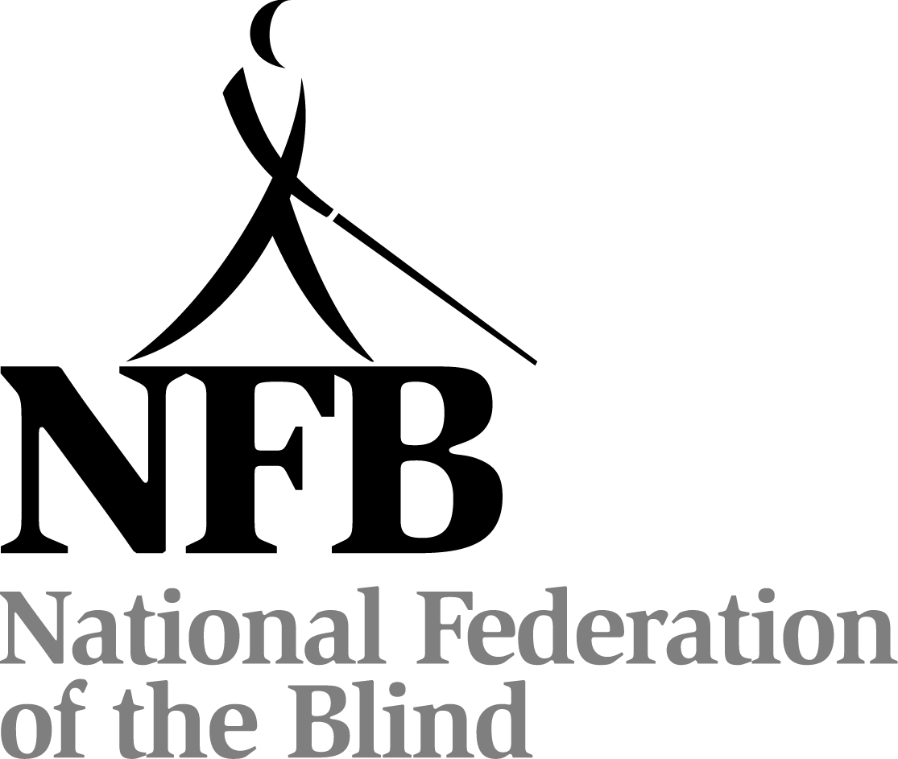

FIFTIETH ANNUAL CONVENTION

NATIONAL FEDERATION OF THE BLIND
OF MISSOURI

March 29 through April 1, 2012

The Holiday Inn Coco Key
Kansas City, Missouri
PLEDGE OF THE
NATIONAL FEDERATION OF THE BLIND

I pledge to participate actively in the effort of the National Federation of the Blind to achieve equality, opportunity, and security for the blind: to support the policies and programs of the Federation and to abide by its Constitution.
The Kansas City Chapter welcomes everyone to our affiliate's founding city where we plan to make this the best convention ever held by the National Federation of the Blind of Missouri.

We in Kansas City are known for our livestock, our barbecue, our pioneering spirit, and our midwestern culture. We love our jazz and even our professional sports teams, though sometimes we cheer for what has been in the past and what we hope to see in the future. Of all that we have to give, the most important is our hospitality. You won't find friendlier people anywhere, and especially is this true in the members of our chapter who are honored to host our fiftieth anniversary of the National Federation of the Blind of Missouri.

Members of our Kansas City Chapter cordially invite you to drop by Hospitality in Room 1510 which will be open from 5:30 PM to 10:00 PM Friday evening.

The Trade Winds Restaurant, the Marketplace, and the Gator's Grab and Go should afford all the variety any palate could desire. There are also food establishments within walking distance for independent Federationists who like a little time on their feet.

This year's hotel convention room rates are $75 for singles, doubles, triples, and quads. However, the hotel is not obligated to honor these rates if proof of registration for the convention is not available when you check out.

The check-out time for the hotel on Sunday is at 12:00 noon. Those who can check-out prior to the morning session will help us avoid congestion at the front desk upon adjournment.

Registration will be held Friday evening in the foyer next to the ball rooms from 5:30 PM until 7:30 PM and again on Saturday morning from 8:00 AM to 9:00 AM. Registration at the convention will cost $18 per person and banquet tickets will cost $30. Please register so you will be eligible for door prizes and other convention activities. Even if you have pre-registered, you should come to this area to pick up your registration packet. Also remember to check out the exhibits which will be near the registration table.

This year's luncheon on Saturday will be at noon in ballrooms A, B, and C. Tickets are $15 and may be purchased at the registration table as long as they last. Special attention is called to the luncheon since the number of attendees is the figure the hotel will need first.

A prayer breakfast, led by the Missouri Association of Blind Students, will be held on Sunday morning at 7:00 AM in Ballrooms A, B, and C.

Door prizes will be given throughout the convention, and each chapter is encouraged to bring their donations to the Kansas City Chapter table in the exhibit area. You must be in the room or must be working on convention business to win.

The general sessions on Saturday and Sunday will be held in Ballroom D. The reception and banquet will be held in Ballrooms A, B, and C. All Federation meetings and convention events are smoke free.
FRIDAY, March 30

9:00 AM The Missouri Association of Blind Students Seminar, Shirley Grauel, President
Ballroom A

9:00 AM Seminar for Parents of Blind Children, Debbie Wunder,
Chairman
Ballroom C

1:00 PM Diabetes Action Seminar, Ruby Polk, State Representative for
the Diabetes Division of the NFB of Missouri
Ballroom B

3:00 PM NFB of Missouri Board Meeting
Ballroom B

5:05 PM Scholarship Committee meeting, Shelia Wright, Chairman
Ballroom A, B, and C

6:00 PM Missouri Association of Blind Merchants, Sam Neal, President
Ballroom C

6:00 PM Dog Guide Division, Stephanie McDowell, Chairman
Ballroom A

7:00 PM Membership Committee, Debbie Wunder, Chair
Ballroom B

8:00 PM Resolutions Committee, Dacia Luck, Chair
Ballroom C

9:00 PM Ways and Means Committee, Gene Fleeman, Chair
Ballroom A

9:00 PM Blind Students Committee, Shirley Grauel, Chair
Ballroom B

10:00 PM Nominating Committee, Shelia Wright, Chair
Room to be announced by the Chair
SATURDAY, March 31

6:30 AM Scholarship Breakfast (Scholarship Recipients and committee
members), Shelia Wright, Chair
Board Room

MORNING Session

8:15 AM Call to order
Ballroom D

8:20 AM Welcome from the Kansas City Chapter, Shelia Wright,
President, National Federation of the Blind of Kansas City

8:30 AM Welcome from the Mayor of Kansas City, Sylvester (Sly) James

8:40 AM Introduction of scholarship winners, Shelia Wright

8:45 AM Making a Joyful Noise: our history captured in song, the Joyful
Noise Choir directed by Sandy Halverson

9:00 AM Report of the Nominating Committee, Shelia Wright, Chair

9:05 AM Changing What It Means to be Blind: a report from our national
Representative, Dr. Marc Maurer, President, National Federation of the Blind

9:45 AM Questions from the floor

9:50 AM Ten minute break

10:00 AM Guys and Dolls: Fashion and Faus, Julie McGinnity, Shirley
Grauel, Julie Salih, Debbie Wunder, and Dacia Luck

10:30 AM Presidential report, Gary Wunder

11:00 AM I Am Blind and I Am Confident: Finding Independence Through
the National Federation of the Blind, Roman Solano

11:10 AM Fifty Years of History, a Foundation for What We Are Today,
Dan Keller, Moderator; Martha Kelly; Gene Coulter;
Tom Stevens; and Gary Wunder

11:40 AM Resolutions and Constitutional Amendments, Dacia Luck, Chair

12:00 PM Adjourn

1:30 PM Crowning of the King and Queen, Gene Fleeman, Chairman,
Ways and Means Committee

1:40 PM The Wolfner Library: In Your Mailbox, In Your Computer, and
Helping You With All Your Reading Needs, Richard Smith, Director

2:00 PM Questions from the floor

2:05 PM Vocational Rehabilitation: Employment Is What Butters Our
Bread, Mark Laird, Director, Rehabilitation Services for the Blind

2:30 PM Questions from the floor

2:40 PM Dog, Cane, and Gadget: the Blind Person's Path to Mobility
Julie McGinnity, Moderator; Debbie Wunder; and Dacia Luck

3:00 PM But How Will That Help Her See, Kelly Newsom, Teacher of
Tomorrow

3:10 PM Seventh Inning Stretch

3:20 PM Braille: How, Now, and Wow, A Surprise Presenter

3:30 PM Living With Diabetes: Something Almost All of Us Will Need to
Know How to Do, Mike Freeman, President, Diabetes Action Network

3:50 PM The NFB Updates Our Songs: the Contest, Dan Keller, Moderator and Contestant

4:20 PM Becoming All I Can Be: a Report From the Colorado Center
for the Blind

4:40 PM Washington Seminar: a First-Timer’s Perspective, Halley Korff and Bethany Bennington

5:00 PM Adjourn

6:00 PM Cash bar prior to banquet
Ballrooms A, B, and C

6:30 PM Banquet of the National Federation of the Blind of Missouri,
Shelia Wright, Mistress of Ceremonies
Ballrooms A, B, and C

Invocation

Crowning of the King and Queen

Introduction of Guests

Presentation of Awards

Other Business at the direction of the Mistress of Ceremonies

Banquet Address: Marc Maurer, President, National Federation of the Blind

Auction by the Ways and Means Committee, Gene Fleeman, Chairman

9:00 PM Dance to the Music; Presented by the Kansas City Chapter (If dancing isn't for you, just sit back and enjoy the music, visit with old friends, and get to know someone new.)

Sunday, April 1

7:00 AM Prayer Breakfast hosted by the Missouri Association of Blind Students
Ballrooms A, B, and C

8:30 AM Call to Order

8:35 AM Whozit That Serves, Darian Smith and Chris Parsons

8:55 AM Report of the Audit Committee, Dan Flasar, Chair

9:20 AM Reading of the Treasurer's Report, Carol Coulter, Treasurer

9:35 AM Governmental Affairs Report, Shelia Wright, Chairman

9:50 AM A report from our Ways and Means Committee, Gene Fleeman,
Chairman

10:00 AM Membership Report, Debbie Wunder, Chairman

10:10 AM Elections

10:40 AM Resolutions and Constitutional Amendments continued, Dacia Luck, Chairman

11:00 AM Plans for our newest division

11:10 AM Singing the standards: Song leader to be announced

11:40 AM Old Business

11:50 AM New business: Appropriation of Funds to tenBroek, the national treasury, national convention stipend
Matters Presented from the Floor

12:00 PM Adjourn

