
The Blind Missourian
May 2012


.

National Federation of the Blind
Of Missouri

“Striving to achieve Equality, Opportunity, and Security for the Blind”

2012 National Federation of the Blind of Missouri’s 50th State Convention 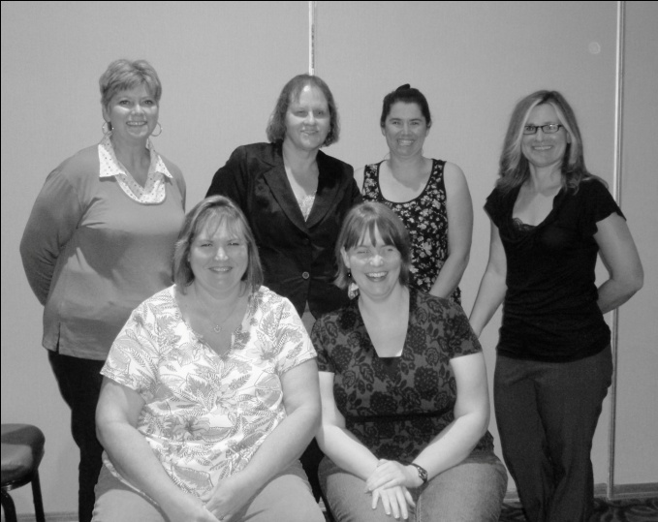 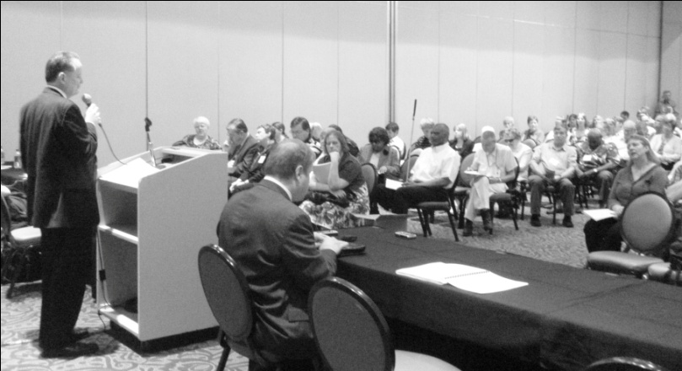
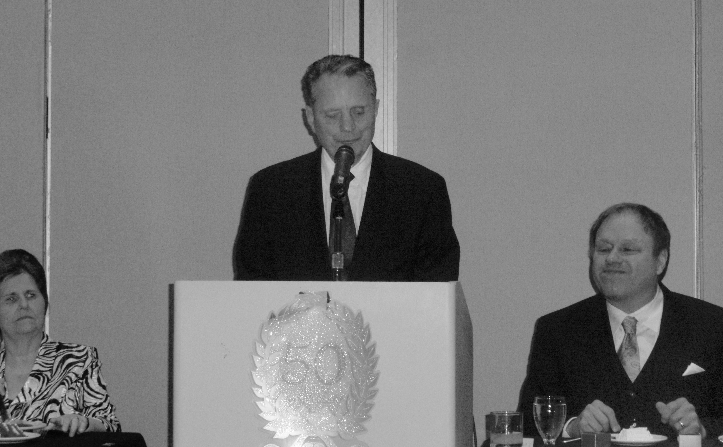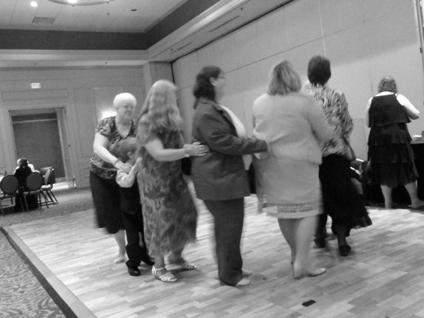
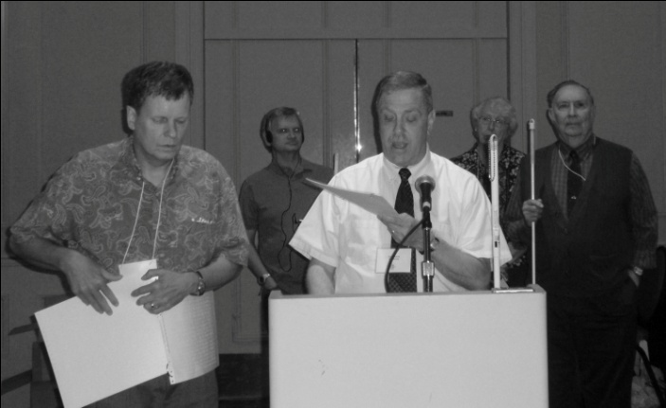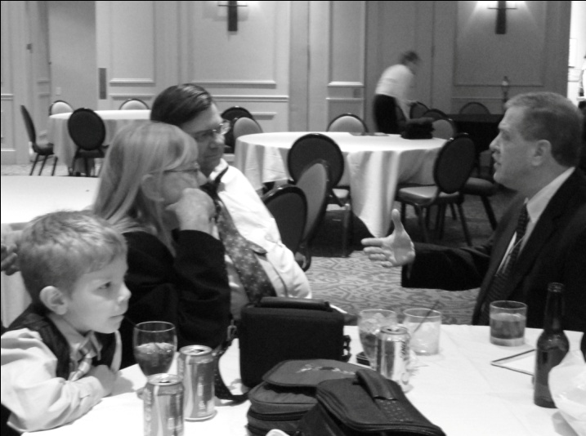

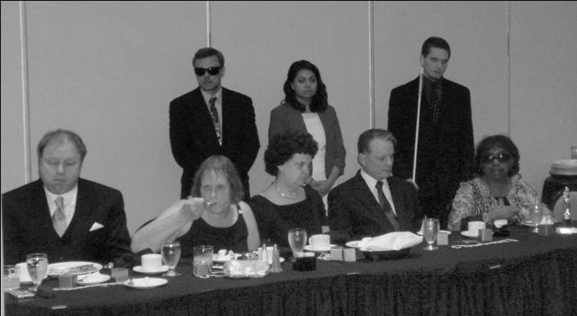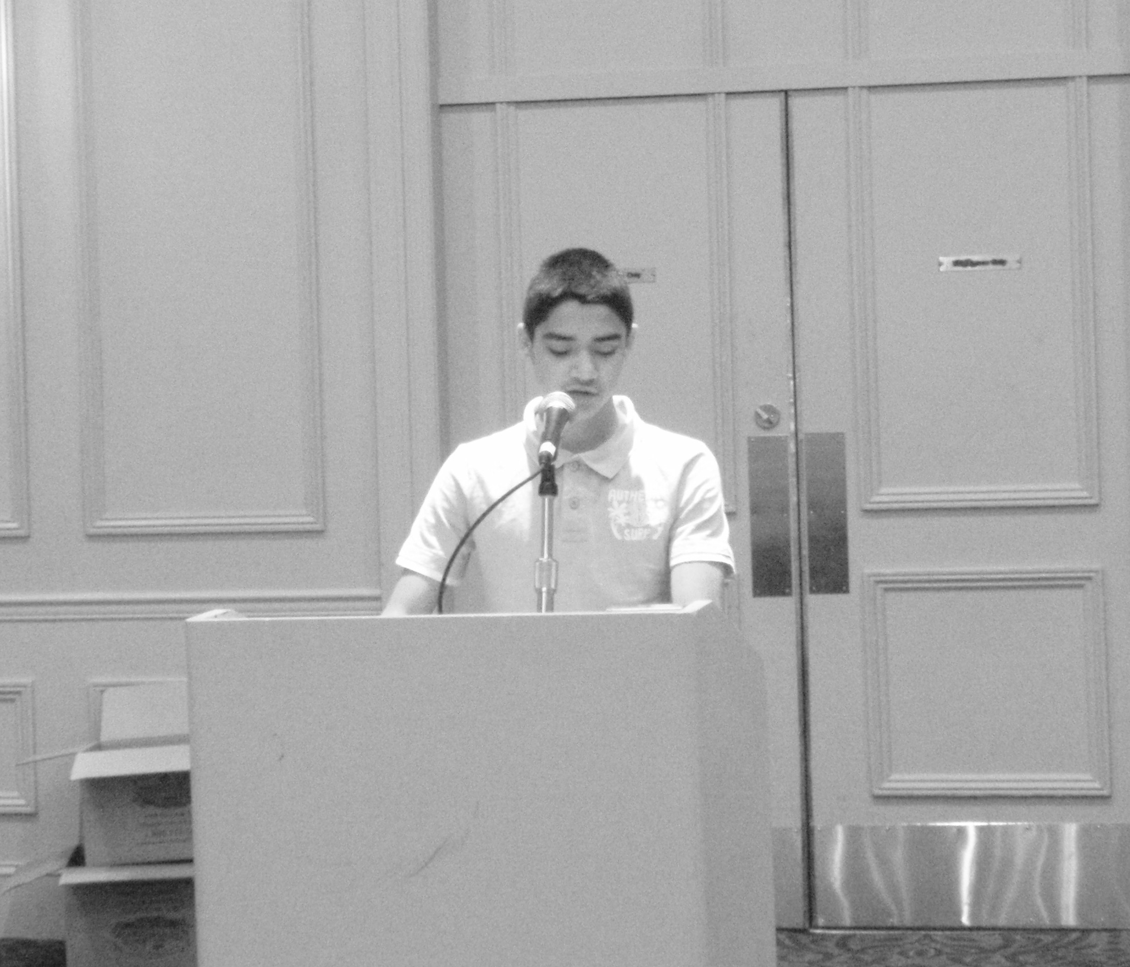

Table of Contents

Presidential Report by Gary Wunder 1
2012 State Convention Resolutions 6
Closing the Gap: The Blind Task Force by Julie Salih 14
50 Years: A History by Dan Keller, Dick Morris
Eugene Coulter, and Tom Stevens 16
Lieutenant Colonel Charles T. Stevens by Carol Coulter 25
Gary Wunder by Carol Coulter 27
Of Wolves and Buzzards by Tom Stevens 29
Mission Believe 31
Mission Believe Application 32
A Heart Felt Thank you by Dan Flasar 34
A New Look By Carol Coulter 35

Presidential Report
March 31, 2012
Last year was one of the most exciting in recent history with the cases, the legislation, and the outreach we did. When I look at the mid-year point between conventions, I'm sometimes afraid there won't be much to report. Somehow my fear of having nothing to say and this report being 3 minutes or less never turns out to be justified, and there's always a flurry of activity that makes each year difficult to pack into 20 or 30 minutes.
Let me start this morning with a heartfelt acknowledgement. We have in this room a number of new people: new to the organization, new friends, and most are newer to the world than some of us. I'm talking, of course, about our students and their desire to move from being a committee to a division in our organization. While no one person ever deserves all the credit, often one person does deserve the bulk of it. The reason we have so many students with us today is Shirley Grauel. Her work today is the culmination of two years of late-night early-morning e-mails, several trips, and a bunch of conference calls, but what a seminar we had yesterday, and what a future our new division will have. Thank you so much my friend for giving us this gift. Shirley's e-mail signature line is "Smile, it will make people wonder what you're up to." Well today we're smiling, but no one's guessing why, and everyone knows who has given us reason to smile.
One of the most moving presentations on our 2011 agenda was made by Kirk Ford, the blind father we were in the process of helping to gain custody rights so he could visit his children. Because Kirk is blind, he had visitation rights with his daughter but was court ordered to avoid specific street crossings while in her company; these were deemed by the judge to be unsafe for the blind or at least for a blind man with a child. Kirk could see his younger son only when someone sighted was present to supervise the visit. The order made it clear that a blind man could not competently care for a toddler.
When we were asked to help, this was the way things stood. To reopen the case we had to pay Kirk's portion of the fee due the Guardian ad Litem, his lawyer fees, and his court costs. This we did with a $5,000 grant from our national treasury, the affiliate making up the remainder.
Kirk Ford now has full visitation rights with his children; there are no limitations on where he may take them; there is no requirement that someone with sight supervise his visits; there are no restrictions in the final order that have anything to do with Kirk's being blind, and this is due to people like you who care enough to pledge your money, your time, and your heart to the National Federation of the Blind and to this young father.
At last year's convention we talked a lot about Baby Mikaela and her parents Blake and Erika. They came to tell their story and to say thank you for the legal battle we waged on their behalf, but the battle wasn't over. No less than five bills were introduced into the Missouri General Assembly seeking to prevent this kind of behavior by Children's Services from happening again. The legislation passed and was signed by Governor Jay Nixon. According to the statute, blindness can no longer be used as a reason to take children from their blind parents. As Dan Keller reminds us, the passage of the Model White Cane Law did not mean that all kinds of rights began falling from the sky. What happened to this family will likely happen again to someone else, but now we have more tools at hand to combat it; maybe the next time we won't be talking about 57 days but 57 hours or, better yet, 57 minutes.
Last year the state legislature passed a bill which, if enacted, would have dramatically changed civil rights protections for blind employees. In order to win a complaint of discrimination based on blindness, the plaintiff would have to show that blindness was the sole reason for dismissal. To make it even more difficult, he would also have to show that it was the intent of the employer to discriminate. I have read that proving discrimination based on disability is so hard that 96 percent of the cases that make it to court result in a verdict in favor of the employer, but this bill was advertised as one that would make Missouri more business friendly. Those even more in favor of its passage said it would make Missouri less hostile to business.
We opposed the legislation and Governor Nixon vetoed the act. He asked for public support to help in sustaining the veto, and we turned out in numbers large enough that he took notice. Legislation almost identical to that vetoed last year has again been passed, and the governor intends to use his power to stop it. The question will be whether there are enough members in the House and Senate who agree with the Governor and sustain his veto.
Just over a month ago we held our annual Jefferson City Seminar. We prepared a fact sheet before the event, but no sooner had we assembled that document than another issue surfaced that soon became a primary talking point for us and for the legislators we met. The issue was medical care for the blind, specifically the medical care that has been associated with receipt of the Blind Pension since 1967. A legislative subcommittee forced a vote without debate on a proposal to take money now being used to fund medical care and transfer it to higher education. The reaction of the general assembly was shock, anger, and a commitment to stand with us. But, as the tactics of the subcommittee faded in the memory of the House of Representatives, having $28 million for higher education became ever more attractive. About 2,800 blind people receive medical care through this program; if this money is routed to higher education, a number of larger constituencies would be pleased: students, faculty, staff, and parents would all appreciate stable funding which this proposal would afford to institutions of higher learning.
On March 20 the House of Representatives entertained a motion for the adoption of this transfer. One amendment among several that had been prepared was offered. It died by a vote of 102 to 49 and the bill was recommended to the full House for passage. They approved it two days later.
The Senate had initially been even more adamant than the House in its denunciation of what it characterized as the irresponsible House committee proposal, but now that the bill has been sent to the Senate, there is no longer the unequivocal commitment to the blind and the assurance that the Senate is a more deliberative body. The President Pro Tem, who once said this proposal would go nowhere in the Senate, now says that any proposal by the House must be carefully considered. Many in his body think there is merit in it because the blind people who get this medical care would not otherwise qualify for Medicaid, and that there is nothing from the House that is off the table for consideration by the Senate.
There are many things wrong with this proposal, but the most glaring is that it stands to radically change health coverage without warning to people who have relied on it all their lives. Nobody knows how many people receiving this benefit will qualify for Medicare or how much out of pocket expense they will incur even if they are covered. No one knows how many, who will not qualify for Medicare, will be unable to get insurance because of pre-existing conditions. No one in the House or Senate has yet demonstrated they are bothered by the hypocrisy of claiming that the Affordable Care Act or Obama Care will require insurance companies to accept people with pre-existing conditions, all the while knowing that these provisions of the new law do not take effect until 2014, that the law is being challenged in the Supreme Court, and that the Republican controlled House has pledged to overturn it if they are able to take the United States Senate. It is disingenuous to tout the promises of the Act as a substitute for what blind people have now, while simultaneously railing against it and working for its defeat.
How this battle will come out is anybody's guess, but we have much to be proud of regardless the outcome. We have put more feet on the ground than any other organization at the Governor's rally; the majority of the written testimony that has been used came from you; the points that are made in the petition now circulating on the web and on paper came from us, and we have garnered the majority of the press. Although we have lead, we have also coordinated. We have never put promotion of our organization over the cause at hand, and we have shown state lawmakers that they cannot use the lack of unity among the blind on this issue.
I said we went to the legislature with other issues. Promoting our blindness skills program was prominent on our agenda, trying to preserve what we have in these difficult economic times. Following the dictates of the convention, we acted on a resolution and got a bill introduced that, when passed, will mandate the use of accessible voting machines in all elections and not just in those involving federal contests. We have again sought the introduction of legislation to change Missouri law to conform to the federal act for the procurement of textbooks for elementary and secondary students. Please join me in thanking all who attended this seminar and who have subsequently written, called, and have worked so hard to advance our legislative agenda.
Four people went to the Washington Seminar with assistance from the Affiliate. They were Dan Flasar, Gene Fleeman, Roger Hanger, and Debbie Wunder. We were also joined by our teacher of tomorrow from Missouri, Kelly Newsom. Because of the college leadership program sponsored by the NFB, we were also joined by Halley Korff and Bethany Bennington. All added to the diversity of the delegation we brought, and each person made immeasurable contributions to our presentations.
The work to get a law requiring home appliances to be constructed in such a way that they can be used non-visually has gotten support from an unlikely quarter, with my current representative, Blaine Luetkemeyer, working with us in hopes of becoming the lead Republican sponsor in the House. President Maurer has already given us details about this and other national legislation, but I want to say a big thanks to the people who went to DC on our behalf and ask that you join me in appreciating their sacrifice.
Although we didn't mention her in the history of our cases, some of you will know the name Chastity Jackson. When she wanted to attend the summer program at the Colorado Center for the Blind, we worked to convince her school district that this training was something they should fund. She has since graduated from high school and college and has been an on again off again member, committed at some level to our philosophy, but not engaged in actively sharing and implementing it. Several months ago she came to us with a request for help. Chastity wants to be a vendor but was initially denied entrance into the program because of a less than desired credit score. We decided to help because we believe rehabilitation should not be conditioned on a credit score, that rehabilitation can and should include financial management for people who need it, and because we believe that we need blind people who work and the business enterprise program needs managers.
Some of our fights with Rehabilitation Services for the Blind are legendary, but under the leadership of Mark Laird, we often find that our differences need not divide us; instead they give us a chance to prove that people of good will, imagination, and some creativity can sit at a table and develop a solution based on service and a belief in blind people. Chastity is scheduled for vending training, and I hope one day she becomes one of those rich vendors who make so much that she won't begin to qualify for the blind pension and won't have to worry about her medical care.
In January we once again honored our Braille Readers are Leaders at the Missouri School for the Blind. Stephanie McDowell was once again the coordinator for this event, and she reports that the students loved the recognition, loved their Braille, and loved to meet capable blind people who have gone beyond school to have meaningful lives and careers. Thank you to Stephanie and to all who helped her in representing us so well at the school.
This year we concentrated on building our membership. The work of the student committee, soon to be a division, is much in evidence today. The Springfield Chapter can boast twice as many members as last year at this time, and all of our other chapters have seen increases. What we have done is not enough but it is progress--slow but forward progress toward sustaining our organization and ensuring it is here for the generations who need it now and who will need it in the future.
Dan Keller told us he believes there will always be a need for the Federation, for while the struggles look different on the outside, at their heart they are all the same. Are blind people so abnormal that we should be grateful for whatever we get, so broken that anything that comes to us must spring from pity and charity, or are we full human beings with brains, motivation, and a focus to achieve? How you feel about that question is why you are in this room today. The fact that there are so many who do not regard us as full human beings is also why you are here. Unlike other organizations of the blind throughout history, we are not here to commiserate and complain among ourselves. We are here because we believe as much in the unbelievers as we do in ourselves. We believe in their goodwill, their capacity to learn, their eagerness to embrace people who possess confidence and competence. We believe in the transformative power of the human spirit and the human mind to overcome almost any problem we can define, and we believe in the soul from which this eternal hope springs.
This weekend we celebrate a number, the number fifty, but Monday brings all the challenges of today and many we cannot conceive of that will occupy our tomorrows. Just as we have pledged to pay back those who have given us so much we enjoy today, we honor a more sacred pledge -- to pay it forward so that people we know, many we do not, and undoubtedly some who don't yet exist, will not only have a life but a life worth living.
What we do in the coming year and in the next decade will determine whether we live our lives as free people: educated, integrated, and playing vital roles in our community, or whether we fall behind, a causality of the digital divide and a visual paradigm. I believe the decision our country will make rests with us, and though this places tremendous responsibilities on us as advocates and active American citizens, there is no one I trust more than the National Federation of the Blind to carve out that future. With the love, energy and commitment we share, there is nothing we cannot do.

RESOLUTIONS
By Dacia Luck
There were a total of nine resolutions brought before the convention, and all nine passed. I would like to thank my committee for working on them with me as well as everyone who submitted a resolution.
The first resolution is about defining Rittgers convention fund standards and it was submitted by Gene Coulter.
The second resolution is regarding medical services for blind persons and the cuts the Missouri House has made. This resolution was also submitted by Gene Coulter.
The third resolution deals with accessible voting and the right for blind persons to have a secret ballot in all elections. This resolution was also submitted by Gene coulter.
The fourth resolution is regarding how RSB distributes referrals when it comes to providing vendors for their clients. This resolution was submitted by Bryan Schulz.
The fifth resolution is a resolution commending our state president Gary Wunder for all his years of service to the affiliate. This resolution was submitted by Tom Stevens.
The sixth resolution is a resolution commending our National President, Dr. Marc Maurer for all his wonderful years of service. This resolution was submitted by Tom Stevens.
The seventh resolution is a resolution commending Penn Valley Community College’s Disability Access Office for their work they do with blind students. This resolution was submitted by Diana Aubuchon.
The eighth resolution is regarding the Business Enterprise Program, (BEP) and providing jobs and training for blind persons. This resolution was submitted by Tom Stevens.
The ninth and final resolution is regarding how RSB handles subcontracting BEP locations. This resolution was submitted by Tom Stevens.
All nine resolutions are printed below.

Resolution 2012-01
Defining Rittgers Convention Fund Standards

WHEREAS, in 1961 Gwen and George Rittgers lead in the efforts to establish the new state affiliate of the National Federation of the Blind, with George serving as our first president; and

WHEREAS, under their leadership this affiliate flourished and grew throughout the state, becoming a vital voice for blind persons in Missouri; and

WHEREAS, before her death, Gwen contributed the seed money for a convention fund to help first timers get to the convention, as well as helping those who needed assistance if sufficient funds were available, after priority was given to first timers; and

WHEREAS, it was anticipated that local chapters would contribute to the fund to make it self-perpetuating so that maximum participation at our conventions would be realized: Now, therefore,

BE IT RESOLVED by the National Federation of the Blind of Missouri in Convention assembled this 31st day of March, 2012, in the city of Kansas City, Missouri, that each chapter be encouraged to donate at least $50.00 per year to the George and Gwen Rittgers Convention Fund; and

BE IT FURTHER RESOLVED that the following standards be adopted to replace the standards adopted in 1989 for allocating funds from the fund:

1. The state board will allocate the maximum amount to be used from the fund by January 31 of each year.

2. An individual application must be made 30 days before the beginning of convention by the person requesting the funds, or by their chapter president, which explains the reason for the request.

3. It is not intended that these funds pay the entire cost of convention attendance and the committee is only to allocate funds based on need and will not use the entire allocated amount unless recipients needs justify it.

4. The State President may authorize funding after the deadline in extraordinary circumstances if funds remain in the allocation.

5. Whenever practical, funds will be directly paid either to cover hotel costs or convention registration and meals.

6. New or perspective members will be given highest priority in their request.

7. Persons who have previously attended a Missouri convention will then be given consideration.

8. No person shall receive funds a second or subsequent time unless they experience an unexpected financial crisis that would otherwise prevent their attendance.

Resolution 2012-02
Regarding Medical Services to Blind Persons

WHEREAS, the Missouri House of Representatives has slashed funding for medical services for blind persons; and

WHEREAS, this cut would be catastrophic to blind persons, causing great financial hardship and resulting in many persons having to be placed in assisted living; and

WHEREAS, for almost 50 years both Democratic and Republican controlled General Assemblies have appropriated this funding both in good times and in lean times; and

WHEREAS, the Missouri State Senate is now considering the state budget after which both the House and Senate will vote on the final budget presented by the Conference Committee: Now, therefore,

BE IT RESOLVED by the National Federation of the Blind of Missouri in Convention assembled this 31st day of March, 2012, in the city of Kansas City, Missouri, that we urge the Senate to restore full funding for medical services for the blind; and

BE IT FURTHER RESOLVED that we urge the entire General Assembly to pass a final budget containing full funding for this vital program.

Resolution 2012-03
Regarding Accessible Voting

WHEREAS, the Help America Vote Act (HAVA) has made it possible for blind persons to cast a secret ballot for the first time in history in national elections; and

WHEREAS, all election jurisdictions are required to have voting machines that are accessible to the blind for these elections; and

WHEREAS, currently these same jurisdictions do not use this equipment for other elections, therefore depriving blind people of their sacred right to a secret ballot; and

WHEREAS, most members of society would be appalled if they had to announce their vote to another person: Now, therefore,

BE IT RESOLVED by the National Federation of the Blind of Missouri in Convention assembled this 1st day of April, 2012, in the city of Kansas City, Missouri, that we call on the Missouri Legislature to pass H.B. 1901 which will ensure that blind persons will be able to cast a secret ballot in all elections, not just federal elections; and

BE IT FURTHER RESOLVED that this organization take whatever steps are required to make all elections accessible to the blind and provide us with a secret ballot.

Resolution 2012-04
Regarding Utilization of RSB Contractors

WHEREAS, the state of Missouri agency known as Rehabilitation Services for the Blind (RSB) has signed contracts with individual citizens or companies that provide instructional training such as Braille or adaptive computing skills for clients of the agency; and

WHEREAS, the client in need of learning new skills should have control of selecting which contracted vendor is assigned to provide the training under the term of client choice; and

WHEREAS, a client may not know the available contracted vendors and is basically picking a name out of a hat without any comment or guidance being offered by the client's counselor, and the chances of one specific vendor annually receiving at least 80% of all referrals distributed under this format would be highly unlikely; and

WHEREAS, one vendor currently does receive approximately 80% of the referrals; and

WHEREAS, Engineering contracts were set to expire in June of 2009 and to date, the contracts have continually been extended instead of allowing a promised rebid process and the vendors are not able to modify various contract terms or services provided: Now, therefore,

BE IT RESOLVED by the National Federation of the Blind of Missouri in Convention assembled this 31st day of March, 2012, in the city of Kansas City, Missouri, that this organization strongly urge RSB to more fairly distribute client referrals among all qualified vendors instead of heavily favoring one specific vendor; and

BE IT FURTHER RESOLVED that the organization urge RSB to allow contract modifications no later than two years after the date of the initial contract being authorized; and

BE IT FURTHER RESOLVED that the organization strongly encourages RSB to provide the client with vendor qualifications so the client can make an informed choice in vendor selection.

Resolution 2012-05
Regarding Commending President Gary Wunder for his Exemplary Service by the Governor of the Great State of Missouri

WHEREAS, Gary Wunder has led the NFB of Missouri as president for more than 25 years; and

WHEREAS, his superlative leadership has done much to enhance the lives of the blind of Missouri; and

WHEREAS, this state has become one of the foremost states in our great union; and

WHEREAS, singular credit should be given to this extremely effective and successful leader: Now, therefore,

BE IT RESOLVED by the National Federation of the Blind of Missouri in Convention assembled this 31st day of March, 2012, in the city of Kansas City, Missouri, that this organization urge very strongly a commendation to its President Gary Wunder by the Governor of the great state of Missouri.

Resolution 2012-06
Regarding Commending President Marc Maurer

WHEREAS, Dr. Marc Maurer has distinguished himself by singularly performing innumerable tasks on behalf of the blind of the United States; and

WHEREAS, he has also gained world-wide status; and

WHEREAS, this success is bringing much credit to the blind and recognition of their many talents and abilities: Now, therefore,

BE IT RESOLVED by the National Federation of the Blind of Missouri in Convention assembled this 31st day of March, 2012, in the city of Kansas City, Missouri, that President Dr. Marc Maurer is recommended for a special citation by the president of the United States.

Resolution 2012-07
Regarding Commending Penn Valley College

WHEREAS, the Metropolitan Community College system has five campuses serving over 18,000 students; and

WHEREAS, they offer small personal classes at each campus; and

WHEREAS, within each individual campus is an Access Office serving disabled students to various degrees; and

WHEREAS, each campus offers diversity, especially the Penn Valley Campus; and

WHEREAS, each access office has seen increased student usage, especially at the Penn Valley Campus; and

WHEREAS, the Penn Valley Access Office exceeds the services provided at all other campuses, growing to serve 325 students in 2004 to later serving 479 students in 2010; and

WHEREAS, the student population served by Penn Valley's Access Office has continued to increase, with unduplicated service of 543 students in 2009, 532 students in 2010, and 567 students in 2011, receiving specialized services; and

WHEREAS, the number of blind and visually impaired students served through the Penn Valley Access Office has increased to double or more than any other campus; and

WHEREAS, the current number of blind students served is 16; and

WHEREAS, one service agency refers their blind students to Penn Valley due to the services provided there as opposed to the other campuses: Now, therefore,

BE IT RESOLVED by the National Federation of the Blind of Missouri in Convention assembled this 1st day of April, 2012, in the city of Kansas City, Missouri, that the National Federation of the Blind of Missouri commends the services provided by the Penn Valley Access Office.

Resolution 2012-08
Regarding Business Enterprise Program and Work

WHEREAS, the Randolph-Sheppard Act makes it possible for blind persons to be trained for and employed in the management of small businesses; and

WHEREAS, the Business Enterprise Program (BEP) of Rehabilitation Services for the Blind (RSB) has gone for more than two (2) years without training of blind individuals to take responsibility in management of small businesses; and

WHEREAS, the existing program has shown a steady decline over several years in both the training and employment of blind persons; and

WHEREAS, more than ten (10) percent of BEP locations are currently being managed by sighted persons which in turn reduces employment opportunities for blind persons: Now, therefore,

BE IT RESOLVED by the National Federation of the Blind of Missouri in Convention assembled this 1st day of April, 2012, in the city of Kansas City, Missouri, that BEP and RSB immediately and dramatically reshape their priorities to fulfill their responsibilities within the Randolph-Sheppard Act.

Resolution 2012-09
Regarding subcontracting Business Enterprise Program (BEP) locations

WHEREAS, the Randolph-Sheppard Act envisions circumstances where
it is not possible for an entity such as the Business Enterprise Program (BEP) to
equip and manage a business location; and

WHEREAS, subcontracting of locations is a feasible option; and

WHEREAS, the BEP under Rehabilitation Services for the Blind (RSB) program is exhibiting a dramatic lack of initiative in this area: Now, therefore,

BE IT RESOLVED by the National Federation of the Blind of Missouri in
Convention assembled this 1st day of April, 2012, in the city of Kansas City, Missouri, that the BEP program under RSB, immediately take advantage of this opportunity in increasing measure.

CLOSING THE GAP: THE BLIND TASK FORCE
By Julie Salih
The Task Force on Blind Student Academic and Vocational Performance Blind Task Force held its most recent meeting on November 8, 2011 in Columbia, Missouri. It was my first meeting as a representative for the National Federation of the Blind. As an educator, and especially as someone who has been on both sides of the Special Education fence, it was exciting to be at this meeting to learn more about how to educate Missouri’s blind children. Special education and student performance have always been of interest to me.
I realized from the moment I walked in the room that I was by far the least experienced member of the Task Force. I say this not to self-deprecate, but rather to give an honest account of what I felt and saw. I thought I would be completely out of place. These teachers all worked in the Special Education field. They had been doing so for several years and held degrees in Special Education or a related discipline. I have a degree in Spanish. I have years of experience as a student in Special Education, and I have family members with disabilities who are working through the Special Education system. I have an education minor. I have a ton of empathy and understanding for students who struggle, who just don’t “get it” as fast as the other kids, or who are misunderstood as a result of their disabilities. But I wasn’t sure if experience, education, and empathy were going to be a long enough yardstick to measure up to the other teachers or allow me to be the advocate I was told I would have to be.
I decided that the best way to get myself out there was just to introduce myself to someone. I walked to the end of the long table and said hello to the woman sitting there. She was very friendly and I quickly learned that she is a teacher of the visually impaired in a school district in southern Missouri. We got to talking about the importance of Braille literacy and the way some students just fall through the cracks of the system because they are not encouraged to read Braille, or, even worse, discouraged from reading, period. We chatted about misconceptions of the blind and the far too many misguided educators who unintentionally enable blind students to be dependent on the sighted. During our conversation, I realized that maybe I wasn’t so out of place. Maybe I didn’t know as much about the legal side of Special Education as these people, but I sure had the passion and the desire to learn. I sure knew what the issues were. Now I just needed to be a part of the team to solve them.
The meeting began with a technology demonstration. A BrailleNote Apex, Bookport Plus, and Focus40 Braille display took the stage to show off the advances in technology that have made note-taking easier for students and allowed them to gather important information in classes without having to rely on a sighted peer, or worse, completely miss relevant information. We discussed how each note-taker works, as well as the advantages and disadvantages of each. As a partially blind person who does not use any of the technology that was demonstrated, I still found it beneficial to know the basic idea of how these things work. As a teacher, you never quite know the difference you make to your students or the impact your words and actions have on their lives. But knowing your students’ needs is paramount to being successful, and having a basic idea of how they do something such as take notes can help to build rapport with them.
In spite of the advances in technology, the resounding chorus of the meeting seemed to be that blind students in Missouri are not performing well on standardized tests. Lack of funding has made it nearly impossible for some students to receive orientation and mobility training until middle or high school. This is outrageous. Stephen Barr, the representative from the Department of Elementary and Secondary Education (DESE) gave a report on the annual yearly progress of students. His report consisted of many statistics, which pertained to the percentage of students in Special Education who graduate from high school with a regular diploma, the percentage who are competitively employed, and the percentage of children ages three thru five who are receiving the majority of their Special Education services within the regular classroom. The exact numbers are unknown, and, honestly, if I wrote out the exact numbers or even the statistics, someone might decide that going to the dentist is more fun than reading this article.
The point is this. There is a gap between student knowledge and student performance. At our last meeting, the Task Force restructured committees to discover where the gap lies and more importantly, why it exists. We want to educate about what services are available to blind students and encourage teachers to learn about them. We want to teach teachers how to be advocates for their blind students. We also want to reach out to parents, to be a resource and guide for them as they help their children get an education. The Children’s Vision Summit is one way we do this. We are working on planning the Summit for the spring of 2013. Details are in the making, and there is nothing definite to be said yet. But we do all this with one thing in mind: we want to be witnesses to student success. We work to see that the blind have equal opportunity for quality education just as the sighted. We want to see the gap close.

50 Years: A History
By Dan Keller, Dick Morris, Eugene Coulter, and Tom Stevens
Note: Martha Kelly also made a wonderful presentation as part of the panel presenting this topic but her remarks were not a part of this document. Hopefully her memories will be included in this or another issue of the Blind Missourian as she was the only person who was a part of both our first decade and 50th Anniversary.
Here is a summary of the presentation made on March 31, 2012 at our 50th Annual Convention in Kansas City. It has been submitted for two reasons. First, so there is a permanent record of our history and secondarily due to time constraints some items needed to be omitted from the discussion that day.
In the early twentieth century, the blind consumer movement was scattered and fragmented. Dr. Jacobus tenBroek had a vision for a nationwide consumer movement and brought representatives from seven states to Pennsylvania in 1940 to form the National Federation of the Blind. Missouri was one of those seven states.
Twenty years later however, all was not well. There were rumblings in the ranks. By 1957 a division began to form in the then Missouri Affiliate over the Blind Pension law, White Cane Week, vendor issues, and the national structure of the Federation . Then, in 1961, Alma Murphy, the president of the Missouri Federation of the Blind, was one of the dissenters who lead the formation of what became the American Council of the Blind.
But all was not lost in Missouri. George Rittgers, Gwen Phillips (later Rittgers), Cotton and Marie Busby, Jack and Martha Kelly, Bob Peterson, Ethel “Tiny” Beedle, and five more, all from Kansas City, did not side with the majority. George Rittgers vowed that there would definitely be a National Federation of the Blind in Missouri and here we are. Our first convention was held fifty years ago, November 16-18, 1962.
This is where we come in. We are the legacy of not only Jacobus tenBroek and Kenneth Jernigan, but also of George Rittgers and that group from Kansas City.
Now, even though there was still a National Federation of the Blind in Missouri, the battle was not over—not by a long shot. One of our first battles was over a very simple thing: our name.
The fledgling NFB of Missouri began with the name “Federated Blind” in 1961, but since the dissident group still had the name “Missouri Federation of the Blind” and protested any use of the name “Federation” or “Federated”, the affiliate was chartered under the name “Progressive Blind of Missouri” at the 1962 National Convention. That name was chosen by state president George Rittgers, but we still wanted our own name—the National Federation of the Blind.
A name change to "National Federation of the Blind (A Missouri Corporation)" was sought and initiated. In 1974, a will was probated which did not clarify the recipient sufficiently. The amount was split between the Missouri Federation of the Blind and the National Federation of the Blind (A Missouri Corporation). The basic amount was about $10,000.
The president of the Missouri Federation pledged that the NFB would never see a dollar of the will, causing a lawsuit to be initiated, claiming the full amount for the Missouri Federation of the Blind. The suit and its legal maneuvers carried on for approximately three years. John Dower, by then our state president, wrote a letter to the legal counsel for the NFB setting forth his thoughts in support of the right of the NFB to the funds and use of the name, “National Federation of the Blind”. During this time, the court decreed that we could not use the name "National Federation of the Blind." So, John decided to use "The National Blind" until the perplexing suit came to a conclusion.
To say the least, there was great joy and relief when the final decision came in favoring the National Federation of the Blind. Part of John's argument had been incorporated into the decision the judge wrote. We now reverted to being known by OUR name, National Federation of the Blind (A Missouri Corporation).
The suit greatly assisted the National Federation of the Blind, in that it set the legal precedent regarding our name. State affiliates across the nation began the administrative process of changing the name where it had not already been done. While several name disagreements have since arisen, the NFB has exclusive right to use the name and has stood very firm in this. Thus, the long and sometimes perplexing road to clarification and use of our name is concluded, and Missouri was a major factor in the arrival at a solution. Incidentally, the NFB now owns the name “Missouri Federation of the Blind”.
There was one more name change. In the 1980s, as the Missouri Federation of the Blind became the Missouri Council of the Blind, we finally changed our name to the National Federation of the Blind of Missouri.
Of course the battle for our name was only one of many battles through the years. Most of our battles have been situations in which we helped our blind brothers and sisters avoid discrimination in employment, gaining benefits to which they were entitled, or win the right to raise their own children.
- Virginia Reagan: hired as a schoolteacher in Thayer, Missouri, but denied employment when the school board realized she was blind and in a wheelchair. She was awarded back pay, but her poor health caused her to move to a convent and practice her religious faith by serving God instead of serving through his children.

- Nadine Rice: employed as a receptionist in St. Louis, but moved to a mailroom position as she began to lose her sight, despite the fact that her RSB evaluation said she could continue in her present position by using adaptive equipment and alternative techniques. We were able to keep her job, and when she finished her training, she was free to continue in her current job or seek other employment in the St. Louis city government.

- Grace Haner: employed as a nurse’s aide for twenty years. A new supervisor dismissed her, saying there was fear that she would harm patients even though she had never done so in her many years at the hospital. We helped her hire a first-rate lawyer, won the case, and she got about $30,000 as a settlement.

- Carol Coulter and Wilma Eide: both were initially denied daycare licenses by the Division of Family Services, and the licenses they were first given were conditioned on there always being someone with sight on the premises. After our intervention both women were offered licenses that had no such conditions and they have provided many years of childcare. Wilma's case was chronicled in a presidential report; Carol's was featured in a 1990 convention presentation and is found in the pages of the Braille Monitor article titled “Changing Diapers into Dollars.”

- Jim Moynihan: denied a promotion because he got a lower score than some of his colleagues; some cheating was found to occur; sighted applicants were given the choice of handwriting their answers for transcription by secretaries but Jim was only given the option of using a computer which did not play to his strengths. Jim's case went to the Equal Employment Opportunity Commission. He won, and was promoted to the rank of GS 13. Ironically, Jim was an investigator in Kansas City for the Office for Civil Rights.
- Gene Coulter: worked as a hospital unit clerk for the University of Missouri hospitals and clinics. When he requested accommodations in the form of a closed-circuit television, the hospital did not want to accommodate him based on the expense and the limited space afforded to hospital unit clerks. Gene was fired; we helped appeal that firing. While the case was on appeal, the University gave Gene a desk where he sat for eight hours a day for six months doing nothing as the grievance progressed. His termination was reversed, he was reinstated, and then, to show that he too could act arbitrarily and capriciously, he quit! His decision to leave the University helped to build the expertise that we now rely on for so many of our cases involving Social Security, the Blind Pension, and other complicated state and federal rules.

- Gary Owens: Gary lost enough vision that in 1991 he was terminated from his position with the 3M Company. He sought rehabilitation training and has since held a number of jobs. According to the Social Security Administration, in 1998 there was one month in which he was over the allowable limit to receive SSDI. They therefore alleged that he ceased to be eligible for payments as he was no longer disabled and demanded a payment of more than $132,000. We took his case and he paid not a dime to the Social Security Administration.

- Larry Murphy: relieved of his duties by the Buchanan County Highway Department because of his blindness. His termination came about when he applied for the position of foreman and his boss swore that there would be no blind foremen working in his highway department branch. Again we hired a first-rate lawyer and Larry and his family was awarded monetary damages in a six-figure amount.

- Baby Mikaela: when the Children's Division of the Department of Social Services found out that Mikaela’s parents, Blake Sennett and Erika Johnson, were blind, they removed the baby from their custody, alleging that they were unfit parents solely because of their blindness. We represented Blake and Erica, and just before their case was to go to hearing, the department caved.

- In the 1970’s the Blindness Teacher Certification Program at Mizzou allowed blind persons to get a degree but denied teaching certification to them. After intervention by Tom Stevens, this restriction was removed.

Some of our battles have been with the legislature, battles to either promote the passage of legislation that would benefit the blind of this state, or to prevent the passage of legislation that would harm the blind of this state:

- The White Cane law was passed in 1977 (SB10) allowing equal access to blind persons in all forms of public accommodation from renting apartments, using public transportation, and the use of dog guides some 13 years before The Americans with Disabilities Act.
- The Fraudulent Portrayal of Blindness Act established in 1978 that it is illegal to pretend to be blind for personal gain.

- Insurance regulation was updated removing blindness as a reason for denial of life insurance.

- The first ID bill removing age restriction was passed in 1979. Previously it had been a liquor ID card which a person could not apply for until after their 21st birthday. There have been at least 2 amendments since then to fine tune the law. One changed the card to look like a license, changing it to a Non-Driver’s License; the other required that it be renewed so it would have value as an ID. The second amendment was in response to our issue with Venture Stores refusing to accept the ID from blind persons wishing to pay by check.

- The Braille Bill was passed in 1990 mandating that Braille be taught in our schools.

- A Learners Permit bill allowing children of non-drivers to have designated persons ride with them became law in 1998 so that blind parents could make it possible for their sighted children to learn to drive.

- HB 401 creating the Blindness Taskforce and Blindness Skills Specialists went through in1999.

Sometimes we had battles with the state government and the state agency for the blind. Sometimes these were battles the public came to know about through vigorous publicity on our part; sometimes they were paperwork battles that meant everything in terms of our organizational survival.
- An early battle for our leadership was getting the coveted tax exempt status.

- The National Accreditation Council (NAC) was an agency in the 1970’s and 1980’s that accredited agencies serving the blind many of these were the worst of the agencies and their sheltered workshops were among those paying workers less than the minimum wage. The Missouri School for the Blind (MSB) was considering NAC accreditation in the early 1980’s which we opposed by our picketing of the State Board of Education and a visit to the MSB Board.

- We were foremost in insisting that Wolfner Library get an Advisory Committee, and in retaliation the NFB was not appointed to the committee when it was created.

- Later on Beth Eckles, who was a very popular librarian for Wolfner, was fired by Secretary of State Rebecca Cook even though the library was flourishing under her watch. We did our best to get her reinstated, even picketing the Secretary of State’s office, unfortunately to no avail.

- We filed a lawsuit against Rehabilitation Services for the Blind (RSB) over their refusal to distribute literature for organizations of the blind. A compromise was reached resulting in the current referral program.
There have been several TV shows and Movies portraying blindness in a poor light. “Mr. Magoo” in which we all remember him stumbling and bumbling through life. “Good and Evil” was another horrible show where a man named George is the lead character and happens to be blind. He represented the worst caricature of blindness television had known: loud, incompetent, klutzy, boorish, sexist, and completely unaware of the reactions of others around him. We don’t want to forget about “Blindness”, the movie in which the town went blind and then went crazy. We also need to mention “MacGyver”, in which actor Dana Elcar who was approaching blindness was incorporated into the show’s script, and portrayed blindness in a positive light. Mr. Elcar appeared at a National Convention.

Not all of our battles were with outside forces. Nick Whitney was our State Treasurer in the early 1980’s. A will from the estate of Nona P Moran had been intended for the National Body of the Federation, a fact made clear by the address used to designate the NFB as a recipient. The Affiliate had never done business at this address on Woodson Avenue in St. Louis, and the national office had done nationwide mailings for years using this address as the return. Mr. Whitney learned of the Will and both the board of the Affiliate, and Tom Stevens, as its President, had been content to let him handle the paperwork. We never asked to see the Will, and never suspected it could have been misdirected. National officers of the federation report asking Nick Whitney for copies of the Will, requests which he did not honor. The Will was obtained through a bank, or some other means, and the Missouri board was convened in Baltimore to determine whether we were willing conspirators in this fraud. The money remaining from the Will was turned over to the National Treasury and a grant of $7500 was made to the Affiliate so we might both honor our commitments and have enough seed money to invest in other programs and fund raising ventures. No demand was made on the Affiliate for money which had already been spent from this bequest. We were soon to learn that our treasury had other troubles which led to the removal of our treasurer and to his expulsion from the NFB of Missouri.

One of our members in St. Louis was working with a group, Midwest Enterprises for the Blind, to develop separate housing for the blind, something that is completely at odds with the NFB philosophy. The issue was taken up at the state level and discussed at the 1989 convention; the end result was that the St. Louis chapter took the necessary disciplinary action and expelled that member.

Even though we’ve listed our battles first in this review, we weren’t always fighting, despite what others may say. We were growing, adding new people, and adding new chapters. It began with Kansas City, 1961 then followed St. Louis, 1971, St. Joseph, and Columbia, 1974, Warrensburg, 1974, Kirksville, 1974, Springfield, 1977, Jackson County, 1979, Jefferson City, 1981, Gateway City 1983, Hannibal, 1990, South Central (Rolla/Salem), North Central (Chillicothe), Southeast (Cape Girardeau), Mississippi Triangle, 1992, Lewis and Clark, 2003.
Communication is also an important part of what we do. Communicating with the state legislature, as we’ve already discussed; communicating with the School for the Blind and local school districts on how best to educate their blind students; communicating with employers about blindness issues in the workplace; communicating with the general public about their perceptions of blindness; and communicating with each other about the movement are all vital to our organization’s continuing success.
We communicate with each other in many ways. Now we have cell phones, email, and email lists, text messaging, Facebook, and let’s not forget how much of the world is all atwitter about Twitter—all of these methods of communication were unheard of, probably not even thought of, in 1961. Back then we used mailings; Gary Wunder had a mailed presidential release in the 1980s. But for nearly fifty years, our main method of communication has been the Blind Missourian.
The Blind Missourian has played an important role in our ability to keep our membership and others informed about the issues concerning the blind along with what is happening across the state. There have been several different editors over the years; each one bringing their own style to the newsletter. Our editors have come from a variety of backgrounds bring different levels of expertise to the job but they have all had one thing in common and that is to produce a newsletter that is well written and informative. One that will help keep us all connected. The following people all had a hand in making the Blind Missourian what it is today; our editors were: Elsie White, Martha Kelley, Tom Stevens, Gary Wunder, Dottie Neely, Fred Wurtzel, Annette Grove, Patricia Morrow, and currently Carol Coulter.
Much of our communication with the general public has a twofold purpose: first, as we said, to change their perceptions about blindness in general and second, to raise money for our movement. Through the years, we’ve had many different fundraisers.
Our state fund raisers in the early 1960s consisted of peanut brittle and ceramic elephants. Later we worked with Funding Management Company (David Seymour) to raise money. We also sold many items in subsequent years including wooden toys, “Huggables” which were stuffed animals, metal pencil sharpener toys, NFB turtle candy, and t-shirts. We participated in or held several events including: Skate-a-thons, Walk-a-thons (1983 to the present), King and Queen contests between chapters (1984 to the present), the Missouri State Fair, Fair St. Louis (2002), Shows including the Gatlin Brothers and Bellamy Brothers (1981) and Jeannie C. Riley, Magic Show and Casino Night by Mario Manzini, and a Treasure Chest at National Convention.
Our chapters have also had unique and numerous fund raisers. Our host chapter, Kansas City, does yearly nut sales. Other chapters have sold candy, lots and lots of candy, fruit cakes in Springfield, Pretzels in St. Louis, a mile of pennies in Jefferson City, Midnight movies and Pepsi Chugging contest in Columbia, car washes, trivia nights, silent auctions, and yes even more candy.
The American Royal Parade was not really a fund raiser but annually members of the entire affiliate gathered in Kansas City to march proudly in this event. It was great for public relations. Some local chapters still participate in their community’s local parades.
Of course, we would accomplish nothing without leadership, so we need to pay tribute to those who have led the affiliate over the last half century:
First our Presidents in our first decade were George Rittgers, Cotton Busby, Tiny Beedle and Melvin Lewis. John Dower served from 1973 to 1977 followed by Tom Stevens from 1977 to 1979, Gary Wunder 1981 to 1983, Billie Weaver 1983 to 1985 and Gary Wunder from 1985 to the present.
Then there were and are others who make the president’s work possible. A list seems inadequate but time considerations dictate that we do so. There are likely omissions and for that we apologize but here are some of the people we are proud to call Federationists and leaders: Bill and Jama Sims, Gwen Rittgers, Jana Sims Moynihan, Willa Patterson, Rhoda Dower, Helen Stevens, Debbie Wunder, Wilbur Beedle, Mary Lewis, Ed Bryant, Carl and Irene Wyatt, Lawson Weaver, Gene and Carol Coulter, Rita Lynch, Susan and John Ford, Bill Neal, and Shelia Wright. We would be remiss if we did not mention our friends from the Sunflower State who have helped us grow and prosper: Dick Edlund, Susie Stanzel, and Jack and Martha Kelley.
In thinking about our history it occurs to me that many of the issues we faced in our early days continue to surface. In the mid-70s I remember the Maxine Bohrer case concerning a woman in Wichita who wanted to do childcare. In 2010 there was an episode here where an infant was taken from her blind parents. Obviously there is still work to do.
Knowing the Federation philosophy held by our members remains vital to our success. Patti Chang, in her banquet address in 2010 urged us to reach our full potential and to not be content to, as she put it, "skate through life." This rattled my cage pretty good because I must admit I've done some skating in my day. But that's why our Federation is so important. We have people in this group who don't hesitate to bruise our egos by telling us what we need to know instead of what we want to hear. But since we are a family, we should expect to be told the truth. Patti Chang did it to me in 2010; Willa Patterson and Jana Sims Moynihan did it in 1976.
In my first years with the National Federation of the Blind, we were getting states to enact model white cane legislation. Just because those bills were signed into law, our civil rights didn’t come tumbling out of the sky for us. As an example, the National Accreditation Council demonstrations we did helped expose fraud and abuse in the workshops. The National Accreditation Council doesn't appear to be the threat that it once was, but subminimum wages and discriminatory practices remain.
In summary, I would like to say that, although we have a lot of history, the NFB can never go away. Things we dealt with in the past remain relevant today. The history we remember will only be as successful as how we manage our future.

Lieutenant Colonel Charles T. Stevens
By Carol Coulter
Tom was born in rural Nevada, Missouri and was the big brother to two sisters. His family was mainly farmers but his mother did teach school for 42 years and taught in settings ranging from a one room school house to a single classroom setting Tom said her favorite was the first grade. Due to the fact that Tom’s family were sharecroppers, he attended five different elementary and three different high schools. He said he didn’t think it was that big of a deal because that was all his family knew.
After graduation from high school, Tom worked for a year and then headed off to College. He attended SMS and said he graduated with a degree in agriculture and a wife. Tom met Helen square dancing. Their group performed on the Grand Ole Opry and was the opening act for the TV show “Ozark Jubilee”. The team was declared Americas Favorite square dance team but by that time Tom and Helen had moved on. He said they turned pro.
While in college Tom was serving in the National Guard and involved with the ROTC program. When he graduated he had earned the rank of Lieutenant and took a commission with the Army. His first assignment was to Fort Bragg where he went to Jump School and then to Fort Jackson in South Carolina where their first son Mark was born. The next stop for Tom and his family was Germany where he served for five years. Augsburg, Germany was where the rest of Tom and Helen’s children were born. In Germany Tom started out as an Infantry Platoon Leader and then he was chosen to be the Honor Guard and Security Platoon Leader for the 24th Infantry Division. Two years later, Tom became a Rifle Company Commander and then he went to Armored Personnel Carriers. In 1963 the Stevens family returned to the states. Tom was sent to Fort Benning Georgia. He spent three year there and spent part of that time at the Airborne School and Ranger Training. He said he wanted to be the best Infantryman he could be.
Tom then spent a year in Vietnam as an advisor to the Vietnamese for a year. He then came back to Rolla, Missouri and taught ROTC for a year. Tom returned to Vietnam with an American Infantry Division. In the process of returning home Tom started having problems with his vision. He spent the next 22 months in the hospital in the process of becoming blind.
Tom decided to go back to school in Springfield, MO after he got out of the hospital. He spent three years there working in counseling and then moved to Columbia, MO to work toward a PhD. He got the job as Director of the Bureau for the Blind and had to devote his time to that position. Mr. Stevens was the Director from 1979 thru 1984.
Tom became acquainted with the National Federation of the Blind in 1974 when Gary Wunder invited Tom and Helen to a meeting. Tom says Gary announced he was going to Warrensburg so they needed a chapter president and Tom was elected as the new president and served for the next 4 or 5 years. In 1975 the NFB held its state convention in Columbia and Tom finds himself elected to the position of 1st Vice president but he doesn’t stop there. John Dower tells Tom that he is going to step down as affiliate president and in 1977 Tom becomes president of the Missouri Affiliate. He was only able to serve one term because of his job with the Bureau for the Blind. In about 1984 the national office asked Tom to serve as chairman of the Associates Program and in 1985 he became involved with the Writers Division. Tom had been the editor of The Blind Missourian from 1975-1979.
Tom Stevens has given a lot to all of us, from his 16 years in the Army to his 38 years of service with the NFB. He is always ready to do whatever needs to be done and never asks anyone to do something he has not already done. Tom is that driving force that keeps you motivated, that force that you don’t always appreciate until it is no longer there. The Columbia chapter can attest to this. Tom had left town for awhile and in his absence the chapter seemed to be missing that extra spark of energy that we soon realized was supplied by Tom. Tom thank you for all you do.

Gary Wunder
By Carol Coulter
Gary Wunder was born in Kansas City in 1955, weighing in at 1 pound 14 ounces; he was 3 months premature. Gary is the oldest of 4 (2 brothers and a sister). The Wunder family moved to a farm about the time Gary was to start school. Gary lived with his grandmother in Kansas City for a while so that he could attend Norman Elementary school which had a resource room. The resource room was like a one room school house in that it had children of all ages. As you gained proficiency in Braille, cane travel etc. you would start attending classes outside the resource room until eventually you were only stopping by to pick up or drop off things. Gary’s family only lived 30 miles away, so his father would occasionally pick him up for an overnighter during the week and almost every weekend.
Gary attended the Missouri School for the Blind (MSB) for the sixth and seventh grades. He said that he went there because a boy who had been in his fifth grade class had come back and was always bragging about all the cool fun stuff they got to do there. He asked Gary if he had ever ridden a Greyhound bus or a train by himself. He asked Gary if he had ever lived in a place with its own pool and bowling alley. Of course the answer was no, so Gary asked his parents about going and after some discussion as to why he wanted to go, of which he doesn’t remember the reasons he gave, the Wunders went to visit the school. The school told them they didn’t know of a compelling reason for Gary to attend but they also didn’t know of a compelling reason for him not to attend. Gary went to the Missouri School for the Blind and on the first night there he realized that he was 250 miles away from home. After about three days, Gary called home and told his parents that he made a mistake and this wasn’t the place for him; he wanted to come home. His mother was all for it but his dad said no this was the place he wanted to go so he had to stay there a year or two and then they would discuss it. He stayed and learned a lot at MSB. He received cane travel for the first time. Gary had been getting around his neighborhood by shuffling his feet and using echo reflection. He learned about respecting all people no matter what their ethnicity. He also learned a little bit about independence.
Gary went back home for the eighth grade and attended a small school called Cass Midway. The principal said they had never had a blind student before. He said they couldn’t teach Braille or travel but since he already knew these things and had already been in a class with regular sighted students, the principal welcomed Gary to the school.
Gary’s plans after high school were to get a guide dog and attend the University of Kansas City so that he could stay with his grandmother. His plans changed when he was told by the district supervisor that if he wanted their help with expenses he needed to attend the summer orientation program that was being held on the Columbia Campus. Gary’s father told him that while the man was rude and probably wrong he was going to have to play by this man’s rules until he was able to change them and that with a good education he could change them. Gary still doesn’t like the way he was treated but is happy that things turned out the way they did. He found out he could walk to just about any place he wanted to go and he didn’t need his dates to pick him up. He had tasted independence and didn’t want to live with grandma anymore. Gary also learned that what these Federation people had been talking about in regards to the agency was true.
Gary attended his first chapter meeting in Kansas City when Melvin Lewis offered to let him see his guide dog and told him they had coffee and donuts there. So, being a young teenager what more could you ask for; so he went. After a couple of meetings Gary became the corresponding secretary. He decided he liked these people and the work they were doing, so when he came to Columbia, he started the Columbia Chapter. Gary also started a chapter in Warrensburg, MO when he was a student at Central Missouri State University to get a degree in electronics. Gary originally wanted to open his own electronics repair shop.
Gary returned to Columbia and after working at an electronics shop for awhile, went back to school and picked up computer programming. He got an internship with the University of Missouri Hospital and when it ended, they hired him. Gary later learned that the man he had interned with worked for two men Gary had met on his Ham Radio. One was the head of the Pathology Department and the other was the Director of Laboratories but Gary says he is sure that neither one tried to apply any pressure to get him the job. Gary stayed at this job until The National Federation of the Blind hired him to be the editor of the Braille Monitor.
Mr. Wunder became President of the National Federation of the Blind of Missouri in 1979. He has been President ever since with the exception of a two year break in 1983 when a very capable Billie Weaver took over. She had to deal with the problems that the treasurer, Nick Whitney had created. Billie decided after dealing with that mess she did not wish to seek another term, so Gary was reelected.
The Missouri Affiliate can’t thank him enough for all the work he has done to keep this affiliate alive and recognized as a strong and active affiliate. He has served this organization for 33 years, so after reading the article”50 years: a history”, know that Gary was our leader through a majority of these events. Gary we thank you for all the hours of work, vacation time given up, the letter writing, travel, meetings and stress.

OF WOLVES AND BUZZARDS
By Tom Stevens
Several months ago, I predicted that the blind pension would be under serious attack. Part of that prediction was based on the legal action being taken by another blind group which contests the way that Blind Pension overage is divided. At this time part of that overage goes to rehabilitation, but I believe that the aim of the litigators is that all of the Blind Pension funds go to Blind Pension recipients. If the suit is upheld at some time in the future the effect will be to sharply decrease rehabilitation services in Missouri.

My prediction was made before this legislative session where the Missouri House Budget Committee is attacking medical benefits, which are currently available to blind pension recipients. It is trumpeted by budget committee people that higher education is in dire need of this $28 million dollars. I strongly disagree; noting that no college president in Missouri makes less than $20,000 a month. Educators did not target Blind Pension benefits, but that is where the House budget wants to send this pot of money. One wonders how many of the House Budget Committee members have seriously considered their proposal. Or are they hungry wolves circling a crippled animal?

To change directions slightly, it is noted that two legislative initiatives have appeared in Congress and which threaten a group of employed blind persons. Those proposals involve the transportation reauthorization and are proposed by the Ohio delegation. They are in the form of amendments to House Resolution 7 and to Senate 1813. They would propose that commercial entities have access to the roadside rest areas on Federal Highways. This means that big money corporations could bid on those rest areas, with the very real potential of outbidding the current contractors. In short, say by by to 2500 blind persons and their employees. This would be another example of “the poor” giving to the rich so the rich can get richer.

The amendment in the US Senate has been voted down by a wonderful margin of 86 – 12. I have not heard, as this is written, 19 March, about the HR 7 Amendment. I would hope it dies.

I am concerned about these attacks which just happen to involve blind folks. Like the baby snatching in Kansas City, well meaning people just happened to be driving the roller that ran over the family. We have taken action, but would you believe that another case raised its head in Columbia? A blind mother knew of our chapter and fast action by the Coulter family may have neutralized that threat.

Now hear this!!! Blind parents, blind pension recipients, and blind vendors…. All who are in the way of a huge roller which severely threatens your rights. One might ask: Who is next?

Were it not for the National Federation of the Blind and its advocacy activities in Washington, or our advocacy in Jefferson City, Kansas City, and Columbia, where would we be? I used the symbol of the hungry wolves circling the crippled animal to illustrate the threats. If any of these come to fruition it will not be long before the wolves have had their feast and the buzzards have arrived.

Each of us has a responsibility to be active by phone, computer, letter, and on foot. None of these threats will go away today, but each of them, both collectively and singly, further cripple the animal. The best resources available to eliminate the problems: OURSELVES.

A Weekend Event for Blind Teens and Their Parents
August 3-5, 2012
Windermere Conference Center in Roach, Missouri
Launch Your Dreams!
- Break the Blindness Barrier for youth and expand expectations that students and their parents have as they navigate life.

- Students will be paired with highly successful blind mentors who through a variety of discussions and activities will help these students realize that blindness does not define or limit their independence and level of success.

- Parents will be provided information and tools that will help them know how to advocate for their child’s educational, social and vocational needs to enable them to reach their full potential.

The Sky’s The Limit!
- Rock climbing
- Wilderness obstacle course
- Water play

Equip Yourself with the Tools for Success
- Meet successful blind people
- Setting goals
- Independent Travel
- Self-advocacy
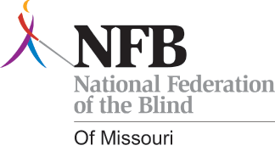
For more information, contact:
National Federation of the Blind of Missouri
573-268-6989
DebbieWunder@centurytel.net

MISSION BELIEVE
The Sky’s the Limit
Sponsored by the National Federation of the Blind of Missouri
August 3-5, 2012
Windermere Conference Center - Roach, Missouri
Student Profile
Return profiles by June 3, 2012 to:
National Federation of the Blind of Missouri
3910 Tropical Lane
Columbia, MO 65202
Name: ______________________________________________________________
Gender: _______ Birth Date: ____________ Grade: _______________
Parent/Guardian Name(s): ______________________________________________
Home Address: ______________________________________________________
City, State and Zip: __________________________________________________
Phone Numbers: (home) __________________ (cell) __________________
Email Address: ____________________________________________________
Reading medium:
Contracted Braille ____ Un-contracted Braille ____ Large Print _____ Both _____
Name of School _________________________________________________
Please clearly describe any medical conditions or disabilities the student has, including cause of blindness, visual functioning (if any), any medications that will need to be taken during the event, and any other special considerations (medical or otherwise) of which we need to be aware.

Has the student ever participated in a summer camp or blindness skills program?
If so, where and when?
On a separate sheet, please write a paragraph describing three goals you have set for yourself and why these goals are important to you.(To be completed by the student)

Parent Profile
Name of Parents/Guardian who will be participating in this event with this student:

Reading medium: Braille __________ Print __________ Large Print __________
Please describe any special considerations (medical or otherwise) of which we need to be aware regarding the adults accompanying this student:

** Please note the following:
• Applications should be received no later than June 3, 2012. However, space will be limited to 16 students and their parents.
• This form is the initial part of the application process and will be followed by a telephone interview with student and parents/guardian.
• Accepted students and parent(s) must be able to attend the entire weekend activities.
• This program is being funded by grants and donations. There will be no cost to participants.
For more information contact Debbie Wunder at 573-268-6989 or by email at DebbieWunder@centurytel.net

A Heart Felt Thank You
By Dan Flasar
Editor’s note: This is an e-mail taken from the NFBMO list Serve
Hi everyone,
I haven't been very active lately - as some of you know, I've had some
medical problems for the last 2 months, which is why I wasn't able to attend
our state convention. Without getting into a lot of detail, I've been dealing
with severe back and leg pain. I am relieved to say that my prognosis is
looking much better over the next few months - it's going to take a lot of
rehab work - and I'm ready for it.
As many of you may know, acute medical conditions - and the consequent pain
and continuous consultations, procedures and tests - can contract your
life. The routines of living become disrupted and sometimes have to be
renegotiated. Normal interests in the outside world are displaced by the regimens
of therapy and alleviation of symptoms. Forgoing usual social get-togethers
(like chapter meetings and conventions) further increase a sense of
isolation. Of course, we all learn to cope with these things over time, and I am
grateful for all my family and friends who have kept in touch.
I was feeling physically and emotionally very low the night I listened to
the convention banquet speeches. The announcement that I had been selected
to receive the Jernigan award took me very much by surprise - I was - and
still am - moved to tears.
I was reminded of the reasons I sought out the NFB in the first place. I
was losing my vision, unsure about my job, my life and how I would adapt. I
wanted to find confident, accomplished, compassionate and energetic people
who had successfully dealt with what I was going through - to learn from
their experiences and make new friends.
Well... I got what I was looking for - and a lot more.
I have always tried to contribute to the NFB - but I can never equal the
warmth and friendship you all have given to me over the years. I am very
humbled and grateful by the recognition the Jernigan Award represents, and I
promise that I will always do my best to live up to it.
Thank you very much, my friends.
Dan Flasar

A New Look
By Carol Coulter
The Blind Missourian needs a proper cover so get your creative juices flowing and e-mail them to me at cjcoulter@centurytel.net. The design should be in black and white to keep printing costs down. The winner gets $25.00. Hurry deadline is June 30, 2012.

PLEDGE OF THE
NATIONAL FEDERATION OF THE BLIND
I pledge to participate actively in the effort of the National Federation of the Blind to achieve equality, opportunity, and security for the blind: to support the policies and programs of the Federation and to abide by its Constitution
Board of Directors
National Federation of the Blind of Missouri

Officers:
Gary Wunder, President Julie McGinnity, Recording Secretary
Shelia Wright, First Vice President Dacia Luck, Corresponding Secretary
Ruby Polk, Second Vice President Carol Coulter, Treasurer

Board Members:
Eugene Coulter Cory McMahon
Gary Horchem Jeremiah Wells
Chris Tisdal Bob Williams
Gene Fleeman

Chapter Presidents
Gene Coulter, Columbia Helen Parker, South Central
Rita Lynch, Jefferson City Gary Horchem, Springfield
Shelia Wright, Kansas City Dennis Grabill, St. Joseph (contact)
Chris Tisdal, Lewis and Clark Chris Parsons, St. Louis

Blind Missourian Editor Carol Coulter
Proof Readers Helen Stevens
Shelia Wright
Gary Wunder
Read by Elisabeth Coulter

FREE MATTER FOR THE

BLIND AND PHYSICALLY

HANDICAPPED

NFB of Missouri
1613 Blue Ridge Rd.
Columbia, MO 65202

