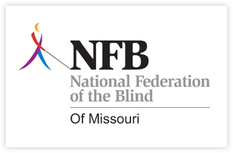
Missouri Association of Guide Dog Users
A proud Division of the National Federation of the Blind
Guide Dog Seminar

Is a guide dog for you? Come join us for an informative and fun seminar to explore the use of guide dog and cane in everyday travel and beyond.

Some topics covered will be:

Travel outside of the US
The ADA and service animals
The importance of O&M
Panel of guide dog and cane users
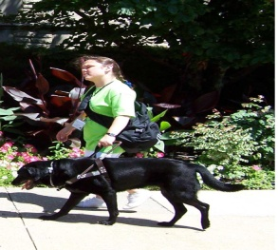
Date: October 27, 2012
Time: 9:00-4:00
Place: St. Louis Society for the Blind
Registration Fee: $15 (continental breakfast & lunch included)

For more information please contact:
Julie McGinnity- 314-610-7740 or email at kaybaycar@gmail.com
Debbie Wunder- 573-874-1774 or email at debbiewunder@centu

You do not need to be a guide dog user to participate

