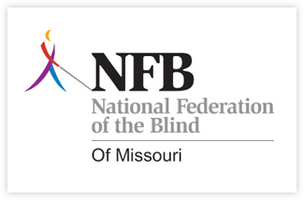
Missouri Association of Guide Dog Users
A proud Division of the National Federation of the Blind
Guide Dog Seminar Registration Form

Thank you for your participation in our seminar. Please take a moment to fill out this form and return it with payment by October 15, 2012.

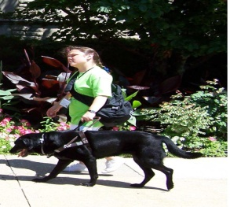NAME: First: _______________________ Last: ____________________

ADDRESS: Street: ________________________________

City: __________________ State: ______ Zip: _________

Phone: _____________________________ Email: _________________________

How did you hear about the seminar?
Flyer___ Family or friend___ Professional__ Guide dog handler__ Other___________________

Please indicate if you are
A guide dog handler__ Interested in getting a guide dog__ A professional__
Other_______________

The fee for this seminar is $15 per person.. Please make checks payable to the Missouri Association of Guide Dog Users. All cash and checks should be mailed to:

Missouri Association of Guide Dog Users
35 Kassebaum Lane
Unit 104
St. Louis Mo 63129

If you have any questions, please contact:
Julie McGinnity- 314-610-7740 or email at kaybaycar@gmail.com
Debbie Wunder- 573-874-1774 or email at debbiewunder@centurytel.net

