Paw Prints
A Publication of the
Missouri Association of Guide Dog Users
Fall Edition 2012
Debbie Wunder, Editor

Guide Dogs in the Workplace
by Stephanie McDowell

From the Editor: Stephanie McDowell is the immediate past president of our dog guide division and deserves a lot of credit for picking up the ball when our former president thrust the job upon her. She is a wonderful person with a very important occupation. She is joined by a fantastic helper and here is her story:

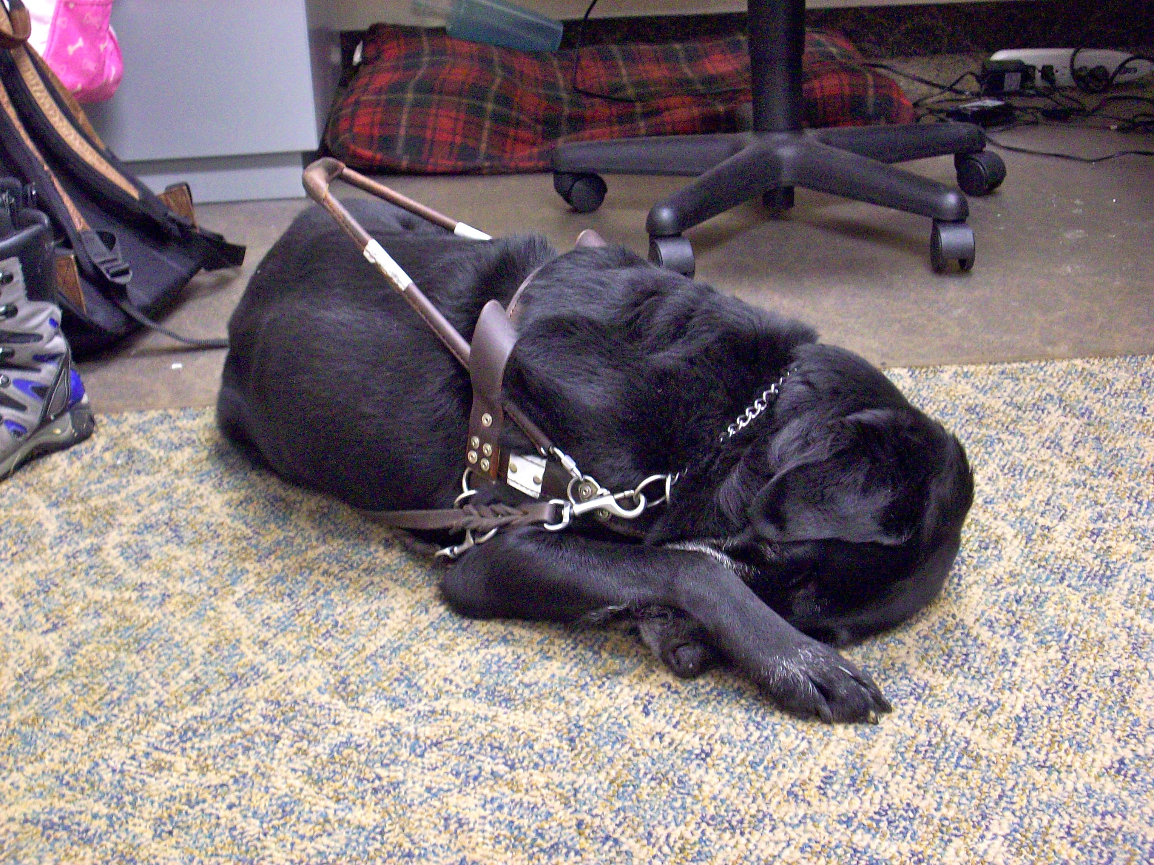
I am a social worker and have been employed at a non-profit agency five years. My previous guide dog has accompanied me to work the whole time I have been there, and now my new guide dog does the same.

Over the last five years I have learned a lot about having a guide dog in the workplace, and trust me, it isn't the same as having your guide on a college campus, which I will leave for one of our college students to cover. Instead I will talk about the affect my dog has had on my ability to successfully do my job, and some of the unique challenges I have had to face as a guide dog handler in the workplace. I will talk about the importance of behavior and grooming, dealing with coworkers, meeting your guide dog's needs, and other tips for working your dog in the workplace.

The Importance of Behavior and Grooming

As a professional I must play the part if my clients are going to trust that I can help them and if other professionals in my field are going to see me as their equal. This means dressing, acting, and speaking professionally. What does this have to do with a guide dog in the workplace? Our dogs are a reflection on us, and like it or not, they will affect how we are seen by our coworkers and others we come in contact with during a workday. I feel that it is very important to maintain my dog's behavior and grooming. As a professional I am expected to behave and present myself in a certain way. I see my dog as an extension of me and feel that I am not representing myself in the best possible light if my dog does not behave or look like the professional she is. I feel my guide dogs have enhanced my ability to maintain a professional image. I really enjoy being able to show my dog a place once or twice and have her remember it.

Since my work often takes me outside the office, I enjoy having my guide dog with me. She gives me a sense of security when dealing with quiet cars or unfamiliar surroundings.

Dealing with Coworkers

My coworkers have all loved my guide dogs, and I cannot deny that my dogs have touched their lives in a special way. This affect really became evident when I recently retired my previous guide and brought my new guide into the workplace.

In some cases my coworkers have wanted to play with my dog or try to give the dog treats. So how do you gently tell your coworkers that they can't treat your dog like the family pet? This situation is very challenging because your coworkers are people you have to interact with on a regular basis. I have found that being very clear about the rules and staying consistent about them is helpful in making sure that no one's feelings are hurt. I learned this the hard way when I first started working. One thing I did when I brought my new guide dog into the workplace was to send out an email introducing the dog (everyone wanted to know about the dog) and reminding them of the rules I had set. I also reminded them that she is young, and we are still forming a team. I also found that showing a little affection, such as giving her a quick pat or touch and praising her for doing a good job, genuinely helps those coworkers who feel sorry for the poor dog because all they ever see is that she works.

Meeting Your Guide Dog's Needs during the Workday

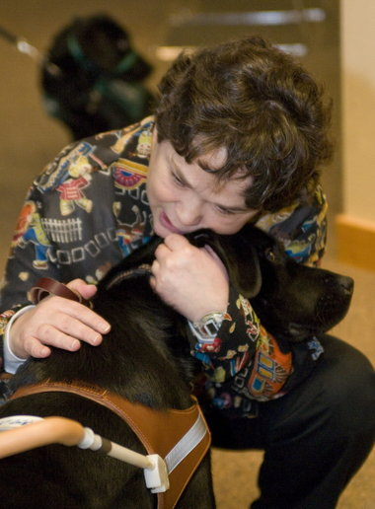
Of course guide dogs are still dogs and have the same needs as any other dog. They need water, food, exercise, and some downtime. They also need protection from the elements when traveling to and from work, and let's not forget relieving. This need can be very challenging, especially when you are in the middle of a very hectic work day full of meetings, deadlines, and phone calls that can't be ignored.

So how do you make sure all your dog's needs are met, while ensuring that you are getting the job done? Keeping your dog on an eating, watering, and relieving schedule will prevent accidents from happening. It is also important to have items you will need readily at hand: clean-up bags, a portable water dish, bottled water, and food if you will be out during feeding time. It is also helpful to bring a towel to dry the dog off if you end up commuting in the rain. It can also be put on the ground for the comfort of the dog if the ground is too hot or cold.

Some people feel guilty about taking time away from their work to take care of their guide dog's needs. I have found that it can actually be a stress reliever or an opportunity to clear my mind by getting away from a problem for a few minutes.

Other Tips for Working Your Dog in the Workplace

- Keep your dog's schedule the same, even on the weekends. It helps keep the dog on schedule while at work.

- Arrive at meetings early if possible; it will allow you time to situate yourself and the dog before the meeting gets started.

- Coworkers will often volunteer to take care of your guide dog's needs. Don't let them, unless absolutely necessary.

- Remember there are people in your workplace who are afraid of dogs, don't like dogs, or may even be allergic to dogs. Try to be considerate of coworkers.

- Keep your cane skills up; you never know when your dog might get sick or hurt.

- Have a good sense of humor. You will encounter many people during the workday who know nothing about guide dogs and will say or do some strange things. The dog might do some unexpected things too.

With a little forethought and planning, your work can be enhanced by your guide and everyone benefits by her presence.

--

A dog on stage
by Julie McGinnity

From the Editor: Julie McGinnity probably needs no introduction, but she is our newly elected president, was responsible for dreaming up our seminar, and is a leader in our Missouri Affiliate. Here is what she has to say about using a dog guide and performing on stage:

Dog guides are permitted in every public establishment: malls, airplanes, and grocery stores to name a few. Our dogs work confidently in these environments, and when we receive training with our dogs, we learn how to navigate these places with them.

When I entered training at Guiding Eyes for the Blind as a seventeen-year-old, I had a rather strange request. I wanted to know how I could learn to work my dog on stage and perform with her by my side. I am currently a vocal performance major at Webster University and sing on stage nearly every week. Not only do I perform at school, but I also sing at church, in singing competitions, and occasionally in weddings. In nearly every performance my dog Brie lies calmly beside me on stage. She follows the person ahead of me in line when I sing with the church choir and when I sing a solo at church or school. I feel independent as I navigate on and off stage with my dog.

I hear many things after a performance about my dog's behavior on stage. Some people tell me how amazed they are that she can be so still and remain so calm as I sing, and others let me know if she moved in the slightest during the performance. At a singing competition last year a judge wrote on my comment sheet: "I want to take your dog home with me."

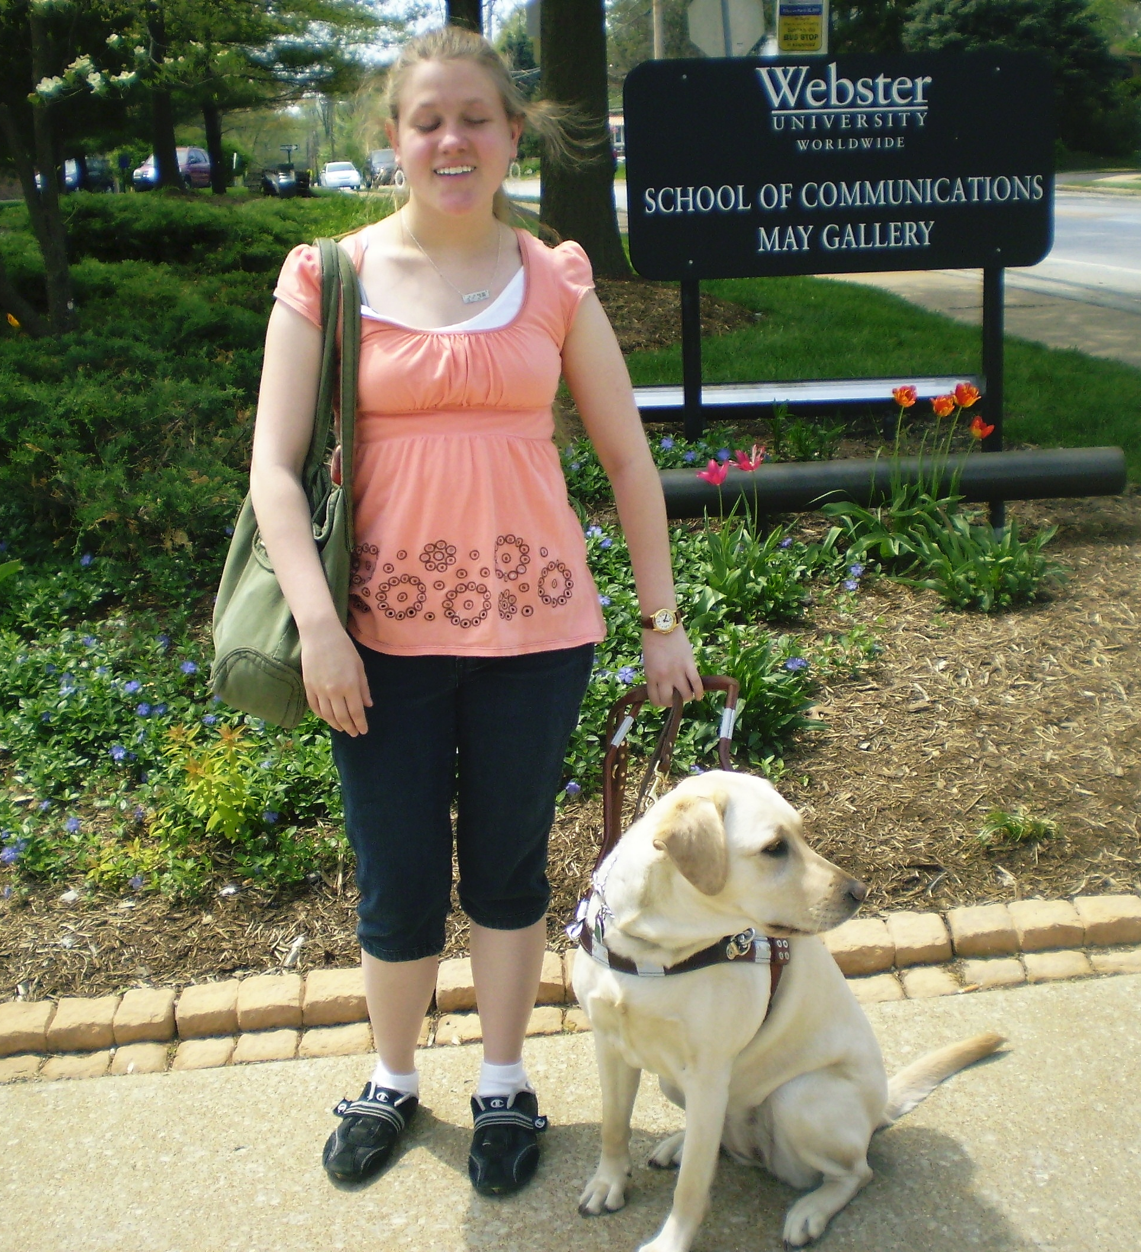
Of course, I know that if I bring my dog on stage, people will be watching her and making comments about her behavior. You might ask how I would miss the movements of my own guide dog on stage. The answer is something I have had to learn over the few years I've worked with Brie. When I perform, I must not show the audience that I am aware of my dog, but at the same time I need to be constantly aware of her. As I sing I cannot give the audience a reason to be distracted from my performance. No matter what kind of trick my dog pulls, I must remain in the moment of the song. If she slides around on stage because she desires the sunlight, I must ignore her completely. If she sits up and makes eye contact with someone in the audience, I cannot stop in the middle of my song to correct her. Perhaps once I am an internationally acclaimed opera singer, I can play the diva and pause the entire show in order to correct my dog, but now I simply attempt to ignore these distractions. As you can probably guess, this can be quite difficult.

Brie behaves herself most of the time, but dogs will be dogs. For example, I know now that if there is sunlight on stage, I need to surrender the battle and let her be in the sun, or put my foot down on her leash as she rests on the stage.

Bringing Brie on stage is merely a matter of trust. I will admit it took a while to truly trust her to behave during my performances, but now performing is something we do on a regular basis, like going to the mall or riding in a car. My job is to sing; her job is to accompany me on and off stage and remain with me patiently while I perform. Together we are quite a team, and I'm proud to share the stage with such a professional.

Cagney and Lacey
by Debbie Eifler

From the Editor: Debbie Eifler is a dedicated and loving member of our Kansas City Chapter. In her article she talks about Cagney and Lacey, a crime-fighting team who were dramatized on television. Mr. Magoo was a popular television cartoon character who was popular when Debbie grew up, and while we understand her characterization of herself, this is not how we see her. Still, this is how she saw herself before getting a dog guide. Here is Debbie's story:

Cagney is a five-year-old seventy pound black lab guide dog. But I am not Lacey; I am more like a female version of Mr. Magoo. Mr. Magoo was a cartoon about a near-sighted old man back in the 60s, which leads me into this article.

My name is Debbie Eifler. I am happily married to Steve, who is also disabled. I could not have children. I was born with Cerebral Palsy, which affected my eye sight. I am partially-sighted (20/400 with correction) and very little side vision. My eyes don't track, so I have to turn my head to see things that are not directly in front of me. These issues are why Cagney is so important in my life.

I am very positive, very outgoing, and very much involved in life. I feel I could not have such a full life without my guide and best friend.

Let's start with my job. I work at the Children's Center for the Visually Impaired (a preschool serving blind and visually impaired children, birth through kindergarten). I am an assistant at the preschool and have been on staff there for twenty-four years. My duties are such that I am all over the building: pushing carts and running other errands. Cagney has a kennel where she stays, and she loves it. The kids and adults see the two of us walking to and from the building, and this teaches everyone how to act around a guide dog. Everyone knows not to pet or talk to Cagney while she is working, unless they ask me first.

Cagney is very low key and calm, so she has earned very positive comments from everyone who sees us together. She is very helpful to me when getting from one place to the other. She guides me around a crowd of people and paces me when we are crossing the streets of Kansas City. We use the city bus every day to get around and I am so blessed that she is with me. She helps me find empty seats and she steps off the bus first so I can tell how far I need to step down. My depth perception is also affected by my vision loss.

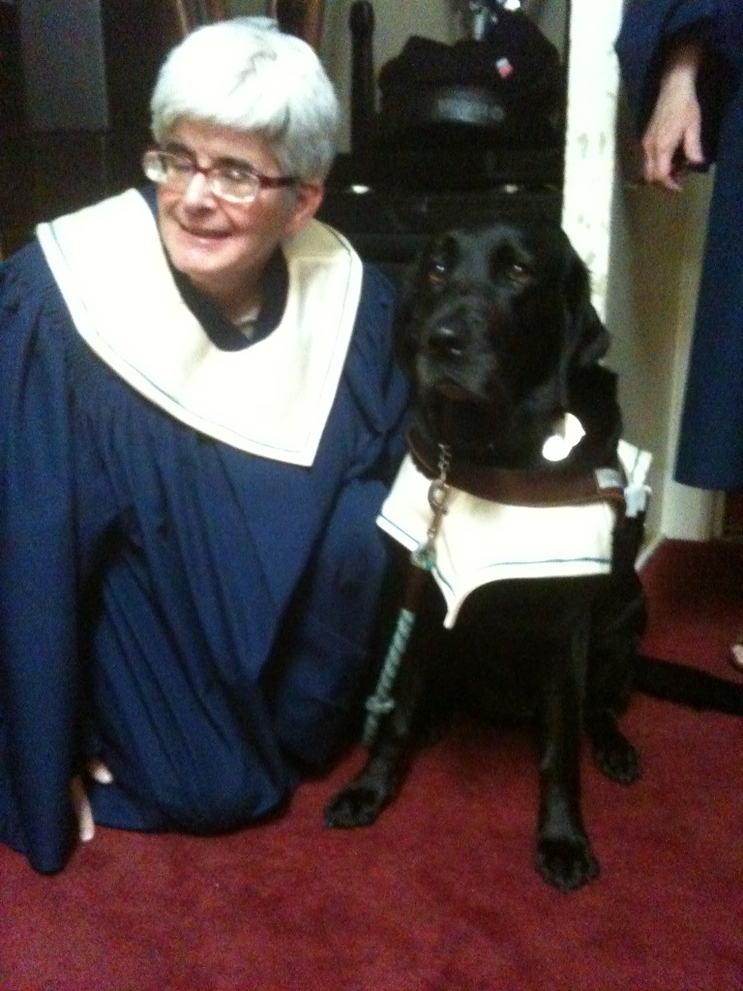
I am the US audio director for the International Al Jolson Society, and I go to our yearly conventions, which are held in different cities each year. I go to sell my audio, and Cagney is right there with me. She helps me around new places and helps me navigate around complicated airports. I see the same folks at the convention each year; they love Cagney and always ask me to bring her. Of course, I would anyway!

I've started singing in the church choir again since I got Cagney, and she sits or lies in the choir loft right next to me. You can even see her on YouTube; sometimes she sits when we all stand to sing. A couple of the kids from my preschool go to church there and always love it when they see Cagney and me up there.

Now I am the secretary for our local chapter of the NFB. I have become involved in going to our capitol with Cagney and advocating for issues involving folks with blindness. I have even talked to the media on these issues. Cagney was even petted by the governor of Missouri. I am also really excited about going to my first national convention with Cagney at my side, and I really want to get involved and learn from everyone else.

Cagney has helped me gain more confidence in myself. I didn't think that I would ever qualify for a guide dog, didn't think I would ever need one, but I am fifty-five now, and my vision has gotten worse over the years. But because of Cagney, I have not had to alter my lifestyle much at all; she just makes it possible for us to keep on going. What better way to promote the guide dog program. Thank you, Cagney for letting me have a life with you.

When my husband is with me, I like to let him help me, but when he is not with me, it is comforting to know that Cagney will always be there when I need her. I realize she will get old like the rest of us, but like the trusted family car, I will rely on her until the time comes to let her retire gracefully and with dignity. I want to give her everything that she has given me.

The Joy of Raising a Guide Dog
by Kathy Hinz

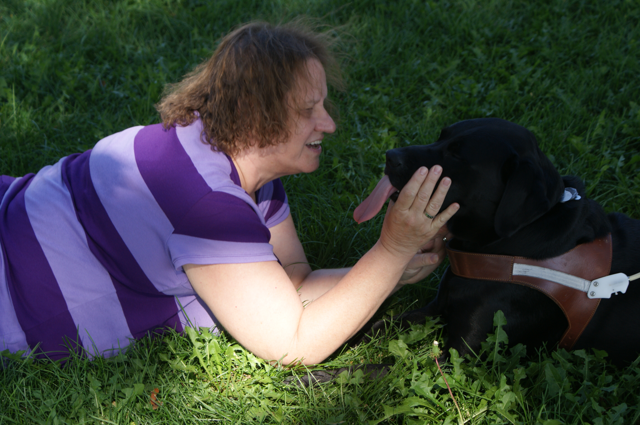
Raising puppies for Guide Dogs for the Blind has become not only a way of life for our family, but it has also introduced us to a fabulous community of people. When our youngest son, Travis was eight years old, he looked for a community service project in which he could participate. We began attending 4-H guide Dog meetings in our area and were soon hooked. When Travis turned nine, our family submitted paperwork to join the club and became puppy raisers for Guide Dogs for the Blind.

Raising a puppy for Guide Dogs for the Blind is a 24x7 adventure. Each family member has specific responsibilities for the puppies. Both Shawn and Travis take the puppy raising role very serious and are active participants in our 4-H Guide Dog club.

When a puppy has specific behaviors that need extra work, we build the lessons into our family schedule. At one point Travis was in a wheelchair and we made quite a train as we walked through stores together every evening. Puppy raisers can start a pup at eight weeks and keep him or her until formal training, which is usually between fourteen to eighteen months old. We can also take a transfer, which is a puppy who has been started by a different puppy raiser. Many people help out as puppy sitters and they get to meet most of the puppies in the club. All the options are great in their own respects.

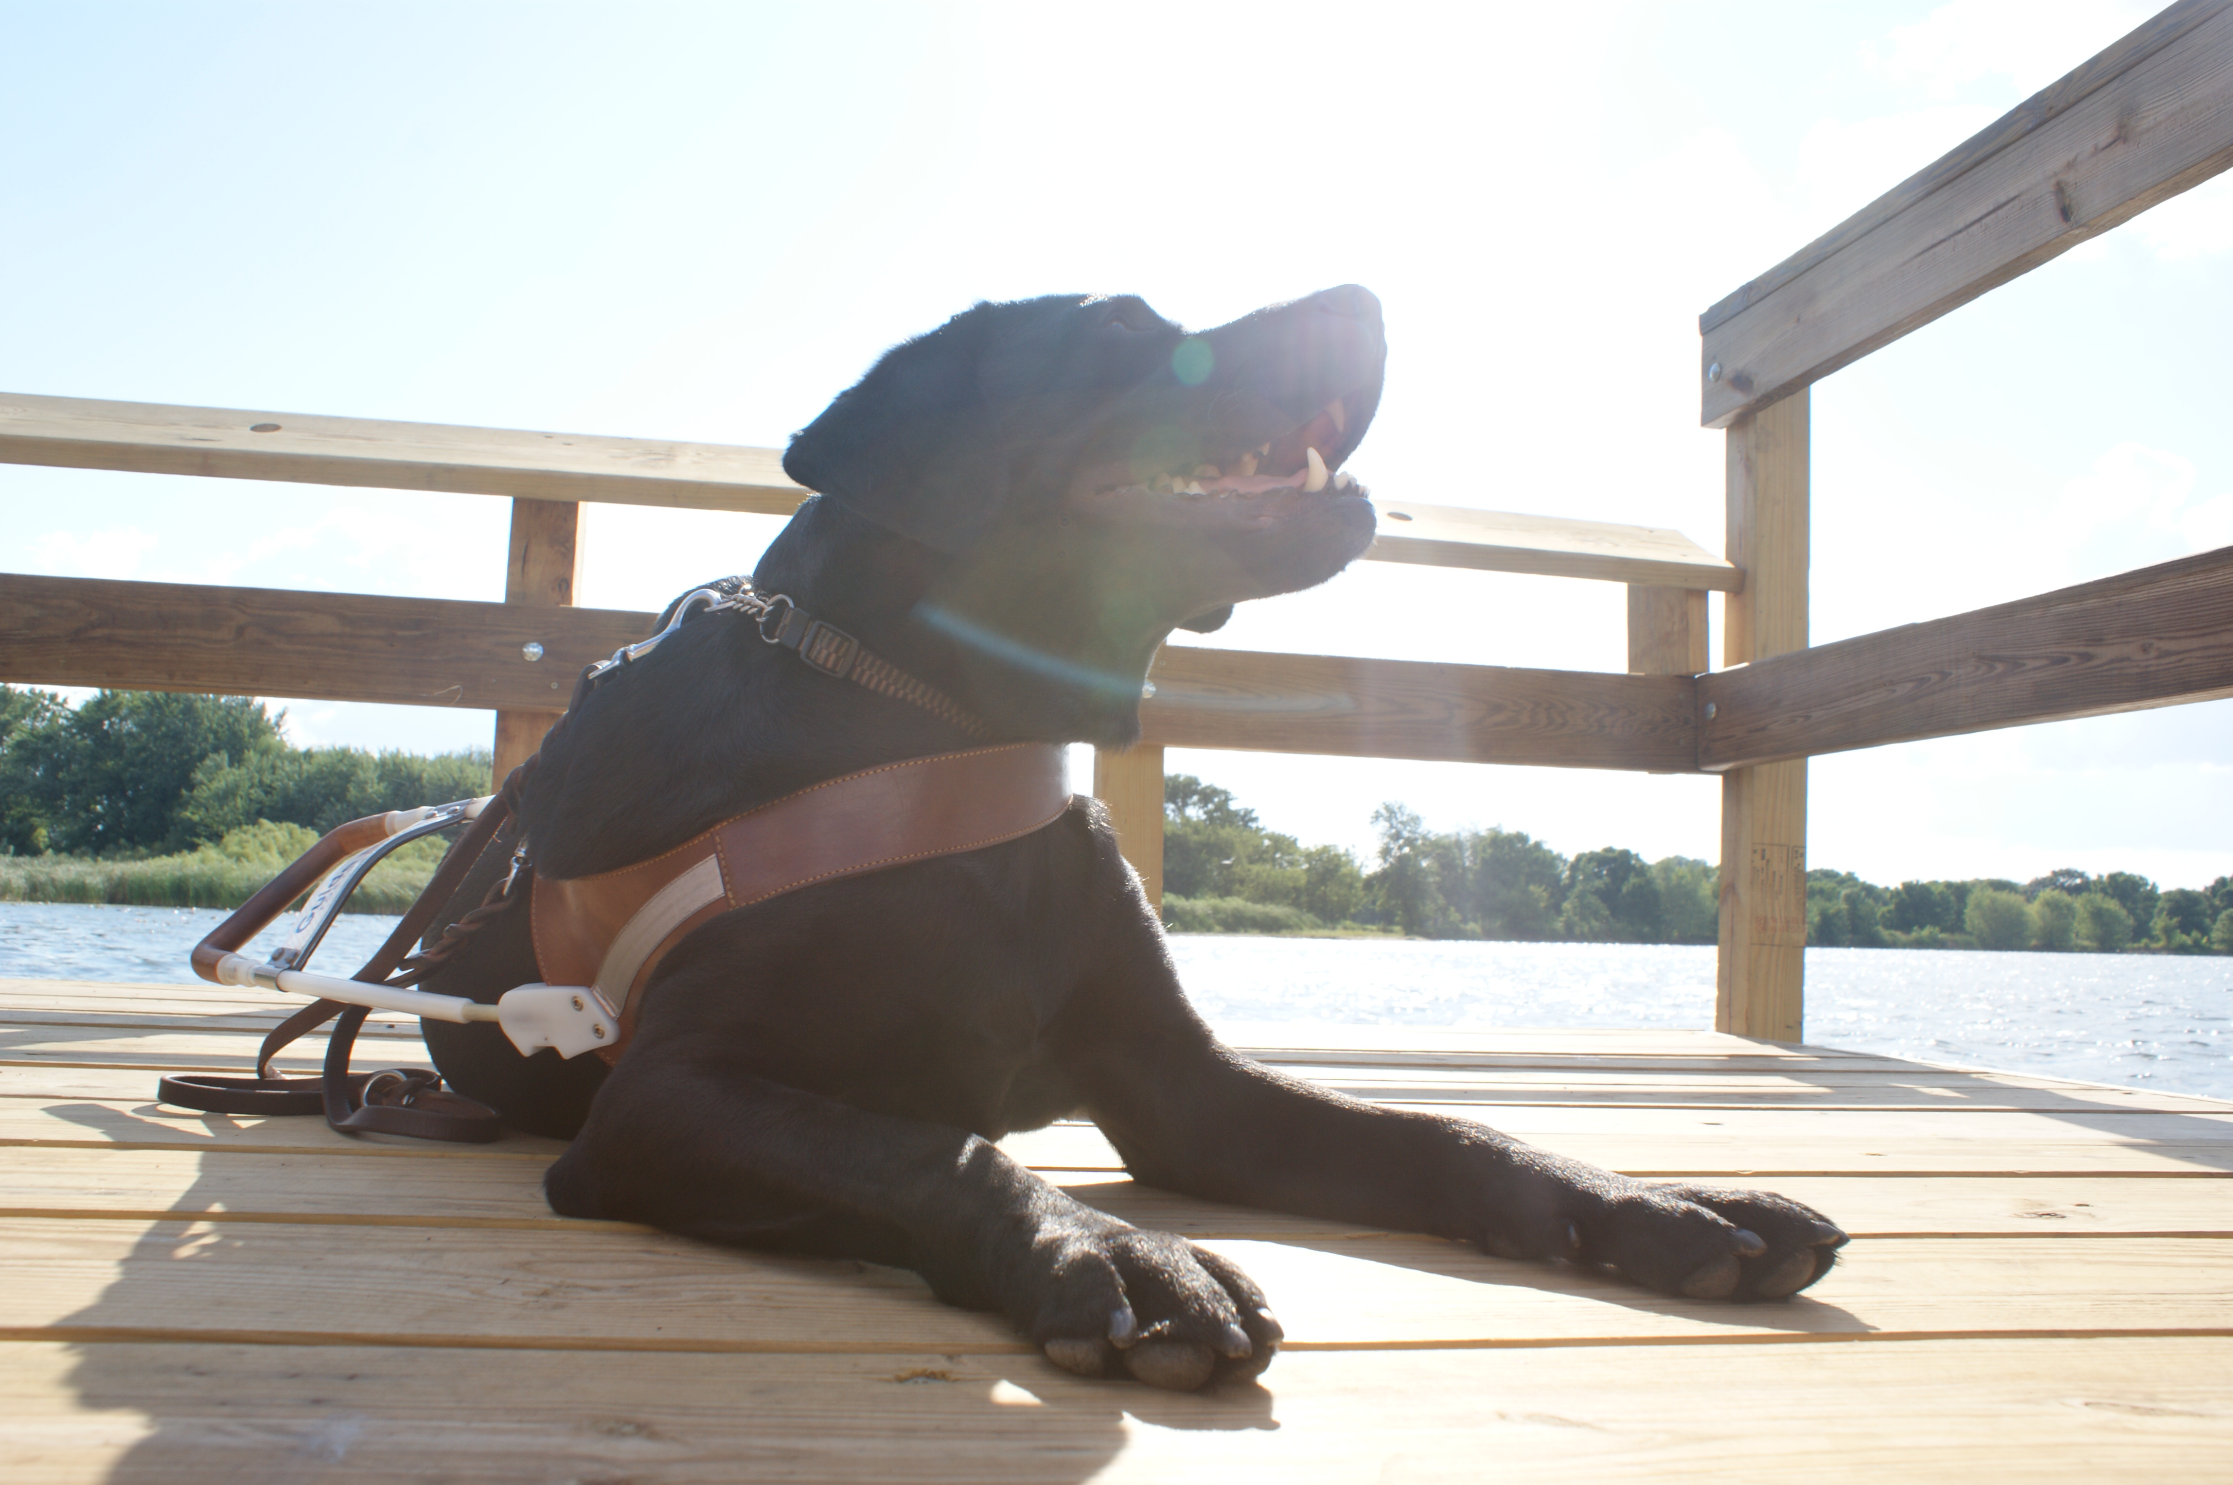
One puppy we raised, named Duran, will always hold a special place in our hearts. He was just naughty enough to keep things fun and interesting but so well behaved that we enjoyed our time with him. Duran had such a great sense of humor. Travis would make forts out of blankets in the living room; Duran would sit right outside the fort and then quickly pull off one of the blankets and run away. Travis would stomp over to Duran, retrieve the blanket, and re-build the fort. Again, Duran would wait until all was quiet and then sneak over and steal a blanket. This game went on and on for the entire time that Duran was with our family.

By far the most rewarding part of raising Duran for Guide Dogs for the Blind was meeting his new partner, Debbie. Immediately we could tell that the two had bonded nicely. Debbie would rub Duran while she was speaking and Duran would look at her with adoration in his eyes. We were so sad that Duran was moving on, but meeting Debbie and watching the two of them interact will always be a high point in our lives. We went home knowing that Debbie and Duran made such a great team and were really going to enjoy working together.

Dog Guide Hotline Available

Thee leader in service animal policy & advocacy – provides several innovative and valuable services. One such service is the NAGDU Information & Advocacy Hotline. The hotline not only offers information about the training and use of guide dogs and the legal rights of individuals who use service animals, including guidance for specific industries, it offers the option to speak with an advocate who is trained to mediate issues of discrimination.

“We find that most access problems are the result of a lack of information,” says Michael Hingson, the Association’s Vice President who serves as Project Manager for the hotline. “This hotline is an excellent resource for accurate information.”

The NAGDU Information & Advocacy Hotline currently offers general information about service animals under the Americans with Disabilities Act (ADA), as well as specific guidance concerning restaurants, taxicabs, and health care facilities. Future plans for the hotline include summaries of each of the state laws concerning service animals, more industry specific information, and guidance in a variety of languages, such as Mandarin and Arabic. The Hotline is available anytime by calling, toll-free, 888-NAGDU411 (888-624-3841).

