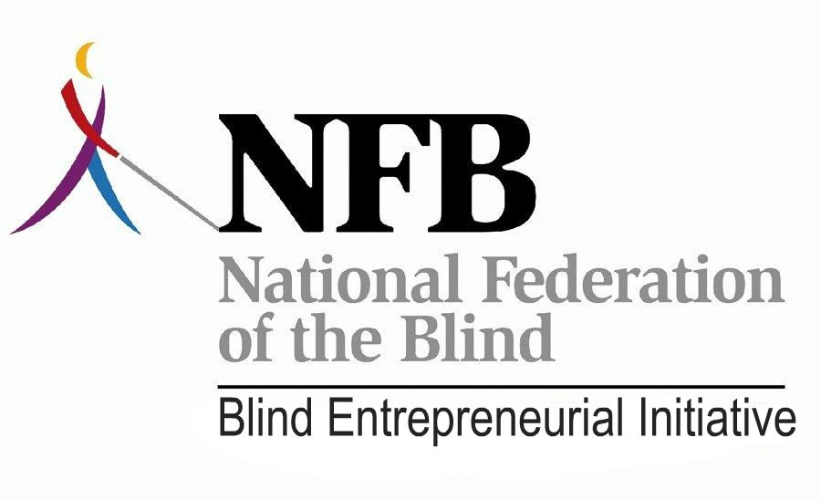
The Holiday Blitz
November 2012

Well, the holidays are upon us and it is that time of year to slow down, spend time with our family and friends, and reflect on our many blessings. One of the things for which we should be thankful is the National Federation of the Blind and Dr. Maurer’s belief that blind people can be successful entrepreneurs. The NFB Entrepreneurs Initiative (NFBEI) is a direct result of that belief. And I can’t help but believe we are making a difference.
Holidays or not, it has been a busy time for the NFBEI. Here are some of the highlights from last month:
Training for State Attorneys—Wow! What a smashing success! When we first started talking about conducting a training program for state attorneys, we never imagined the response we got. The training was conducted on November 29th in Philadelphia with close to 80 participants and almost 30 states represented. The training featured a comprehensive agenda with lots of opportunities for discussion. Topics covered included the history of the Randolph-Sheppard Act, issues in federal contracting, teaming partner arrangements, branding, a review of what the courts have said about Randolph-Sheppard, arbitration, the Veteran’s Administration, active participation, and more. We were blessed to have some of the brightest legal minds in the Randolph-Sheppard arena to present on various topics. Thanks to Peter Nolan, Andy Freeman, and Susan Rockwood-Gashel, and we appreciate their participation. One of the highlights was a presentation by Alabama attorney Steve Simpson and Maryland attorney Elliott Schoen who talked with the group about the keys to being a successful state attorney working in Randolph-Sheppard. The feedback we got was very positive. The NFBEI wants to do more training like this in the future. If there is a national need that you know about and would like to suggest a training program, we are interested in hearing your ideas.
National Council of State Agencies for the Blind Fall Meeting – I was happy to get to attend NCSAB’s Fall Meeting in San Diego and get reacquainted with old friends and colleagues. The focus of the meeting was on partnerships and NABM President Nicky Gacos was asked to put together a panel presentation on partnerships in Randolph-Sheppard. It was a terrific panel and he even had a working micro-market set up. I participated on the panel and talked about why we need partnerships in Randolph Sheppard. As unbelievable as it may seem, we still have state agencies that are philosophically opposed to partnerships between vendors and private sector providers. We in the NFBEI encourage programs to take a more flexible approach in order to provide customers what they crave, which is quality service and great products at excellent prices. While at the meeting, I had the opportunity to meet privately with a couple of state directors to discuss issues in their respective states and set the stage to facilitate solutions to problems in their state programs.
Troop Dining: A New Twist— The twists and turns of the troop dining world seem to be endless. We reported last month about issues at Fort Bragg (North Carolina), Fort Campbell (Kentucky), and Fort Jackson (South Carolina). The latest development is with the contract for the troop dining at the Marine base in Hawaii. The Marines have sought consultation from RSA before awarding the contract and RSA has been very slow in responding. Without going into specifics, it appears that the military may be consulting with RSA on every contract award. The regulations actually require such consultation but there was little focus on it until the decision was rendered in the Colorado versus the Air Force arbitration case. Such consultations, if done properly, can actually be a plus for Randolph-Sheppard. In fact, it could be one of the most positive developments for troop dining opportunities in the last several years if RSA takes a strong stance. However, many of us have serious concerns about RSA’s ability to effectively provide such consultation at this particular point. It is an issue we are working on very diligently and should have much more to report on this next month. Let’s hope it is positive.
The Traveling Man— November saw me in Virginia at that state’s annual BEP meeting. I did my “Consumers Leading, Promoting, and Protecting: What the NFBEI is Doing for You”. It was well received. I love to brag about what we are doing with the NFBEI. I logged a lot of miles this year traveling to state BEP meetings. All of the meetings are over for this year but they will be ramping back up in the spring. We welcome an invitation to your state’s meeting. Between me, Nicky Gacos, Kevan Worley, and other leaders, we can accommodate most requests. Let us help make your state training a meaningful upward mobility experience.
Individual State Issues – We continue to be involved with issues in various states. We are frequently called on by vendors and SLA’s alike to provide technical assistance, consultation, and support. Whether it be assisting Florida with its VA and Coast Guard issues or advocating for vendors in Indiana prisons, the NFBEI is trying to make a difference. I encourage vendors and states to call on us.
NABM Retains Services of Susan Rockwood-Gashel – For those of you who haven’t heard, NABM is contracting with former Hawaii Assistant Attorney General Susan Rockwood-Gashel to provide legal services. Susan is tenacious and one of the most thoughtful, assertive, and talented Randolph-Sheppard attorneys in the country. Susan provides legal advice to NABM and the NFBEI and also works on vendor issues in the states. She has already proven to be a valuable asset and her services are made available due to the generous support of NABM members.
Networking with the USBLN – The NFBEI and NABM continue to work to develop other partners beyond Randolph-Sheppard. Kevan Worley and NABM member Melissa Smith attended the United States Business Leadership Network conference in Orlando. Kevan said, “As NFBEI and our partners look to expand opportunities, we will be seeking new partners such as the USBLN."
Mark Your 2013 Calendars – The New Year is almost here and you need to make sure your calendars are marked for some important events coming up in 2013. First up is the NFB’s Washington Seminar which will be held February 4-7. The host hotel will be the Holiday Inn Capitol, 550 C Street SW. For information about the Washington Seminar, you can contact Kevan Worley at kevanworley@blindmerchants.org or by phone (866) 543-6808. Merchants will be gathering at noon, Monday, February 4th at the Holiday Inn Capitol. Blind entrepreneurs need to make their presence felt at this very important event. If we are to fend off future attacks to our program, it is imperative that blind entrepreneurs establish a relationship with their elected officials. The Washington Seminar is a good place to start while also advocating for other issues that affect Americans who are blind. BLAST, the biggest and best training available in Randolph-Sheppard, will be held May 20-23 in Indianapolis. Make plans to be there and let’s make this the biggest and best BLAST ever.
Sustaining the NFBEI – The NFBEI is an effort funded by the National Federation of the Blind but we work on behalf of ALL blind vendors. We need all blind vendors to help us sustain this important initiative. Yes, the NFB is fully committed to the NFBEI but all nonprofit organizations face funding challenges. Dr. Marc Maurer expects the Randolph-Sheppard community to help foot the bill and rightfully so. If you think what we are doing is important and you want to do your part to sustain the initiative, your contribution would be appreciated. You can send a check made out to NABM and note in the memo portion of the check that it is for the NFBEI. Checks can be mailed to:
National Association of Blind Merchants
1837 S Nevada Ave
PMB 243
Colorado Springs, CO 80905
Well, that’s it for now. Now, we can look to the wonderful holiday season. I hope everyone reading this has a terrific holiday and a fabulous New Year.

Terry Smith
NFB Entrepreneurs Initiative
tsmith@nfb.org
(423) 468-4969

