SAVE THE DATE!
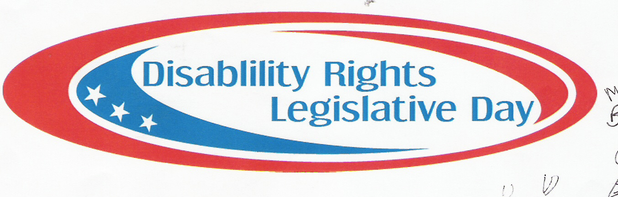

12th Annual
Disability Rights
Legislative Day!

April 9th, 2013
Missouri State Capitol
Jefferson City, MO
Be There!

More information to come…

Questions? Please Contact:

Cathy Brown: cathybrown@dcil.org
Becky Dickey: badrld@centurylink.net
TO RSVP PLEASE CONTACT:

