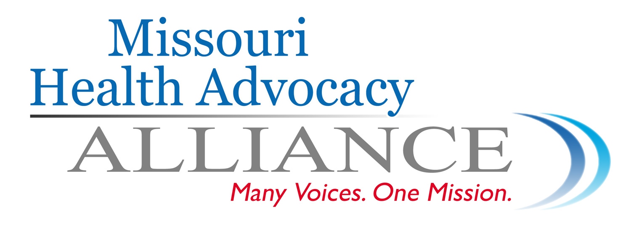

Coalition of Missouri Health Care Advocates Applaud Legislative Action on Medicaid Expansion

HB 627 heard in committee, marking the “official beginning of a conversation to expand access to health care for thousands of Missouri families…” --- Senate sees action as well

Jefferson City, MO – A diverse coalition of Missouri’s health care advocates applauded a hearing today in the House Government Oversight and Accountability committee of HB 627, which would expand the state’s Medicaid program to cover Missourians earning up to 138% of the federal poverty level, or about $32,000 for a family of four. SB 349, which contains the same provision for Medicaid expansion, was first-read in the Senate last week.

“This hearing in the House – and last week’s introduction of a Medicaid expansion bill in the Senate – mark the official beginning of a conversation to expand access to health care for thousands of Missouri families. We applaud Senator Paul LeVota and Representative Jake Hummel for starting this important conversation,” said Andrea Routh, Executive Director of the Missouri Health Advocacy Alliance. “This is really simple: We have a Medicaid program in our state – we just need to expand it with these federal dollars.”

The Affordable Care Act contained a provision for states to expand their health care programs for low-income residents, but state legislatures must take action to do so. Missouri would pay nothing to make the change in the first three years and in most of the years following that will likely make up its share with cuts to other health care programs that are no longer needed and new revenue from the jobs created by the expansion.

This influx of health care dollars is expected to create 24,000 Missouri jobs in the first year alone and may prove a lifeline for dozens of rural hospitals and clinics that operate in underserved areas.

About the Missouri Health Advocacy Alliance:
The Alliance is a statewide non-profit advocacy organization dedicated to quality affordable health care for all. Since 2008, the Alliance has been working to build the consumer and community leadership required to transform the American health system. With the belief that this transformation will happen when consumers are fully engaged and have an organized voice, The Alliance works in partnership with national, state and local consumer organizations, policymakers, and foundations, providing leadership and support to change the health care system so it serves everyone – especially vulnerable members of society.

