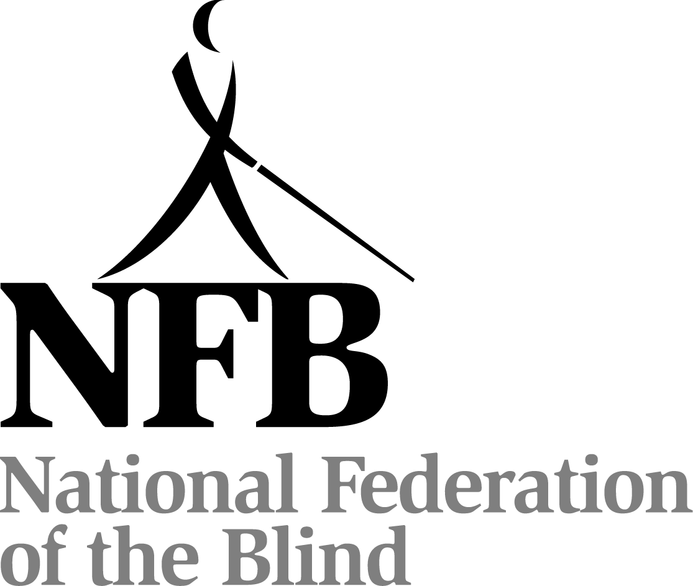

FIFTY-FIRST ANNUAL CONVENTION

NATIONAL FEDERATION OF THE BLIND
OF MISSOURI

April 12 to April 14

The Capitol Plaza
Jefferson City, Missouri

The Jefferson City chapter welcomes everyone to our Capitol City where we have proudly represented the National Federation of the Blind of Missouri to our governmental leaders for more than thirty years.
We in Jefferson City are known not only for our state capitol but for the old Missouri State Prison—one of the oldest west of the Mississippi—our visitor’s bureau, and many historic homes in Municburg. The most important thing we have to give is our hospitality, and we will do all we can to make this a memorable and joyous event for all who come.
Members of our Jefferson City chapter cordially invite you to drop by Hospitality in the Kansas City room, which will be open from 5:30 PM to 10:00 PM Friday evening.
The Park Place Restaurant is open from 6:30 AM to 2:30 PM and the Fountain Court Lounge is open from 1:30 PM until midnight. The hotel also has room service. These two fine dining facilities should afford all the variety any palate could desire, but there are also food establishments within walking distance for independent Federationists who like a little time on their feet. The hotel also has a heated whirlpool hot tub, indoor pool, and a fitness center. For the more sedentary among us, it also features free WI-FI and a gift shop.
This year's hotel convention room rates are $79 per night plus tax for singles, doubles, triples, and quads. Keep in mind that the hotel is not obligated to honor these rates if proof of registration for the convention is not available when you check out.
The checkout time for the hotel on Sunday is at noon. Those who can check out prior to the morning session will help us avoid congestion at the front desk upon adjournment.
Registration will be held Friday evening in the Atrium from 5:30 PM until 7:30 PM and again on Saturday morning from 8:00 AM to 9:00 AM. Registration at the convention will cost $20 per person and banquet tickets will cost $30. Please register so you will be eligible for door prizes and other convention activities. Even if you have preregistered, you should come to this area to pick up your registration packet. Also remember to check out the exhibits which will be near the registration table.
There will be two special lunches, one on Friday and one on Saturday. These lunches will both be held at noon in the Carnegie Room. Tickets are $15 and may be purchased through the preregistration system and for the Saturday lunch at the registration table as long as they last. Special attention is called to the luncheons since the number of attendees is the figure the hotel will need first.
A prayer breakfast, led by the Jefferson City chapter will be held on Sunday morning at 7:00 AM in the Carnegie Room.
Door prizes will be given throughout the convention, and each chapter is encouraged to bring their donations to the Jefferson City chapter table in the exhibit area. You must be in the room or must be working on convention business to win.

The general sessions on Saturday and Sunday will be held in the Lincoln Room. The reception and banquet will be held in the Truman Room. All Federation meetings and convention events are smoke free.

PLEDGE OF THE
NATIONAL FEDERATION OF THE BLIND

I pledge to participate actively in the effort of the National Federation of the Blind to achieve equality, opportunity, and security for the blind: to support the policies and programs of the Federation and to abide by its Constitution.

FRIDAY, April 12

8:30 AM The Missouri Association of Blind Students Seminar—Bethany Bennington, President
Truman B

8:30 AM Diabetes Action Network Registration

9 AM-12PM Diabetes Action Network—Debbie Wunder, President
Truman C

8:30 AM-3 PM Seminar for Parents of Blind Children—Chantel Alberhasky, President
Truman A

3:30 PM NFB of Missouri Board Meeting
Truman B

5:05 PM Scholarship Committee meeting—Sheila Wright, Chairman
Truman A

6:00 PM Missouri Association of Blind Merchants—Sam Parker, President
Truman C

6:00 PM Dog Guide Division—Julie McGinnity, President
Truman B

7:00 PM Membership Committee—Debbie Wunder, Chair
Truman C

8:00 PM Resolutions Committee—Dacia Luck, Chair
Truman B

9:00 PM Ways and Means Committee—Gene Fleeman, Chair
Truman A

9:00 PM Missouri Association of Blind Students—Bethany Bennington, Chair
Truman B

10:00 PM Nominating Committee—Chris Tisdal, Chair
SATURDAY, April 13

6:30 AM Scholarship Breakfast (Scholarship Recipients and committee members)—Shelia Wright, Chair
Carnegie Room

MORNING Session

8:15 AM Call to order
Lincoln Room

8:20 AM Welcome from the Jefferson City chapter—Rita Lynch, President, National Federation of the Blind of Jefferson City

8:25 AM Presentation of the Colors by VFW Post 1003

8:30 AM Welcome from the Mayor of Jefferson City—Eric Struemph

8:40 AM Introduction of scholarship winners—Shelia Wright

8:45 AM Welcoming our visitors from out of state

8:50 AM Sharing some Federation songs—Julie McGinnity

9:00 AM Report of the Nominating Committee—Chris Tisdal, Chair

9:05 AM Dreaming big, facing challenges, and making life better for the blind—Fred Schroeder, Second Vice President, National Federation of the Blind

9:45 AM Questions from the floor

9:50 AM Ten minute break

10:00 AM What have you done for me lately: how we get and keep new members—Garrick Scott, Director of Youth Programs, National Federation of the Blind of Georgia

10:15 AM Changing perceptions of the blind among those who protect our children—Marta Halter, Deputy Director for Practice and Professional Development, Children’s Division, Missouri Department of Social Services

10:30 AM Taking our message to the field—Carol Coulter, Coordinator, Children’s Services Outreach

10:40 AM Resolutions and constitutional amendments—Dacia Luck, Chairman, Resolutions Committee

11:10 AM Advocacy Isn’t A Spectator Sport—Jeremy LaFaver, Missouri State Representative

11:25 AM Questions from the floor

11:30 AM Remaining on good terms with the Social Security Administration—Gene Coulter, Income Specialist, NFB of Missouri

11:55 AM Ways and Means announcement about King and Queen Contest and other fundraising activities—Gene Fleeman, Chairman, Ways and Means Committee

12:00 PM Adjourn for lunch

Afternoon Session

1:30 PM Announcement of the King and Queen—Gene Fleeman, Chairman,
Ways and Means Committee

1:40 PM You call it a phone, I call it my plug-in to the world: a panel discussion—Erin Magoon, Gary Horchem, and Kyle Borah

2:00 PM What if all I want is a telephone—Shelia Wright

2:05 PM A short history of Wolfner & NLS, changing of formats, BARD development, and the current age of constant transition—Dr. Richard Smith, Director, Wolfner Library

2:25 PM Questions from the floor

2:35 PM The blind in science and beyond—Dr. Cary Supalo, Assistant Professor of Chemistry, Illinois State University, Normal Illinois

2:45 PM Mission Believe: Hearing it from the staff, the parents, and their children—Debbie Wunder, Coordinator; Ron and Angel Turner; Rosina Foster; and others

3:05 PM How Missouri Rehabilitation Services for the Blind is helping to bring about equality, opportunity, and security for the blind—Mark Laird, Deputy Director, Family Support Division, Rehabilitation Services for the Blind

3:25 PM Questions from the floor

3:35 PM Seventh inning stretch

3:45 PM Presidential report—Gary Wunder, President

4:05 PM Stepping into life: now that I have training, where do I go from here--Kimberley Johnson Director of student and Career Services, and Brenda Mosby, Vocational Specialist, Colorado Center for the Blind

4:35 PM Struggles in the workplace: How Section 508 fails the blind—Susie Stanzel, Information Technology Systems Specialist, United States Department of Agriculture, Kansas City, Missouri

4:55 PM End-of-session announcements

5:00 PM Adjourn for dinner

6:00 PM Cash bar prior to banquet
Truman Room

6:30 PM Banquet of the National Federation of the Blind of Missouri—Chris Griggs, Master of Ceremonies
Truman Room

Invocation

Crowning of the King and Queen

Introduction of Guests

Presentation of Awards

Other Business at the direction of the Master of Ceremonies

Banquet Address—Fredric K. Schroeder, President, National Federation of the Blind of Virginia

Auction by the Ways and Means Committee—Gene Fleeman, Chairman

9:00 PM Dance to the Music—Presented by the Jefferson City chapter, live music from the band Sunny and Partly Cloudy. (If dancing isn't for you, just sit back and enjoy the music, visit with old friends, and get to know someone new.)

Sunday, April 14

7:00 AM Prayer Breakfast hosted by the Jefferson City chapter, presided by Kathy Hurley and Gail Lundberg, officiated by Rev. Paul Bruer, a retired Baptist Minister. Music provided by Deborah McAlexander
Carnegies Room

8:30 AM Call to Order
Lincoln Room

8:35 AM Personal management: how do I take notes, label medicine, keep lists, and perform other essential survival skills—Ruby Polk, Rita Lynch, Don Branch

8:55 AM Student challenges in the 21st century—Candice Chapman, Bethany Bennington, Julie McGinnity

9:15 AM Report of the Audit Committee—Dan Flasar, Chair

9:25 AM Reading of the Treasurer's Report—Carol Coulter, Treasurer

9:40 AM Governmental Affairs Report—Shelia Wright, Chairman

9:50 AM Report from Ways and Means Committee—Gene Fleeman, Chairman

10:00 AM Membership Report—Debbie Wunder, Chairman

10:10 AM Elections

10:35 AM Resolutions and Constitutional Amendments continued—Dacia Luck, Chairman

10:50 AM Division reports—Diabetes Action Network, Missouri Association of Guide Dog Users, Parents of Blind Children, Missouri Association of Blind Students

11:10 AM Songwriting competition

11:40 AM Old Business

11:50 AM New business—Appropriation of Funds to tenBroek, the national treasury, national convention stipend, matters presented from the floor

12:00 PM Adjourn

