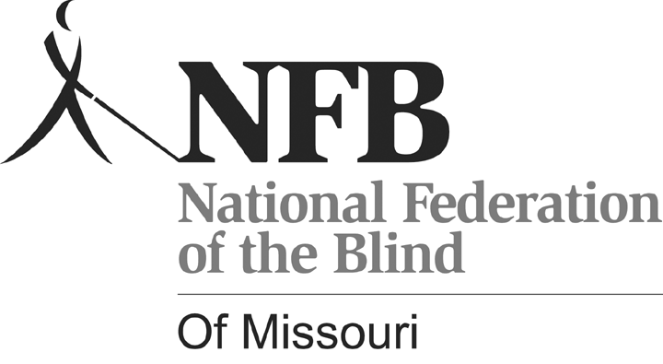
Gary Wunder, President
3910 Tropical Lane
Columbia, MO 65202-6205
Phone (573) 874-1774 www.nfbmo.org

LEGISLATIVE AGENDA OF BLIND MISSOURIANS

PRESENTED TO
THE SECOND SESSION of the NINETY-SEVENTH GENERAL ASSEMBLY

From: The National Federation of the Blind of Missouri

Date: February 10 & 11, 2014

The National Federation of the Blind of Missouri appreciates the opportunity to work with members of our Missouri General Assembly to collaborate and recommend solutions to meet the needs of blind citizens. We are committed to increasing opportunity for blind and visually impaired individuals and are pleased to be a resource to you when legislation affecting the blind is before the legislature or when you may need information about programs and services to answer constituent inquiries.

The National Federation of the Blind is a membership organization of and for the blind. As a grassroots organization we are blind people speaking on behalf of blind people. We come together on the local, state, and national level to address issues of importance to our fellow blind citizens and the community we live in. We promote programs that encourage self-determination, independence, and equality of opportunity.

PROVIDING A TOOL FOR
THE ACCURATE ASSESSMENT OF READING FOR THE BLIND

What you are doing now is second nature; you are reading, and the skill is considered so essential that your formal instruction began at six and informal instruction before that. Changing shapes into letters, words, and deriving meaning from them is critical to what you do, so the desirability of learning to read efficiently has never been a question in your education. Not so if one is blind. The equivalent of print for the sighted is Braille for the blind, and this is recognized in the education laws of Missouri in RSMo 167.225. Though the law says that no blind person shall be denied instruction in Braille, it does allow school districts to conduct evaluations to determine whether print or Braille is the most appropriate method for reading and writing for a given student. It is telling that the first action taken by the Department of Elementary and Secondary Education following the passage of SB 740 was to develop boilerplate language school districts could use to say that they had considered Braille as the primary learning media and had concluded print would be more appropriate. Far too often print is determined to be the most appropriate reading medium because the process used in making evaluations is flawed and because the strong preference of teachers and school administrators is to teach what they know and use the resources easily available to them.

The consequences for blind students are devastating. Blind people who can see enough to read some print require that it be enlarged. In the early grades this is how it is presented, but when learning to read is replaced by reading to learn, the print gets smaller and the amount of it that one must read gets larger.

It is common practice for students with visual impairments to hold reading materials very close to their faces, and/or to hunch their bodies over the materials when reading. In addition to the posture and other health concerns these reading positions raise, years of field practice and experience have demonstrated that youth who read print materials at very close distances suffer eye strain, headache, neck and back pain, fatigue, and diminished concentration, reading speed, and comprehension. Consequently, any valid assessment should ensure that children are evaluated when sitting up straight and with materials held or placed at standardized distances.

We must modify Missouri's statutes so that Section 167.225 mandates the use of the National Reading Media Assessment. Our state must have a clear standard to use in determining who will be taught print and who will be taught Braille. Bringing blind people into the workforce demands this change, and we urge the Missouri General Assembly to embrace literacy for the blind with the same vigor that our society embraces literacy for the sighted.

ACCESSIBLE VOTING IN ALL ELECTIONS

The Help America Vote Act (HAVA) recognizes the right of the blind to vote privately and independently by requiring nonvisual access for the blind through the use of accessible voting systems in all federal elections. Electronic voting technologies, designed and properly configured with nonvisual access, provide blind voters with the ability to cast their votes privately and independently and to verify, without sighted assistance, that their ballots accurately reflect their voting choices. Electronic voting systems were certified and purchased, and each polling place has at least one accessible voting machine. All certified machines in Missouri provide a paper trail.

Many of us felt a new sense of pride when, just a few years ago, we cast the first independent and truly secret ballot of our lives. Unfortunately, these machines are not offered to voters unless federal races are also occurring. This may vary from state to state and in Missouri from one area of the state to another, since Election Boards throughout the state govern the elections in their area.

On behalf of the blind and disabled, the National Federation of the Blind asks state officials to pass legislation that would require that accessible voting machines, which are already available, be used in all state and local elections in Missouri. We take our responsibilities to our community, state, and nation seriously and believe that equal rights, including the right to a secret ballot, should apply to voting in all elections. Please help pass HB 1278 and help disabled voters to have the same rights in every election as you have.

BLIND PENSION REQUIREMENT FOR PERIODIC EYE EXAMINATIONS

Currently, under RSMo 209.040, all recipients of Blind Pension are required to have an eye examination every five years. Among those required to have the examinations are persons having little or no usable vision including those with prosthetic eyes. These exams are paid for entirely out of state funds because there is no federal match for this program.

While it is reasonable to require a vision examination for those whose vision may change or barely meet eligibility requirements, it is a waste of limited state resources to fund these exams for persons with permanent eye conditions that result in them having only light perception or no vision at all. We are asking the legislature to add a sentence to RSMo 209.040 providing a waiver of the periodic vision re-examination for those persons who are deemed by a physician skilled in diseases of the eye to have no usable vision, thus saving the state treasury an unnecessary expenditure.

