Apple TV with 1080p HD gives you access to the best content — blockbuster movies, TV shows, sports, your music and photos, and more — right on your widescreen TV. You can even play content from your iOS devices on your TV using AirPlay. Best of all, Apple TV is just $99.
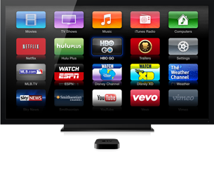
Choose from thousands of current and classic movies and TV shows from iTunes — many in stunning 1080p HD. And access content from Netflix, Hulu Plus, YouTube, Vimeo, and more.

Wirelessly play video, show off photos, and enjoy music and more from your iOS devices on your widescreen TV and home entertainment system.

