Bose Soundlink Mobile Travel Package

Description
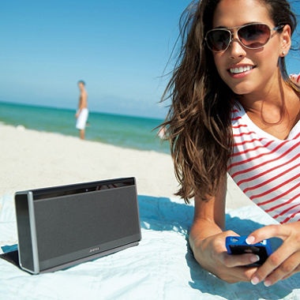
The speaker is small enough to take with you, so you can enjoy Bose sound wherever you go. The speaker connects wirelessly to your mobile phone or any Bluetooth® device. Bose proprietary technology delivers deep, low notes for a full-range listening experience. The SoundLink® speaker’s sleek design features a Black aluminum grille and brushed chrome end caps. It has an integrated cover made of durable Slate Gray nylon, which protects it during transport. It?s easy to put the speaker in your bag and take it with you to the park, the beach or anywhere you go. Plus, the cover unfolds into a stand. The automatic sleep-mode powers down the speaker when you close the cover. You can keep the party going for hours with a rechargeable lithium-ion battery. And the speaker has an auxiliary input for use with other devices.
Bundle includes: SoundLink® Wireless Mobile speaker and SoundLink® Wireless Mobile car charger.

Specifications

- Full-range sound from a small Bluetooth® speaker, thanks to proprietary Bose technologies
- Bluetooth® technology enables high-quality, wireless stereo performance from your smartphone or other source to the SoundLink® speaker
- Compact size lets you take the speaker anywhere; it's small and lightweight enough to carry in one hand or place in a backpack or travel bag
- Rechargeable lithium-ion battery delivers more power and longer playing time than other rechargeable batteries ? up to 8 hours
- Integrated cover protects the speaker and unfolds into a stand for instant playing anywhere
- Convenient controls for power and volume located on speaker itself; other functions controlled by your mobile phone or other Bluetooth device. No remote needed
- 30-foot wireless range lets you keep your phone or other device with you and place the SoundLink speaker where you want
- USB port for software updates ensures ongoing Bluetooth device compatibility
Assembled Size • 5.1"H x 9.6"W x 1.9"D • 2.8 lbs.

