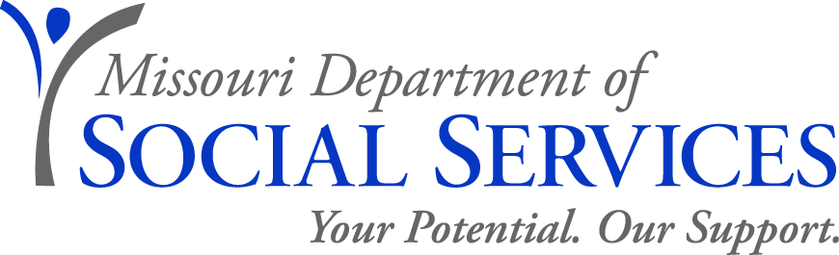

JOB ANNOUNCEMENT

Vocational Rehabilitation Counselor for the Blind
or Senior Vocational Rehabilitation Counselor for the Blind
Family Support Division, Rehabilitation Services for the Blind
Greene County (1 position)
August 1, 2014

The Family Support Division, Rehabilitation Services for the Blind, is seeking applications for the position of Vocational Rehabilitation Counselor (VRC) for the Blind or a Senior Vocational Rehabilitation Counselor (SVRC) for the Blind. This position is based in the Springfield office in the Greene County RSB Office located at 149 Park Central Sq., Room 640, Springfield, MO, 65806.
JOB DUTIES: The Vocational Rehabilitation Counselor works under the general supervision of the District Supervisor but exercises increasing independence and initiative within established agency guidelines.
The Vocational Rehabilitation Counselor is responsible for assisting blind and visually impaired clients to obtain, or retain employment. VRC’s provide guidance and counseling regarding the client’s personal and vocational adjustment throughout the rehabilitation process, assists clients through informed choice in determining appropriate vocational goals and is a resource for clients seeking information regarding employment and employment goals. VRC’s determine eligibility for services, assesses vocational, social, and medical needs through appropriate testing and medical reports. Essential job duties include conducting initial interviews with vocational rehabilitation applicants; determining eligibility for the vocational rehabilitation program. VRC’s conduct comprehensive vocational evaluations assist the client in determining employment goals consistent with their interests, abilities and capabilities and to determine specific needs to reach the chosen vocational goal. Serves as a resource to service providers; coordinates and authorizes fiscal expenditures based on an agreed to individualized plan of employment.

VRC’s will assist clients to obtain an employment outcome using a variety of job development and job placement strategies including contacting employers, assessing employers’ needs, and providing resources and education to employers and clients. Counsels and guides the clients in the establishment of self-employment goals. VRC’s become familiar with and implement service provision in accordance with statutory and regulatory requirements. VRC’s serve as a liaison providing education, technical assistance, and resource sharing to clients, families, and community stakeholders including service providers, the business community, government agencies, schools, and healthcare professionals.
QUALIFICATIONS FOR VRC: Applicants must meet the following minimum qualifications: Possession of a Master’s Degree from an accredited school of rehabilitation counseling, counseling, guidance and counseling, clinical psychology, counseling psychology, or social work. (Possession of a current Certified Rehabilitation Counselor certification issued by the Commission on Rehabilitation Counselor Certification will substitute for possession of the Master’s Degree.)
QUALIFICATIONS FOR SVRC: Possession of a Master’s Degree from an accredited school of rehabilitation counseling, counseling, guidance and counseling, clinical psychology, counseling psychology, or social work and two years experience as a VRC with Rehabilitation Services for the Blind or comparable experience in other vocational rehabilitation programs.
OR
Possession of a current Certified Rehabilitation Counselor certification issued by the Commission on Rehabilitation Counselor Certification and two years of experience as a VRC with Rehabilitation Services for the Blind or comparable experience in other vocational rehabilitation programs.
SALARY RANGE: Annual salary range for VRC is $34,596 - $48,636. If filled as a SVRC, annual salary range is $37,176 - $52,680.
TO APPLY: Interested applicants must forward a completed Paper Application for Merit System Employment (http://oa.mo.gov/pers/howtoapply.htm) and official transcripts to Annette Summers (fax number 314 - 877-2761). Upon accessing the web site, select "Paper Application Form" because the EASe on-line process is not yet available for these positions. Even if you are already on a register, you must submit a Paper Application for Merit System Employment to Ms. Summers on or before August 15, 2014. If you have questions regarding this position, please contact Randy Custer at (417) 895-6391.
Transfers – Individuals who are a currently a VRC or SVRC and are not on probation or a corrective action plan, and are seeking a lateral transfer (same range), please provide a transfer application (http://www.oa.mo.gov/pers/TranRempAppt.htm ) to Ms. Summers to the fax number as instructed above and to the Office of Administration at 573- 526-5382.
RECRUITMENT AREA: Accepting applications from all qualified applicants.
APPLICATION DEADLINE: Friday, August 15, 2014 by 5:00 p.m.
Applications will be subject to review prior to scheduling interviews
DSS IS AN EQUAL OPPORTUNITY EMPLOYER

