The Missouri Association of Guide Dog Users, a division of the
National Federation of the Blind of Missouri, presents:
The Tools in your Toolbox:
A Seminar on Travel and Navigation
This is your opportunity to learn more about the tools, we, the blind,
can use to travel confidently and successfully. Presentations will
feature everything from guide dogs to GPS and we will discuss in depth the application of these tools in our lives.
How to make wrenching decisions
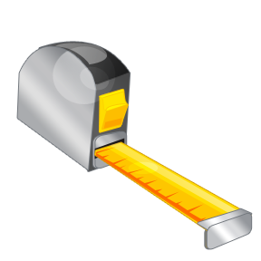Measuring up…
Driving towards the goals you have set

When: Saturday, October 25, 2014 from 10AM to 4PM
Where: The Kansas City Westport Library
118 Westport Road, Kansas City, Missouri 64111
Cost: $5 (includes lunch) RSVP by October 18th to:

Julie McGinnity at (314) 610-7740
Email: kaybaycar@gmail.com

