To Host a call and control what is going on:
Call the access number 1-567-704-7446
Enter the conference Id 4743226* then enter the host ID 874-1774#
You are now hosting
To call as a participant:
Dial the access number 1-567-704-7446
Then dial the conference ID 4743226#

Host Keypad Controls
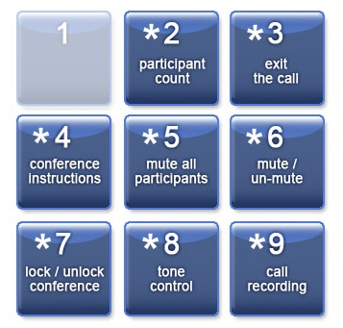
- Caller Count - *2 key (Host only)
Allows the host to get a count of how many callers are on the call.
- Exit Conference - *3 key
Exits the conference call (disconnect).
- Instructions - *4 key
Plays a menu of touch tone commands.
- Conference Modes - *5 key (Host only)
The default mode is open conversation (you can change the default mode in your Portal). Pressing the *5 key will switch the mode (assuming your default is "Open Conversation") from default to one of the following:
  - Press once: Q and A mode. Mutes the audience. The audience can un-mute their own phone by pressing *6 for questions or guest speakers
  - Press again: Presentation Mode. Puts the audience into mute mode where they will be unable to un-mute their phone.
  - Press third time: Will set the call back into default open conversation mode.
- Mute - *6 key
Pressing *6 will mute the line. Pressing *6 again will un-mute the line.
- Security - *7 key (Host only)
Pressing *7 will secure the conference and block all other callers attempting to enter. Pressing *7 again will re-open the conference to all others who wish to join.
- Tone Control - *8 key (Host only)
The default setting is Entry and Exit tones ON (you can change the default tone setting in your Portal). Pressing the *8 key will switch the mode from default (assuming your default is "Entry and Exit tones ON") to one of the following:
  - Press Once: Sets entry and exit tones to OFF.
  - Press again: Sets entry tone to OFF, and exit tone to ON.
  - Press third time: Will set the call back into default with both tones ON.
- Call Recording - *9 key (Host Only)
Pressing *9 will begin recording the call, and callers will hear an announcement; Pressing *9 again will stop the recording. Playback of the recording is available 10 minutes after the call for 30 days. Recordings can be downloaded or Emailed from the website.
You can record a custom Audio greeting by going to the website and look for the Custom Audio button.We are set up for up to 6 hours of continuous recording.

