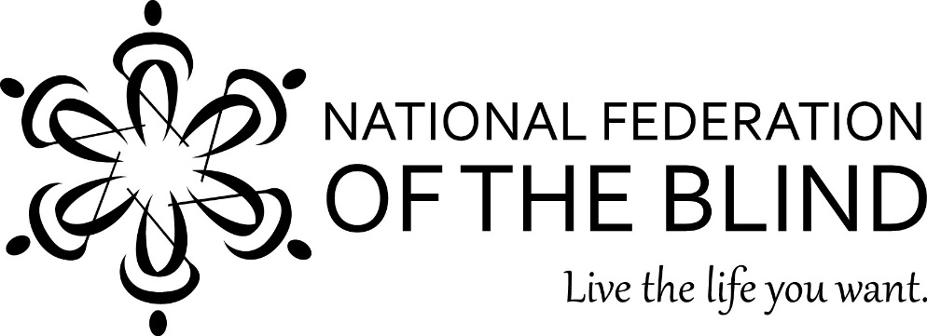
The National Federation of the Blind of Illinois Presents a Seminar for Parents and Teachers

“Raising the Bar”

Saturday April 18, 2015
8:00 a.m. to 5:00 p.m. -- Chicago Midway Marriott Hotel
On Saturday, April 18, 2015, the National Federation of the Blind of Illinois will hold concurrent annual Spring Seminars for Students and Parents at the Chicago Marriott-Midway Hotel, 6520 S. Cicero Ave., Chicago, Il. 60638. These seminars will be a day-long event consisting of meetings for visually impaired students, teachers and parents of children with visual impairment or blindness. Topics will include socialization, education, assistive technology, development of requisite blindness skills, and much more.
Our keynote speaker is Natalie Shaheen, director of education programs at the NFB Jernigan Institute in Baltimore.
Children ages three to twelve are invited to participate in Kids Camp. This all-day program will provide children with the chance to try new activities and to meet other young people who are also visually impaired or blind. Siblings of your visually impaired child are very welcome.
The student seminar is appropriate for anyone age 13 and older who is a student or interested in student issues. This seminar is run by our Illinois Association of Blind Students. We will have demonstrations of adaptive sports opportunities such as Judo, Beep Kickball, and Goalball. Our guest speaker for the Beep Kickball event will be Judy Byrd of Atlanta, the inventor of the game.
Cost: $30 for parents’ seminar; $15 for our student seminar; and $10 for ages 3 to 12, including box lunches. Overnight accommodations are available for $109 at the Chicago Midway Marriott by calling 708) 594-5500. Indicate that you are asking for the National Federation of the Blind rate. For those traveling from outside the Chicago-metro area, financial assistance may be available. Please apply through the Chappell-Dennis Memorial Awards at www.nfbofillinois.org on or before March 15, 2015
The National Federation of the Blind (NFB) is a 50,000-member organization that works to insure the full participation of blind people in all aspects of society. The National Organization of Parents of Blind Children (NOPBC) is a division of NFB that has been helping to spread a positive message about vision loss to parents for more than twenty-five years.
If you would like to attend the seminar, please submit the registration form by April 3, 2015. For more information, please contact Debbie Kent Stein at (773) 203-1394 or dkent5817@att.net. Vision impairment can be reduced to a nuisance with proper training. Please come and learn how.

