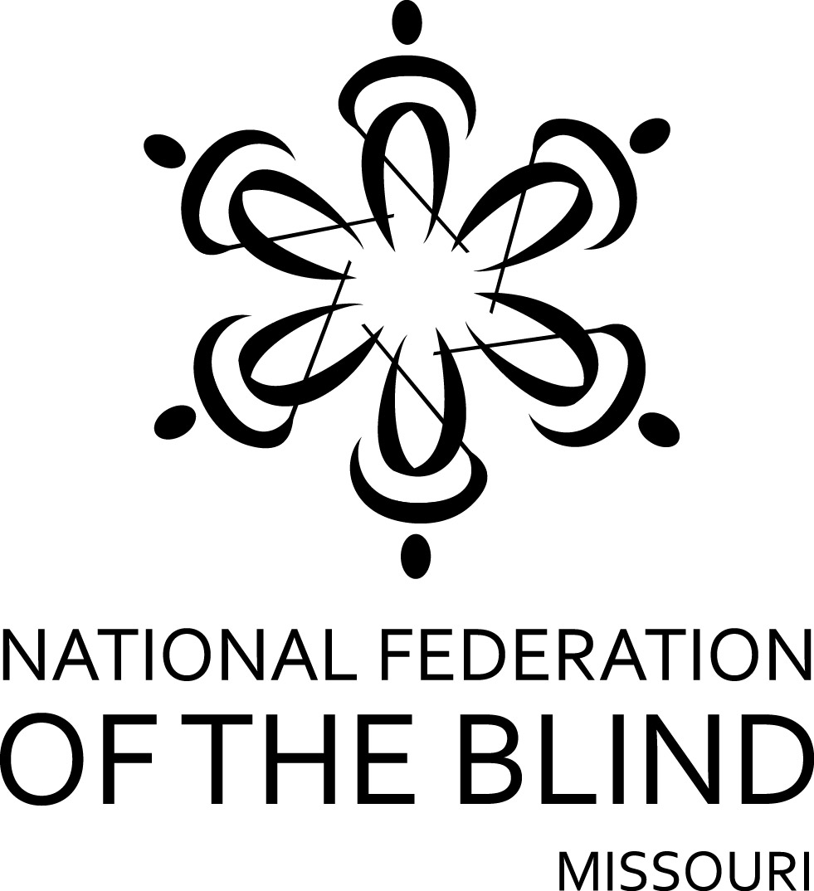

FIFTY-THIRD ANNUAL CONVENTION

NATIONAL FEDERATION OF THE BLIND
OF MISSOURI

March 27 to March 29, 2015

Sheraton Clayton Plaza Hotel
7730 Bonhomme Avenue; Clayton, Missouri 63105
(314) 863-0400
PLEDGE OF THE
NATIONAL FEDERATION OF THE BLIND

I pledge to participate actively in the effort of the National Federation of the Blind to achieve equality, opportunity, and security for the blind: to support the policies and programs of the Federation and to abide by its Constitution.

The Lewis and Clark chapter welcomes everyone to our wonderful city where we have proudly represented the National Federation of the Blind of Missouri for eleven years. We welcome you to the Gateway to the West. Saint Louis was founded in 1763 because of its location on the Mississippi River, high bluffs, and excellent forests. The area has always been a place to stop before moving westward. The metropolitan area is full of history and charm. Residents and visitors experience both the bustle and excitement of the city and the feel of a small town community. We promise to welcome you and show you the hospitality and good old fun for which our area is known. We in St. Louis are known for our award-winning baseball team, our quite-respectable football team, our Gateway Arch, and, of course, for our Lewis and Clark chapter. Our goal is to make you feel welcome, to be glad you have come, and to help our organization in making life better for blind people.

Members of our Lewis and Clark chapter cordially invite you to drop by the hospitality room. It is in Gallery 8 and will be open from 5:00 PM to 11:00 PM Friday evening.
The hotel restaurant is open from 7:00 AM until 11:00 PM. Room Service is open from 6:00 AM until 11:00 AM for breakfast, from noon until 3:00 for lunch, and from 5:00 to 11:00 PM for dinner.
Check-out time for the hotel is 12:00 PM on Sunday. Since our sessions sometimes run up until noon, we encourage those who can to checkout before the Sunday morning session.
The hotel has a guide dog relief area. Please check with the desk to be directed to it, and be prepared to pick up to keep the area clean for other guide dogs that follow you.
Please remember that all of our events are smoke-free, and the hotel reserves the right to fine anyone who leaves a room that has been used for smoking. If at check-in your room smells like smoke, get someone from the hotel to visit it so you are not charged with committing the abuse.
Registration will be held Friday evening in the lobby of the Gallery room from 5:30 PM until 8:00 PM and again on Saturday morning from 8:00 AM to 8:30 AM. Registration at the convention will cost $20 per person, and banquet tickets will cost $35. Please register so you will be eligible for door prizes and other convention activities. Even if you have preregistered, you should come to this area to pick up your registration packet. Also remember to check out the exhibits, which will be near the registration table.
This year's luncheons on Friday and Saturday will be at noon in Gallery 5-7. If you did not get your tickets through preregistration, please see if they are still available as soon as possible since these are the first counts the hotel will need.
A prayer breakfast led by the Lewis and Clark chapter will be held on Sunday morning at 7:00 AM in Gallery 5-7.
Door prizes will be given throughout the convention, and each chapter is encouraged to bring their donations to the registration table in the exhibit area. You must be in the room or must be working on convention business to win.
The general sessions on Saturday and Sunday will be held in Gallery 1 on level 2. The reception and banquet will be held on level 3 in Fleur de Lys A. Since elevator capacity is limited, please start for events a bit early. You won’t want to miss anything, and, if you are a presenter, you know how difficult it is once we get behind on the agenda.

FRIDAY, March 27

9:00 AM Diabetes Action Network—Debbie Wunder, President
Level 2, Gallery 8

9:00 AM Seminar for Parents of Blind Children—Rosina Foster, President
Level 2, Gallery 3

1:00 PM Employment Research Committee Seminar—Alice Conway, Chairman
Level 2, Gallery 1

3:30 PM NFB of Missouri Board Meeting
Level 2, Gallery 1

5:05 PM Scholarship Committee meeting—Dan Flasar, Chairman
Level 2, Gallery 1

5:30 PM Dog Guide Division—Julie McGinnity, President
Level 2, Gallery 3

7:00 PM Missouri Association of Blind Merchants—Gene Fleeman, President
Level 2, Gallery 4

7:00 PM Membership Committee—Debbie Wunder, Chair
Level 2, Gallery 1

7:00 PM The Missouri Association of Blind Students Seminar—Cari Ford, President
Level 2, Gallery 3

8:00 PM Resolutions Committee—Erin Magoon, Chair
Level 2, Gallery 1

9:00 PM Ways and Means Committee—Carol Morgan, Chair
Level 2, Gallery 4

10:00 PM Nominating Committee—Melissa Smith, Chair
Room to be announced by the Chair

SATURDAY, March 28

6:30 AM Scholarship Breakfast (Scholarship Recipients and committee members), Dan Flasar, Chair
Gallery 5

General Session—Gallery 1

8:15 AM Call to order
National Anthem, Cecilia Lee
Moment of Silence

8:20 AM Welcome from the Lewis and Clark Chapter—Chris Tisdal, President

8:40 AM Introduction of scholarship winners—Dan Flasar

8:45 AM Welcoming our visitors from out of state

9:00 AM Report of the Nominating Committee—Melissa Smith, Chair

9:05 AM Making things happen for seventy-five years—A National Report—James Gashel, Secretary, National Federation of the Blind

9:40 AM Questions from the floor

9:50 AM Ten minute break

10:00 AM The new kid at Wolfner Library—Donna Riegel, Director, Wolfner Library for the Blind and Physically Handicapped

10:20 AM Questions from the floor

10:30 AM Delta Gamma Center for Children with Visual Impairments – working together to assure that blind youth can fully participate in their families and community—Debbie Naucke, Executive Director, Delta Gamma Center for Children with Visual Impairments

10:50 AM Questions from the floor

11:00 AM Resolutions and Constitutional amendments—Erin Magoon, Chairman, Resolutions Committee

11:25 AM Changes in Blind Pension and the role of the National Federation of the Blind in making it happen—Gene Coulter, Social Services Liaison

11:35 AM Presidential Report—Gary Wunder, President National Federation of the Blind of Missouri

12:00 PM Adjourn

1:30 PM Crowning of the King and Queen—Carol Morgan, Chairman, Ways and Means Committee

1:45 PM Education, employment, WIOA, and a status report from RSB—Kevin Faust, Deputy Director, Missouri Rehabilitation Services for the Blind; Michael St. Julian, Assistant Deputy Director, Missouri Rehabilitation Services for the Blind

2:15 PM Questions from the floor

2:25 PM The Echo of the BELL: A ringing success in 2014—Debbie Wunder, Coordinator, Braille Enrichment for Literacy and Learning; Adnan Gutic, Chief Braille Instructor; Richie Tienter, student; Kendra Damron, student; Kathy Hurley, grandmother

3:00 PM Afternoon break

3:10 PM It’s not just classes and grades: personal examples of why we need the TEACH Act—Bethany Bennington, Biochemistry Major with Health Sciences focus; Julie McGinnity, Masters of Music and Vocal Performance; Cari Ford, Bachelor of Social Work; Amy Plumlee, Bachelor of Social Work

3:40 PM Questions from the floor

3:50 PM Challenges facing the Business Enterprise Program in Missouri and throughout the country—Gene Fleeman, Military Dining Contract Manager, Ft. Leonard Wood and President, Missouri Association of Blind Merchants; Harold Wilson, manager, PTO Concessions, US Patent and Trade Office and Vice President, National Association of Blind Merchants

4:20 PM Employment of the blind: Here’s how it works for me—Alice Conway, Assistant General Counsel, Commercial and Employment Law, Monsanto Corporation; David Hertweck, Principal Engineer, Bausch & Lomb; Julie McGinnity, Student Assistant, Adaptive Computing Technology Center, Voice Instructor, community music program

5:00 PM Adjourn

6:00 PM Cash bar prior to banquet
Fleur de Lys A

6:30 PM Banquet of the National Federation of the Blind of Missouri—Brent Ford, Master of Ceremonies

Invocation, Pastor Wayne Lawrence

Crowning of the King and Queen

Introduction of Guests

Presentation of Awards

Other Business at the discretion of the MC

Banquet Address: James Gashel, National Representative

Auction by the Ways and Means Committee, Carol Morgan, Chairman

9:00 PM Dance to the Music; Presented by the Lewis and Clark chapter (If you don’, just sit back and enjoy the music, visit with old friends, and get to know someone new.)
SUNDAY, March 29

7:00 AM Prayer breakfast hosted by the Lewis and Clark chapter Gallery 5-7

General Session—Gallery 1

8:30 AM Call to Order

8:35 AM Report of the Audit Committee—Dan Flasar, Chair

8:45 AM Reading of the Treasurer's report—Carol Coulter, Treasurer

9:05 AM Governmental Affairs report—Shelia Wright, Chairman

9:20 AM A report from our Ways and Means Committee—Carol Morgan,
Chairman

9:30 AM Membership report—Debbie Wunder, Chairman

9:40 AM Exploring your full potential by attending an NFB center—Dan Wenzel, Executive Director, BLIND, Inc.; Matt Higgins, student, BLIND, Inc.; David Nietfeld, Travel Instructor, Colorado Center for the Blind; Maureen Nietfeld, Home Management Instructor, Colorado Center for the Blind; Chris Parsons, Technology Instructor, Colorado Center for the Blind

10:10 AM Resolutions and Constitutional amendments continued—Erin Magoon, Chairman

10:20 AM New credit card technology and the blind—Gary Horchem, Web Master, National Federation of the Blind of Missouri

10:30 AM Elections

11:00 AM My life as a school teacher—Harold Wilson

11:15 AM Fighting for the right to keep our children: the blind reach out to Children’s Services Workers—Carol Coulter, Parent Advocacy Coordinator

11:25 AM Old business

11:35 AM New business: Appropriation of Funds to tenBroek, the national treasury, SUN Fund, national convention stipend
Matters Presented from the Floor

12:00 PM Adjourn

