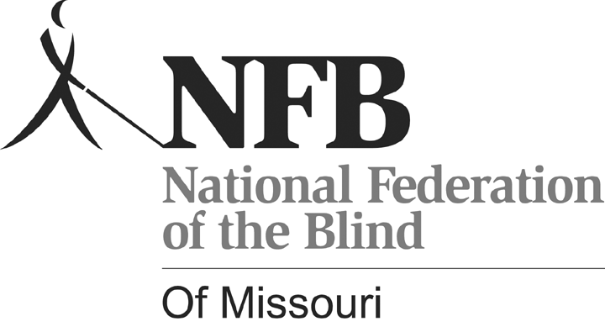

Gary Wunder, President

3910 Tropical Lane

Columbia, MO 65202-6205

Phone (573) 874-1774 www.nfbmo.org

LEGISLATIVE AGENDA OF BLIND MISSOURIANS

PRESENTED TO

THE SECOND SESSION OF THE NINETY-EIGHTH GENERAL ASSEMBLY

From: The National Federation of the Blind of Missouri

Date: February 8 & 9, 2016

We appreciate the opportunity to meet with you and your staff about the legislation that can improve the lives of blind people in Missouri. Members volunteer our time, energy, and resources to reach out to newly blind people. The issues we bring to you stem from real life experiences that we as blind people face: issues that create barriers to employment, community involvement, and everyday life. The NFB has worked with the Missouri Legislature for many years to find solutions that help blind people fully engage in their community--solutions that lead to opportunity and productivity. We promote programs that encourage self-determination, independence, and equality of opportunity. Sometimes the solution requires a change in state statutes. We hope you will stand with us to resolve these issues in Missouri.

**Waiver of Rights to Damages by Blind Employee**

There is a very old and discriminatory statute that has been in effect since the early 1900s. It conflicts with equal employment opportunities outlined in today’s state and federal laws. Yet unemployment among the blind is at 70%. Many Employers still have reservations about hiring a blind person--reservations that are based on misconceptions about blindness. It is not uncommon for a blind person to be told by an employer that he or she would like to hire one of us, but their insurance company will not allow them to do so. These actions stem from erroneous facts, are in violation of Missouri’s insurance laws, and simply represent some of the fear and misconceptions we must combat as we look for jobs. It is also why we as blind advocates believe this statute allowing this Waiver is detrimental and must be removed from state statutes.

Here is the reference: 537.170. It shall hereafter be lawful for any blind person over the age of eighteen years to agree to and with his or her employer to waive his or her right to damages or compensation for any personal injury arising out of or in the course of his or her employment for which injury such blindness was the direct or contributory cause, and any such agreement shall be valid and binding upon the parties thereto.

Members of the National Federation of the Blind are calling for your assistance in repealing this statute. This legislation should not be controversial, and the bill should not have a fiscal note.

**Required Identification to Purchase Alcohol**

The National Federation of the Blind worked hard to get Missouri to establish a non-driver’s license to meet the need for valid identification for Missourians who are unable to drive, and, when that form of identification still was not accepted as a valid identification because it did not have an expiration date, we went back to the legislature to advocate that an expiration date be added to the non-driver’s license, thus requiring renewal and keeping it current. Therefore, we were concerned when a thirty-five year old blind chemist, business owner, and a former professor with a PhD in chemistry came to Missouri on business, and an establishment in St. Joseph refused to sell him a drink. Significant business often transpires over drinks and dinner. Imagine the awkwardness this situation would create and the way such discrimination could impact the impression that somehow the blind person is different, maybe less responsible. This individual did have a valid non-driver’s license from the state where he resides, but an obvious omission in current law acknowledges only a driver’s license or a Missouri State ID as valid forms of identification.

When this discriminatory action came to our attention, we researched Missouri law to determine how this could happen in our state. We learned that the applicable state statute actually lists the required forms of identification that are accepted as valid identification to verify age when purchasing alcohol. While it included our Missouri non-driver’s license and an out-of-state driver’s license, it did not include an out-of-state non-driver’s license. Therefore, we have been advised by a lawyer and by the office of Missouri’s attorney general that changing this practice will require legislation amending Missouri Statute 311.328, which states “the valid forms of identification are a Missouri driver's license, a Missouri issued non-driver identification card, a valid driver's license issued by any other state, {a valid non-driver's license issued by any other state,} a military identification, or a passport. Servers are further allowed to limit the forms of identification they accept by not accepting military ID's or passports.”

We trust that this language in the statute is a matter of omission and not an intentional decision. Whether intentional or merely an oversite, this statute permits a server or store owner to discriminate against blind people who may visit Missouri or who may be planning to bring business to Missouri. Let’s make this a welcoming state by introducing legislation to amend this statute. Our suggested language appears above with the wording in brackets. Will you help with this issue?

**Accessible Voting In All Elections**

The Help America Vote Act (HAVA) recognizes the right of the blind to vote privately and independently by requiring nonvisual access for the blind through the use of accessible voting systems in all federal elections. Electronic voting technologies, designed and properly configured with nonvisual access, provide blind voters with the ability to cast their votes privately and independently and to verify, without sighted assistance, that their ballots accurately reflect their voting choices. Electronic voting systems were certified and purchased, and each polling place has at least one accessible voting machine. All certified machines in Missouri provide a paper trail.

The Missouri Secretary of State’s office has been evaluating newer accessible machines that mark directly on the paper ballot. The options are there if legislation is passed to make the paper ballot the official ballot of Missouri and, as the existing machines need to be replaced, the technology will be available. The accessible machines are already required for the state to comply with HAVA, the Help America Vote Act. Some election boards may set these machines up more frequently than others, but many polling places only use them in federal elections. A secret ballot should not depend on which offices are up for election. We are asking that accessible machines are consistently available in all elections. The cost of setting them up should be minimal since text-to-speech options are available. Concerted effort is made to get voters to the polls; Missouri should assure that, when they arrive, blind voters have the means to cast their ballots privately and independently. Please help pass HB 1379, and grant disabled voters the same privilege you take for granted as you exercise your right to vote, and ensure this happens for all elections.

The National Federation of the Blind knows that blindness is not the characteristic that defines blind people or their future. Every day we raise the expectations of blind people, because low expectations create obstacles between blind people and our dreams.

“Blindness is not what holds us back.”