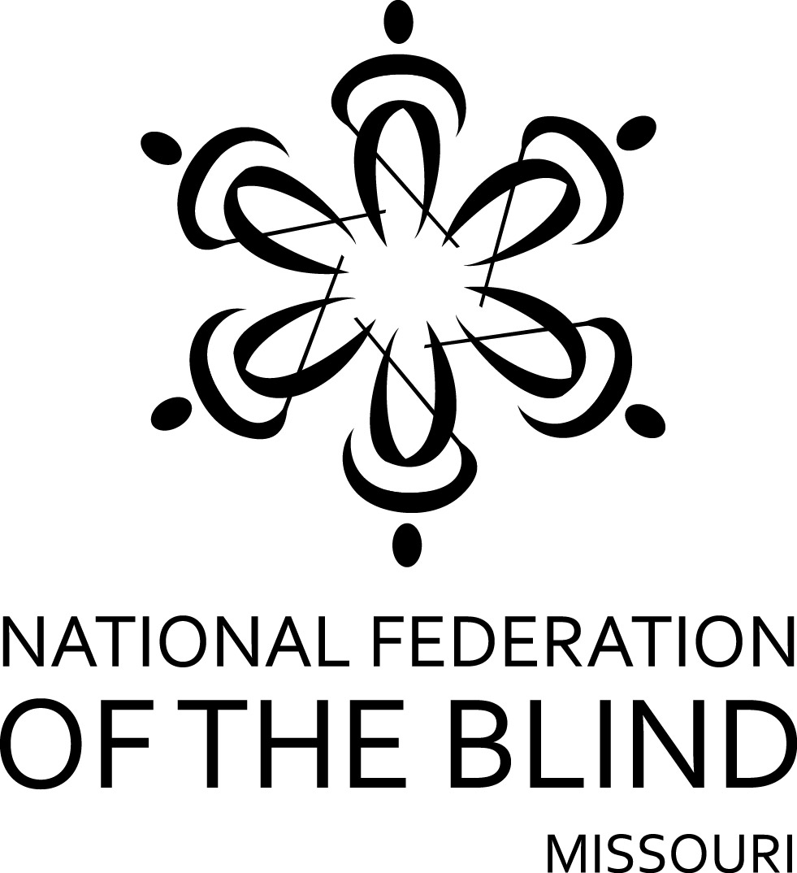

FIFTY-FOURTH ANNUAL CONVENTION

NATIONAL FEDERATION OF THE BLIND
OF MISSOURI

April 1 to April 3, 2016

Doubletree by Hilton Hotel
2431 North Glenstone Avenue; Springfield, Missouri 65803
(417) 831-3131
PLEDGE OF THE
NATIONAL FEDERATION OF THE BLIND

I pledge to participate actively in the effort of the National Federation of the Blind to achieve equality, opportunity, and security for the blind: to support the policies and programs of the Federation and to abide by its Constitution.

Welcome to Springfield! Three brothers, along with their families, arrived in this area early in 1830 and were quickly followed by other settlers. Named to honor Nathanael Greene, of Revolutionary War fame, Greene County was organized in 1833 and once composed the entire southwest corner of the state. On February 18, 1838, the town of Springfield was established. National attention was given to Springfield in 1858 when the city became a stop on the Butterfield Overland Mail, a stagecoach line, from Tipton, Missouri, to San Francisco, California.
Springfield is recognized as the birthplace of Route 66. In 1938 Route 66 became the first US numbered road in America—the “Mother Road”—stretching from the Great Lakes to the Pacific Coast. The red booths and gleaming chrome in mom-and-pop diners, the stone cottages of tourist courts, and the many service stations along this route saw America fall in love with the automobile. Red’s Giant Hamburger, said to be the birthplace of the drive-up order window, was located on the route.
A “big, small town,” Springfield offers a great blend of fascinating attractions, historical treasures, sports excitement, and cultural and leisure activities in a welcoming environment. The city offers 102 parks, including a linear trail system that integrates with the city’s growing on-street bike route system; an airport; an art museum; a zoo; the Springfield Lasers professional tennis team; and the Springfield Cardinals minor-league baseball team. Our city is home to Bass Pro Shops, Missouri State University, Drury and Evangel universities, and the Assemblies of God USA.
We are also delighted to have you here to help us celebrate the fortieth birthday of the NFB Springfield Chapter. We continue to work hard to bring to life our motto in the Springfield area—Live the Life You Want!
Members of our chapter cordially invite you to drop by the hospitality room. It is in the Aleck Scott Room and will be open from 5:00 PM to 10:00 PM Friday evening.
Houlihan’s restaurant opens at 11:00 AM closing at midnight on Friday and Saturday. It is open from 11:00 AM to 11:00 PM Sunday through Thursday. Gracie’s complete buffet with omelet station is open daily for breakfast from 6:00 AM to 10:00 AM Monday through Friday and 7:00 to 11:00 AM Saturday and Sunday. Room Service is also available from 11:00 AM to 11:00 PM. Lastly, the Ozark Mountain Buffet, which features a more limited selection, is open for breakfast from 7:00 AM to 9:00 AM.
Check-out time for the hotel is 12:00 PM on Sunday. Since our sessions sometimes run up until noon, we encourage those who can to checkout before the Sunday morning session.
The hotel has a guide dog relief area. Please check with the desk to be directed to it, and be prepared to pick up to keep the area clean for other guide dogs that follow you.
Please remember that all of our events are smoke-free, and the hotel reserves the right to fine anyone who leaves a room that has been used for smoking. If at check-in your room smells like smoke, get someone from the hotel to visit it so you are not charged with committing the abuse.
Registration will be held Friday morning in the Rathdangen Foyer from 8:15 to 9:00 AM. It will be held again from 5:00 until 7:00 PM in the same location. On Saturday Registration will be held 8:00 to 8:30 AM, again in the same location. Registration at the convention will cost $20 per person, and banquet tickets will cost $35. Please register so you will be eligible for door prizes and other convention activities. Even if you have preregistered, you should come to this area to pick up your registration packet. Also remember to check out the exhibits, which will be near the registration table.
This year's lunch on Friday and Saturday will be at noon in Gracie’s Restaurant. If you did not get your tickets through preregistration, please see if they are still available as soon as possible since these are the first counts the hotel will need.
A prayer breakfast led by the Springfield chapter will be held on Sunday morning at 7:00 AM.
Door prizes will be given throughout the convention, and each chapter is encouraged to bring their donations to the registration table in the exhibit area. You must be in the room or must be working on convention business to win. Please see that prizes get to Laura Rios, this year’s door prize chairman.
The general sessions on Saturday and Sunday will be held in the Rathdangen Ballroom. The same is true for the banquet.

FRIDAY, April 1

9:00 AM Diabetes Action Network—Debbie Wunder, President
Rathdangen 1

9:30 AM Seminar for parents of blind children—Rosina Foster, President
Rathdangen 3

12:00 PM Luncheon, Gracie’s Restaurant

1:15 PM NFB of Missouri board meeting
Rathdangen 1

2:30 PM Membership Committee meeting—Debbie Wunder, Chairman
Rathdangen 1

3:45 PM Ways and Means Committee—Carol Morgan, Chair
Rathdangen 1

6:00 PM Resolutions Committee—Erin Magoon, Chair
Rathdangen 1

7:15 PM Dog Guide Division—Julie McGinnity, President
Rathdangen 2

8:00 PM Missouri Association of Blind Merchants—Gene Fleeman, President
Rathdangen 3

8:30 PM The Missouri Association of Blind Students Seminar—Bethany Bennington, President
Rathdangen 2

10:00 PM Nominating Committee—Chris Tisdale, Chair
Charles H. O’Reilly Jr. Board Room

SATURDAY, April 2

6:30 AM Scholarship Breakfast (Scholarship Recipients and committee members), Julie McGinnity, Chair
Charles H. O’Reilly Jr Board Room

General Session—Rathdangen Room
8:15 AM Call to order
National Anthem, Dacia Cole
Moment of silence

8:20 AM Welcome from the Springfield Chapter—Erin Magoon, President

8:40 AM Introduction of scholarship winners—Julie McGinnity

8:45 AM Welcoming our visitors from out of state

9:00 AM Report of the Nominating Committee—Chris Tisdale, Chair

9:05 AM A national report—Pamela Allen, Treasurer, National Federation of the Blind

9:45 AM Questions from the floor

9:50 AM Ten minute break

10:00 AM Resolutions and Constitutional amendments—Erin Magoon, Chairman, Resolutions Committee

10:30 AM Transition services and a WIOA update—Keith Roderick, Fiscal and Administrative Manager, Rehabilitation Services for the Blind

10:50 AM Questions from the floor

11:00 AM Being a blind performer: how to use the glass slipper to break the glass ceiling—Julie McGinnity, president of the Performing Arts Division of the National Federation of the Blind

11:15 AM Wolfner: we’re more than the people who send you books—Donna Riegel, Director, Wolfner Talking Book and Braille Library

11:35 AM Questions from the floor

11:40 AM If you’re going to eat it, you’ll have to burn it—Jessica Beechum, director, We Fit Wellness, Colorado Springs, Colorado

11:55 AM Important announcements about the afternoon

12:00 PM Adjourn

1:30 PM Announcing the King and Queen—Carol Morgan, Chairman, Ways and Means Committee

1:45 PM I travel, I teach, I teach travel—Ben Vercellone, Travel Instructor, Rehabilitation Services for the Blind

2:00 PM Questions from the floor

2:10 PM Presidential Report—Gary Wunder, President

2:30 PM Sleepiness during the day: I am not slothful or inattentive—Melissa Olivadoti, Senior Medical Science Liaison, Vanda Pharmaceuticals

2:50 PM Questions from the floor

3:00 PM Afternoon break

3:10 PM The blind and surviving as patients and visitors in today’s medical system—Erin Magoon, Debbie Wunder, and Carol Morgan

3:30 PM Questions from the floor

3:40 PM What stands between blind people and employment, and what can the NFB do about it—Alice Conway and members of the Employment Research Committee

4:10 PM Seniors in Charge: what the NFB has for blind seniors—Wayne Marshall, President, National Federation of the Blind of Colorado Aurora chapter; Student and Senior Services Specialist, NOMC, Colorado Center for the Blind

4:30 PM Before you can be a senior, you have to be a young person—Brent Batron, Youth Director and Assistant Director of the Colorado Center for the Blind

4:55 PM Evening logistics

5:00 PM Adjourn

6:00 PM Cash bar prior to banquet
Rathdangen Ballroom

6:30 PM Banquet of the National Federation of the Blind of Missouri—Erin Magoon, Mistress of Ceremonies

Invocation, Stan Magoon

Crowning of the King and Queen

Introduction of Guests

Presentation of Awards

Other Business at the discretion of the MC

Banquet Address: Pamela Allen, National Representative

Auction by the Ways and Means Committee, Carol Morgan, Chairman

9:00 PM Official NFB talent show: Are the blind really more musical—Sponsored by the Springfield Chapter; other music will follow, time permitting.

SUNDAY, April 3

7:00 AM Prayer breakfast hosted by the Springfield chapter—Rathdangen 3

General Session—Rathdangen Room
8:30 AM Call to Order

8:35 AM Report of the Audit Committee—Dan Flasar, Chair

8:45 AM Reading of the Treasurer's report—Carol Coulter, Treasurer

9:05 AM Governmental Affairs report—Shelia Wright, Chairman

9:20 AM A report from our Ways and Means Committee—Carol Morgan, Chairman

9:30 AM Membership report—Debbie Wunder, Chairman

9:40 AM Somebody has gone and changed my Braille, but I am a life-long Learner—Gail Bryant, Columbia Braille Teaching Services

10:00 AM So we’re giving away a KNFB Reader: who can use it, and what does it do—Amy Plumlee, President, National Federation of the Blind of Missouri, Old Drum Chapter

10:15 AM Resolutions and Constitutional amendments continued—Erin Magoon, Chairman

10:30 AM Elections

11:25 AM Old business

11:35 AM New business: appropriation of Funds to tenBroek, the national treasury, SUN Fund, national convention stipend
Matters presented from the floor

12:00 PM Adjourn

