Shingle Creek Resort
Below are a few pictures with narrative descriptions of shingle Creek from the NFB 2016 Convention. ENJOY!
Narration by: Anyee Knox
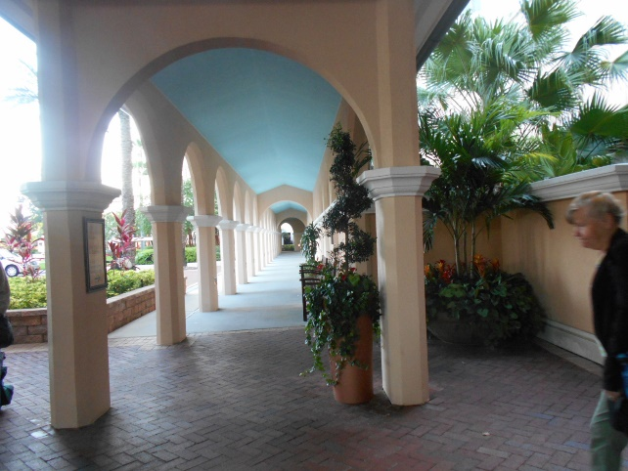
Standing on the front of Shingle Creek Hotel looking to the left. There is a brick walk way with concrete white columns going down an arched roof walkway with lots of plants.
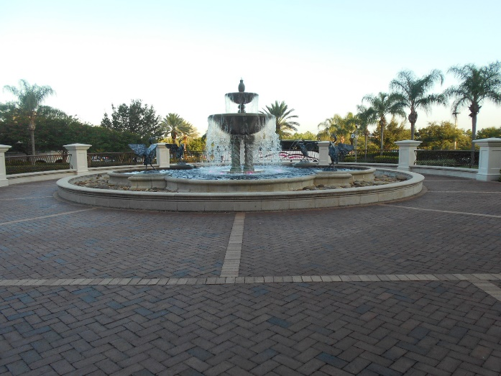
In front center of hotel. There is a water fountain made of concrete. The fountain has a piece that sticks up at the very top that leads down to a small water bowl where the water flows to a larger bowl then down to a pond. The water constantly cascade down. The waterfall is a circle where you can walk or drive around. The outside is surrounded by a gate. On the other side of the gate is a lot of palm trees and parking.
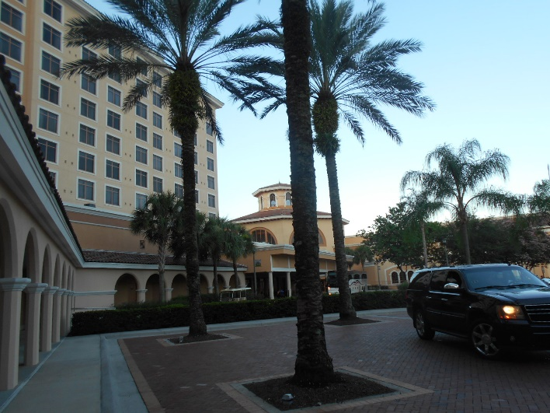
This picture view is from standing on the front in the center of Shingle Creek. Looking to the right. The hotel building is tall and tan, with a lot of windows. Next to the square building is a round dome section which also has windows. It has beautiful tall palm trees. That are brown narrow, with green branches at the top only hanging off. It also has a brick parking lot.
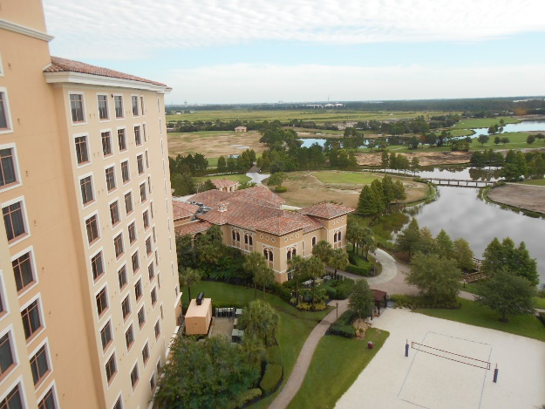
This is a high view from the 11th floor of the hotel room. Back of resort. Looking out the window you see the tall tan building with all the windows, a volleyball court, a pathway that leads to a single level tan building, lots of water and trees with a beautiful sky.
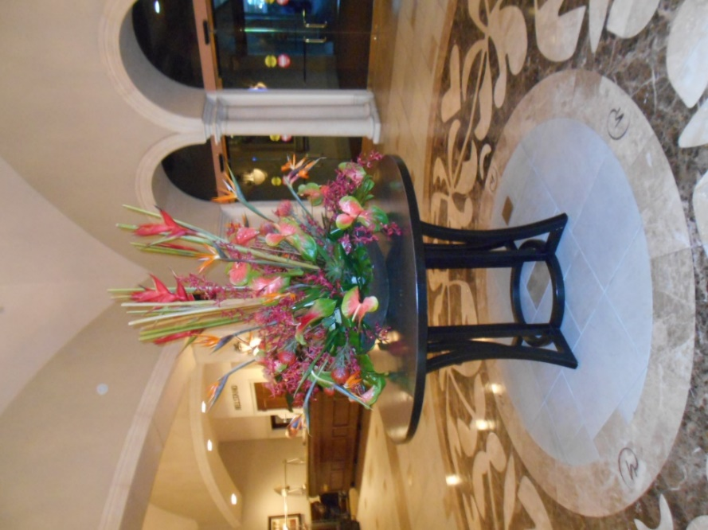
Vestibule of hotel lobby. In the center of the floor there’s a brown table that stands about 3 and a half feet tall holding a plant about 3 feet tall with flowers that are orange, purple, and green peddles. It also has a lot of colorful stems sticking out of it [very beautiful].
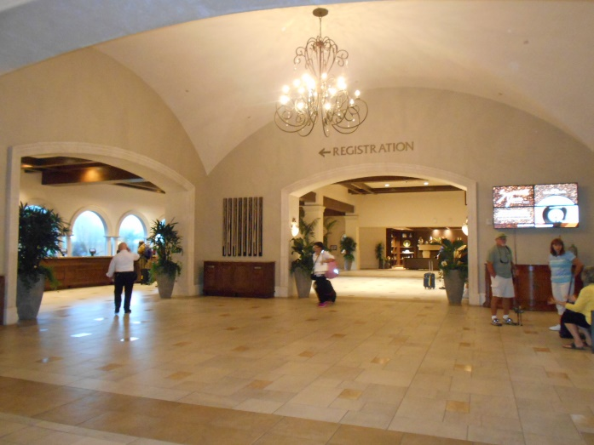
Check in area of Shingle Creek. In the hotel lobby to the left was the check in area. A beautiful dark wooden desk that was about 20 yards long, a huge chandelier hanging with lots of lights, big plants, with a large television on the wall to the right, a lot of open space with tan & gold floor tiles, Straight back is a sitting area. There are also large plants.
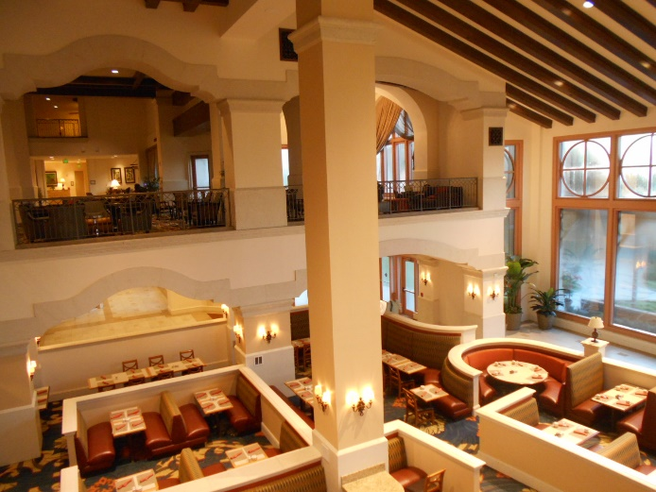
This is a picture of the dining room. From the second floor view looking down from the balcony. You can see the tables and chairs also the table décor. There are sections divided by a 4 foot wall. From here it looks like a maze. There is a tall white column that goes from the floor up to the ceiling that has lights on each sides. There are large glass windows were you can see a nice view of the sky. If you look straight across you can see the lobby.
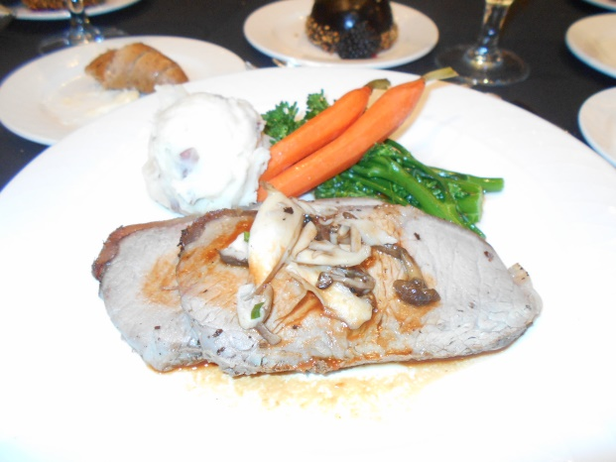
Banquet Dinner, We had medium rare sirloin steak. On the side was almond mashed potatoes, carrots, and broccoli rob. Yum-yum!
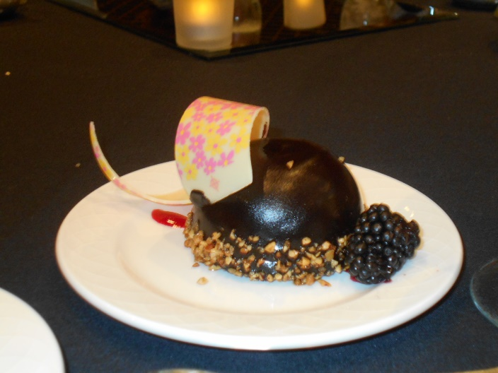
Lava berry cake Banquet dessert, This is a picture of a lava cake. Inside of this lava cake there is a multi berry compote with a berry sauce. This lava cake also has a white chocolate decoration on the top of it. This lava cake is cover with peanuts at the bottom with a black berry on the side.
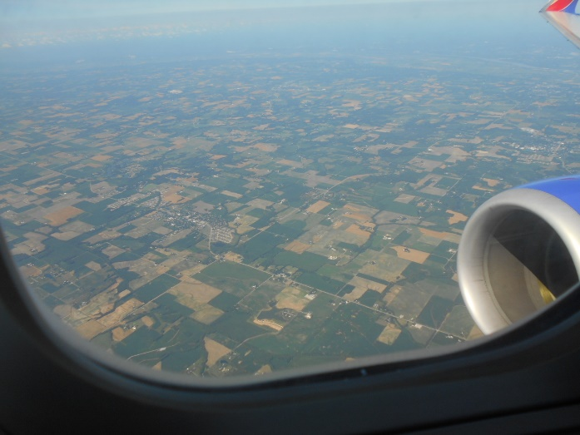
Out the window of the Southwest air plane coming home. You can see a lot of grass and small tiny buildings.

I hope that you enjoyed the descriptive pictures. Give us feedback and if you enjoyed them we can do more in the future.

Thanks,
St. Louis MO – NFB Lewis & Clark Chapter

