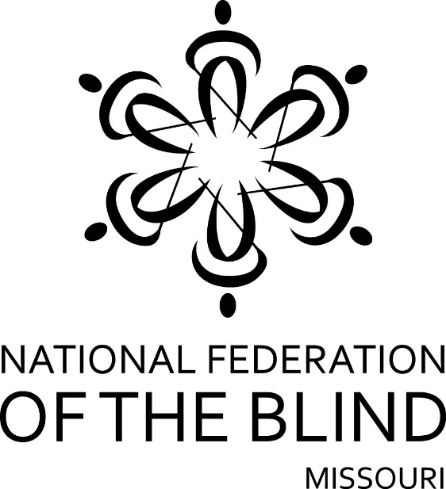

FIFTY-FIFTH ANNUAL CONVENTION

NATIONAL FEDERATION OF THE BLIND
OF MISSOURI

April 7 to April 9, 2017

Adam’s Mark Hotel
9103 E. 39th Street, Kansas City, MO 64133
(816) 737-0200
Top of Form
Bottom of Form

PLEDGE OF THE
NATIONAL FEDERATION OF THE BLIND

I pledge to participate actively in the effort of the National Federation of the Blind to achieve equality, opportunity, and security for the blind: to support the policies and programs of the Federation and to abide by its Constitution.

Welcome to Kansas City, a tremendous city that joins two states, represents the best of the old west, and the progressive ideas of the twenty-first century. From the Symphony to the stockyards, we have it all, and the Kansas City Royals and Kansas City Chiefs show that we are competitive and we are winners.
By any measure the Kansas City Chapter of the National Federation of the Blind is the springboard for what we now know as the National Federation of the Blind of Missouri. Whether we were the Progressive Blind of Missouri, the National Federation of the Blind in Missouri, the National Blind, or some other variant of our name we were forced to use by the courts, we have always been an integral part of the National Federation of the Blind, and this is clearly demonstrated not only by our past but by our current participation in the organization.
We welcome you to our city, invite you to learn about its rich history and culture, and welcome you to what we hope will be a memorable, unified, and progressive convention of the National Federation of the Blind’s Missouri affiliate.
Members of our chapter cordially invite you to drop by the hospitality room. It is in the Grand Ballroom D and will be open from 5:00 PM to 10:00 PM Friday evening.
The hotel includes several fine restaurants, among them Moore & Moore BBQ, located on the lobby level. They advertise themselves as the king and queen of BBQ and invite you to try them out and decide whether the claims are as good as the food. They will be open on Thursday from 11:00 AM until 9:00 PM. On Friday and Saturday they will be open from 11 AM until 11 PM.
If BBQ isn’t a pallet pleaser for you, consider Casey’s Bar.
Check-out time for the hotel is 12:00 PM on Sunday. Since our sessions sometimes run up until noon, we encourage those who can to checkout before the Sunday morning session.
The hotel has a guide dog relief area. Please check with the desk to be directed to it, and be prepared to pick up to keep the area clean for other guide dogs that follow you.
Please remember that all of our events are smoke-free, and the hotel reserves the right to fine anyone who leaves a room that has been used for smoking. If at check-in your room smells like smoke, get someone from the hotel to visit it so you are not charged with committing the abuse.
Registration will be held Friday morning in the Grand Ballroom Foyer from 8:15 to 9:00 AM. It will be held again from 5:00 until 7:00 PM in the same location. On Saturday Registration will be held from 8:00 to 8:30 AM in the same location. Registration at the convention will cost $20 per person, and banquet tickets will cost $35. Please register so you will be eligible for door prizes and other convention activities. Even if you have preregistered, you should come to this area to pick up your registration packet. Also remember to check out the exhibits, which will be in the Grand Ballroom foyer.
This year's lunch on Friday and Saturday will be at noon in Casey’s. If you did not get your tickets through preregistration, please see if they are still available as soon as possible since these are the first counts the hotel will need.
A prayer breakfast led by the Kansas City chapter will be held on Sunday morning at 7:00 AM. It will be in Grand E, F, and G.
Door prizes will be given throughout the convention, and each chapter is encouraged to bring their donations to the registration table in the exhibit area. You must be in the room or must be working on convention business to win. Please see that prizes get to Jeff Giffen, this year’s door prize chairman.
The general sessions on Saturday and Sunday will be held in the Grand Ballroom A, B, and C. The banquet will be in Grand E, F, and G.

THURSDAY, April 6

7:00 PM One Touch Self Defense—Roger Crome, president, NFB of Missouri Mineral Area Chapter; Amy Plumlee, president, NFB of Missouri Old Drum Chapter
The Board Room

7:00 PM Informal Gathering—unhosted, unscripted
Grand Salon C

FRIDAY, April 7

9:30 AM The Strategies We Use to be Competent, Capable and Caring Parents—Carol Coulter, Coordinator and Facilitator
Grand Salon A

9:30 AM Seminar for parents of blind children—Rosina Foster, President
Grand Salon B
9:30 AM Business Meeting, Diabetes Action Network—Grand Salon C

12:00 PM Luncheon, Casey’s

1:15 PM NFB of Missouri board meeting
Grand salon A, B, and C

2:30 PM Membership Committee meeting—Debbie Wunder, Chairman
Grand salon A

3:45 PM Ways and Means Committee—Carol Morgan, Chair
Grand salon B

6:00 PM Resolutions Committee—Erin Magoon, Chair
Grand salon A

7:00 PM One Touch Self Defense—Amy Plumlee, president, NFB of Missouri Old Drum Chapter; Roger Crome, president, NFB of Missouri Mineral Area Chapter
Grand Salon C

7:15 PM Dog Guide Division—Julie McGinnity, President
Grand salon B

8:00 PM Missouri Association of Blind Merchants—Gene Fleeman, President
Grand salon C

8:30 PM The Missouri Association of Blind Students Seminar—Holly Carneal, President
Grand Salon A

10:00 PM Nominating Committee—Melissa Smith, Chair
Room to be determined by the chairman Jr. Board

SATURDAY, April 8

6:30 AM Scholarship Breakfast (Scholarship Recipients and committee members), Julie McGinnity, Chair
Casey’s Private Room

General Session—Grand A, B, and C

8:30 AM Call to order
National Anthem, Julie McGinnity
Moment of silence

8:20 AM Welcome from the Kansas City Chapter—Ruby Polk, President

8:30 AM Welcome from the Honorable Mayor Sly James

8:40 AM Introduction of scholarship winners—Julie McGinnity

8:45 AM Welcoming our visitors from out of state

9:00 AM Report of the Nominating Committee—Melissa Smith, Chair

9:05 AM Happenings Throughout the Nation as we Keep our Promises to the Blind of America—Ronald Brown, Second Vice President, National Federation of the Blind

9:45 AM Questions from the floor

9:50 AM Fit Break—Robin House, Chairman, Sports and Recreation Committee

9:55 AM Partnering with Agencies to Improve Outcomes for Blind People—Keith Roderick, Fiscal and Administrative Manager, Rehabilitation Services for the Blind

10:15 AM Questions from the Floor

10:25 AM It’s All About Transitioning—Ian Shadrick, ??; Sheila Koenig, ??

10:45 AM Questions from the floor

10:55 AM Where is Tom—Bryan Schulz, Member, Show Me Chapter

11:05 AM CCVI: Sixty-five Years in the Blink of an Eye—Nicola Heskett, executive director, Children’s Center for the Visually Impaired

11:25 AM Questions from the floor

11:30 AM Beyond Barriers: The Future of Higher Education with the AIM HE Act—Holly Carneal, President, Missouri Association of Blind Students

11:55 AM Important announcements about the afternoon

12:00 PM Adjourn

1:30 PM Announcing the King and Queen—Carol Morgan, Chairman, Ways and Means Committee

1:40 PM Missouri Shows Them: The Missouri Assistive Technology Program Puts Missouri at the Top of the List—David Baker, director, Missouri Assistive Technology Program

2:00 PM Questions from the floor

2:10 PM The NFB Philosophy in Action: Bringing New Meaning to Training and Rehabilitation—Pamela Allen, Director, Louisiana Center for the Blind; Christine Parsons, technology instructor, Colorado Center for the Blind; Ryan Strunk, Board Member, Blindness, Learning in New Dimensions; Julie McGinnity, student, Colorado Center for the Blind

2:35 PM Questions from the floor

2:40 PM Like You, We Are All about Literacy—Abbey Rimel, Deputy Director, Wolfner Talking Book and Braille Library

3:00 PM Questions from the floor

3:10 PM Fit Break—Robin House, chairperson, National Federation of The Blind of Missouri Sports and Recreation Committee

3:15 PM Presidential Report—Gary Wunder, President, National Federation of The Blind of Missouri

3:45 PM ??—Representative Brandon Ellington

4:00 PM Questions from the Floor

4:05 PM Advances in Technology: Improving Lives for the Blind—Gene Fleeman, President, Missouri Association of Blind Merchants

4:15 PM Resolutions and Constitutional Amendments—Erin Magoon, Chairman, Resolutions Committee

4:55 PM Evening Logistics

5:00 PM Adjourn

6:00 PM Cash bar prior to banquet
Grand E, F, and G

6:30 PM Banquet of the National Federation of the Blind of Missouri—Shelia Wright, Mistress of Ceremonies

Invocation, Ruby Polk

Crowning of the King and Queen

Introduction of Guests

Presentation of Awards

Other Business at the discretion of the MC

Banquet Address: Ron Brown, National Representative and Second Vice President, National Federation of the Blind

Auction by the Ways and Means Committee, Carol Morgan, Chairman

9:00 PM Spinning the Hits from the 1960s to the Present
Sponsored by the Kansas City Chapter

SUNDAY, April 9

7:00 AM Prayer breakfast hosted by the Kansas City chapter—Grand E, F, and G

General Session—Grand A, B, and C

8:30 AM Call to Order

8:35 AM Report of the Audit Committee—Lawrence Luck, Chair

8:40 AM Reading of the Treasurer's report—Carol Coulter, Treasurer

9:00 AM Governmental Affairs report—Shelia Wright, Chairman

9:15 AM A report from our Ways and Means Committee—Carol Morgan, Chairman

9:25 AM Membership report—Debbie Wunder, Chairman

9:35 AM Insider Threats: Conquering the Weakest Link—Joe Orozco, Intelligence Analyst, Federal Bureau of Investigation

9:55 AM The Crooked Path Made Straight: Reflections on an Outstanding Blind Woman, Her Times, and the Influence of the National Federation of the Blind—Marc Maurer, Immediate Past President, National Federation of the Blind

10:15 AM Resolutions and Constitutional amendments continued—Erin Magoon, Chairman

10:30 AM Elections

11:30 AM Old business

11:35 AM New business: appropriation of Funds to tenBroek, the national treasury, SUN Fund, national convention stipend
Matters presented from the floor

12:00 PM Adjourn

