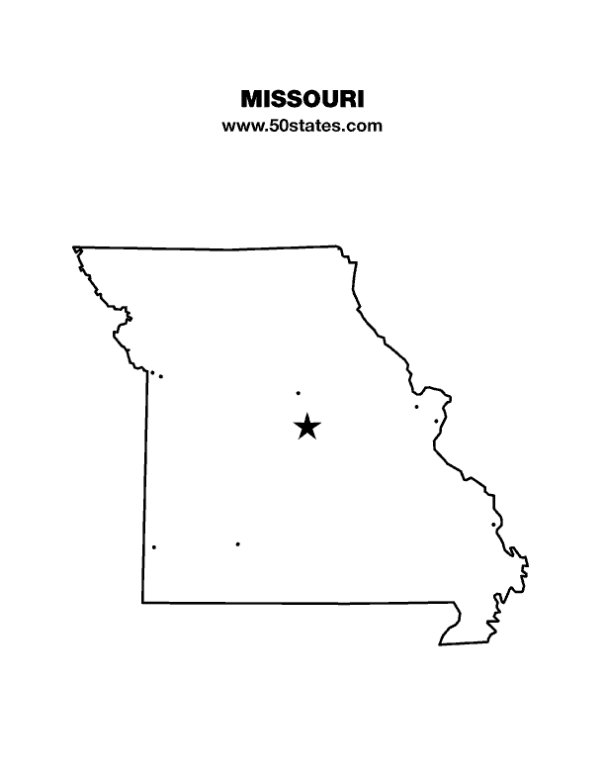
The Blind Missourian
June 2017

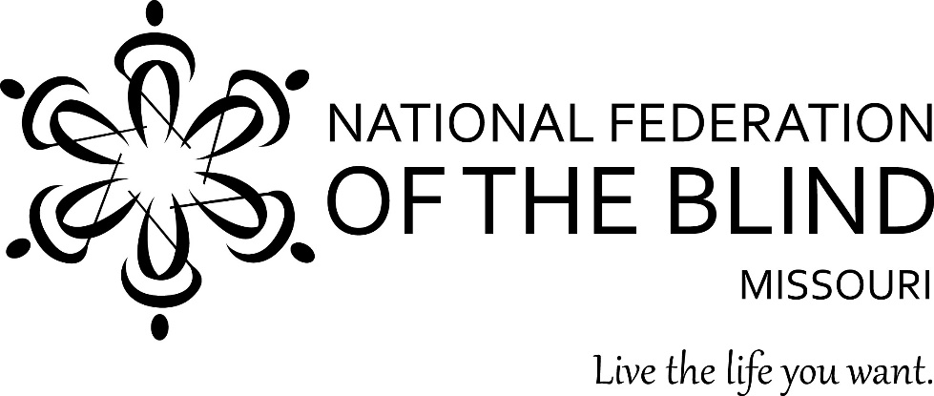

Table of Contents

Presidential Report by Gary Wunder 1
Dear Missouri Federationists by Shelia Wright 10
2017 Resolutions by Erin Magoon 11
National Fitness Challenge by Robin house 14

What A Rewarding Experience by Erika Wolf 15

A Tribute to a Soldier and a Friend by Gary Wunder 16

PLEDGE OF THE
NATIONAL FEDERATION OF THE BLIND
I pledge to participate actively in the effort of the National Federation of the Blind to achieve equality, opportunity, and security for the blind: to support the policies and programs of the Federation and to abide by its Constitution.

Presidential Report
Presented to the Fifty-Fifth Annual Convention
of the National Federation of the Blind of Missouri
April 8, 2017

Thank you very much for the warm welcome. It is always a pleasure to come before you to summarize some of our activities, and I'm sure it will be different for me next year when this job falls to someone else. People ask me how many reports I have given, and the truth is that I don't know. I can easily tell you how many years I have been the state president, but exactly when I started giving the affiliate a written report is not clear to me. My memory is 1987, but before that written report I'm sure there was a less formal review on our convention agenda.
I remember when I started being concerned with organizing state conventions. When I was the first vice president, Tom Stevens and I would work on these things, and assembling an agenda was a harder task than it is now. Our print agenda was written using a Selectric typewriter, a machine we thought of as advanced at the time because it was a ribbonless typewriter that offered some limited ability to make a correction if you caught your mistake before taking the paper out of the machine. Back then our agenda was Brailled using a Perkins Brailler, and it was copied using a thermoform machine. We now talk about how early to get it out to advertise the convention, but back then people got their copy when they registered and only then if things worked out right. I remember that once we arrived at convention to find that no Braille agendas had been prepared from the master because the chapter president said he simply didn't have time to make copies. It was then that I heard Tom Stevens use the expletive for which he is best known: growl. You will observe that the word has five letters; I could've offered him some that were shorter by one letter, but he didn't ask, so I didn't offer.
I want to begin my report to you by saying how pleased I was to be invited to the thirty-fifth anniversary of the National Federation of the Blind of Missouri's Jefferson City Chapter. It was wonderful to revisit the chapter's history, some of us being present at the founding, and others surviving the many ups and downs that might have destroyed a less committed group. Rita Lynch has been the leader who has held the chapter together, serving not only as its longtime president but as one of its most active members, regardless her position. Rita is not with us today because her son Larry has been granted a weekend home by the United States Army before his deployment to Kuwait and perhaps places even more dangerous. Rita hasn't missed a convention in thirty-five years, but there is no question that she is where she needs to be right now. I told her that she shouldn't waste a moment feeling bad about being somewhere other than here, and I got her to commit to another thirty-five conventions and more if she can manage to break the stellar record she has already compiled. Please join me in sending Rita a cheer that she can hear all the way to Jefferson City.
On last year's convention agenda, we received a presentation from the Employment Research Committee, its task to figure out what contribution we can make to increasing the number of blind people who are employed and enhancing the opportunities for those who are. As promised at last year's convention, a seminar was held in October of 2016, and thirteen potential employees attended, most sponsored by Rehabilitation Services for the Blind. The seminar began on Friday evening and ended Sunday at noon. In between we covered everything from resumes to table etiquette. The presentations made were well constructed and delivered, and the agenda planners included plenty of time for questions, answers, and observations from those in the audience. I want to thank all of the people who participated in this effort, and I know that it will contribute to more blind people finding and retaining good jobs that bring them closer to being fully integrated into our society.
We are always challenged by the need to find new members and to help those who are already committed become more involved. In August we held a membership seminar in St. Louis, and while our numbers were not what we expected, we have gotten new people to join the Lewis and Clark Chapter and have helped several others to become more involved. President Riccobono often urges that we raise expectations for the blind and ends many of his presentations with the rallying cry "let's go build the Federation." These are inextricably intertwined, and I think it is important for us to remember and convey to other people that we are only as strong as the men and women who take up an oar to row the boat that takes us to first-class citizenship. We have no shortage of good ideas that come from people who think of us as a can-do organization. But they need to understand that their good ideas are only the starting point—we need their help in carrying out the challenge they have asked us to accept. Let's continue to think about creative ways to reach out to people who have not heard about us, different ways to send the message of hope and opportunity we offer, and more effective ways of sustaining new relationships so that the people we recruit can move from acquaintance to friend to Federationist.
For the third year in a row our affiliate sponsored a BELL Program or what is now known as the BELL Academy. BELL, of course, stands for Braille Enrichment for Literacy and Learning, and again we rented the Delta Gamma Center for the event. Not only is it an excellent facility, but the hope is to build a good relationship with Delta Gamma, to understand their programs and have them understand ours, and to work more cooperatively to serve the needs of blind children. Of course we hope that some of those blind children will come to see that we offer much more than instruction in Braille, that we give them the best chance of living the lives they want, and that we need them to ensure that these efforts are continued long into the future.
Of all the BELL stories I have heard from Debbie and her dedicated volunteers, the one that brought me closest to tears didn't have anything to do with Braille. We want our students to experience both the joy and the benefits of physical activity, so the staff set up a rope with knots near each end, and our students learned how to race. Some had never participated in physical competition; some had never even learned to run. How amazing it is to think that one could go through childhood without ever knowing the joy of rapid movement, that wonderful bouncing sensation that is, for a time, so much more exciting than walking. And yes, may I say it again: competition, competition, competition. They loved it, and so too did the staff—not just enjoying the competitiveness of their students, but engaging in a little competitiveness themselves. Just ask Debbie Wunder and Carol Coulter about the race, but don't ask them when they're both together—they may tell you different stories. Thank you to Debbie Wunder; Shelia Wright; Carol Coulter; Jennie Carmack; Holly Carneal; Bryan Schulz; Chris Tisdal; Deb Bush; Robin House; Shawnee Korf; Justin Cole; Elisabeth Coulter; Randy Carmack; Rita Lynch; and our teacher, Adnan Gutec.
Last year one of the bills we took to the Missouri Legislature was a bit out of character with the efforts we advertise to the public as fully integrating the blind into society. The problem we put resources into solving was that blind people from other states who were of drinking age could not purchase alcohol in Missouri. This might not seem like a big deal when compared with helping someone out from under an alleged overpayment from Social Security involving thousands of dollars, but the problem we set about solving was real, and it was an issue of significance and consequence. Dr. Cary Supalo is the owner of a company which sells scientific instruments adapted so that they can be used by blind people. He is always looking for customers and investors, and on one of his trips to Missouri he invited a potential customer for dinner and drinks. Imagine Dr. Supalo's embarrassment when he learned that he could not be sold a libation because he had no driver's license to present. Lacking a driver's license, he was asked for a Missouri identification card, but he does not live in Missouri, and Missouri law did not accept the identification card from the state where he lives. This was a humiliation to Dr. Supalo, something which he believed served to separate him from the normal and capable adult he is and the man he wanted his client to see.
Well the long and the short of it is that last year we asked that legislation be introduced to change the statute to allow for out-of-state identification cards to be used as legal verification that one is of drinking age. Several members of the Missouri General Assembly said that they would introduce legislation to remedy this, and still others said that they would see that relevant amendments were passed to larger bills to get the job done. As much as we work hard to follow the proposals we have caused to be introduced or otherwise support, this one slipped past us, and it wasn't until we went looking for sponsors this year that we realized we had already been successful. Let's all have a drink to Shelia Wright, the hard-working members of her committee, and each and every person in this state who wrote and called on behalf of our right to make a toast in the name of progress.
A little over a month ago I was contacted by Kevan Worley, who wanted to know if Missouri was interested in a fitness challenge that could make us more physically fit and make us a bit of money. I admit that the money part was primary in my saying yes, but you will notice that many members who would normally be sitting quietly during convention aren't holding down a seat but are off in the corner marching in place. The reason is that they are all wearing Fitbits, an electronic gadget that counts steps and sends those step counts to a nationwide database where everyone in the contest can see the step counts of everyone else. Missouri is part of the United States Association of Blind Athletes and the Anthem Insurance Company National Fitness Challenge to improve the health of blind people by establishing and measuring progress in meeting the targets set by the American Heart Association for health. Ten thousand steps a day is what they recommend, and Missouri is in competition with twelve other blindness organizations to meet and exceed that goal. We are competing with large agencies throughout the country and are the only consumer organization to win a contract. If we do all of the things we have committed to do with the USABA, we will benefit by receiving $10,000. Not all of this money will be spendable on other Federation projects, some going to carrying out this program, but if we are wise in the management of our resources, some will, and we will all be the better for the work. I should qualify that last statement—we will all be the better if we don't kill one another. Carol Coulter complains that her husband is a walking machine from sunrise to sunset. "He walks when he's upstairs watching M*A*S*H, no matter how many back-to-back episodes they air. The floor goes squeak, squeak, squeak. Finally I yell at him, he comes downstairs, and instead of just sitting and talking, he walks around and around the island in our kitchen. Send him to the basement, and the activity is the same: clop, clop, clop. This man is driving me crazy." Thank you to Robin for her work in seeing this project through and for chairing one of our most exciting new committees.
Though none of us walked to get there, we participated again this year in the Washington Seminar, and the weather was much more accommodating. Our lead issue was the AIM High Act, legislation designed to replace inaccessible instructional materials and technology with materials and tools that can be used by blind people. We also worked on the Access Technology Affordability Act, a proposal which, when enacted, will give tax credits to those of us trying to purchase the expensive technology that allows us to participate in the information age. We also asked Congress to make a one-time appropriation to the National Library Service for the purchase of refreshable Braille displays that will be given to any blind person who wants a portable device for displaying Braille under his or her fingertips. But of course, what good is a device for reading if the information one wants isn't available. So it is that we are again pressing for the passage of the Marrakesh Treaty, which will allow the cross-border sharing of accessible books, the result being the elimination of needless duplication, the reduction in the spending of limited resources, and more books for us to read and thereby increase the richness of our lives.
Four people attended the seminar with the sponsorship of the affiliate. They were Shelia Wright, the event coordinator; Bethany Bennington; Debbie Wunder; and Julie McGinnity, who took a week from her training to be part of our delegation. I was, of course, the tagalong, helping out when I could take some time from reporting for the Braille Monitor. Right before our Washington trip Debbie and I subscribed to a service called Aira, which I have written about in the Blind Missourian. As an Aira Explorer or a beta tester, I wanted to see if the system would really be helpful to me in navigating in unknown environments. So Julie is in DC to demonstrate and enhance her training, the goal being to show herself and others that she can find anything that is out there to find, and here I am trying to use the services of someone in California to find those things for me. Julie about took my head off for interfering in her training to be more independent; okay, for any of you who know both of us, you know that's a lie. She about bit my knee off. So after our little squabble about who was going to test what and when, we ended up having a great time. I was reinforced in my belief that Julie has a backbone, and she was reinforced in her belief that sometimes I can be a stubborn old dog.
A moment ago I mentioned one of our victories in Jefferson City, implying that we once again held a Jefferson City seminar. Of course we certainly did, but because I was not in attendance due to the funeral of my mother-in-law, I'm going to leave it to Shelia in her governmental affairs report to highlight the activities that occurred there. Those of you who are a part of our NFB of Missouri email list have seen the notes of commendation that have been passed to our chairman, so please join me in publicly thanking Shelia Wright for all of her work.
No report would be complete without discussing the cases we have taken on this year. Last year I told you about Layla Walker and her tremendous progress since joining the family of Dori and Jason. This mother and father are exactly the people you would want to have if you are a blind child hoping to get a good education in this country. They are bright, motivated, and not at all averse to doing whatever research they can to see that Layla gets everything she needs included in her individualized education plan. Shelia Wright has accompanied them to at least four meetings this year, and she reports that the school district is very interested in helping, but sometimes they need direction and a little encouragement. As Shelia modestly says, "I wouldn't say that we have to push them hard to get Layla the things she needs, but it does seem that the meetings proceed quicker and easier when they know there is an advocate from the National Federation of the Blind in the room." I've argued with Shelia before, and I know that she's right. Congratulations to Layla on her progress, to Dori and Jason for their love and persistence, and to Shelia for doggedly pursuing this case and making sure that the school district knows that the National Federation of the Blind of Missouri is squarely behind whatever Layla needs to become a successful and happy adult.
Beryl and Vicki Jordan are longtime Federationists we first came to know when they lived in Maryville. Beryl is one of the most independent travelers I know, using what public transportation there is to get around the state and occasionally using his thumb to get to those places public transport no longer serves. Several years ago Beryl and Vicki received some money through an inheritance from Vicki's father, and although they did what they could to comply with the rules of the Social Security Administration, they received an ominous letter from the agency stating that the couple had been overpaid. They were alleged to owe $24,000. They got themselves a lawyer, paid him $4,500, and for that substantial payment Vicki and Beryl received this legal advice: settle, pay, walk away, and wait for the rest of my bill.
Having tried to handle this themselves, they came to us for help. Vicki's paperwork was superb, Beryl's recall of it was almost as good, and after a face-to-face negotiation with a staff member from the agency, we got a decision that concluded the couple did not owe money but might even be due a refund. It hasn't come yet, but they are so relieved to be through with an almost $24,000 debt that they are willing to let well enough alone.
This case is but one of many that we handle dealing with Social Security and Missouri's blind pension. Most I do not handle but refer to Gene Coulter, and please join me in thanking him for all that he does to help people through these difficult financial issues.
Amiah Washington is a young teenager who lives in Knob Noster, Missouri, and attends its local school. Just one year ago the school classified her as virtually incapable of benefiting from an education. All of her materials were offered in print, and as the print size diminished, so too did her progress. Her mother Samantha is a single parent who works a fulltime and a part-time job as a speech pathologist. So concerned was she about her daughter's lack of progress in the school district that she spent $7,000 of her own hard-earned money in legal fees trying to make the district step up and see Amiah for the bright and beautiful person she is. When we became involved in Amiah's case, both she and her mother were leaning toward transferring Amiah to the Kansas School for the Blind. This would have resulted in a commute of almost three hours each day, would have meant that Amiah could not be schooled along with her friends, would have cost the school district far more in out-of-state tuition than they would spend by providing services directly, and would've been a hardship to everyone involved. With the help of our national body we were able to provide legal assistance to Amiah that has resulted in a quality IEP, a 180-degree shift in the attitude of the school district's administration, and in real progress for Amiah as she works to catch up and compete with her fellow students. Immediate past president Marc Maurer has been involved in this case and was not only responsible for encouraging President Riccobono to authorize it, but helped to see that Amiah received a BrailleNote Touch so that she could do much of her work in Braille and have it transcribed for review by her teachers. I have been to two meetings with Amiah and her mom and one meeting with the school district. This is the kind of case one feels good about being behind, and I think that the result will be that Amiah Washington grows up to be the competent and capable adult that God means her to be.
With Amiah, Layla, and Beryl, we have made a significant contribution that is reflected in our brand promise: "Together with love, hope, and determination, we transform dreams into reality."
In moving for a moment to internal matters, let me thank a few people who are making significant contributions to the infrastructure that lets us do the work we all find so important. One big effort this year has been to update our website so that it now reflects the branding of the National Federation of the Blind and uses state-of-the-art tools that let us display and update both the information we want the public to see and the information we need to effectively run the affiliate. Gary Horchem started us on the long road in converting from web software that was popular in the 90s to the Drupal Content Management System that is frequently used today. When Randy Carmack took over from Gary, our new webmaster's primary concern was addressing security and ensuring that our website was both visually appealing and totally accessible. The countless hours he has spent on this project have borne fruit, and we now have a website that will allow us easily to update and proudly display the work that we do in the National Federation of the Blind of Missouri. Not only has Randy created a first-rate website, but he created the registration system that you and I used to sign up here. I know that he did a good job, for I have not gotten one call or complaint from our treasurer about the inability to reconcile the number of people registered and the money she expects to see. If there were bumps in the system, they were so insignificant that they never made it on my radar, and for this I am exceedingly grateful to Randy.

Although it is less obvious and less glamorous, not only does every state need a first-rate website, but it also needs a way to keep an updated list of members. That list needs addresses, phone numbers, committee assignments, and preferences for receiving materials from the affiliate. For a long time we have struggled with many different sources for this information: the editor of the Blind Missourian has a list; the president has a list; the scholarship chairman has a list; the first vice president has fifty different lists; and if you think those lists are consistent or easy to access, I want to invite you to the ocean cruise we are hosting over on the Kansas side directly after adjournment tomorrow.
Thanks to the hard work of Bryan Schulz, we now have a central database that can be updated once and can send names, addresses, and other important information to our chapters and our committees. We can generate mailings to statewide committees just by adding the names of members, and the lists we give you won't just have names for you to go look up. The lists will be as complete as the one Erin Magoon generated for our statewide standing committees, but it can be provided with far less work thanks to Bryan. Many people in the Federation are fantastic when it comes to doing jobs they are asked to do, but Bryan did this job because he realized it needed to be done and took it on himself to do it. Please join me in thanking him for something which will receive little visibility, but will replace the cumbersome and inefficient process we have used for decades.
Before I move on to my concluding remarks, let me say a big thank you to our committees, which have been more active this year than in any time in my memory. This convention was announced by a press release. Other recent events have likewise been advertised outside the organization. Hats off to our public relations committee and to Daniel Garcia.
We are more active on social media than ever before, and this is due in large part to the work of Amy Plumlee. Through social media we are reaching out in the twenty-first century, and we must learn to do even more of it—we Facebook, we tweet, we engage.
Our transition to blindness group has met regularly, our sports and recreation committee slugs it out with the membership committee for time on Tuesday evenings, and many of the presentations we have heard at the seminars and during convention sessions have been the result of coordination through communication. This shows momentum, and momentum is absolutely essential if we are to grow.
What I have talked with you about this afternoon is by no means an all-inclusive list of the places I have visited this year or the work that has been done with or without my involvement. It is but a smattering of our activities, those which I thought most needed to be highlighted. The people who have worked on these projects cause me to feel tremendous pride inside, and they have reaffirmed for me why I am a member of the National Federation of the Blind. Not everything we decide to do gets done in the time frame promised or even in the time frame we might wish, but a great deal does occur thanks to our collective efforts, and thanks to the people who go beyond thinking that a thing should be done, to seeing that it will be done.
I will close now by taking just a minute or two to say thank you for the great honor you have extended to me. I've served in this office since 1979 with one two-year interruption that was granted to me by our former president Billie Weaver. I told her I needed some time to finish the work of adopting my little girl and building a house. She gave me that time, and never do I want anyone to think about my years as president without remembering that the two year break I mentioned was filled by someone who possessed great love for this organization, demonstrated wisdom and patience in leading it, and helped build the base which has been our foundation for so long. I don't think any of my terms have been as difficult as the one I asked her to undertake, and I will always remember her with gratitude.
My own service is easily summarized. We did a lot of work, had a lot of fun,
navigated around some rocks that might have damaged us beyond repair, and together we have made better the lives of many a blind person in this state and in the country. I have enjoyed the honor that comes in being called Mr. President, even when I have growled about some of the work that is necessary to keep that title. This organization has on many a day put a spring in my step, has given me confidence to believe in myself, and has helped me through rough times that would have been far rougher had it not been for the faith and confidence I knew you had in the work we would do together.
This is my final report to you, but there aren't too many final events that will be signified when the gavel drops tomorrow. I will no longer be president, but I see this as a plus. It can be a good thing for the growth of the affiliate, the strengthening of our base of leaders, and a wonderful chance to see the affiliate led by someone who has watched it up close, knows where it can be improved, and has good strong personal relationships with the people who can make it happen. I look forward to sitting in a different part of the room during meetings of the board, cringing as someone gavels me down for talking to my neighbor or for speaking before being recognized by the chair.
I end with just a few more words of thanks. High on my list to thank has to be my family. They are the people who have accepted my being gone on weekends. They are the ones who watched television alone because I had promised a letter or to participate in a call. They have been the people who suffered from Gary on a short fuse when things weren't going the way I wanted with my paid work or some organizational problem. I want to thank the officers and board members who have for so many years done the work that makes a report like this possible. I have been honored to write and stand before you to present it, but this is more an annual report than it ever has been a presidential report.
Ladies and gentlemen, no group could have been better to me than you have been, and I intend to show you how much I appreciate it by continuing to be a vital and active part of the affiliate. You folks are the best there is, and I look forward to serving you for another decade or so in whatever capacity you wish. Let's go build the Federation!

Dear Missouri Federationists
By Shelia Wright
What a convention! Despite the challenges with the hotel, it flowed smoothly, and the evidence of our accomplishments for the year were reflected so eloquently in President Wunder's annual report. It was a privilege to have Ron and Jean Brown with us at this year's convention, and Ron did an outstanding job as our 2017 national representative. We were also blessed to have the Maurers, the Allens, Sandy Halverson (a former president of the Kansas City Chapter), and representatives from all three of our NFB centers. Federationists from seven other states were also on hand for our Missouri convention and each of them cheered us on and witnessed this historic convention for our Missouri Affiliate.
This convention was special as we had an opportunity to express our appreciation and love for Gary Wunder, who has served as president of the Missouri Affiliate thirty-six of the last thirty-eight years. What a tremendous leader, mentor, advocate, and friend he has been to all of us, and we celebrated with him as he retires as our president. However, we are very fortunate that Gary will continue to be our colleague in the Federation.
I'd like to thank each of you for your vote of confidence by electing me as president of the Missouri Affiliate. What an honor to have an opportunity to serve as your president. I pledge to do my very best. The transition will not occur over night, and I am thankful that Gary will be able to help make the transition smooth.
Congratulations to those elected to new positions on our Board of Directors. I feel really good about the composition of our board and look forward to working with each of you. I believe the election results have already been posted, but I would like to recognize each of my newly elected colleagues on the board here. They are: Julie McGinnity - First Vice President, Gene Fleeman - Second Vice President, Dacia Cole - Recording Secretary, Erin Magoon – Corresponding Secretary, Carol Coulter -Treasurer, and board positions - Gene Coulter, Amy Plumlee, and Jenny Carmack. Congratulations to each of you. Those who were not up for election this year who serve on the board are: Roger Crome, Daniel Garcia, Melissa Smith, and Chris Tisdal. While I will be talking with each of you very soon, I look forward to our first board meeting on June 17, 2017, in St. Louis. Chris Tisdal is already working on the arrangements.
The National Federation of the Blind of Missouri needs each of you to be
engaged in our organization as we move forward. Please think about your strengths and where you would like to serve. Let's continue to build the Federation.
Commendations to the Kansas City Chapter and the Old Drum Chapter on a great convention. Stay tuned to the Blind Missourian and our social media for other convention highlights. Thanks again to all!
Shelia Wright, President National Federation of the Blind of Missouri
7928 NW Milrey Drive Kansas City, MO 64152
Home/Work: 816-741-6402 Mobile: 816-679-5258
Email: sbwright95@gmail.com Website: http://www.nfbmo.org

2017 Resolutions
By Erin Magoon

Here are the resolutions that were passed at the National Federation of the Blind of Missouri state convention which was held April 6-9 in Kansas City, MO.

Resolution 2017-01

A Resolution Regarding The Honorable Gary L. Wunder

WHEREAS, Gary L. Wunder has been an exemplary member of the National Federation of the Blind of Missouri for forty-five years, serving on the affiliate board of directors since 1975; and

WHEREAS, he was instrumental in the founding of the Columbia Chapter on February 28, 1974, and the original Warrensburg Chapter on April 25, 1975; and

WHEREAS, he has served for thirty-six of the past thirty-eight years as our President with extreme determination and dedication; and

WHEREAS, Mr. Wunder has served with the highest honor and distinction,
it is only fitting that he be honored as befits his accomplishments; and

WHEREAS, The Missouri Affiliate Award (also given as the Rittgers Award) has been periodically presented at the direction of the affiliate president to a person or group demonstrating extraordinary service to the blind of Missouri: Now, therefore,

BE IT RESOLVED by the National Federation of the Blind of Missouri assembled this 8th day of April, 2017, in the City of Kansas City, Missouri, that from this day forward the Affiliate Award shall be renamed the Gary Wunder Award; and ,

BE IT FURTHER RESOLVED, as befitting a gentleman of his high distinction Gary L. Wunder is hereby named President Emeritus of the National Federation of the Blind of Missouri with all of the rights and privileges of a member of the board of directors except that of voting for as long as he remains a member of this organization.

Resolution 2017-02
A Resolution Regarding Sony’s Play Station

WHEREAS, video games have become a staple of online and real-time socialization and entertainment; and

WHEREAS, accessibility options for blind people have been largely ignored by the video game industry, thereby excluding blind people from this form of socialization and entertainment: Now, therefore,

BE IT RESOLVED by the National Federation of the Blind of Missouri in Convention assembled this 8th day of April, 2017, in the city of Kansas City, Missouri, that we commend Sony for including text-to-speech accessibility on the Play Station IV console; and

BE IT FURTHER RESOLVED that the National Federation of the Blind of Missouri encourage and work with Sony toward the expansion of this accessibility so that its games and consoles will continue to be fully accessible for blind consumers.

Resolution 2017-3
A Resolution Regarding Senate Bill 43 On Discrimination Against Disabled People

WHEREAS, the unemployment rate among blind people and those with other disabilities is extraordinarily high, and it is extremely difficult to prove a discriminatory act; and

WHEREAS, current Missouri law requires that a disabled person proves that the person’s disability was a contributing factor in any discriminatory act; and

WHEREAS, Missouri Senate Bill 43, which has been passed by the state senate, would force a disabled person to prove that their disability was the motivating factor that led to the adverse action, an apparent violation of the Americans with Disabilities Act; and

WHEREAS, the National Federation of the Blind of Missouri strongly opposes any legislation that would put barriers in the way of any blind person getting or keeping a job: Now, therefore,

BE IT RESOLVED by the National Federation of the Blind of Missouri in Convention assembled this 8th day of April, 2017, in the City of Kansas City, Missouri, that we urge the members of the Missouri House of Representatives to vote down this oppressive legislation; and

BE IT FURTHER RESOLVED that we urge the governor to veto Senate Bill 43 if it reaches his desk.

Resolution 2017-04
A Resolution Regarding Equal Salaries for Rehabilitation Services For The Blind Counselors

WHEREAS, Rehabilitation Services for the Blind employs rehabilitation counselors to help Missouri’s blind citizens get the education and training that leads to employment; and

WHEREAS, the agency is hampered in hiring and retaining qualified counselors because its pay rate for these employees is significantly lower than the Division of Vocational Rehabilitation and similar agencies in surrounding states; and

WHEREAS, the special knowledge and skills to meet the unique needs of blind people would by any reasonable standard argue for a pay rate that exceeds that paid to the general agencies: Now, therefore,

BE IT RESOLVED by the National Federation of the Blind of Missouri assembled this 8th day of April, 2017, in the city of Kansas City, Missouri, that we urge the Missouri Department of Social Services to make the salaries commensurate with the Division of Vocational Rehabilitation Services; and

BE IT FURTHER RESOLVED that, failing successful action by the Missouri Department of Social Services, this organization will address this issue with the Missouri Legislature.

National Fitness Challenge
By Robin House

The National Federation of the Blind (NFB) of Missouri with a thirty-five member team of Missourians, is participating in the National Fitness Challenge (NFC) sponsored by the United States Association of Blind Athletes (USABA) and the Anthem Foundation. Twenty-five participants received a Fit Bit Flex 2 in order to track steps and active minutes. The goal for each participant is 10,000 steps a day and thirty active minutes. The National Fitness Challenge officially began April 1 and continues through November 30. As part of the National Fitness Challenge, participants were involved in a 5 K event and will be participating in a Paralympic Day this fall as well as two, seven-week exercise groups. Individuals are competing with each other within the state of Missouri. The NFB of Mo. team is competing against twelve other teams across the United States. The NFB of Mo. team came in third place in April with a collective step count of over five million. Each month throughout the National Fitness Challenge, first, second, and third place teams receive gift cards from Dick’s Sporting Goods to use for the good of the group. All participants are blind and visually impaired. The goal of the program is to increase fitness and participation of people who are blind in community events and increase the awareness of the public.

What A Rewarding Experience
By Erika Wolf
Run for Sight, an annual fund-raising event sponsored by The Delta Gamma Center for Blind and Visually Impaired Children located in St. Louis, MO, was held this past May 7, 2017. This event enabled the National Federation of the Blind of Missouri-National Fitness Challenge participants to experience an extraordinary outlet to ban together as a team of runners and walkers to support the cause of raising as many funds as possible for the center. There were sixteen participants from across the state present at the run representing the NFB MO NFC. This was the first time that many blind and visually impaired runners/ walkers came together to make up a team in the past twenty-five years, which is how long The Delta Gamma Center for Children has been hosting this annual event. The Delta Gamma Center’s aim is to increase a wide array of learning and social skill developmental programs and opportunities for blind and visually impaired children. The center supports blind and visually impaired children and their families from the early age of development, age zero-three, introducing families to vision loss and blindness, up until a child reaches the age of maturity.
From a personal perspective, it was my privilege to be part of Run for Sight this year. As a first-time runner, running a three and a half mile course alongside a sighted guide and my fellow NFB MO NFC cohorts was a great experience. What a tremendous feeling it was to run the newly selected 5 K course around Ballpark Village.
There really hadn’t been much preparation made on my part training for my first run, and being partnered with an experienced runner as a guide. Although, my guide had previously run a number of courses and half marathon runs, my guide had no prior experience guiding a blind runner, let alone, a first-time one.
The day before the event was to take place, I contacted my volunteer running guide for the morning fund-raiser to discuss a strategy for running with one another through the massive crowd of people expected to be at the city-wide event. Right away, I stressed the importance of how we would communicate with one another as we ran and that I felt an effective tether to use would be a rolled-up hand towel that we could both hang on to as we meandered through the crowd. This tool turned out to be the most effective one for me, as my running guide and I tactually communicated with each other on how we were moving as we sifted through the high number of runners and walkers.
We got off to a late start because we were unable to connect up before the run was to begin, so we didn’t get in line with all the timed runners at the very beginning. In spite of this happening, we still managed to run a respectful race to the finish line, bringing us breathlessly up to where all finished runners and walkers were congregated upon finishing their set course.
Something very spectacular transpired while running with my guide. I became keenly aware of my physical fitness ability to run without practice, what it is like to put my trust and faith in another human being besides my normal - mobility tool and friend, my one-of-a-kind, one-in-a million guide dog, Chandra.
Run for Sight was a winning experience for all involved and something I’m extremely proud an honored to have been a part of and look forward to participating in years to come.
There is something so entirely gratifying building belief in oneself and the blind as a whole, and that is exactly what this National Fitness Challenge enabled me to do. I’m extremely proud to be a member of the National Federation of the Blind and look forward to becoming more actively involved in the organization as a whole.

A Tribute to a Soldier and a Friend
by Gary Wunder

Have you ever seen people lined up on the street, impatiently waiting for their opportunity to go blind? Of course not. But I have found myself surprised when I have realized how many people found that becoming blind gave them opportunities and a chance to meet people who made them feel that their experience was not only a challenge but a blessing. Tom Stevens often makes this point in public speeches, and although I would never wish that anyone be deprived of their sight, I do find myself feeling blessed by the fact that blindness has brought certain people into my orbit, and together we have been able to work on doing something to improve the life experience of thousands of people.
Larry Arnold is a man I met because fate, biology, or some other force decided that he was going to be blind. Larry and I met more than thirty-five years ago, and I was immediately impressed with his enthusiastic, articulate, and forceful way of letting his views be known. He was a listener and a learner, but once he knew something that he thought was important, he would find an audience, and they too would learn.
Being the active fellow he was, Larry early on earned himself a place in the office of the state representative from his area, a man who was destined to be a governor named Bob Holden. When representative Holden served in the Missouri legislature, he made it easier for us to get appointments with ranking members of the legislature, key personnel in the executive branch, and annual meetings with the governor. He did this because he liked, admired, and every day had to work with Larry Arnold, and persistence was one of Larry's most prominent character traits. When representative Holden became Governor Holden, Larry still helped us get our annual meeting, but he was frustrated that the governor did not turn out to be a better advocate. Larry's wry comment was, "you would think with all that teaching that he would've learned better."
I served with Larry Arnold on the State Rehabilitation Council for the Blind, a group that is charged with overseeing the activities of Rehabilitation Services for the Blind. When I chaired that group, I could always count on Larry to volunteer for or except committee assignments, and when the next meeting came around, you can bet that he would have his report. At the time of Larry's service on the rehab council, he worked for a company that set up seminars and events both in the Springfield area and throughout the state. One of Larry's jobs with his company was to publicize these events, and the expertise he gained in doing this job was freely shared with our Missouri affiliate, sometimes with him taking the initiative to do publicity, and at other times acting as the teacher so that we would learn how to do what he so easily did. In his capacity as a member of the state rehab council, he served as a real inspiration for those on and off the council who were looking for employment.
Larry learned earlier this year that he had stage IV cancer and that the question was not whether it would take his life but when. Although his cancer caused him to feel significant discomfort, he made it a point to come to the fifty-fifth annual convention of the NFB of Missouri, and, as he said to me and the convention assembled, "We came into the Federation together, and we’re going out together." Nothing touched me more than when he said that he was determined to come to the convention to be a part of the ceremonies surrounding my retirement as state president, and realizing what a sacrifice he made caused me to feel ever so grateful for the service I was permitted to give and the people who walked shoulder to shoulder to see that we got things done.
Larry was laid to rest on Saturday, May 6, and the turnout for his funeral was impressive. It was clear that Larry had friends and allies not only in the National Federation of the Blind but from many other organizations and individuals who were touched by his example, his bravery, his optimism, and his dedication to duty. I will always count as one of the more significant blessings I have been given in my life the friendship of Larry Arnold and the fact that he was so much more than an acquaintance, a colleague, and a friend. Larry was part of our Federation family, and though his passing leaves us with a hole in our lives, his example shows us how to begin to fill it with acts of kindness and generosity that duplicate what Larry would be doing if he were still with us today.

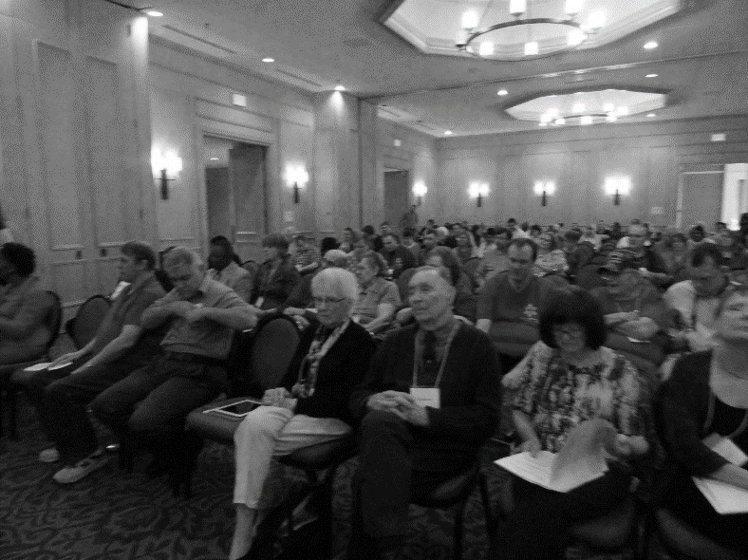

1. Audience listening to President Wunder's last report. Audience members include long time members Tom and Helen Stevens and Larry Arnold. Larry passed away shortly after convention.

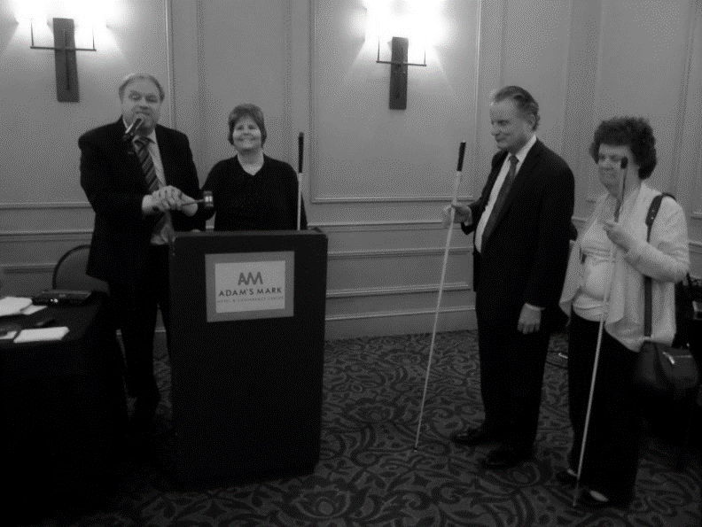
4. Newly elected President Shelia Wright and President Emeritus Gary Wunder join hands on the gavel to close the 2017 convention.

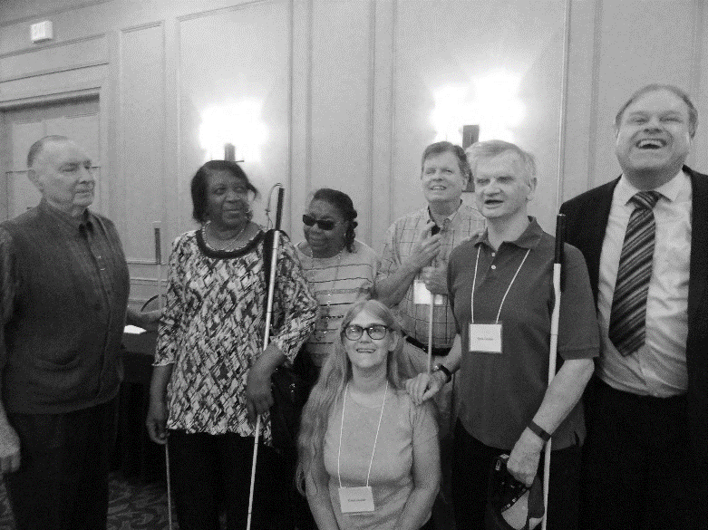
5. Members since at least 1979 when Gary Wunder became the President of MO. L-R: Tom Stevens, Gloria Carson, Willa Patterson, Dan Keller, Gene Coulter, Gary Wunder, in front Carol Coulter. Not pictured: Helen Stevens, Gail Bryant and Diana Aubuchon.

6. The new Board: L-R Carol Coulter, Jenny Carmack, Guide Dog Nelson Row 2: Dacia Cole, Julie McGinnity, Erin Magoon, Melissa Kane Row 3 Chris Tisdal, Gene Coulter, Daniel Garcia, Amy Wilson, Gene Fleeman, Shelia Wright, Roger Crome, Gary Wunder

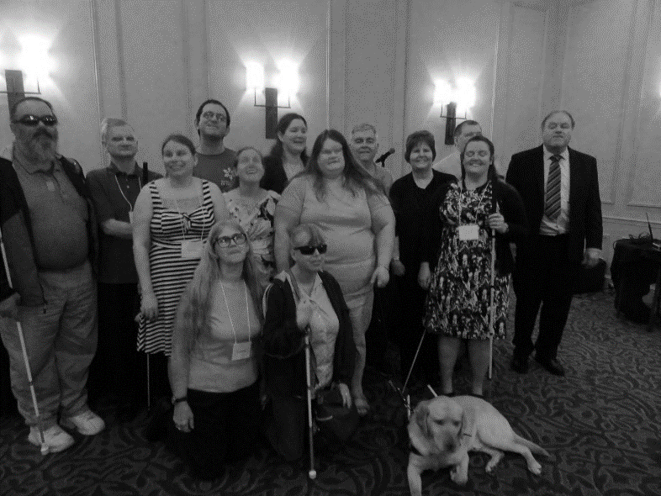
Board of Directors
National Federation of the Blind of Missouri

Officers:
Shelia Wright, President Julie McGinnity, First Vice President
Gene Fleeman, Second Vice President Dacia Cole, Recording Secretary
Erin Magoon, Corresponding Secretary Carol Coulter, Treasurer

Board Members:
Eugene Coulter Roger Crome Jenny Carmack
Amy Wilson Chris Tisdal Melissa Kane
Daniel Garcia President Emeritus, Gary Wunder

Chapter Presidents
Debbie Wunder, Columbia Helen Parker, South Central
Melissa Kane, Jefferson City Ben Vercellone, Springfield
Ruby Polk, Kansas City Chris Tisdal, Lewis and Clark
Roger Crome, Mineral Area Chapter Dan Keller, Show-Me State Chapter
Amy Wilson, Old Drum Chapter

Blind Missourian Editor Carol Coulter
Proof Readers Helen Stevens, Shelia Wright, and Gary Wunder
Read by Elisabeth Coulter

FREE MATTER FOR THE

BLIND AND PHYSICALLY

HANDICAPPED

NFB of Missouri
1504 Furlong Dr.
Columbia, MO 65202

